Chapter 1

Introduction

  - Background
The main aim of “Digitalised Menu Card” application is to digitalise the orders from the customers in the restaurants. It is an interactive menu for restaurants and hotels, viewed on a networked LCD screen located on tables, offering full range of ordering and interactive services.

1.2 Objectives
The new menu also can be added to the menu card. By placing their orders on the LCD screen. Then the food order and table number are sent to the kitchen directly once ordered by the customers. The customer can give feedback for the food they have. This will help the hotel owner to improve the same and make necessary changes if required. We can pre-order the food stuff before reaching the restaurant and it saves the lot of time.

1.3 Purpose and Scope
1.3.1 Purpose
The main purpose of this application is to make the services of the restaurant efficient and to minimize the wastage of paper. We can now review the food which we have. We can also see the review of the food available in the particular restaurant.
1.3.2 Scope
In the current dining environment physical menu are used to convey the food list. Menus are paper based so it imposes restriction on the content of the menu card and to update the menu card according to the restaurant availability is a tough job. This document describes the requirements of the digital menu cards and its advantage over the formal dining environment.

Chapter 2

System Analysis

2.1 EXISTING SYSTEM
In the existing system, current dining environment physical menu are used to convey the food list. Menus are paper based so it imposes restriction on the content of the menu card and to update the menu card according to the restaurant availability is a tough job. If the manager wants to audit the records of order then also it is not an efficient way of searching the records. The customer has to wait for the waiter for taking their order and this process is time-consuming. And for every small order, we have to call the waiter number of times and it leads to some misunderstanding from the side of the waiter. So we have to make changes in the existing system to eliminate the above problem.

2.2 PROPOSED SYSTEM
In the proposed system, Restaurants provide LCD screens this will allow the user to access the menu card of the restaurant it will help the customer to view the review of the food. This will help the customer to view the description about the content of the food. Admin can modify the menu according to the availability. The new menu also can be added to the menu card. By placing their orders on the LCD screen. Then the food order and table number are sent to the kitchen directly once ordered by the customers. The customer can give feedback for the food they have. This will help the hotel owner to improve the same and make necessary changes if required. We can pre-order the food stuff before reaching the restaurant and it saves the lot of time.

2.3 REQUIREMENT ANALYSIS
2.3.1. Problem Definition
In this project, customers have to place their orders on the LCD screen. Then the food order and table number are sent to the kitchen directly once ordered by the customers. The new menu also can be added to the menu card. This will help the hotel owner to improve the same and make necessary changes if required. We can pre-order the food stuff before reaching the restaurant and it saves the lot of time.

2.3.2. Requirement Specification
The process of studying and analyzing the user needs to arrive at a definition of the problem domain and system requirements objectives. Discovery of the boundaries of the new system and how it must interact with its environment within the new problem domain. Detect and resolve conflicts between (user) requirements Negotiate priorities of users. Prioritize and triage requirements such that managers can give realistic project estimates and developers can design, implement, and test .Classify requirements information into various categories and allocate requirements to sub-systems. Evaluate requirements for desirable qualities.
We have seen how to specify requirements in terms of structure, standards, and writing rules, but: How to identify the real problems to solve in the elicitation results? How to detect conflicting aspects? How to negotiate to resolve conflicts? How to decide what is important and a priority? How to ensure that nothing is forgotten? How to validate that the findings of the analysis are good? How to use models in this context? invention and definition of the behavior of a new system (solution domain) such that it will produce the required effects in the problem domain. Start from a knowledge of the problem domain and the required effects determined by elicitation and analysis. Generally involves modeling. Results in the specification document precise expression of requirements, may include models.
Requirement modeling:
This is an essential task in specifying requirements map elements obtained by elicitation to a more precise form help better understand the problem Help find what is missing or needs further discussion different modeling languages Informal: natural language Goal-oriented modeling(GRL) Functional modeling: UML(Unified Modeling Notation) SDL(Specification and Description Language) Logic, UCM(Use Case Maps).
Requirement classification:
In order to better understand and manage the large number of requirements, it is important to organize them in logical clusters it is possible to classify the requirements by the following categories. Features Use cases Mode of operation User class. This makes it easier to understand the intended capabilities of the product and more effective to manage and prioritize large groups rather than requirements.

2.4 HARDWARE REQUIREMENTS
- Hard Disk : 40GB
- RAM : 1GB
- Processor : Core2duo And Above
2.5 SOFTWARE REQUIREMENTS
- Operating System : Windows XP and higher versions
- User Interface : HTML, CSS, Bootstrap
- Client-side Scripting : JavaScript
- Programming Language : PHP
- Other technologies : JDBC
- Server : Apache Tomcat 8.0.28
- Database : MYSQL

2.6 JUSTIFICATION OF PLATFORM
PHP:
PHP is such a language that encourages dynamic and creative programming. It is easy to include the professional element in websites besides which it is highly dependable and reliable. These are some of the reasons why PHP is the preferred language for Enterprise applications. Thus the layout or template of an enterprise application may be created by a web designer in India for example however it is usually implemented using the PHP programming language. You can think of Java byte codes as the machine code instructions for the Java Virtual Machine (Java VM). Every Java interpreter, whether it’s a development tool or a Web browser that can run applets, is an implementation of the Java VM. Java byte codes help make “write once, run anywhere” possible. The byte codes can then be run on any implementation of the Java VM. That means that as long as a computer has a Java VM, the same program written in the Java programming language can run on Windows 2000, a Solaris workstation, or on an iMac.
PHP is a feature rich programming language for which several different frameworks are available. These frameworks basically provide the foundation to promote the Rapid application development process (RAD). Such frameworks incorporate a proper methodology and encourage developers to write more efficient and effective code suitable for enterprise applications. Besides which, PHP is efficient, affordable and a professional open source programming language. This open source language can be installed on several different web servers and operating systems. In fact it can be installed on almost all the operating systems. There are a range of RDBMS options available to use with PHP as well.
PHP Variables:
In PHP a variable is prefixed by a $ sign. A variable does not need formal declaration, nor do variables need to have declared types. A variable can even change its meaning and type during its lifetime. The following example uses a string variable called $greeting, which is assigned with the value "Hello". If you are familiar with C or Perl then it should be fairly easy to work out what this example does.
<?php
$greeting="Hello";
echo $greeting ", World!";
?>
HTML Forms and PHP
When an HTML form is submitted to a PHP script, the variables from that form are automatically be made available to the script by PHP. Therefore, if a user enters data into a named input field, a variable with that name becomes available to the PHP script, already initialized with the value entered by the user.
The following example illustrates this:
<FORM METHOD="GET" ACTION="submit.php">
What's your name? <INPUT NAME="name" SIZE=3>
</FORM>
This fragment of HTML merely creates a form with one data entry field called "name". When the user enters some text into the name field and the form is submitted, the server calls the script submit.php with the variable $name already initialized. The following snippet of PHP code shows how this variable can be used.
<?php
echo "Hello, $name!";
?>
PHP Functions
As it is a structured programming language, PHP allows you to organize your script by the use of functions. A function is defined using the keyword 'function', followed by the name of the function and an argument list in parenthesis. The body of the function is enclosed in curly brackets, exactly like a C function. For example:
function example($variable1, $variable2) {
echo "Example function\n" ;
return $retval ;
}
Other than the 'function' keyword, this syntax will be familiar to anyone who is familiar with C functions. There is also a library of built-in functions available. These give you the ability to perform tasks such as:
- setting cookies
- send mail
- perform FTP operations
- interface with the server's filesystem
- interface with databases
- execute other programs on the server
There are also freely downloadable libraries available that also allow you to carry out the following:
- Manipulate images
- Create Shockwave flash files
- Create PDF documents
- Perform encryption/decryption
WORKING WITH COOKIES:
You can set cookies in the browser from PHP using the setcookie() function. setcookie() adds headers to the HTTP response. As headers must be inserted before the body of the page, you will need to finish all of your setcookie() calls before any body output (usually HTML) is printed.
<?php
if (!$name) {
echo "What is your name? ";
echo "<FORM ACTION=\"$PHP_SELF\" METHOD=\"GET\">\n";
echo "<INPUT NAME=\"name\" SIZE=20>\n";
echo "</FORM>";
exit;
} setcookie("name", $name);
?>
PHP and Databases:
Probably PHP's most powerful feature is its ability to interface with a wide range of databases. PHP includes a huge set of in-built functions to provide an interface between the PHP script and the database software. The PHP manual (available from the PHP website) provides a full list of all the functions that are available for each supported database.In general, functions exist for making a connection to a database, updating and querying the database (using SQL) and retrieving results from the database
And Finally: What Does 'PHP' stand for?
When the prototype of PHP was originally devised in 1994 by Rasmus Lerdorf, it was given the working title of Personal Home Page Tools. Rasmus later combined Personal Home Page Tools with another application he had written (Form Interpreter, or FI) to create PHP/FI. This system grew at an amazing pace and although the name PHP stuck, the original meaning became less and less relevant. Eventually PHP was rewritten and repackaged with the name 'PHP: Hypertext Preprocessor'. Most people ignore that, however, and simply refer to it as PHP.

Chapter 3
System Design
3.1 MODULE DIVISION
In this application we have two modules.
1. Admin
2. User
1. Admin Module:
In this module admin adds different categories of food into menu card . Divide the products as category wise and add them. Some of the categories are Non-veg, Veg, Ice creams etc. He adds all the details of these products in the system so that we can easily add them to cart and order.
2. User Module:
In this module user can see all the products added by the admin. In these products they can choose what they want to buy as category wise. To order the items user need to just add the items the cart.
3.2 DATA DICTIONARY
cool_items
Column | Type | Null | Default | Links to | Comments | MIME
id (Primary) | int(11) | No
Name | varchar(255) | Yes | NULL
Image | varchar(255) | Yes | NULL
Price | double | Yes | NULL

Table: 3.2.1

Indexes
Keyname | Type | Unique | Packed | Column | Cardinality | Collation | Null | Comment
PRIMARY | BTREE | Yes | No | Id | 4 | A | No

Table: 3.2.2

feedback
Column | Type | Null | Default | Links to | Comments
id (Primary) | int(11) | No
Name | varchar(255) | Yes | NULL
Email | varchar(255) | Yes | NULL
feedback | varchar(255) | Yes | NULL

Table: 3.2.3

Indexes
Keyname | Type | Unique | Packed | Column | Cardinality | Collation | Null | Comment
PRIMARY | BTREE | Yes | No | Id | 0 | A | No

Table: 3.2.4

ice_items
Column | Type | Null | Default | Links to | Comments
id (Primary) | int(11) | No
Name | varchar(255) | Yes | NULL
Image | varchar(255) | Yes | NULL
Price | double | Yes | NULL

Table: 3.2.5

Indexes
Keyname | Type | Unique | Packed | Column | Cardinality | Collation | Null | Comment
PRIMARY | BTREE | Yes | No | Id | 4 | A | No

Table: 3.2.6

menu_detail
Column | Type | Null | Default | Links to | Comments | MIME
id (Primary) | int(11) | No
Name | varchar(255) | Yes | NULL
Image | varchar(255) | Yes | NULL
Price | double | Yes | NULL

Table: 3.2.7

Indexes
Keyname | Type | Unique | Packed | Column | Cardinality | Collation | Null | Comment
PRIMARY | BTREE | Yes | No | Id | 6 | A | No

Table: 3.2.8

totalc
Column | Type | Null | Default | Links to | Comments | MIME
Total | float | Yes | NULL

Table: 3.2.9

veg_items
Column | Type | Null | Default | Links to | Comments | MIME
id (Primary) | int(11) | No
Name | varchar(255) | Yes | NULL
Image | varchar(255) | Yes | NULL
Price | double | Yes | NULL

Table: 3.2.10

Indexes
Keyname | Type | Unique | Packed | Column | Cardinality | Collation | Null | Comment
PRIMARY | BTREE | Yes | No | Id | 4 | A | No

Table: 3.2.11
3.3 E-R DIAGRAM
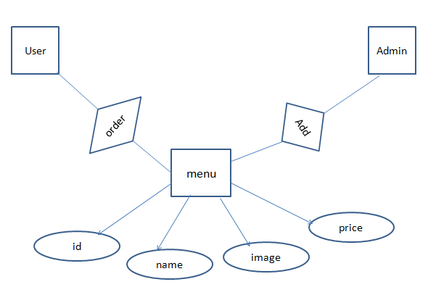
An Entity Relationship (ER) Diagram is a type of flowchart that illustrates how “entities” such as people, objects or concepts relate to each other within a system. ER Diagrams are most often used to design or debug relational databases in the fields of software engineering, business information systems, education and research. Also known as ERDs or ER Models, they use a defined set of symbols such as rectangles, diamonds, ovals and connecting lines to depict the interconnectedness of entities, relationships and their attributes. They mirror grammatical structure, with entities as nouns and relationships as verbs.
Entity relationship diagrams provide a visual starting point for database design that can also be used to help determine information system requirements throughout an organization. After a relational database is rolled out, an ERD can still serve as a referral point, should any debugging or business process re-engineering be needed later.

3.4 DATA FLOW/UML DIAGRAMS
Data Flow Diagram:
DFD is also called as bubble chart. It is a simple graphical formalism that can be used to represent a system in terms of input data to the system, various processing carried out on this data, and the output data is generated by this system.
Data flow diagram (DFD) is one of the most important modeling tools. It is used to model the system components. These components are the system process, the data used by the process, an external entity that interacts with the system and the information flows in the system.
DFD shows how the information moves through the system and how it is modified by a series of transformations. It is a graphical technique that depicts information flow and the transformations that are applied as data moves from input to output.
DFD is also known as bubble chart. A DFD may be used to represent a system at any level of abstraction. DFD may be partitioned into levels that represent increasing information flow and functional detail.
UML Diagrams:
UML stands for Unified Modeling Language. UML is a standardized general-purpose modeling language in the field of object-oriented software engineering. The standard is managed, and was created by, the Object Management Group.
The goal is for UML to become a common language for creating models of object oriented computer software. In its current form UML is comprised of two major components: a Meta-model and a notation. In the future, some form of method or process may also be added to; or associated with, UML.
The Unified Modeling Language is a standard language for specifying, Visualization, Constructing and documenting the artifacts of software system, as well as for business modeling and other non-software systems.
The UML represents a collection of best engineering practices that have proven successful in the modeling of large and complex systems.
The UML is a very important part of developing objects oriented software and the software development process. The UML uses mostly graphical notations to express the design of software projects.
Goals:
The Primary goals in the design of the UML are as follows:
- Provide users a ready-to-use, expressive visual modeling Language so that they can develop and exchange meaningful models.
- Provide extendibility and specialization mechanisms to extend the core concepts.
- Be independent of particular programming languages and development process.
- Provide a formal basis for understanding the modeling language.
- Encourage the growth of OO tools market.
- Support higher level development concepts such as collaborations, frameworks, patterns and components.
- Integrate best practices.
UML Diagrams
A diagram is the graphical presentation of a set of elements, most often rendered as a connected graph of vertices (things) and arcs (relationships). There are two types of diagrams, they are: Structural and Behavioral Diagrams.
Structural Diagrams
The UML is four structural diagrams exist to visualize, specify, construct and document the static Aspects of a system. Icon View the static parts of a system using one of the following diagrams. Structural diagrams consist of Class Diagram, Object Diagram, Component Diagram, and Deployment Diagram.

Behavioral Diagrams
The UML’s five behavioral diagrams are used to visualize, specify, construct, and document the dynamic aspects of a system. The UML’s behavioral diagrams are roughly organized around the major ways which can model the dynamics of a system. Behavioral diagrams consists of Use case Diagram, Sequence Diagram, Collaboration Diagram, State chart Diagram, Activity Diagram.
A use case is a set of scenarios that describing an interaction between a user and a system. A use case diagram displays the relationship among actors and use cases. The two main components of a use case diagram are use cases and actors.
Use case Diagram
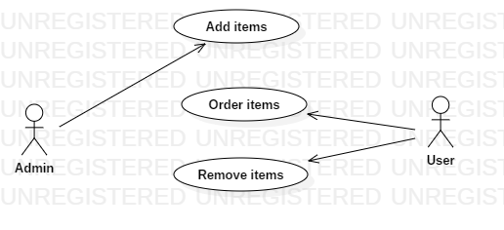
Fig: 3.4.1
Use case diagrams are used to gather the requirements of a system including internal and external influences. These requirements are mostly design requirements. Hence, when a system is analyzed to gather its functionalities, use cases are prepared and actors are identified.
Sequence Diagram
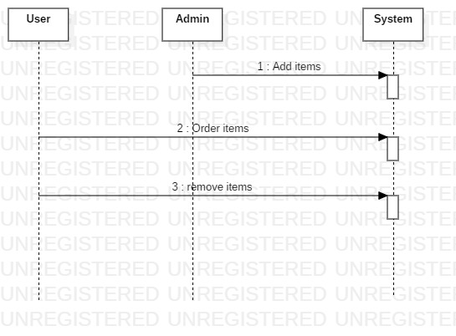
Fig: 3.4.2

A sequence diagram in Unified Modeling Language (UML) is a kind of interaction diagram that shows how processes operate with one another and in what order. It is a construct of a Message Sequence Chart. Sequence diagrams are sometimes called event diagrams, event scenarios, and timing diagrams.
Activity Diagram
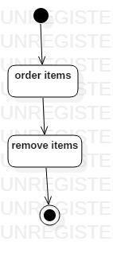
Fig: 3.4.3

Activity diagrams are graphical representations of workflows of stepwise activities and actions with support for choice, iteration and concurrency. In the Unified Modeling Language, activity diagrams can be used to describe the business and operational step-by-step workflows of components in a system. An activity diagram shows the overall flow of control.
Class Diagram
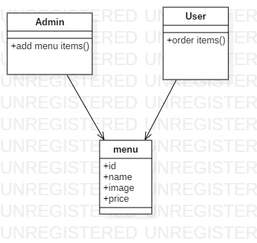

Fig: 3.4.4
Class diagram is a static diagram. It represents the static view of an application. Class diagram is not only used for visualizing, describing, and documenting different aspects of a system but also for constructing executable code of the software application.
Class diagram describes the attributes and operations of a class and also the constraints imposed on the system. The class diagrams are widely used in the modelling of object oriented systems because they are the only UML diagrams, which can be mapped directly with object-oriented languages.

Chapter 4

Implementation and Testing

4.1 CODE

index.php

<!DOCTYPE html>
<html lang="en">
<head>
<title>Bootstrap Example</title>
<meta charset="utf-8">
<meta name="viewport" content="width=device-width, initial-scale=1">
<link rel="stylesheet" href="https://maxcdn.bootstrapcdn.com/bootstrap/3.3.7/css/bootstrap.min.css">
<script src="https://ajax.googleapis.com/ajax/libs/jquery/3.3.1/jquery.min.js"></script>
<script src="https://maxcdn.bootstrapcdn.com/bootstrap/3.3.7/js/bootstrap.min.js"></script>
<style>
/* Remove the navbar's default margin-bottom and rounded borders */
.navbar {
margin-bottom: 0;
border-radius: 0;
}

/* Set height of the grid so .sidenav can be 100% (adjust as needed) */
.row.content {height: 450px}

/* Set gray background color and 100% height */
.sidenav {
padding-top: 20px;
background-color: #f1f1f1;
height: 100%;
}
/* Set black background color, white text and some padding */
footer {
background-color: #555;
color: white;
padding: 15px;
}
/* On small screens, set height to 'auto' for sidenav and grid */
@media screen and (max-width: 767px) {
.sidenav {
height: auto;
padding: 15px;
}
.row.content {height:auto;}
}
li a:hover{
background-color:#555;
color:white;
}
</style>
</head>
<body>
<nav class="navbar navbar-inverse">
<div class="container-fluid">
<div class="collapse navbar-collapse" id="myNavbar">
<ul class="nav navbar-nav">
<li class="active"><a href="#">Home</a></li>
<li><a href="#">About</a></li>
<li><a href="index21.html">Contact</a></li>
</ul>
</div>
</div>
</nav>
<div class="container-fluid text-center">
<div class="row content">
<div class="col-sm-2 sidenav">
<ul>
<li><font size="4"><a href="Veg.php">Non Veg</a></font></li>
<br>
<li><font size="4"><a href="index2.php">Veg</a></font></li>
<br>
<li><font size="4"><a href="index4.php">Drinks</a></font></li>
<br>
<li><font size="4"><a href="index3.php">Ice creams</a></font></li>
</ul>
</div>
<div class="col-sm-8 text-left">
<h1 align="center">Welcome</h1>
<img src="res2.jpeg" height="350" width="850">
</div>
<div class="col-sm-2 sidenav">
<div class="well">
<a href="MyOrders.php"><input type="button" value="My Orders"></a>
</div>
<!-- <div class="well">
<Button type="button">Order now</button>
</div>-->
</div>
</div>
</div>
<footer class="container-fluid text-center">
<p>Footer Text</p>
</footer>
</body>
</html>

Veg.php
<?php
session_start();
$connect = mysqli_connect("localhost", "root", "", "mymenu");
if(isset($_POST["add_to_cart"]))
{
if(isset($_SESSION["shopping_cart"]))
{
$item_array_id = array_column($_SESSION["shopping_cart"], "item_id");
if(!in_array($_GET["id"], $item_array_id))
{
$count = count($_SESSION["shopping_cart"]);
$item_array = array(
'item_id' => $_GET["id"],
'item_name' => $_POST["hidden_name"],
'item_price' => $_POST["hidden_price"],
'item_quantity' => $_POST["quantity"]
);
$_SESSION["shopping_cart"][$count] = $item_array;
}
else
{
echo '<script>alert("Item Already Added")</script>';
echo '<script>window.location="Veg.php"</script>';
}
}
else
{
$item_array = array(
'item_id' => $_GET["id"],
'item_name' => $_POST["hidden_name"],
'item_price' => $_POST["hidden_price"],
'item_quantity' => $_POST["quantity"]
);
$_SESSION["shopping_cart"][0] = $item_array;
}
}
if(isset($_GET["action"]))
{
if($_GET["action"] == "delete")
{
foreach($_SESSION["shopping_cart"] as $keys => $values)
{
if($values["item_id"] == $_GET["id"])
{
unset($_SESSION["shopping_cart"][$keys]);
echo '<script>alert("Item Removed")</script>';
echo '<script>window.location="Veg.php"</script>';
}
}
}
}
?>
<!DOCTYPE html>
<html>
<head>
<title>Webslesson Tutorial | Simple PHP Mysql Shopping Cart</title>
<script src="https://ajax.googleapis.com/ajax/libs/jquery/2.2.0/jquery.min.js"></script>
<link rel="stylesheet" href="https://maxcdn.bootstrapcdn.com/bootstrap/3.3.6/css/bootstrap.min.css" />
<script src="https://maxcdn.bootstrapcdn.com/bootstrap/3.3.6/js/bootstrap.min.js"></script>
</head>
<body>
<br />
<div class="container" style="width:700px;">
<h3 align="center">Menu Card</h3><br />
<?php
$query = "SELECT * FROM menu_detail ORDER BY id ASC";
$result = mysqli_query($connect, $query);
if(mysqli_num_rows($result) > 0)
{
while($row = mysqli_fetch_array($result))
{
?>
<div class="col-md-4">
<form method="post" action="Veg.php?action=add&id=<?php echo $row["id"]; ?>">
<div style="border:1px solid #333; background-color:#f1f1f1; border-radius:5px; padding:16px;" align="center">
<img src="<?php echo $row["image"]; ?>" class="img-responsive" /><br />
<h4 class="text-info"><?php echo $row["name"]; ?></h4>
<h4 class="text-danger">$ <?php echo $row["price"]; ?></h4>
<input type="text" name="quantity" class="form-control" value="1" />
<input type="hidden" name="hidden_name" value="<?php echo $row["name"]; ?>" />
<input type="hidden" name="hidden_price" value="<?php echo $row["price"]; ?>" />
<input type="submit" name="add_to_cart" style="margin-top:5px;" class="btn btn-success" value="Add to Cart" />
</div>
</form>
</div>
<?php
}
}
?>
<div style="clear:both"></div>
<br />
<h3>Order Details</h3>
<div class="table-responsive">
<table class="table table-bordered">
<tr>
<th width="40%">Item Name</th>
<th width="10%">Quantity</th>
<th width="20%">Price</th>
<th width="15%">Total</th>
<th width="5%">Action</th>
</tr>
<?php
if (!empty($_SESSION["shopping_cart"])) {
$total = 0;
foreach ($_SESSION["shopping_cart"] as $keys => $values) {
?>
<tr>
<td><?php echo $values["item_name"]; ?></td>
<td><?php echo $values["item_quantity"]; ?></td>
<td>$ <?php echo $values["item_price"]; ?></td>
<td>$ <?php echo number_format($values["item_quantity"] * $values["item_price"], 2); ?></td>
<td><a href="index.php?action=delete&id=<?php echo $values["item_id"]; ?>"><span class="text-danger">Remove</span></a></td>
</tr>

<?php
$total = $total + ($values["item_quantity"] * $values["item_price"]);
}
?>
<tr>
<td colspan="3" align="right">Total</td>
<td align="right">$ <?php echo number_format($total, 2); ?></td>
<td></td>
if(isset($_post['save'])){
$sql="INSERT INTO totalc (total) VALUES('".$_POST[".$total"]."')
}
<?php
} else {
echo '<tr><td>cart is empty</td></tr>';
}
?>
</table>
</div>
</div>
<br />
<p align:center>
<a href="order.html">order confirm</a>
</body>
</html>

order.php
<?php
$total=$_GET['total'];
$conn = new mysqli("localhost", "root", "", "mymenu");
$sql = "INSERT INTO `totalc`(`total`) VALUES ($total)";
if (mysqli_query($conn, $sql) === TRUE) {
echo "<br><br><center>Orders Confirmed Will Be Delivered Soon</center>";
} else {
echo "Error: in $category" . $sql . "<br>" . $conn->error;
}

MyOrders.php
<h3>Order Details</h3>
<div class="table-responsive">
<table class="table table-bordered">
<tr>
<th width="40%">Item Name</th>
<th width="10%">Quantity</th>
<th width="20%">Price</th>
<th width="15%">Total</th>
<th width="5%">Action</th>
</tr>
<?php
session_start();
if (!empty($_SESSION["shopping_cart"])) {
$total = 0;
foreach ($_SESSION["shopping_cart"] as $keys => $values) {
?>
<tr>
<td><?php echo $values["item_name"]; ?></td>
<td><?php echo $values["item_quantity"]; ?></td>
<td>$ <?php echo $values["item_price"]; ?></td>
<td>$ <?php echo number_format($values["item_quantity"] * $values["item_price"], 2); ?></td>
<td><a href="Veg.php?action=delete&id=<?php echo $values["item_id"]; ?>"><span class="text-danger">Remove</span></a></td>
</tr>
<?php
$total = $total + ($values["item_quantity"] * $values["item_price"]);
}
?>
<tr>
<td colspan="3" align="right">Total</td>
<td align="right">$ <?php echo number_format($total, 2); ?></td>
<td></td>

<?php
} else {
echo '<tr><td>cart is empty</td></tr>';
}
?>
</table>
</div>
</div>
<br />
<p align="right">
<a href="order.php?total=<?php echo $total ;?>">order confirm</a>

admin.php
<?php
if(isset($_POST['submit'])){
$image=$_POST['image'];
$itemname=$_POST['item'];
$price=$_POST['price'];
$category=$_POST['cat'];
$conn = new mysqli("localhost", "root", "", "mymenu");
$sql = "INSERT INTO `$category`(`id`, `name`, `image`, `price`) VALUES ('','$itemname','$image',$price)";
if (mysqli_query($conn, $sql) === TRUE) {
echo "inserted successfully";
} else {
echo "Error: in $category" . $sql . "<br>" . $conn->error;
}
}
?>
<form action="" method="post">
<table>
<tr>
<tD><label>Image:</label></tD><td><input type="text" placeholder="image name" name="image"></td>
<tD><label>Item Name:</label></tD><td><input type="text" placeholder="item name" name="item"></td>
<tD><label>Price:</label></tD><td><input type="text" placeholder="price" name="price"></td>
<tD><label>Category:</label></tD><td><select name="cat"><option>select category</option><option value="veg_items">Veg</option><option value="menu_detail">Non-Veg</option><option value="cool_items">Beverages</option><option value="ice_items">Ice Creams</option></select></td>
<tD></tD><td><input type="submit" name="submit"></td>
</tr>
</table>
</form>

UpdateAnddeleted.php
<?php
$conn = new mysqli("localhost", "root", "", "product_details");
if(isset($_POST['update'])){
$id=$_POST['id'];
$image=$_POST['image'];
$itemname=$_POST['name'];
$price=$_POST['price'];
$category=$_GET['type'];
$sql = "UPDATE `$category` SET `name`='$itemname',`image`='$image',`price`=$price WHERE `id`=$id";
if (mysqli_query($conn, $sql) === TRUE) {
echo "updated successfully";
} else {
echo "Error: in $category" . $sql . "<br>" . $conn->error;
}
}
?>
<table>
<tr>
<th>Id</th>
<th>Image</th>
<th>Name</th>
<th>Price</th>
<th>Update</th>
<th>Delete</th>
</tr><?php
$sql = "SELECT * FROM `veg_items` ";
$result = mysqli_query($conn, $sql);
if (mysqli_num_rows($result) > 0) {
while ($row = $result->fetch_assoc()) {
?>

<tr>
<td><form action="UpdateAndDelete.php?type=<?php echo "veg_items";?>" method="post"><?php echo $row['id'];?><input type="hidden" name="id" value="<?php echo $row['id'];?>" readonly=""></td>
<td><input type="text" name="image" value="<?php echo $row['image'];?>"></td>
<td><input type="text" name="name" value="<?php echo $row['pname'];?>"></td>
<td><input type="text" name="price" value="<?php echo $row['price'];?>"></td>
<td><input type="submit" name="update" value="Update"></form></td>
<th><button><a href="delete.php?id=<?php echo $row['id'];?>&type=<?php echo "veg_items";?>">Delete</a></button></th>
</tr>
<?php
}
}
?>
</table>
<table>
<tr>
<th>Id</th>
<th>Image</th>
<th>Name</th>
<th>Price</th>
<th>Update</th>
<th>Delete</th>
</tr><?php
$sql = "SELECT * FROM `menu_detail` ";
$result = mysqli_query($conn, $sql);
if (mysqli_num_rows($result) > 0) {
while ($row = $result->fetch_assoc()) {
?>
<tr>
<td><form action="UpdateAndDelete.php?type=<?php echo "menu_detail";?>" method="post"><?php echo $row['id'];?><input type="hidden" name="id" value="<?php echo $row['id'];?>" readonly=""></td>
<td><input type="text" name="image" value="<?php echo $row['image'];?>"></td>
<td><input type="text" name="name" value="<?php echo $row['pname'];?>"></td>
<td><input type="text" name="price" value="<?php echo $row['price'];?>"></td>
<td><input type="submit" name="update" value="Update"></form></td>
<th><button><a href="delete.php?id=<?php echo $row['id'];?>&type=<?php echo "menu_detail";?>">Delete</a></button></th>
</tr>
<?php
}
}
?>
</table>
<table>
<tr>
<th>Id</th>
<th>Image</th>
<th>Name</th>
<th>Price</th>
<th>Update</th>
<th>Delete</th>
</tr>
<?php
$sql = "SELECT * FROM `cool_items` ";
$result = mysqli_query($conn, $sql);
if (mysqli_num_rows($result) > 0) {
while ($row = $result->fetch_assoc()) {
?>
<tr>
<td><form action="UpdateAndDelete.php?type=<?php echo "cool_items";?>" method="post"><?php echo $row['id'];?><input type="hidden" name="id" value="<?php echo $row['id'];?>" readonly=""></td>
<td><input type="text" name="image" value="<?php echo $row['image'];?>"></td>
<td><input type="text" name="name" value="<?php echo $row['pname'];?>"></td>
<td><input type="text" name="price" value="<?php echo $row['price'];?>"></td>
<td><input type="submit" name="update" value="Update"></form></td>
<th><button><a href="delete.php?id=<?php echo $row['id'];?>&type=<?php echo "cool_items";?>">Delete</a></button></th>
</tr>
<?php
}
}
?>
</table>
<table>
<tr>
<th>Id</th>
<th>Image</th>
<th>Name</th>
<th>Price</th>
<th>Update</th>
<th>Delete</th>
</tr>
<?php
$sql = "SELECT * FROM `ice_items` ";
$result = mysqli_query($conn, $sql);
if (mysqli_num_rows($result) > 0) {
while ($row = $result->fetch_assoc()) {
?>
<tr>
<td><form action="UpdateAndDelete.php?type=<?php echo "ice_items";?>" method="post"><?php echo $row['id'];?><input type="hidden" name="id" value="<?php echo $row['id'];?>" readonly=""></td>
<td><input type="text" name="image" value="<?php echo $row['image'];?>"></td>
<td><input type="text" name="name" value="<?php echo $row['pname'];?>"></td>
<td><input type="text" name="price" value="<?php echo $row['price'];?>"></td>
<td><input type="submit" name="update" value="Update"></form></td>
<th><button><a href="delete.php?id=<?php echo $row['id'];?>&type=<?php echo "ice_items";?>">Delete</a></button></th>
</tr>
<?php
}
}
?>
</table>

4.2 TESTING APPROACH

Testing is a process of executing a program with the intent of finding an error. A good test case is one that has a high probability of finding an as-yet –undiscovered error. A successful test is one that uncovers an as-yet- undiscovered error. System testing is the stage of implementation, which is aimed at ensuring that the system works accurately and efficiently as expected before live operation commences.
It verifies that the whole set of programs hang together. System testing requires a test consists of several key activities and steps for run program, string, system and is important in adopting a successful new system. This is the last chance to detect and correct errors before the system is installed for user acceptance testing.
The software testing process commences once the program is created and the documentation and related data structures are designed. Software testing is essential for correcting errors. Otherwise the program or the project is not said to be complete. Software testing is the critical element of software quality assurance and represents the ultimate the review of specification design and coding. Testing is the process of executing the program with the intent of finding the error. A good test case design is one that as a probability of finding a yet undiscovered error. A successful test is one that uncovers a yet undiscovered error. Any engineering product can be tested in one of the two ways:
The purpose of testing is to discover errors. Testing is the process of trying to discover every conceivable fault or weakness in a work product. It provides a way to check the functionality of components, sub-assemblies, assemblies and/or a finished product It is the process of exercising software with the intent of ensuring that the Software system meets its requirements and user expectations and does not fail in an unacceptable manner. There are various types of test. Each test type addresses a specific testing requirement.

4.2.1 Unit Testing

Unit testing focuses verification effort on the smallest unit of software i.e. the module. Using the detailed design and the process specifications testing is done to uncover errors within the boundary of the module .All modules must be successful in the unit test before the start of the integration begins.
In this project each service can be thought of a module. There are so many modules like login, Admin and Normal User. Giving different sets of inputs has tested each module. When developing the module as well as finishing the development so that each module works without any error. The inputs are validated when accepting from the user.
4.2.2 Integrating Testing
Integration tests are designed to test integrated software components to determine if they actually run as one program. Testing is event driven and is more concerned with the basic outcome of screens or fields. Integration tests demonstrate that although the components were individually satisfaction, as shown by successfully unit testing, the combination of components is correct and consistent. Integration testing is specifically aimed at exposing the problems that arise from the combination of components.
TEST CASES
Introduction to Test Cases
A test case specifies one way of testing the system, including what to test with which input or result, and under which conditions to test. In practice, what to test can be any system requirement or collection of requirements whose implementation justifies a test that is possible to perform and that is not too expensive to perform.
The following are some test case.

No. of test case | 1
Name of test | Admin Login
Sample Input | Admin enters his valid user id and password for entering into his account.
Expected output | Message as “Admin Login Success”
Actual output | Same as expected
Remarks | This component clearly tells that admin enters into his account in order to perform admin activities like monitoring Upload ,download and update actions performed by users.

S No. of test case | 2
Name of test | Admin Login Fails
Sample Input | Admin enters invalid login details for entering into his account
Expected output | Displays message as “Admin Login failed”
Actual output | Same as expected
Remarks | This component Clearly tells login is failed
Chapter 5

Results and Discussions

Home Page:
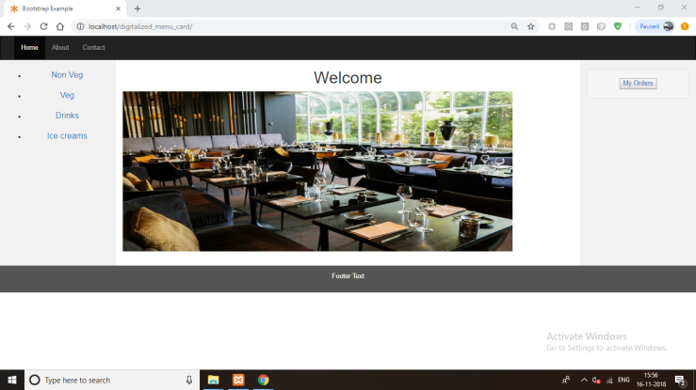
Description: This is the home page of application
Menu card:
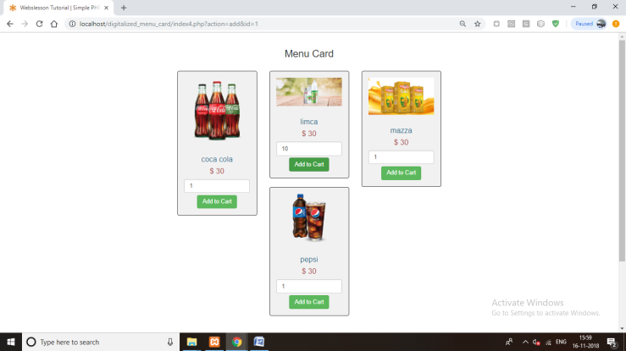
Description: This is the menu card of items
Ordered items:
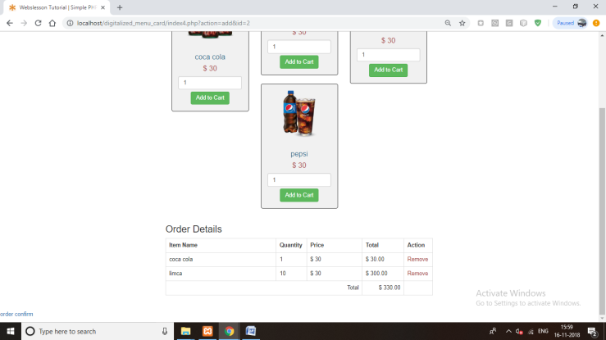
Description: This is the orders adding page

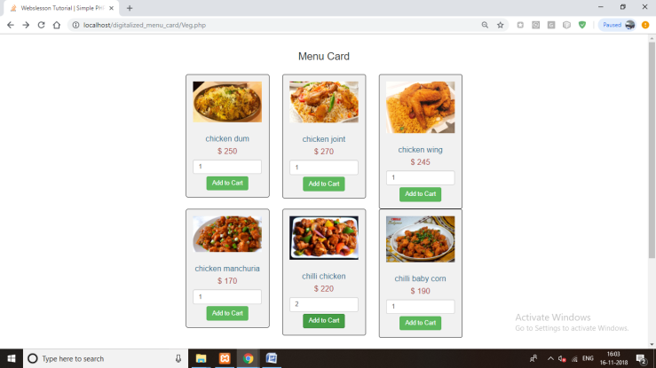

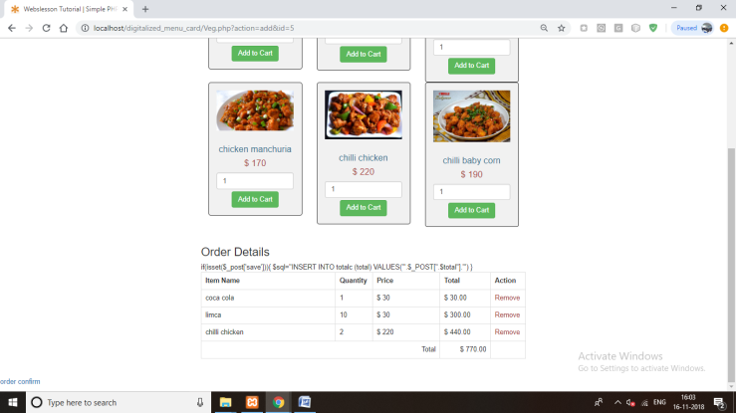

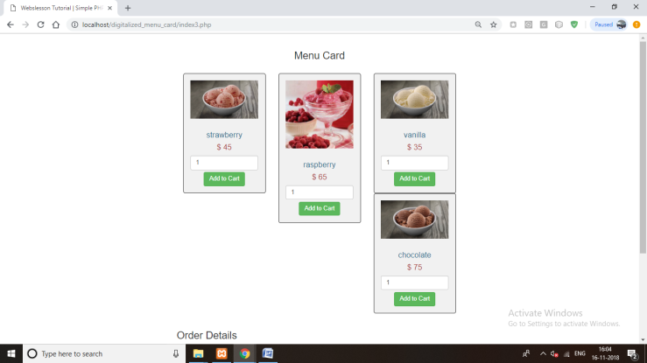

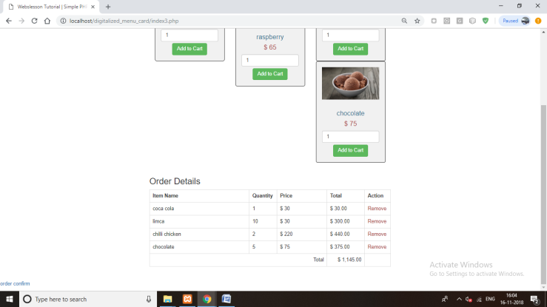
My orders:

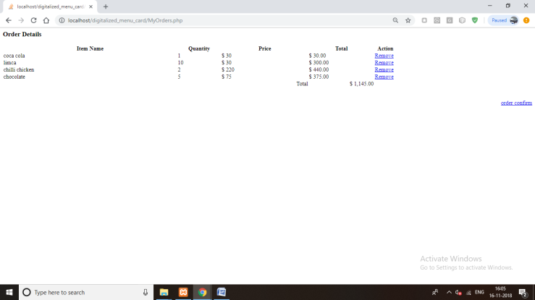

Descrption: This is the ordered items page

Confirm order:

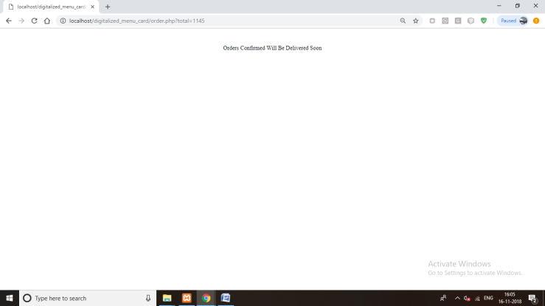

Descrption: This is the confirm page for delivery

Chapter 6

Conclusion and Future Work

Restaurants provide LCD screens this will allow the user to access the menu card of the restaurant it will help the customer to view the review of the food. This will help the customer to view the description about the content of the food. Admin can modify the menu according to the availability. The new menu also can be added to the menu card. By placing their orders on the LCD screen. Then the food order and table number are sent to the kitchen directly once ordered by the customers. The customer can give feedback for the food they have. This will help the hotel owner to improve the same and make necessary changes if required. We can pre-order the food stuff before reaching the restaurant and it saves the lot of time.

Chapter 7

References

[1]

[2]

[3]

