Web Services Activity Service (WS-AS)
a framework for Web Service activities, context propagation and system service association

Authors:
Mark Little, Arjuna Technologies Limited,
Eric Newcomer, IONA Technologies
Editor:
Jim Webber, Arjuna Technologies Limited

Abstract
The ability to scope arbitrary units of work is a requirement in a variety of aspects of distributed applications such as workflow and business-to-business interactions. By scoping work, we mean that it is possible for business activity participants to be able to determine unambiguously whether or not they are participating in the same activity.
In order to correlate the work of participants within the same activity, it is necessary to propagate additional information know as the context to each participant. The context contains information (such as a unique identifier) that allows a series of operations to share a common outcome. For example, in a Web services-based application, a SOAP header block might contain contextual information that is propagated when invoking an operation on a Web Service, or when multiple participants exchange SOAP messages in order to create a larger interaction such as a process flow.
A Web Services Activity Service maintains a repository of context information and tracks contexts shared between multiple participants in Web services interactions. An activity service can also be a participant within an activity, creating a tree to further propagate the context. A Web Services Activity Service accepts and emits SOAP messages for interoperability with any type of participant, regardless of operating system, programming language, or platform – and is independent of underlying transfer or transport protocols.
Context is always propagated in addition to application payload, where context information travels within the SOAP header blocks while application payload (that is, the content intended for processing by a SOAP node playing the ultimateReceiver role) is propagated inside the SOAP body.
The context information is specific to the type of activity being performed, such as to identify a transaction coordinator, the other participants in an activity, or recovery information in the event of a failure, etc. Therefore, a single context type is not sufficient for all types of activity that an activity service may be required to support. Hence, the capabilities of the activity service must be extensible in an application specific manner and services must be able to augment the context as they require to suit their own particular application domains.
Given the importance of context propagation in many distributed systems, including Web Services, standardisation on a context framework (activity service) is a logical progression in increasing the usefulness and robustness of the Web Services architecture. That is, there is a distinct requirement for a generic context propagation service that allows users and services to register with it, and customise it on a per-service or per-application basis. This service also supports newly emerging Web Service standards such as coordination, workflow and transactions.

Introduction
The Web Services Activity Service (WS-AS) is the first of three parts of the Web Services Transaction Processing (WS-TP) specification. These specifications are intended to be useable in isolation; we group them here only for the purposes of showing how they can be employed in a particular critical use case. The other two parts are:
- Web Services Coordination Framework (WS-CF)
- Web Services Transactions (WS-TXN)
The WS-AS specification defines the scope of context sharing for other services and specifications to use; WS-TP uses this as the basic unit of WS-TP processing. WS-AS is intended as a lightweight mechanism for allowing multiple Web services to share a common context. Web services share a common context when they perform related activities such as performing multiple interactions with a data management resource, interactive display, or automated business process.
WS-AS defines the context, the scope of context sharing, and basic rules for context management. WS-AS describes how to define an Activity in which multiple Web services are related through shared context. The responsibility for actions in relationship to the context resides with the individual Web services within the Activity.

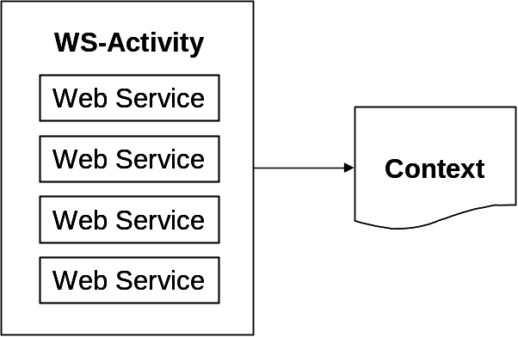
Figure 1 Web Services Activity Concepts
Figure 1 illustrates the basic concepts within the Web Services Activity. A group of Web services is related to each other through their association with a Web Services Activity Service that manages a shared context for the group.

Scope of Sharing
Web services are increasingly being used as an integration platform for distributed enterprise applications. The resulting applications can be very complex in structure, with complex relationships between their constituent applications, compounded by the need to share common data or context across multiple interactions. Furthermore, the execution of such an application may take a long time to complete, and may contain long periods of inactivity, often due to the constituent applications requiring user interactions.
The ability to scope arbitrary units of distributed work is a requirement in a variety of aspects of distributed applications, e.g., quick updates, workflow, business-to-business interactions, automated business processes, and others. By scoping work, it is possible for an activity’s participants to be able to determine unambiguously whether or not they are in the same activity. This is the fundamental functionality of a Web services activity service, which may be implemented using a separate, distinct, service or by adding semantics to the behaviour of participants.
In order to correlate the work of distributed participants within the same activity, it is necessary to propagate additional information (the context) to participants. The context contains information such as a unique ID that allows a series of operations to share a common outcome. For example, a SOAP header block might contain context information that is propagated when interacting with a service, or when multiple participants exchange SOAP messages in order to create a larger interaction such as a process flow or other aggregation of Web services.
The activity context information is represented as a Web resource, accessible by dereferencing its URI. Context operations may flow implicitly (transparently to the application) with normal messages sent to participants/endpoints during Web service execution, or may be an explicit action on behalf of a participant. Context information flows within SOAP header blocks with normal payloads sent to participants/endpoints. A single context type is not sufficient for all uses of an activity service. Hence, it must be extensible in an application specific manner: services must be able to augment the context as they require. Furthermore, it may be required that additional application specific context information flow to these participants or the services which use them.
Context propagation is a fundamental requirement of many distributed systems, including Web services. However, the type of context information that is used may vary depending upon the circumstances, e.g., in an atomic transaction system is may be a URI for the coordinator, whereas for secure data interchange it may we the sender’s public encryption key. Therefore, what is needed is standardisation on a context framework (activity service) and a minimum definition of context that allows services to register with it, and customise it on a per activity basis. The activity service is intended to be flexible and extensible to support newly emerging Web services standards such as workflow and transactions. This specification presents a suitable activity service architecture and protocol set.

Problem statement
Define a specification for a generic context propagation service for Web Services, to be known as the Web Services Activity Service (WS-AS). Outline the necessary infrastructure and protocol requirements to support such a service.
The WS-AS as proposed can be used in conjunction with other business protocol activities, e.g., Web Services coordination, choreography, and the OASIS/BTP specification. The WS-AS also includes a description of the protocol, infrastructure and required environmental definitions needed to control the activities associated with an application.
The WS-AS is designed to be used together with and to compliment other Web services technologies such as reliable messaging, routing, security, and process flow.
The goals of the specification are to:
- Define the notion of a Web Service Activity and the core infrastructure necessary to support this (e.g., a context service).
- Provide a basic definition of a core infrastructure service consisting of an Activity Service for the Web Services environment, i.e., the WS-AS.
- Define the mappings onto the Web Services environment (SOAP message and header definitions, context definition, endpoint address requirements, etc.).
- Define the required infrastructure support such as event mechanisms, etc.
- Illustrate common usage patterns (e.g., sharing common resources, activity coordination, transactions etc.).

WS-AS architecture
The section outlines the architecture of WS-AS, describing the components that implementations provide and those that are required from applications. The WS-AS represents a Web services interaction of a number of activities related to an overall application. In particular it:
- Defines demarcation points which specify the start and end points of an activity.
- Registers Web services so that they that can become participants in the lifecycle of an activity and manage and augment the context associated with that activity. The participants are notified of the lifecycle of an activity (e.g., when it starts or ends) and contacted when context information is to be propagated, and when the overall results of the Activity require further action by the individual participants.
- Propagates context information (essentially information about the activity structure at the sender) across the network, either by reference (its URI) or by value (the “contents” of the URI).
WS-AS is not aimed specifically at a single service type or application domain: it is a more low-level and fundamental service concerned purely with the management of abstract activity entities through shared context. The main components of the WS-AS are:
- An Activity Service: defines the scope of an activity and how information about it (the context) can be referenced and propagated in a distributed environment. Activities can be hierarchically structured, such that nesting and concurrent activities are possible. The Activity Service may be a Web Service that is physically remote from, or collocated with its users.
- A context: defines basic information about the activity structure that is identified using a URI, propagated on application messages. The context contains information necessary for multiple Web services to be associated with the same activity. This information may be dynamically augmented by applications and services. Activities are managed by the Activity Service, which maintains a repository of shared contexts associated with execution environments; whenever messages are exchanged within the scope of an activity, the Activity Service can supply the associated context which may then be propagated with those messages.
- The Activity Lifecycle service: these Web services are registered with the core Activity Service and are informed of the lifetime of an activity and may further enhance it by suitable higher-level interfaces. For example, a security service implementation may define an activity to represent the scope of a secure interaction between business participants and may then provide explicit authentication interfaces on top of the activity service. Whenever a context is required for the activity associated with the current execution environment, the Activity Service calls each registered ALS and obtains from it an addition to the basic context; from this it eventually assembles the entire context data that can be propagated.
The core activity service is concerned with managing the lifecycle of context propagation.
How application services are invoked is outside the scope of this specification: they may use synchronous RPC-style approaches or asynchronous message passing.
Irrespective of how remote invocations occur, context information related to the sender’s activity hierarchy will need to be referenced or propagated and this specification determines how the format of the context, how it is referenced, and how that context is created.
Services and applications can customise and add to this framework in whatever manner they require and can enrol with it to enable them to control various aspects of the lifecycle of an activity. By default, when an activity begins and ends all that the core framework does is ensure that the context is initialised and the activity execution sequence is managed appropriately with respect to the context.
An activity is initiated by an initial Web service request. The initiating Web service is informed when an activity begins and terminates and has access to the shared context. For example, if a coordination service initiates an activity, it will be informed when an activity terminates and can control that termination in a domain specific manner, e.g., using a two-phase or other completion protocol.

Relationships of Activities and contexts
An increasing number of distributed applications are constructed through the composition of existing applications and services. The resulting applications can be very complex in structure, with complex relationships between their constituent applications. Furthermore, the execution of such an application may take a long time to complete, and may contain long periods of inactivity, often due to the constituent applications requiring user interactions, i.e., these applications require control to flow from process to process, and for this flow to be orchestrated.
An activity is a unit of (distributed) work, involving one or more parties (services, components, objects). An activity is created, made to run, and then completed. An outcome is the result of a completed activity, which may be used to determine subsequent flow of control to other activities, and may result in failure notification messages to the participants of an activity. Activities may execute over long periods of time (minutes, hours, days, …). As we shall see, during its lifetime an activity may require periods of coordination between its constituent parties (participants) or may need to interact with other services such as transaction management and security.
An activity is essentially a way of scoping application specific work. The definition of precisely what an activity is and what services it will require in order to perform that work, will depend upon the environment and application in which it is used. We split the services that are involved within an activity into the following classifications:
- Activity Lifecycle Service (ALS) – these services participate in the life-cycle of the activity (are informed when it starts, ends etc.) and may augment it for their own purposes. For example, a security ALS may define the scope of an activity to be the scope of a security domain. Multiple ALS-es may be enrolled with the activity.
- Application Services (AS) – these are the services that the application uses to obtain the functional aspects of the task. For example, a stock-purchase application may determine that it has several activities which involve determining current stock quantities, placing orders for new stock, and finally delivery of that new stock. Alternatively, an on-line book provider may divide its activities into users placing books into a shopping basket, the user then confirming the books that are to be purchased and providing credit card details, etc.
In both cases the definition of the activity is directly related to the need for a group of Web services to share common information, such as a stock price or a book inventory quantity. An activity is itself implemented as a Web Service, and a Web Service may be enrolled with an activity in order to define it.
The relationship between ALS and Activity Service, Application Services and Applications is shown in Figure 2.
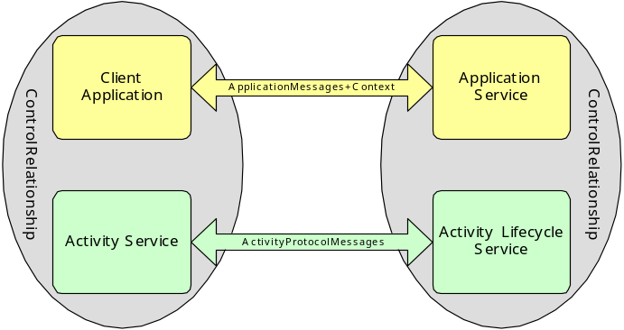
Figure 2 Activity Service Component Relationships

Activity Service and the Web Services stack
The relationship between the Activity Service and the current Web Services stack is shown in Figure 3. It is expected that the services above the Activity Service will be able to fully utilize the facilities it provides.
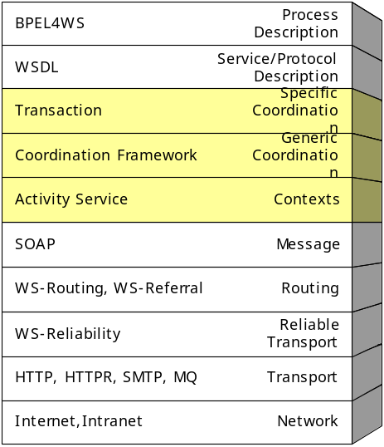
Figure 3: Activity Service and the Web Services stack.

The activity service framework
The first component of the WS-AS is an activity framework (the Activity Service), that supports the abstract notion of an activity and allows applications and services to scope work within these activities by sharing context. The basic infrastructure simply supports the lifecycle of activities and ensures that each is uniquely identified. In addition, information about activities can be propagated between execution environments
For example, an event management system may wish to be informed when an activity starts and ends so that it can disseminate this information to interested parties. Likewise, a transaction service may need to be informed if the activities represent transactions, so that it can ensure any transaction context information is updated appropriately. The basic Activity Service simply manages activity lifecycles and their associated contexts; for example, the start of a new activity may implicitly cause the service to add an entry to a context hierarchy and the termination of the activity may result in an entry being removed from the hierarchy.

Composite activities
Activities can be nested to arbitrary degree. An activity, which contains component activities, may impose a requirement on an ALS implementation for managing these component activities. However, the core Activity Service framework does not specify how (or even if) activities should be coordinated: that is the domain of a coordination service ALS which may be enrolled with the framework.

Contexts
In order for an activity to span a number of Web services, certain information has to flow between the sites/domains involved in the application. This information is commonly referred to as the context and includes information related to the services associated with the framework (e.g., security). It is referenced or propagated in a distributed environment to provide continuity of context information between remote execution environments, and may be transported for example inside SOAP header blocks. This may occur transparently to the client and application services or may be part of an explicit exchange.
As we have described, the activity service framework is simply a means to scope distributed work by associating it with a unique identifier and share related context. The core context propagation framework must provide a generic context structure that enables an activity to be uniquely identifiable such that work can be correlated. Furthermore, it must provide support for applications and services to extend the context structure in an implementation specific manner, e.g., for coordination, transactions, security or replication. This context is shown in Figure 4.
<xs:complexType name="ContextType">
<xs:sequence>
<xs:element name="context-identifier" type="xs:anyURI" minOccurs="1" maxOccurs="1"/>
<xs:element name="activity-service" type="xs:anyURI" minOccurs="0" maxOccurs="1"/>
<xs:element name="type" type="xs:anyURI" minOccurs="0"/>
<xs:element name="participating-services" type="tns:ActivityListType" minOccurs="0"/>
<xs:element name="als-context" type="tns:ALSContextType" minOccurs="0"
maxOccurs="unbounded"/>
<xs:element name="child-contexts" minOccurs="0" maxOccurs="1">
<xs:complexType>
<xs:sequence>
<xs:element name="child-context" type="tns:ContextType" minOccurs="1"
maxOccurs="unbounded"/>
</xs:sequence>
</xs:complexType>
</xs:element>
<xs:any namespace="##other" processContents="lax" minOccurs="0"/>
</xs:sequence>
<xs:attribute name="timeout" type="xs:positiveInteger" use="optional"/>
</xs:complexType>
Figure 4 Activity Service Context
The context consists of a the following items:
- A mandatory URI identifier called context-identifier. This guarantees global uniqueness for an individual activity (such an identifier can also be thought of as a “correlation” identifier or a value that is used to indicate that a task is part of the same work activity.
- An optional element, activity-service, which identifies the activity service responsible for generating the context;
- An optional identifier that indicates the type of the activity;
- An optional list of the services currently participating in the activity, called participating-services;
- Scope for extensions to the context from specific Activity Lifecycle Services, which may include items such as the current execution status of a participant within the activity;
- An optional list of child activities, in the child-contexts element;
- A timeout value, which indicates how long the context information is valid for; after this period has elapses, the activity structure it refers to may no longer exist (e.g., the activity may be terminated and the structure garbage collected). This is to allow an Activity Service implementation, in the event of no external stimulus, to terminate activities automatically rather than have them potentially run forever.
Context propagation may also occur using different protocols than those used by the application. The activity service does not assume a specific means by which contexts are propagated, leaving this up to the implementation.
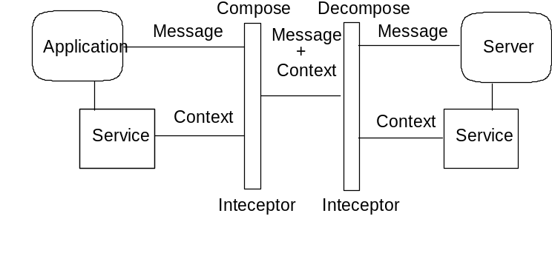
Figure 5: Services and context flow.
The Activity Service maintains context information on behalf of every activity. This information may be propagated in-line with application invocations or may simply be referenced by its URI with all options fields left empty. The context may be built up in two ways:
- Service invocations: as each service is invoked it may augment or otherwise manipulate the context that it receives and propagates.
- ALS: because each ALS participates in the lifecycle of an activity, the Activity Service may build up an initial context based on these service invocations.
As we have already described, WS-AS considers the context to be a first-class entity. As such, an application may choose to propagate either the entire contents of the context with messages or simply the URI of the context, which represents the service (component of the Activity Service) that maintains the context information. It is important to note that in those situations where only the context-identifier element is present in a context, that the URI which it contains can be de-referenced to obtain the full context (to use or update its information), which includes the full set of activity contexts.
The choice of whether to transmit a full or abbreviated context is left to the user. It is however expected that when dealing with large context elements (those which subsume a large number of activities) that the URI-only form will be used for efficiency.
Figure 6, shows the message interactions for the context.
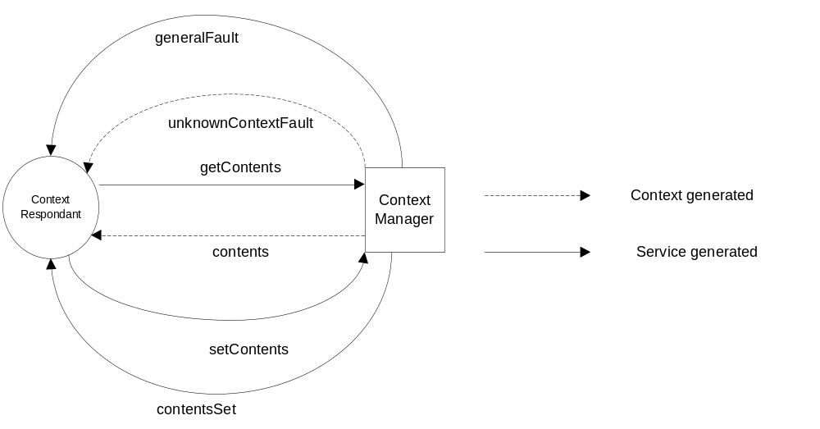
Figure 6: Context interactions.
The ContextManager has the following one-way operations, all of which contain the endpoint address for the ContextRespondant:
- getContents: this message is used to request the entire contents of a specific context.
- setContents: the contents of the context are replaced with the context information provided.
The ContextRespondant has the following one-way operations:
- contents: this message returns the entire contents of a specific context.
- contentsSet: this message is sent to indicate that contents of the context have been updated.
- unknownContextFault: this message is sent to indicate that the specified context cannot be located.
- generalFault: this message is sent to indicate that some other error has occurred during the enlistment.
The WSDL interfaces that elucidate these roles are shown in Figure 7.
<wsdl:portType name="ContextManagerPortType">
<wsdl:operation name="getContents">
<wsdl:input message="tns:GetContentsMessage"/>
</wsdl:operation>
<wsdl:operation name="setContents">
<wsdl:input message="tns:SetContentsMessage"/>
</wsdl:operation>
</wsdl:portType>
<wsdl:portType name="ContextRespondandtPortType">
<wsdl:operation name="contents">
<wsdl:input message="tns:ContentsMessage"/>
</wsdl:operation>
<wsdl:operation name="contentsSet">
<wsdl:input message="tns:ContentsSetMessage"/>
</wsdl:operation>
<wsdl:operation name="unknownContextFault">
<wsdl:input message="tns:UnknownContextFaultMessage"/>
</wsdl:operation>
<wsdl:operation name="generalFault">
<wsdl:input message="tns:GeneralFaultMessage"/>
</wsdl:operation>
</wsdl:portType>
Figure 7 WSDL Interfaces for ContextManager and ContextRespondant Roles

Context information and SOAP
Where messages (either business-level application messages, or WS-AS protocol messages themselves) require contextualization, the context is transported in a SOAP header block. While it is implicit that WS-AS actors understand contexts that arrive in SOAP header blocks, the context propagated with application messages must also be understood by their recipients. Hence in this case each SOAP header block carrying an activity context has the “mustUnderstand” attribute set to “true” and the recipient must understand the header block encoding according to its identifying URI. This is shown in Figure 8.
<?xml version="1.0" encoding="UTF-8"?>
<soap:Envelope xmlns:soap="http://www.w3.org/2002/06/soap-envelope">
<soap:Header encodingStyle="http://www.webservicestransactions.org/schemas/wsas/2003/03"
mustUnderstand="true">
<wsas:context xmlns:wsas="http://www.webservicestransactions.org/schemas/wsas/2003/03"
timeout="999">
<wsas:context-identifier>
http://www.webservicestransactions.org/wsas/abcdef:012345
</wsas:context-identifier>
<wsas:activity-service>
http://www.webservicestransactions.org/wsas/service
</wsas:activity-service>
<wsas:type>http://www.webservicestransactions.org/wsas/context/type1</wsas:type>
<wsas:activity-list>
<wsas:service>http://www.webservicestransactions.org/service1</wsas:service>
<wsas:service>http://www.webservicestransactions.org/service2</wsas:service>
</wsas:activity-list>
<wsas:als-context mustUnderstand="true" mustPropagate="true">
<wsas:type>http://www.webservicestransactions.org/wsas/als/type1</wsas:type>
</wsas:als-context>
</wsas:context>
</soap:Header>
<soap:Body>
<!-- Application Payload -->
</soap:Body>
</soap:Envelope>
Figure 8: Activity Context Transported in a SOAP Header Block

Activity Service components
In this section we shall consider the individual components within the Activity Service architecture. In order to support both synchronous request/response and one-way message interactions, we shall describe the components in terms of their behaviour and the interactions that occur between them. All interactions are described in terms of correlated one-way messages, which an implementation may abstract at a higher level into request/response pairs or one-way RPCs, for example. As such, all communicated messages are required to contain response endpoint addresses solely for the purposes of each interaction, and a correlation identifier such that incoming and outgoing invocations can be associated.
Note that both addressing and message correlation are stop-gap measures which will be harmonized with the prevalent Web Services standards for addressing and reliable messaging once the community has reached consensus on appropriate standards.
One consequence of these one-way interactions is that faults and errors which may occur when an service is invoked are communicated back to interested parties via messages which are themselves part of the standard protocol – and does not use the fault mechanisms of the underlying SOAP-based transport. For example, if an operation might fail because no activity is present when one is required, then it will be valid for the noActivityFault message to be received by the response service. To accommodate other errors or faults, all response service signatures have a generalFault operation.
Note, in the rest of this section we will use the term “invokes operation X on service Y” when referring to invoking services. This term does not imply a specific implementation for performing such service invocations and is used merely as a short-hand for “sends message X to service Y.” As long as implementations ensure that the on-the-wire message formats are compliant with those defined in this specification, how the end-points are implemented and how they expose the various operations (e.g., via WSDL [1]) is not mandated by this specification.

Status
During the existence of the activity its status will either be running, completing, or completed. An activity should report its current status when asked; there is no notion of automatically informing services when a specific state is entered:
<xs:simpleType name="StatusType">
<xs:restriction base="xs:string">
<xs:enumeration value="ACTIVE"/>
<xs:enumeration value="COMPLETING"/>
<xs:enumeration value="COMPLETED"/>
<xs:enumeration value="NO_ACTIVITY"/>
<xs:enumeration value="UNKNOWN"/>
</xs:restriction>
</xs:simpleType>
The meaning of each of the above values is given below:
- ACTIVE: An Activity is associated with the target service and the Activity is in the active state. An implementation returns this status after an Activity has been started and prior to its beginning completion.
- COMPLETING: An Activity is associated with the target service and it is in the process of completing. An implementation returns this status if it has started to complete, but has not yet finished the process. This value indicates that the activity may be performing activity specific work required to determine its final completion status, such as notifying participants of a failure. An activity must enter this state prior to completion.
- COMPLETED: An Activity is associated with the target service and it has completed.
- NO_ACTIVITY: No Activity is currently associated with the target service. This will occur after an Activity has completed, or before the first Activity is created.
- UNKNOWN: An Activity is associated with the target service, but the Activity Service cannot determine its current status. This is a transient condition, and a subsequent invocation should ultimately return a different status. An implementation may attempt to retry the appropriate invocation transparently if such a value is returned initially.
The diagram below indicates the transitions that an Activity can undergo.
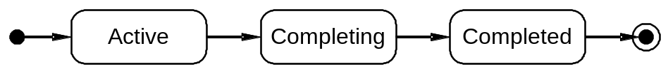
Figure 9: Activity UML state diagram.

CompletionStatus
<xs:simpleType name="CompletionStatusType">
<xs:restriction base="xs:string">
<xs:enumeration value="SUCCESS"/>
<xs:enumeration value="FAIL"/>
<xs:enumeration value="FAIL_ONLY"/>
<xs:enumeration value="UNKNOWN"/>
</xs:restriction>
</xs:simpleType>
When an Activity completes, it does so in one of two states, either success or failure (the meaning of which can only be defined by the application or services that use the activity). During its lifetime, the completion state of the Activity (i.e., the state it would have if it completed at that point) may change from success to failure, and back again many times. This is represented by the CompletionStatusType type, whose values are:
- SUCCESS: the Activity has successfully performed its work and can complete accordingly. When in this state, the Activity completion status can be changed.
- FAIL: some (application specific) error has occurred which has meant that the Activity has not performed all of its work, and should be driven during completion accordingly. When in this state, the Activity completion status can be changed.
- FAIL_ONLY: some (application specific) error has occurred which has meant that the Activity has not performed all of its work, and should be driven during completion accordingly. Once in this state, the completion status of the Activity cannot be changed, i.e., the only possible outcome for the Activity is for it to fail.
- UNKNOWN: The Activity Service cannot determine its current completion status. This is a transient condition, and a subsequent invocation should ultimately return a different completion status. An implementation may attempt to retry the appropriate invocation transparently if such a value is returned initially.

Outcome
<xs:complexType name="OutcomeType">
<xs:sequence>

<xs:any namespace="##other" processContents="lax" minOccurs="0"/>
</xs:sequence>
<xs:attribute name="name" type="xs:anyURI" use="required"/>
</xs:complexType>
When an Activity completes, an Outcome (in effect arbitrary XML content) may be returned to the initial Web service application in order for it to determine the final status of the Activity. A service that does not return an Outcome is implicitly assumed to have completed successfully. Both success and failure states may be encoded within an Outcome.
The OutcomeType type is used by the WS-AS to determine the meaning of the Outcome. The content of the message consists of a mandatory name for the outcome and some valid XML to be interpreted as appropriate by the recipient, as seen in the OutcomeType schema. The type is designed to be extensible, returning a message containing arbitrary valid XML whose form and content is understood by the recipient.

ALS
The intention of the Activity Service is to support the general notion of an activity and an associated context (including an activity identifier), with the capability for lifecycle services (ALS) to enrol with that activity service and participate in the lifecycle of an activity, possibly enhancing the context if necessary. For example, as shown in Figure 10, a coordination service may be associated with the Activity Service and customize the context to include information on the coordinator end-point(s) and participant(s). Note, the Activity Service does not support coordination capabilities at all but simply maintains the execution environment-to-context repository.
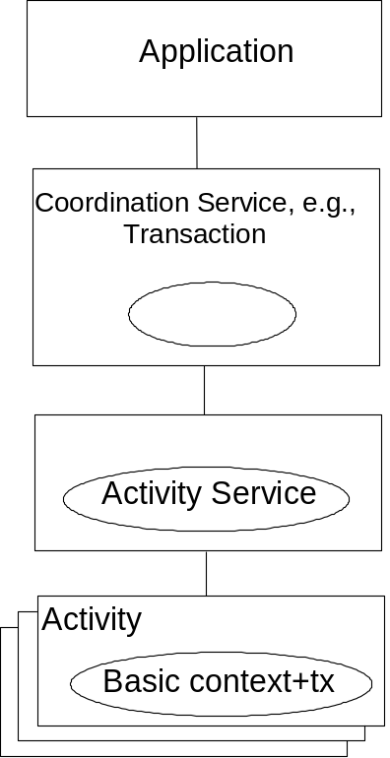
Figure 10: Activity Service and coordination service relationship.

Enlisting and delisting an ALS
In order to enrol an ALS with the activity service, the activity service exposes the ALSRegistrar interface and the entity performing the enrol defines the ALSRegistrant interface to receive the results of the enrolment attempt.
The ALSRegistrar has the following one-way operation:
- enlistALS: the endpoint address for the ALS is specified in the message, along with the endpoint address for the ALSRegistrant, which will be used by the ALSRegistrar to later send a messaging indicating success or failure. Upon success, the ALS will be enrolled with all activities subsequently created by the activity service instance that this ALSRegistrar represents.
The ALSRegistrant has the following one-way operations, all of which contain the endpoint address for the ALS:
- enlisted: this message is sent by the ALSRegistrar to indicate that the ALS has been successfully enlisted.
- invalidALSFault: this message is sent to indicate that the specified ALS is invalid in the current activity service.
- generalFault: this message is sent to indicate that some other error has occurred during the enlistment.
The interactions (message exchanges) between the ALSRegistrar and the service that enlists the ALS is shown in Figure 11. As mentioned, this service receives protocol interactions via an ALSRegistrant service, but we have considered the two roles (enlister and receiver of enlistment messages from the ALSRegistrar) separately. This is purely for illustrative purposes and implementations are free to combine these roles if they see fit.
The service enrolling the ALS calls the ALSRegistrar enlistALS operation supplying the endpoint for the relevant ALS. The ALSRegistrar will eventually respond by calling either the enlisted, invalidALSFault or generalFault operations on the supplied ALSRegistrant service.
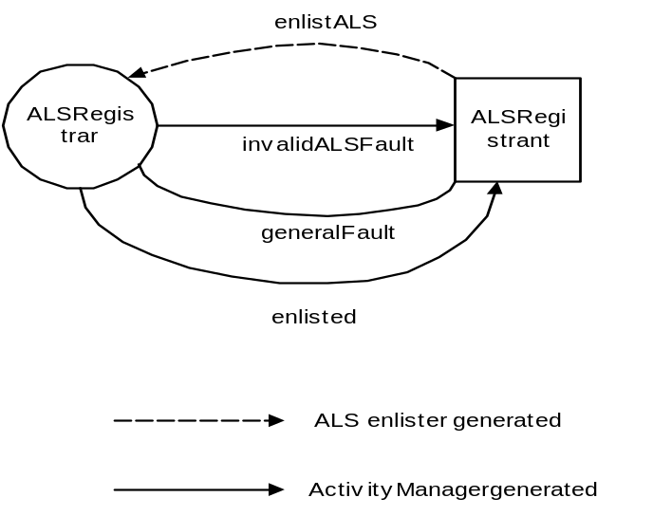
Figure 11: ALSRegistrar and ALSRegistrant interaction.
In order to de-list an ALS with the activity service, the entity performing the de-list defines the ALSRegistrant interface to receive the results of the delistment attempt.
The ALSRegistrar has the following additional one-way operation:
- delistALS: the endpoint address for the ALS is specified, along with the endpoint address for the ALSRegistrant, which will be used by the ALSRegistrar to later callback to indicate success or failure. Upon success, the ALS will be un-enrolled from the activity service instance that this ALSRegistrar represents.
The ALSRegistrant has the following one-way operations, all of which contain the endpoint address for an ALS:
- delisted: this operation is called by the ALSRegistrar to indicate that the ALS has been successfully delisted.
- invalidALSFault: this operation is called to indicate that the specified ALS is invalid in the current activity service – it was not enlisted.
- generalFault: this operation indicates that some other error has occurred during the enlistment.
The interactions between the ALSRegistrar and the service that delists the ALS is shown in Figure 12, highlighting the various message exchanges. As mentioned, this service receives protocol interactions via an ALSRegistrant service, but we have considered the two roles (delister and receiver of delistment messages from the ALSRegistrar) as separate. This is purely for illustrative purposes and implementations are free to combine these roles if they see fit.
The service delisting the ALS calls the ALSRegistrar delistALS operation supplying the endpoint for the relevant ALS.
The ALSRegistrar will eventually respond by calling either the delisted, invalidALSFault or generalFault operations on the supplied ALSRegistrant service.
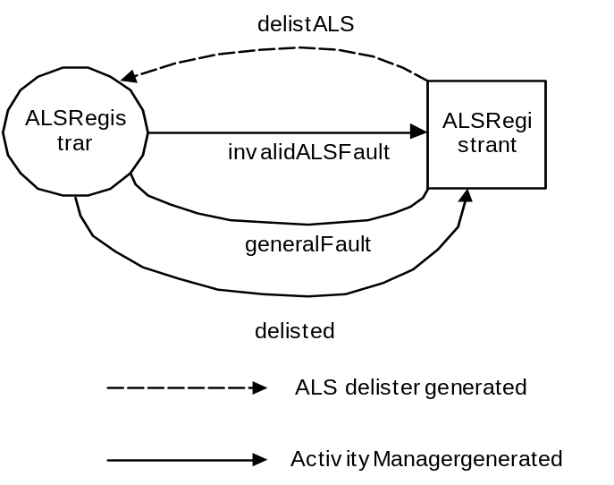
Figure 12: ALSRegistrar and ALSRegistrant interaction.
The WSDL describing the Registrar and Registrant roles is shown in Figure 13
<!-- ALSRegistrar interface -->
<wsdl:portType name="ALSRegistrarPortType">
<wsdl:operation name="enlistALS">
<wsdl:input message="tns:EnlistALSMessage"/>
</wsdl:operation>
<wsdl:operation name="delistALS">
<wsdl:input message="tns:DelistALSMessage"/>
</wsdl:operation>
</wsdl:portType>

<!-- ALSRegistrant interface -->
<wsdl:portType name="ALSRegistrantPortType">
<wsdl:operation name="enlistedALS">
<wsdl:input message="tns:ALSEnlistedMessage"/>
</wsdl:operation>
<wsdl:operation name="delistedALS">
<wsdl:input message="tns:ALSDelistedMessage"/>
</wsdl:operation>
<wsdl:operation name="invalidALSFault">
<wsdl:input message="tns:InvalidALSFaultMessage"/>
</wsdl:operation>
<wsdl:operation name="generalFault">
<wsdl:input message="tns:GeneralFaultMessage"/>
</wsdl:operation>
</wsdl:portType>
Figure 13 ALSRegistrar and ALSRegistrant WSDL

ALS and Activity Service interactions
As we discussed previously, any ALS that is registered with an activity service is invoked during the lifecycle of each activity. The activity context is propagated to the ALS and the ALS may augment or manipulate the context as is appropriate for its implementation. The ALS is also able to perform other implementation specific operations, e.g., coordination when the activity terminates.
In order to execute protocol interactions between activity service and ALS, the following service interfaces are used:
- ALS: this represents the ALS endpoint in the protocol interaction.
- ALSRespondant: this represents the activity service endpoint in the protocol interaction; this is where the ALS sends response messages.
The ALS has the following operations which the activity service invokes. All of these one-way operations are contextualised with the current context (if any) and the ALSRespondant endpoint is exchanged:
- begin: This operation is invoked when a new activity has started.
- completeWithStatus: This operation is invoked when the activity is completing with the status provided. The service can perform whatever lifecycle management it requires (e.g., coordination) that is appropriate for the specified status.
- complete: The complete operation is called by the Activity Service as part of the completion process of an activity to give the service the opportunity to perform any necessary clean-up work.
- getIdentity: this message is used to obtain the unique identification of a specific ALS.
The ALSRespondant has the following one-way operations which the ALS invokes to indicate the result of a previous ALS invocation by the activity service. All of these operations are contextualised with an augmented context (if any):
- begun: the ALS acknowledges that the activity has begun and may have performed implementation specific work.
- completedWithStatus: the ALS acknowledges that the activity is completing with the specified status. It may have performed implementation specific work.
- completed: the ALS acknowledges that the activity has completed. It may have performed implementation specific work.
- identity: this message is used to return the unique identification of a specific ALS.
- invalidALSFault: this operation is called to indicate that the specified ALS is invalid in the current activity service.
- validContextExpectedFault: this operation is called to indicate that the ALS expected a valid context to be associated with the invoked operation but did not find one.
- generalFault: this operation indicates that some other error has occurred during the enlistment.
The interactions between the Activity Service (through the ALSRespondant endpoint) and the ALS services is shown in Figure 14.
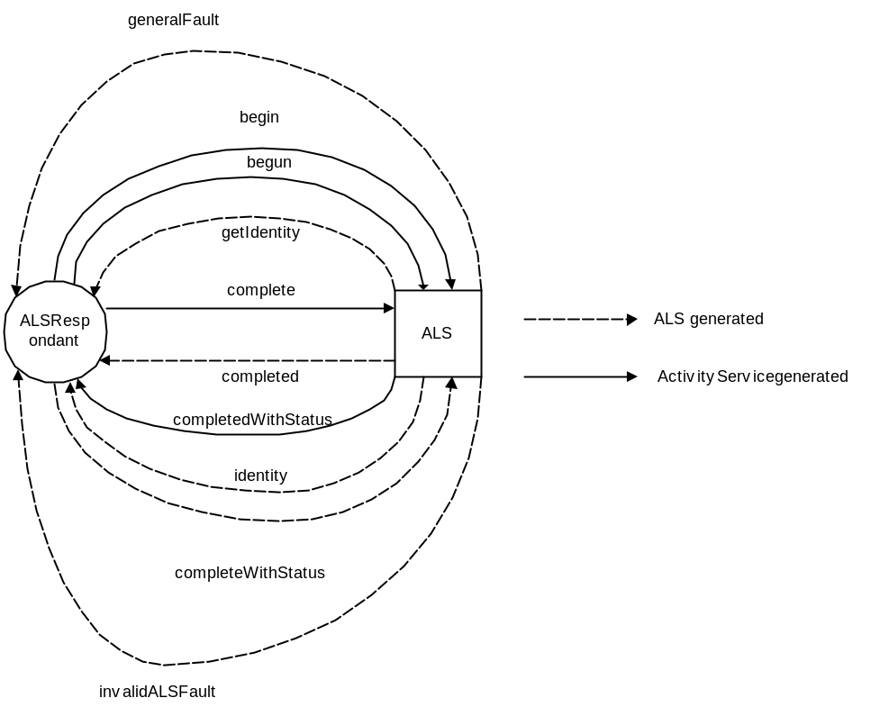
Figure 14: ALSRespondant and ALS interactions.
The Activity Service invokes the ALS begin and the ALS will respond by invoking either begun, invalidALSFault or generalFault on the ALSActivtyService.
If no faults are returned, the Activity Service invokes the ALS completeWithStatus and the ALS will eventually respond by invoking either completedWithStatus, invalidALSFault or generalFault on the ALSRespondant endpoint.
The Activity Service invokes the ALS complete operation and the ALS will eventually respond by invoking either completed, invalidALSFault or generalFault on the ALSRespondant endpoint.
<!-- ALS interface -->
<wsdl:portType name="ALSPortType">
<wsdl:operation name="begin">
<wsdl:input message="tns:ALSBeginMessage"/>
</wsdl:operation>
<wsdl:operation name="completeWithStatus">
<wsdl:input message="tns:CompleteWithStatustMessage"/>
</wsdl:operation>
<wsdl:operation name="complete">
<wsdl:input message="tns:CompleteMessage"/>
</wsdl:operation>
<wsdl:operation name="validContextExpectedFault">
<wsdl:input message="tns:ValidContextExpectedFaultMessage"/>
</wsdl:operation>
</wsdl:portType>

<!-- ALSRespondant interface -->
<wsdl:portType name="ALSRespondantPortType">
<wsdl:operation name="begun">
<wsdl:input message="tns:BegunMessage"/>
</wsdl:operation>
<wsdl:operation name="completedWithStatus">
<wsdl:input message="tns:CompletedWithStatusMessage"/>
</wsdl:operation>
<wsdl:operation name="completed">
<wsdl:input message="tns:CompletedMessage"/>
</wsdl:operation>
<wsdl:operation name="invalidALSFault">
<wsdl:input message="tns:InvalidALSFaultMessage"/>
</wsdl:operation>
<wsdl:operation name="validContextExpectedFault">
<wsdl:input message="tns:ValidContextExpectedFaultMessage"/>
</wsdl:operation>
<wsdl:operation name="generalFault">
<wsdl:input message="tns:GeneralFaultMessage"/>
</wsdl:operation>
</wsdl:portType>

The activity service WSDL
In order to be able to scope work within activities it is necessary for a component of the Activity Service to provide an interface for activity demarcation. The implementation of this service may be collocated with users. Since the activity service maintains information on multiple activities, an activity context may be present on all operation invocations to determine the appropriate activity on which to operate.
Interactions with the Activity Service occur between users (services) and the Activity Service via the UserActivityService and ActivityService interfaces respectively. The WSDL for these services is shown below and we shall describe the interactions in the following section.
<!-- Activity Service interface -->
<wsdl:portType name="ActivityServicePortType">
<wsdl:operation name="begin">
<wsdl:input message="tns:BeginMessage"/>
</wsdl:operation>
<wsdl:operation name="complete">
<wsdl:input message="tns:CompleteMessage"/>
</wsdl:operation>
<wsdl:operation name="completeWithStatus">
<wsdl:input message="tns:CompleteWithStatusMessage"/>
</wsdl:operation>
<wsdl:operation name="setCompletionStatus">
<wsdl:input message="tns:SetCompletionStatusMessage"/>
</wsdl:operation>
<wsdl:operation name="getCompletionStatus">
<wsdl:input message="tns:GetCompletionStatusMessage"/>
</wsdl:operation>
<wsdl:operation name="getStatus">
<wsdl:input message="tns:GetStatusMessage"/>
</wsdl:operation>
<wsdl:operation name="getActivityName">
<wsdl:input message="tns:GetActivityNameMessage"/>
</wsdl:operation>
<wsdl:operation name="getContext">
<wsdl:input message="tns:GetContextMessage"/>
</wsdl:operation>
<wsdl:operation name="setTimeout">
<wsdl:input message="tns:SetTimeoutMessage"/>
</wsdl:operation>
<wsdl:operation name="getTimeout">
<wsdl:input message="tns:GetTimeoutMessage"/>
</wsdl:operation>
<wsdl:operation name="begun">
<wsdl:input message="tns:BegunMessage"/>
</wsdl:operation>
<wsdl:operation name="completedWithStatus">
<wsdl:input message="tns:CompletedWithStatusMessage"/>
</wsdl:operation>
<wsdl:operation name="completed">
<wsdl:input message="tns:CompletedMessage"/>
</wsdl:operation>
<wsdl:operation name="generalFault">
<wsdl:input message="tns:GeneralFaultMessage"/>
</wsdl:operation>
<wsdl:operation name="invalidALSFault">
<wsdl:input message="tns:InvalidALSFaultMessage"/>
</wsdl:operation>
</wsdl:portType>

<!-- UserActivity interface -->
<wsdl:portType name="UserActivityServicePortType">
<wsdl:operation name="begun">
<wsdl:input message="tns:BegunMessage"/>
</wsdl:operation>
<wsdl:operation name="completed">
<wsdl:input message="tns:CompletedMessage"/>
</wsdl:operation>
<wsdl:operation name="completedWithStatus">
<wsdl:input message="tns:CompletedWithStatusMessage"/>
</wsdl:operation>
<wsdl:operation name="completionStatusSet">
<wsdl:input message="tns:CompletionStatusSetMessage"/>
</wsdl:operation>
<wsdl:operation name="completionStatus">
<wsdl:input message="tns:CompletedWithStatusMessage"/>
</wsdl:operation>
<wsdl:operation name="completionStatus">
<wsdl:input message="tns:CompletedWithStatusMessage"/>
</wsdl:operation>
<wsdl:operation name="status">
<wsdl:input message="tns:StatusMessage"/>
</wsdl:operation>
<wsdl:operation name="activityName">
<wsdl:input message="tns:ActivityNameMessage"/>
</wsdl:operation>
<wsdl:operation name="context">
<wsdl:input message="tns:ContextMessage"/>
</wsdl:operation>
<wsdl:operation name="timeoutSet">
<wsdl:input message="tns:TimeoutSetMessage"/>
</wsdl:operation>
<wsdl:operation name="timeout">
<wsdl:input message="tns:TimeoutMessage"/>
</wsdl:operation>
<wsdl:operation name="invalidStateFault">
<wsdl:input message="tns:InvalidStateFaultMessage"/>
</wsdl:operation>
<wsdl:operation name="invalidActivityFault">
<wsdl:input message="tns:InvalidActivityFaultMessage"/>
</wsdl:operation>
<wsdl:operation name="timeoutOutOfRangeFault">
<wsdl:input message="tns:TimeoutOutOfRangeFaultMessage"/>
</wsdl:operation>
<wsdl:operation name="childActivityPendingFault">
<wsdl:input message="tns:ChildActivityPendingFaultMessage"/>
</wsdl:operation>
<wsdl:operation name="noActivityFault">
<wsdl:input message="tns:NoActivityFaultMessage"/>
</wsdl:operation>
<wsdl:operation name="noPermissionFault">
<wsdl:input message="tns:NoPermissionFaultMessage"/>
</wsdl:operation>
</wsdl:portType>NoPermissionFaultMessage
In order to drive the Activity Service, the following two roles (and associated services) are defined for the one-way interactions:
- ActivityService: this has operations begin, complete, completeWithStatus, setCompletionStatus, getCompletionStatus, getStatus, getActivityName, getContext, setTimeout and getTimeout;
- UserActivityService: this is the user/service callback endpoint address for the various ActivityService operations. As such, it has operations begun, completed, completionStatusSet, completionStatus, status, activityName, context, timeoutSet, timeout, invalidStateFault, invalidActivityFault, timeoutOutOfRangeFault, childActivityPendingFault, noActivityFault, noPermissionFault, validContextExpectedFault.
The ActivityService has the following one-way operations, all of which are contextualised with the current context (if any). The UserActivityService endpoint address is exchanged during each operation in order to allow the Activity Service to return the result of the invocation.

begin
The begin operation creates a new activity and initializes the context. Any enrolled ALS Web services have their begin methods called in the scope of the newly initialized context and can augment it accordingly. A begin can be modelled as the first Web service in the Activity to register itself, in the case where there is no formal Activity Service executing as a separate Web service; an unique activity identifier is created for the activity such that any context information that is subsequently obtained will reference this identifier. If an activity context is present on the begin request then the newly created Activity will be nested within it. Otherwise, the Activity exists at the top level. If the parent Activity has been marked as FAIL_ONLY then the invalidStateFault operation will be invoked on the received UserActivityService endpoint. If the activity is completing, or has completed, the invalidActivityFault operation will be invoked on the received UserActivityService endpoint.
The timeout parameter is used to control the lifetime of the Activity. If the Activity has not completed by the time timeout seconds elapses then it is subject to being completed automatically by the Activity Service with the FAIL status. The timeout can have the following possible values:
- any positive value: the Activity must complete within this number of seconds.
- -1: the Activity will never be completed automatically by the Activity Service implementation, i.e., it will never be considered to have timed out.
- 0: the last value specified using the set_timeout method is used. If no prior call to the setTimeout operation has occurred for this thread, or the value returned is 0, then it is implementation dependant as to the timeout value associated with this Activity.
Any other value results in the Activity Service calling the timeoutOutOfRangeFault operation on the UserActivityService endpoint.
Upon success, the new activity will be placed in the ACTIVE state and the Activity Service will invoke the begun operation of the UserActivityService.
If an invalid context is propagated on the begin request then the validContextExpectedFault operation is invoked on the UserActivityService.
The generalFault operation is invoked on the UserActivityService if an unexpected error or fault occurs.

complete
A valid activity context is associated with this invocation. The complete operation causes the associated Activity to complete with its current CompletionStatus, or FAIL if none has been specified using setCompletionStatus. If there are any encompassed active Activities and the completion status is SUCCESS, then the childActivityPendingFault operation is invoked on the associated UserActivityService; the application must then either complete the outstanding nested contexts or force the Activity to end by setting the CompletionStatus to either FAIL or FAIL_ONLY and then call complete again. Prior to completing, any registered ALS is informed via the completeWithStatus method and is able to undertake its specific work. Subsequent to completion, their complete methods are invoked.
If the completion status is FAIL, or FAIL_ONLY, any encompassed active Activities will they have their completion status set to FAIL_ONLY. If there is no Activity associated with the sent context, the noActivityFault operation is invoked on the UserActivityService and no other action is taken. An Activity Service implementation may impose restrictions on which users can terminate an activity, and in which case the noPermissionFault operation may be invoked on the UserActivityService.
Once complete, the Activity Service invokes the completed method on the UserActivityService, passing it the resultant Outcome (which may be an empty message); this can be used to interpret the final outcome of the Activity. If the Activity cannot complete in the status required then the Activity Service will invoke the associated UserActivityServices activityCompleted operation. If the Activity has begun completion, or has completed, then the invalidActivityFault UserActivityService operation is called.
If an invalid context is propagated on the request then the validContextExpectedFault operation is invoked on the UserActivityService.
The generalFault operation is invoked on the UserActivityService if an unexpected error or fault occurs.
Additional fault or success messages are expected to be encoded within the resultant Outcome.

completeWithStatus
A valid activity context should be associated with this invocation. The completeWithStatus operation causes the Activity associated with the context to complete and use the CompletionStatus provided if this does not conflict with any that has previously been set using the setCompletionStatus operation; this is logically equivalent to calling the setCompletionStatus operation followed by the complete operation. The UserActivityService completed operation is called upon success.
If an invalid context is propagated on the request then the validContextExpectedFault operation is invoked on the UserActivityService.
The generalFault operation is invoked on the UserActivityService if an unexpected error or fault occurs.
Additional fault or success messages are expected to be encoded within the resultant Outcome.

setCompletionStatus
A valid activity context is associated with this invocation. This operation can be used to set the CompletionStatus that will be used when the Activity completes. This operation may be called many times during the lifetime of an Activity in order to reflect changes in its completion status as it executes. If this operation is not called during the Activity’s lifetime, the default status is FAIL. When the Activity completes, the CompletionStatus is given to all enlisted ALS-es. It may also appear in the activity context. If the CompletionStatus is FAIL_ONLY and an attempt is made to change the status to anything other than FAIL_ONLY, the invalidStateFault operation will be invoked on the UserActivityService. If the Activity has begun completion, or has completed, then the UserActivityService invalidActivityFault operation will be called. Otherwise, the completionStatusSet operation is invoked.
If an invalid context is propagated on the request then the validContextExpectedFault operation is invoked on the UserActivityService.
The generalFault operation is invoked on the UserActivityService if an unexpected error or fault occurs.

getCompletionStatus
This operation is used to obtain the current CompletionStatus associated with the activity referenced in the propagated context (if any). The Activity Service will invoke the completionStatus on the UserActivityService associated with this invocation, passing the CompletionStatus currently associated with the Activity, or FAIL if setCompletionStatus has not previously been called. If there is no activity associated with the propagated context then the noActivityFault operation will be called.
If an invalid context is propagated on the request then the validContextExpectedFault operation is invoked on the UserActivityService.
The generalFault operation is invoked on the UserActivityService if an unexpected error or fault occurs.

getStatus
This operation is used to obtain the current Status of the activity referenced in the propagated context. The Activity Service will invoke the status operation on the associated UserActivityService to return the current status of the Activity. If there is no Activity associated with the context, the noActivityFault operation is invoked on the UserActivityService.
If an invalid context is propagated on the request then the validContextExpectedFault operation is invoked on the UserActivityService.
The generalFault operation is invoked on the UserActivityService if an unexpected error or fault occurs.

getActivityName
This operation is used to retrieve the name of the activity referenced in the propagated context. The Activity Service invokes the activityName operation on the UserActivityService passing back a printable string describing the activity, or an empty string if there is no activity associated with the invocation.
If an invalid context is propagated on the request then the validContextExpectedFault operation is invoked on the UserActivityService.
The generalFault operation is invoked on the UserActivityService if an unexpected error or fault occurs.

getContext
Given the unique activity identification, this operation causes the Activity Service to invoke the context operation on the associated UserActivityService to returns the context URI for the Activity. If there is no activity associated with the identifier then the noActivityFault operation is used.
If an invalid context is propagated on the request then the validContextExpectedFault operation is invoked on the UserActivityService.
The generalFault operation is invoked on the UserActivityService if an unexpected error or fault occurs.

setTimeout
This operation modifies a state variable associated with the activity service that affects the time-out period associated with the activities created by subsequent invocations of the begin operation. If the parameter has a non-zero value n, then activities created by subsequent invocations of begin will be subject to being completed if they do not complete before n seconds after their creation. The timeout can have the following possible values:
- any positive value: the Activity must complete within this number of seconds.
- -1: the Activity will never be completed automatically by the Activity Service implementation, i.e., it will never be considered to have timed out.
- 0: it is implementation dependant as to the meaning of passing 0 as the value.
A valid timeout value results in the Activity Service calling the UserActivityService’s timeoutSet operation. Any other value results in the timeoutOutOfRangeFault operation being invoked on the associated UserActivityService.
If an invalid context is propagated on the request then the validContextExpectedFault operation is invoked on the UserActivityService.
The generalFault operation is invoked on the UserActivityService if an unexpected error or fault occurs.

getTimeout
Upon successful execution, this operation causes the Activity Service to invoke the timeout operation on the associated UserActivityService and return the value of the time-out period associated with activities created by calls to begin. This need not be the value associated with the current Activity, however.
If an invalid context is propagated on the request then the validContextExpectedFault operation is invoked on the UserActivityService.
The generalFault operation is invoked on the UserActivityService if an unexpected error or fault occurs.
Figure 15 shows the state transitions for an activity and how they relate to the various messages exchanges between the client/user of the Activity Service and the Activity Service. As mentioned above, in order to participate in these message interactions the client/user supplies a UserActivityService endpoint.

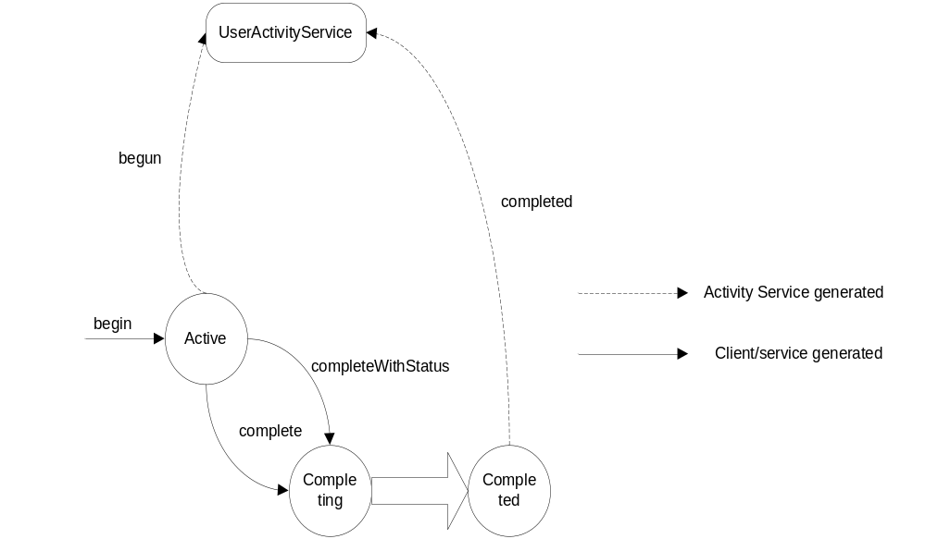
Figure 15 Activity state transitions and messages.

Activity Service schema
<?xml version="1.0" encoding="UTF-8"?>
<xs:schema targetNamespace="http://www.webservicestransactions.org/schemas/wsas/2003/03" xmlns:tns="http://www.webservicestransactions.org/schemas/wsas/2003/03" xmlns:xs="http://www.w3.org/2001/XMLSchema" elementFormDefault="qualified" attributeFormDefault="unqualified">
<xs:complexType name="ActivityListType">
<xs:sequence>
<xs:element name="service" type="xs:anyURI" minOccurs="0"/>
</xs:sequence>
</xs:complexType>
<xs:complexType name="ContextType">
<xs:sequence>
<xs:element name="context-identifier" type="xs:anyURI" minOccurs="1" maxOccurs="1"/>
<xs:element name="activity-service" type="xs:anyURI" minOccurs="0" maxOccurs="1"/>
<xs:element name="type" type="xs:anyURI" minOccurs="0"/>
<xs:element name="activity-list" type="tns:ActivityListType" minOccurs="0"/>
<xs:element name="als-context" type="tns:ALSContextType" minOccurs="0"
maxOccurs="unbounded"/>
<xs:element name="child-contexts" minOccurs="0" maxOccurs="1">
<xs:complexType>
<xs:sequence>
<xs:element name="child-context" type="tns:ContextType" minOccurs="1"
maxOccurs="unbounded"/>
</xs:sequence>
</xs:complexType>
</xs:element>
<xs:any namespace="##other" processContents="lax" minOccurs="0"/>
</xs:sequence>
<xs:attribute name="timeout" type="xs:positiveInteger" use="optional"/>
</xs:complexType>
<xs:element name="context" type="tns:ContextType"/>
<xs:complexType name="ALSContextType">
<xs:sequence>
<xs:element name="type" type="xs:anyURI"/>
<xs:any namespace="##other" processContents="lax" minOccurs="0"/>
</xs:sequence>
<xs:attribute name="mustUnderstand" type="xs:boolean" use="optional" default="false"/>
<xs:attribute name="mustPropagate" type="xs:boolean" use="optional" default="false"/>
</xs:complexType>
<xs:complexType name="OutcomeType">
<xs:sequence>
<xs:element name="completion-status" type="tns:CompletionStatusType"/>
<xs:any namespace="##other" processContents="lax" minOccurs="0"/>
</xs:sequence>
<xs:attribute name="id" type="xs:anyURI" use="required"/>
</xs:complexType>
<xs:simpleType name="StatusType">
<xs:restriction base="xs:string">
<xs:enumeration value="ACTIVE"/>
<xs:enumeration value="COMPLETING"/>
<xs:enumeration value="COMPLETED"/>
<xs:enumeration value="NO_ACTIVITY"/>
<xs:enumeration value="UNKNOWN"/>
</xs:restriction>
</xs:simpleType>
<xs:simpleType name="CompletionStatusType">
<xs:restriction base="xs:string">
<xs:enumeration value="SUCCESS"/>
<xs:enumeration value="FAIL"/>
<xs:enumeration value="FAIL_ONLY"/>
<xs:enumeration value="UNKNOWN"/>
</xs:restriction>
</xs:simpleType>
</xs:schema>

Activity Service WSDL Message Set
<?xml version="1.0" encoding="UTF-8"?>
<wsdl:definitions targetNamespace="http://www.webservicestransactions.org/wsdl/wsas/2003/03" xmlns="http://schemas.xmlsoap.org/wsdl/" xmlns:tns="http://www.webservicestransactions.org/wsdl/wsas/2003/03" xmlns:wsas="http://www.webservicestransactions.org/schemas/wsas/2003/03" xmlns:wsdl="http://schemas.xmlsoap.org/wsdl/" xmlns:xs="http://www.w3.org/2001/XMLSchema">
<wsdl:import location="http://www.webservicestransactions.org/schemas/wsas/2003/03" namespace="http://www.webservicestransactions.org/schemas/wsas/2003/03"/>
<wsdl:message name="BeginMessage">
<wsdl:part name="sender-address" type="wsas:AddressType"/>
<wsdl:part name="recipient-address" type="wsas:AddressType"/>
<wsdl:part name="correlation-id" type="xs:string"/>
<wsdl:part name="timeout" type="xs:positiveInteger"/>
</wsdl:message>
<wsdl:message name="CompleteMessage">
<wsdl:part name="sender-address" type="wsas:AddressType"/>
<wsdl:part name="recipient-address" type="wsas:AddressType"/>
<wsdl:part name="correlation-id" type="xs:string"/>
</wsdl:message>
<wsdl:message name="CompleteWithStatusMessage">
<wsdl:part name="sender-address" type="wsas:AddressType"/>
<wsdl:part name="recipient-address" type="wsas:AddressType"/>
<wsdl:part name="correlation-id" type="xs:string"/>
<wsdl:part name="completion-status" type="wsas:CompletionStatusType"/>
</wsdl:message>
<wsdl:message name="SetCompletionStatusMessage">
<wsdl:part name="sender-address" type="wsas:AddressType"/>
<wsdl:part name="recipient-address" type="wsas:AddressType"/>
<wsdl:part name="correlation-id" type="xs:string"/>
<wsdl:part name="completion-status" type="wsas:CompletionStatusType"/>
</wsdl:message>
<wsdl:message name="GetCompletionStatusMessage">
<wsdl:part name="sender-address" type="wsas:AddressType"/>
<wsdl:part name="recipient-address" type="wsas:AddressType"/>
<wsdl:part name="correlation-id" type="xs:string"/>
</wsdl:message>
<wsdl:message name="GetStatusMessage">
<wsdl:part name="sender-address" type="wsas:AddressType"/>
<wsdl:part name="recipient-address" type="wsas:AddressType"/>
<wsdl:part name="correlation-id" type="xs:string"/>
</wsdl:message>
<wsdl:message name="GetActivityNameMessage">
<wsdl:part name="sender-address" type="wsas:AddressType"/>
<wsdl:part name="recipient-address" type="wsas:AddressType"/>
<wsdl:part name="correlation-id" type="xs:string"/>
</wsdl:message>
<wsdl:message name="GetContextMessage">
<wsdl:part name="sender-address" type="wsas:AddressType"/>
<wsdl:part name="recipient-address" type="wsas:AddressType"/>
<wsdl:part name="correlation-id" type="xs:string"/>
</wsdl:message>
<wsdl:message name="GetTimeoutMessage">
<wsdl:part name="sender-address" type="wsas:AddressType"/>
<wsdl:part name="recipient-address" type="wsas:AddressType"/>
<wsdl:part name="correlation-id" type="xs:string"/>
</wsdl:message>
<wsdl:message name="SetTimeoutMessage">
<wsdl:part name="sender-address" type="wsas:AddressType"/>
<wsdl:part name="recipient-address" type="wsas:AddressType"/>
<wsdl:part name="correlation-id" type="xs:string"/>
<wsdl:part name="timeout" type="xs:int"/>
</wsdl:message>
<wsdl:message name="BegunMessage">
<wsdl:part name="sender-address" type="wsas:AddressType"/>
<wsdl:part name="recipient-address" type="wsas:AddressType"/>
<wsdl:part name="correlation-id" type="xs:string"/>
</wsdl:message>
<wsdl:message name="CompletedWithStatusMessage">
<wsdl:part name="sender-address" type="wsas:AddressType"/>
<wsdl:part name="recipient-address" type="wsas:AddressType"/>
<wsdl:part name="completion-status" type="wsas:CompletionStatusType"/>
<wsdl:part name="correlation-id" type="xs:string"/>
</wsdl:message>
<wsdl:message name="CompletedMessage">
<wsdl:part name="sender-address" type="wsas:AddressType"/>
<wsdl:part name="recipient-address" type="wsas:AddressType"/>
<wsdl:part name="correlation-id" type="xs:string"/>
</wsdl:message>
<wsdl:message name="GeneralFaultMessage">
<wsdl:part name="sender-address" type="wsas:AddressType"/>
<wsdl:part name="recipient-address" type="wsas:AddressType"/>
<wsdl:part name="correlation-id" type="xs:string"/>
<wsdl:part name="error-code" type="xs:string"/>
<wsdl:part name="description" type="xs:string"/>
</wsdl:message>
<wsdl:message name="InvalidALSFaultMessage">
<wsdl:part name="sender-address" type="wsas:AddressType"/>
<wsdl:part name="invalid-als-address" type="wsas:AddressType"/>
<wsdl:part name="correlation-id" type="xs:string"/>
</wsdl:message>
<wsdl:message name="ALSBeginMessage">
<wsdl:part name="sender-address" type="wsas:AddressType"/>
<wsdl:part name="recipient-address" type="wsas:AddressType"/>
<wsdl:part name="correlation-id" type="xs:string"/>
</wsdl:message>
<wsdl:message name="CompletionStatusMessage">
<wsdl:part name="sender-address" type="wsas:AddressType"/>
<wsdl:part name="recipient-address" type="wsas:AddressType"/>
<wsdl:part name="completion-status" type="wsas:CompletionStatusType"/>
<wsdl:part name="correlation-id" type="xs:string"/>
</wsdl:message>
<wsdl:message name="StatusMessage">
<wsdl:part name="sender-address" type="wsas:AddressType"/>
<wsdl:part name="recipient-address" type="wsas:AddressType"/>
<wsdl:part name="correlation-id" type="xs:string"/>
<wsdl:part name="status" type="wsas:StatusType"/>
</wsdl:message>
<wsdl:message name="ActivityNameMessage">
<wsdl:part name="sender-address" type="wsas:AddressType"/>
<wsdl:part name="recipient-address" type="wsas:AddressType"/>
<wsdl:part name="correlation-id" type="xs:string"/>
<wsdl:part name="activity-name" type="xs:string"/>
</wsdl:message>
<wsdl:message name="ContextMessage">
<wsdl:part name="sender-address" type="wsas:AddressType"/>
<wsdl:part name="recipient-address" type="wsas:AddressType"/>
<wsdl:part name="correlation-id" type="xs:string"/>
<wsdl:part name="context" type="wsas:ActivityContextType"/>
</wsdl:message>
<wsdl:message name="TimeoutSetMessage">
<wsdl:part name="sender-address" type="wsas:AddressType"/>
<wsdl:part name="recipient-address" type="wsas:AddressType"/>
<wsdl:part name="correlation-id" type="xs:string"/>
<wsdl:part name="timeout" type="xs:positiveInteger"/>
</wsdl:message>
<wsdl:message name="TimeoutMessage">
<wsdl:part name="sender-address" type="wsas:AddressType"/>
<wsdl:part name="recipient-address" type="wsas:AddressType"/>
<wsdl:part name="correlation-id" type="xs:string"/>
<wsdl:part name="timeout" type="xs:positiveInteger"/>
</wsdl:message>
<wsdl:message name="InvalidStateFaultMessage">
<wsdl:part name="recipient-address" type="wsas:AddressType"/>
<wsdl:part name="correlation-id" type="xs:string"/>
<wsdl:part name="originator" type="xs:anyURI"/>
</wsdl:message>
<wsdl:message name="InvalidActivityFaultMessage">
<wsdl:part name="recipient-address" type="wsas:AddressType"/>
<wsdl:part name="correlation-id" type="xs:string"/>
<wsdl:part name="originator" type="xs:anyURI"/>
</wsdl:message>
<wsdl:message name="TimoutOutOfRangeMessage">
<wsdl:part name="recipient-address" type="wsas:AddressType"/>
<wsdl:part name="correlation-id" type="xs:string"/>
<wsdl:part name="max-timeout" type="xs:positiveInteger"/>
<wsdl:part name="specified-timeout" type="xs:positiveInteger"/>
</wsdl:message>
<wsdl:message name="ChildActivityPendingFaultMessage">
<wsdl:part name="recipient-address" type="wsas:AddressType"/>
<wsdl:part name="correlation-id" type="xs:string"/>
<wsdl:part name="originator" type="xs:anyURI"/>
</wsdl:message>
<wsdl:message name="NoActivityFaultMessage">
<wsdl:part name="recipient-address" type="wsas:AddressType"/>
<wsdl:part name="correlation-id" type="xs:string"/>
<wsdl:part name="originator" type="xs:anyURI"/>
</wsdl:message>
<wsdl:message name="NoPermissionFaultMessage">
<wsdl:part name="recipient-address" type="wsas:AddressType"/>
<wsdl:part name="correlation-id" type="xs:string"/>
<wsdl:part name="originator" type="xs:anyURI"/>
</wsdl:message>
<wsdl:message name="ValidContextExpectedFaultMessage">
<wsdl:part name="recipient-address" type="wsas:AddressType"/>
<wsdl:part name="correlation-id" type="xs:string"/>
<wsdl:part name="originator" type="xs:anyURI"/>
</wsdl:message>
<wsdl:message name="EnlistALSMessage">
<wsdl:part name="sender-address" type="wsas:AddressType"/>
<wsdl:part name="recipient-address" type="wsas:AddressType"/>
<wsdl:part name="correlation-id" type="xs:string"/>
<wsdl:part name="als" type="xs:anyURI"/>
</wsdl:message>
<wsdl:message name="ALSEnlistedMessage">
<wsdl:part name="sender-address" type="wsas:AddressType"/>
<wsdl:part name="recipient-address" type="wsas:AddressType"/>
<wsdl:part name="correlation-id" type="xs:string"/>
<wsdl:part name="als" type="xs:anyURI"/>
</wsdl:message>
<wsdl:message name="DelistALSMessage">
<wsdl:part name="sender-address" type="wsas:AddressType"/>
<wsdl:part name="recipient-address" type="wsas:AddressType"/>
<wsdl:part name="correlation-id" type="xs:string"/>
<wsdl:part name="als" type="xs:anyURI"/>
</wsdl:message>
<wsdl:message name="ALSDelistedMessage">
<wsdl:part name="sender-address" type="wsas:AddressType"/>
<wsdl:part name="recipient-address" type="wsas:AddressType"/>
<wsdl:part name="correlation-id" type="xs:string"/>
<wsdl:part name="als" type="xs:anyURI"/>
</wsdl:message>
<wsdl:message name="GetContentsMessage">
<wsdl:part name="sender-address" type="wsas:AddressType"/>
<wsdl:part name="recipient-address" type="wsas:AddressType"/>
<wsdl:part name="correlation-id" type="xs:string"/>
</wsdl:message>
<wsdl:message name="SetContentsMessage">
<wsdl:part name="sender-address" type="wsas:AddressType"/>
<wsdl:part name="recipient-address" type="wsas:AddressType"/>
<wsdl:part name="correlation-id" type="xs:string"/>
<wsdl:part name="context" type="wsas:ContextType"/>
</wsdl:message>
<wsdl:message name="ContentsMessage">
<wsdl:part name="sender-address" type="wsas:AddressType"/>
<wsdl:part name="recipient-address" type="wsas:AddressType"/>
<wsdl:part name="correlation-id" type="xs:string"/>
<wsdl:part name="context" type="wsas:ContextType"/>
</wsdl:message>
<wsdl:message name="ContentsSetMessage">
<wsdl:part name="sender-address" type="wsas:AddressType"/>
<wsdl:part name="recipient-address" type="wsas:AddressType"/>
<wsdl:part name="correlation-id" type="xs:string"/>
</wsdl:message>
<wsdl:message name="UnknownContextFaultMessage">
<wsdl:part name="sender-address" type="wsas:AddressType"/>
<wsdl:part name="recipient-address" type="wsas:AddressType"/>
<wsdl:part name="correlation-id" type="xs:string"/>
<wsdl:part name="context-identifier" type="xs:anyURI"/>
</wsdl:message>
<wsdl:portType name="ContextManagerPortType">
<wsdl:operation name="getContents">
<wsdl:input message="tns:GetContentsMessage"/>
</wsdl:operation>
<wsdl:operation name="setContents">
<wsdl:input message="tns:SetContentsMessage"/>
</wsdl:operation>
</wsdl:portType>
<wsdl:portType name="ContextRespondandtPortType">
<wsdl:operation name="contents">
<wsdl:input message="tns:ContentsMessage"/>
</wsdl:operation>
<wsdl:operation name="contentsSet">
<wsdl:input message="tns:ContentsSetMessage"/>
</wsdl:operation>
<wsdl:operation name="unknownContextFault">
<wsdl:input message="tns:UnknownContextFaultMessage"/>
</wsdl:operation>
<wsdl:operation name="generalFault">
<wsdl:input message="tns:GeneralFaultMessage"/>
</wsdl:operation>
</wsdl:portType>
<wsdl:portType name="ActivityServicePortType">
<wsdl:operation name="begin">
<wsdl:input message="tns:BeginMessage"/>
</wsdl:operation>
<wsdl:operation name="complete">
<wsdl:input message="tns:CompleteMessage"/>
</wsdl:operation>
<wsdl:operation name="completeWithStatus">
<wsdl:input message="tns:CompleteWithStatusMessage"/>
</wsdl:operation>
<wsdl:operation name="setCompletionStatus">
<wsdl:input message="tns:SetCompletionStatusMessage"/>
</wsdl:operation>
<wsdl:operation name="getCompletionStatus">
<wsdl:input message="tns:GetCompletionStatusMessage"/>
</wsdl:operation>
<wsdl:operation name="getStatus">
<wsdl:input message="tns:GetStatusMessage"/>
</wsdl:operation>
<wsdl:operation name="getActivityName">
<wsdl:input message="tns:GetActivityNameMessage"/>
</wsdl:operation>
<wsdl:operation name="getContext">
<wsdl:input message="tns:GetContextMessage"/>
</wsdl:operation>
<wsdl:operation name="setTimeout">
<wsdl:input message="tns:SetTimeoutMessage"/>
</wsdl:operation>
<wsdl:operation name="getTimeout">
<wsdl:input message="tns:GetTimeoutMessage"/>
</wsdl:operation>
<wsdl:operation name="begun">
<wsdl:input message="tns:BegunMessage"/>
</wsdl:operation>
<wsdl:operation name="completedWithStatus">
<wsdl:input message="tns:CompletedWithStatusMessage"/>
</wsdl:operation>
<wsdl:operation name="completed">
<wsdl:input message="tns:CompletedMessage"/>
</wsdl:operation>
<wsdl:operation name="generalFault">
<wsdl:input message="tns:GeneralFaultMessage"/>
</wsdl:operation>
<wsdl:operation name="invalidALSFault">
<wsdl:input message="tns:InvalidALSFaultMessage"/>
</wsdl:operation>
</wsdl:portType>
<wsdl:portType name="UserActivityServicePortType">
<wsdl:operation name="begun">
<wsdl:input message="tns:BegunMessage"/>
</wsdl:operation>
<wsdl:operation name="completed">
<wsdl:input message="tns:CompletedMessage"/>
</wsdl:operation>
<wsdl:operation name="completedWithStatus">
<wsdl:input message="tns:CompletedWithStatusMessage"/>
</wsdl:operation>
<wsdl:operation name="completionStatusSet">
<wsdl:input message="tns:CompletionStatusSetMessage"/>
</wsdl:operation>
<wsdl:operation name="completionStatus">
<wsdl:input message="tns:CompletedWithStatusMessage"/>
</wsdl:operation>
<wsdl:operation name="completionStatus">
<wsdl:input message="tns:CompletedWithStatusMessage"/>
</wsdl:operation>
<wsdl:operation name="status">
<wsdl:input message="tns:StatusMessage"/>
</wsdl:operation>
<wsdl:operation name="activityName">
<wsdl:input message="tns:ActivityNameMessage"/>
</wsdl:operation>
<wsdl:operation name="context">
<wsdl:input message="tns:ContextMessage"/>
</wsdl:operation>
<wsdl:operation name="timeoutSet">
<wsdl:input message="tns:TimeoutSetMessage"/>
</wsdl:operation>
<wsdl:operation name="timeout">
<wsdl:input message="tns:TimeoutMessage"/>
</wsdl:operation>
<wsdl:operation name="invalidStateFault">
<wsdl:input message="tns:InvalidStateFaultMessage"/>
</wsdl:operation>
<wsdl:operation name="invalidActivityFault">
<wsdl:input message="tns:InvalidActivityFaultMessage"/>
</wsdl:operation>
<wsdl:operation name="timeoutOutOfRange">
<wsdl:input message="tns:TimeoutOutOfRangeFaultMessage"/>
</wsdl:operation>
<wsdl:operation name="childActivityPendingFault">
<wsdl:input message="tns:ChildActivityPendingFaultMessage"/>
</wsdl:operation>
<wsdl:operation name="noActivityFault">
<wsdl:input message="tns:NoActivityFaultMessage"/>
</wsdl:operation>
<wsdl:operation name="noPermissionFault">
<wsdl:input message="tns:NoPermissionFaultMessage"/>
</wsdl:operation>
</wsdl:portType>
<wsdl:portType name="ALSPortType">
<wsdl:operation name="begin">
<wsdl:input message="tns:ALSBeginMessage"/>
</wsdl:operation>
<wsdl:operation name="completeWithStatus">
<wsdl:input message="tns:CompleteWithStatustMessage"/>
</wsdl:operation>
<wsdl:operation name="complete">
<wsdl:input message="tns:CompleteMessage"/>
</wsdl:operation>
<wsdl:operation name="validContextExpectedFault">
<wsdl:input message="tns:ValidContextExpectedFaultMessage"/>
</wsdl:operation>
</wsdl:portType>
<wsdl:portType name="ALSRespondantPortType">
<wsdl:operation name="begun">
<wsdl:input message="tns:BegunMessage"/>
</wsdl:operation>
<wsdl:operation name="completedWithStatus">
<wsdl:input message="tns:CompletedWithStatusMessage"/>
</wsdl:operation>
<wsdl:operation name="completed">
<wsdl:input message="tns:CompletedMessage"/>
</wsdl:operation>
<wsdl:operation name="invalidALSFault">
<wsdl:input message="tns:InvalidALSFaultMessage"/>
</wsdl:operation>
<wsdl:operation name="validContextExpectedFault">
<wsdl:input message="tns:ValidContextExpectedFaultMessage"/>
</wsdl:operation>
<wsdl:operation name="generalFault">
<wsdl:input message="tns:GeneralFaultMessage"/>
</wsdl:operation>
</wsdl:portType>
<wsdl:portType name="ALSRegistrarPortType">
<wsdl:operation name="enlistALS">
<wsdl:input message="tns:EnlistALSMessage"/>
</wsdl:operation>
<wsdl:operation name="delistALS">
<wsdl:input message="tns:DelistALSMessage"/>
</wsdl:operation>
</wsdl:portType>
<wsdl:portType name="ALSRegistrantPortType">
<wsdl:operation name="enlistedALS">
<wsdl:input message="tns:ALSEnlistedMessage"/>
</wsdl:operation>
<wsdl:operation name="delistedALS">
<wsdl:input message="tns:ALSDelistedMessage"/>
</wsdl:operation>
<wsdl:operation name="invalidALSFault">
<wsdl:input message="tns:InvalidALSFaultMessage"/>
</wsdl:operation>
<wsdl:operation name="generalFault">
<wsdl:input message="tns:GeneralFaultMessage"/>
</wsdl:operation>
</wsdl:portType>
<!-- SOAP 1.1 over HTTP bindings -->
<wsdl:binding name="ContextManagerPortTypeSOAPBinding" type="ContextManagerPortTypeSOAPBinding">
<soap:binding transport="http://schemas.xmlsoap.org/soap/http" style="document"/>
<wsdl:operation name="getContents">
<soap:operation soapAction="http://www.webservicestransactions.org/wsdl/wsas/2003/03/getContents" style="document"/>
<wsdl:input>
<soap:body use="literal"/>
</wsdl:input>
</wsdl:operation>
<wsdl:operation name="setContents">
<soap:operation soapAction="http://www.webservicestransactions.org/wsdl/wsas/2003/03/setContents" style="document"/>
<wsdl:input>
<soap:body use="literal"/>
</wsdl:input>
</wsdl:operation>
</wsdl:binding>
<wsdl:binding name="ContextRespondandtPortTypeSOAPBinding" type="ContextRespondandtPortTypeSOAPBinding">
<soap:binding transport="http://schemas.xmlsoap.org/soap/http" style="document"/>
<wsdl:operation name="contents">
<soap:operation soapAction="http://www.webservicestransactions.org/wsdl/wsas/2003/03/contents" style="document"/>
<wsdl:input>
<soap:body use="literal"/>
</wsdl:input>
</wsdl:operation>
<wsdl:operation name="contentsSet">
<soap:operation soapAction="http://www.webservicestransactions.org/wsdl/wsas/2003/03/contentsSet" style="document"/>
<wsdl:input>
<soap:body use="literal"/>
</wsdl:input>
</wsdl:operation>
<wsdl:operation name="unknownContextFault">
<soap:operation soapAction="http://www.webservicestransactions.org/wsdl/wsas/2003/03/unknownContextFault" style="document"/>
<wsdl:input>
<soap:body use="literal"/>
</wsdl:input>
</wsdl:operation>
<wsdl:operation name="unknownContextFault">
<soap:operation soapAction="http://www.webservicestransactions.org/wsdl/wsas/2003/03/unknownContextFault" style="document"/>
<wsdl:input>
<soap:body use="literal"/>
</wsdl:input>
</wsdl:operation>
</wsdl:binding>
<wsdl:binding name="ActivityServicePortTypeSOAPBinding" type="ActivityServicePortTypeSOAPBinding">
<soap:binding transport="http://schemas.xmlsoap.org/soap/http" style="document"/>
<wsdl:operation name="begin">
<soap:operation soapAction="http://www.webservicestransactions.org/wsdl/wsas/2003/03/begin" style="document"/>
<wsdl:input>
<soap:body use="literal"/>
</wsdl:input>
</wsdl:operation>
<wsdl:operation name="complete">
<soap:operation soapAction="http://www.webservicestransactions.org/wsdl/wsas/2003/03/complete" style="document"/>
<wsdl:input>
<soap:body use="literal"/>
<soap:header use="literal" message="tns:ContextMessage" part="context"/>
</wsdl:input>
</wsdl:operation>
<wsdl:operation name="completeWithStatus">
<soap:operation soapAction="http://www.webservicestransactions.org/wsdl/wsas/2003/03/completeWithStatus" style="document"/>
<wsdl:input>
<soap:body use="literal"/>
<soap:header use="literal" message="tns:ContextMessage" part="context"/>
</wsdl:input>
</wsdl:operation>
<wsdl:operation name="setCompletionStatus">
<soap:operation soapAction=
"http://www.webservicestransactions.org/wsdl/wsas/2003/03/setCompletionStatus"
style="document"/>
<wsdl:input>
<soap:body use="literal"/>
<soap:header use="literal" message="tns:ContextMessage" part="context"/>
</wsdl:input>
</wsdl:operation>
<wsdl:operation name="getCompletionStatus">
<soap:operation soapAction=
"http://www.webservicestransactions.org/wsdl/wsas/2003/03/getCompletionStatus"
style="document"/>
<wsdl:input>
<soap:body use="literal"/>
<soap:header use="literal" message="tns:ContextMessage" part="context"/>
</wsdl:input>
</wsdl:operation>
<wsdl:operation name="getStatus">
<soap:operation soapAction=
"http://www.webservicestransactions.org/wsdl/wsas/2003/03/getStatus"
style="document"/>
<wsdl:input>
<soap:body use="literal"/>
<soap:header use="literal" message="tns:ContextMessage" part="context"/>
</wsdl:input>
</wsdl:operation>
<wsdl:operation name="getActivityName">
<soap:operation soapAction=
"http://www.webservicestransactions.org/wsdl/wsas/2003/03/getActivityName"
style="document"/>
<wsdl:input>
<soap:body use="literal"/>
<soap:header use="literal" message="tns:ContextMessage" part="context"/>
</wsdl:input>
</wsdl:operation>
<wsdl:operation name="getContext">
<soap:operation soapAction=
"http://www.webservicestransactions.org/wsdl/wsas/2003/03/getContext"
style="document"/>
<wsdl:input>
<soap:body use="literal"/>
</wsdl:input>
</wsdl:operation>
<wsdl:operation name="setTimeout">
<soap:operation soapAction=
"http://www.webservicestransactions.org/wsdl/wsas/2003/03/setTimeout"
style="document"/>
<wsdl:input>
<soap:body use="literal"/>
<soap:header use="literal" message="tns:ContextMessage" part="context"/>
</wsdl:input>
</wsdl:operation>
<wsdl:operation name="getTimeout">
<soap:operation soapAction=
"http://www.webservicestransactions.org/wsdl/wsas/2003/03/getTimeout"
style="document"/>
<wsdl:input>
<soap:body use="literal"/>
<soap:header use="literal" message="tns:ContextMessage" part="context"/>
</wsdl:input>
</wsdl:operation>
<wsdl:operation name="begun">
<soap:operation soapAction=
"http://www.webservicestransactions.org/wsdl/wsas/2003/03/begun"
style="document"/>
<wsdl:input>
<soap:body use="literal"/>
<soap:header use="literal" message="tns:ContextMessage" part="context"/>
</wsdl:input>
</wsdl:operation>
<wsdl:operation name="completedWithStatus">
<soap:operation soapAction=
"http://www.webservicestransactions.org/wsdl/wsas/2003/03/completedWithStatus"
style="document"/>
<wsdl:input>
<soap:body use="literal"/>
<soap:header use="literal" message="tns:ContextMessage" part="context"/>
</wsdl:input>
</wsdl:operation>
<wsdl:operation name="completed">
<soap:operation soapAction=
"http://www.webservicestransactions.org/wsdl/wsas/2003/03/completed"
style="document"/>
<wsdl:input>
<soap:body use="literal"/>
<soap:header use="literal" message="tns:ContextMessage" part="context"/>
</wsdl:input>
</wsdl:operation>
<wsdl:operation name="generalFault">
<soap:operation soapAction=
"http://www.webservicestransactions.org/wsdl/wsas/2003/03/generalFault"
style="document"/>
<wsdl:input>
<soap:body use="literal"/>
<soap:header use="literal" message="tns:ContextMessage" part="context"/>
</wsdl:input>
</wsdl:operation>
<wsdl:operation name="invalidALSFault">
<soap:operation soapAction=
"http://www.webservicestransactions.org/wsdl/wsas/2003/03/invalidALSFault"
style="document"/>
<wsdl:input>
<soap:body use="literal"/>
<soap:header use="literal" message="tns:ContextMessage" part="context"/>
</wsdl:input>
</wsdl:operation>
</wsdl:binding>
<wsdl:binding name="UserActivityServicePortTypeSOAPBinding"
type="UserActivityServicePortTypeSOAPBinding">
<soap:binding transport="http://schemas.xmlsoap.org/soap/http" style="document"/>
<wsdl:operation name="begun">
<soap:operation soapAction=
"http://www.webservicestransactions.org/wsdl/wsas/2003/03/begun"
style="document"/>
<wsdl:input>
<soap:body use="literal"/>
<soap:header use="literal" message="tns:ContextMessage" part="context"/>
</wsdl:input>
</wsdl:operation>
<wsdl:operation name="completed">
<soap:operation soapAction=
"http://www.webservicestransactions.org/wsdl/wsas/2003/03/completed"
style="document"/>
<wsdl:input>
<soap:body use="literal"/>
<soap:header use="literal" message="tns:ContextMessage" part="context"/>
</wsdl:input>
</wsdl:operation>
<wsdl:operation name="completedWithStatus">
<soap:operation soapAction=
"http://www.webservicestransactions.org/wsdl/wsas/2003/03/completedWithStatus"
style="document"/>
<wsdl:input>
<soap:body use="literal"/>
<soap:header use="literal" message="tns:ContextMessage" part="context"/>
</wsdl:input>
</wsdl:operation>
<wsdl:operation name="completionStatusSet">
<soap:operation soapAction=
"http://www.webservicestransactions.org/wsdl/wsas/2003/03/completedWithStatus"
style="document"/>
<wsdl:input>
<soap:body use="literal"/>
<soap:header use="literal" message="tns:ContextMessage" part="context"/>
</wsdl:input>
</wsdl:operation>
<wsdl:operation name="completionStatus">
<soap:operation soapAction=
"http://www.webservicestransactions.org/wsdl/wsas/2003/03/completionStatus"
style="document"/>
<wsdl:input>
<soap:body use="literal"/>
<soap:header use="literal" message="tns:ContextMessage" part="context"/>
</wsdl:input>
</wsdl:operation>
<wsdl:operation name="completionStatus">
<soap:operation soapAction=
"http://www.webservicestransactions.org/wsdl/wsas/2003/03/completionStatus"
style="document"/>
<wsdl:input>
<soap:body use="literal"/>
<soap:header use="literal" message="tns:ContextMessage" part="context"/>
</wsdl:input>
</wsdl:operation>
<wsdl:operation name="status">
<soap:operation soapAction=
"http://www.webservicestransactions.org/wsdl/wsas/2003/03/status"
style="document"/>
<wsdl:input>
<soap:body use="literal"/>
<soap:header use="literal" message="tns:ContextMessage" part="context"/>
</wsdl:input>
</wsdl:operation>
<wsdl:operation name="activityName">
<soap:operation soapAction=
"http://www.webservicestransactions.org/wsdl/wsas/2003/03/activityName"
style="document"/>
<wsdl:input>
<soap:body use="literal"/>
<soap:header use="literal" message="tns:ContextMessage" part="context"/>
</wsdl:input>
</wsdl:operation>
<wsdl:operation name="context">
<soap:operation soapAction=
"http://www.webservicestransactions.org/wsdl/wsas/2003/03/context"
style="document"/>
<wsdl:input>
<soap:body use="literal"/>
<soap:header use="literal" message="tns:ContextMessage" part="context"/>
</wsdl:input>
</wsdl:operation>
<wsdl:operation name="timeoutSet">
<soap:operation soapAction=
"http://www.webservicestransactions.org/wsdl/wsas/2003/03/timeoutSet"
style="document"/>
<wsdl:input>
<soap:body use="literal"/>
<soap:header use="literal" message="tns:ContextMessage" part="context"/>
</wsdl:input>
</wsdl:operation>
<wsdl:operation name="timeout">
<soap:operation soapAction=
"http://www.webservicestransactions.org/wsdl/wsas/2003/03/timeout"
style="document"/>
<wsdl:input>
<soap:body use="literal"/>
<soap:header use="literal" message="tns:ContextMessage" part="context"/>
</wsdl:input>
</wsdl:operation>
<wsdl:operation name="invalidStateFault">
<soap:operation soapAction=
"http://www.webservicestransactions.org/wsdl/wsas/2003/03/invalidStateFault"
style="document"/>
<wsdl:input>
<soap:body use="literal"/>
<soap:header use="literal" message="tns:ContextMessage" part="context"/>
</wsdl:input>
</wsdl:operation>
<wsdl:operation name="invalidActivityFault">
<soap:operation soapAction=
"http://www.webservicestransactions.org/wsdl/wsas/2003/03/invalidActivityFault"
style="document"/>
<wsdl:input>
<soap:body use="literal"/>
<soap:header use="literal" message="tns:ContextMessage" part="context"/>
</wsdl:input>
</wsdl:operation>
<wsdl:operation name="timeoutOutOfRange">
<soap:operation soapAction=
"http://www.webservicestransactions.org/wsdl/wsas/2003/03/timeoutOutOfRange"
style="document"/>
<wsdl:input>
<soap:body use="literal"/>
<soap:header use="literal" message="tns:ContextMessage" part="context"/>
</wsdl:input>
</wsdl:operation>
<wsdl:operation name="childActivityPendingFault">
<soap:operation soapAction=
"http://www.webservicestransactions.org/wsdl/wsas/2003/03/childActivityPendingFault"
style="document"/>
<wsdl:input>
<soap:body use="literal"/>
<soap:header use="literal" message="tns:ContextMessage" part="context"/>
</wsdl:input>
</wsdl:operation>
<wsdl:operation name="noActivityFault">
<soap:operation soapAction=
"http://www.webservicestransactions.org/wsdl/wsas/2003/03/noActivityFault"
style="document"/>
<wsdl:input>
<soap:body use="literal"/>
<soap:header use="literal" message="tns:ContextMessage" part="context"/>
</wsdl:input>
</wsdl:operation>
<wsdl:operation name="noPermissionFault">
<soap:operation soapAction=
"http://www.webservicestransactions.org/wsdl/wsas/2003/03/noPermissionFault"
style="document"/>
<wsdl:input>
<soap:body use="literal"/>
<soap:header use="literal" message="tns:ContextMessage" part="context"/>
</wsdl:input>
</wsdl:operation>
</wsdl:binding>
<wsdl:binding name="ALSRegistrarPortTypeSOAPBinding"
type="ALSRegistrarPortTypeSOAPBinding">
<soap:binding transport="http://schemas.xmlsoap.org/soap/http" style="document"/>
<wsdl:operation name="enlistALS">
<soap:operation soapAction=
"http://www.webservicestransactions.org/wsdl/wsas/2003/03/enlistALS"
style="document"/>
<wsdl:input>
<soap:body use="literal"/>
<soap:header use="literal" message="tns:ContextMessage" part="context"/>
</wsdl:input>
</wsdl:operation>
<wsdl:operation name="delistALS">
<soap:operation soapAction=
"http://www.webservicestransactions.org/wsdl/wsas/2003/03/delistALS"
style="document"/>
<wsdl:input>
<soap:body use="literal"/>
<soap:header use="literal" message="tns:ContextMessage" part="context"/>
</wsdl:input>
</wsdl:operation>
</wsdl:binding>
<wsdl:binding name="ALSRegistrantPortTypeSOAPBinding"
type="ALSRegistrantPortTypeSOAPBinding">
<soap:binding transport="http://schemas.xmlsoap.org/soap/http" style="document"/>
<wsdl:operation name="enlistedALS">
<soap:operation soapAction=
"http://www.webservicestransactions.org/wsdl/wsas/2003/03/enlistedALS"
style="document"/>
<wsdl:input>
<soap:body use="literal"/>
<soap:header use="literal" message="tns:ContextMessage" part="context"/>
</wsdl:input>
</wsdl:operation>
<wsdl:operation name="delistedALS">
<soap:operation soapAction=
"http://www.webservicestransactions.org/wsdl/wsas/2003/03/delistedALS"
style="document"/>
<wsdl:input>
<soap:body use="literal"/>
<soap:header use="literal" message="tns:ContextMessage" part="context"/>
</wsdl:input>
</wsdl:operation>
<wsdl:operation name="invalidALSFault">
<soap:operation soapAction=
"http://www.webservicestransactions.org/wsdl/wsas/2003/03/invalidALSFault"
style="document"/>
<wsdl:input>
<soap:body use="literal"/>
<soap:header use="literal" message="tns:ContextMessage" part="context"/>
</wsdl:input>
</wsdl:operation>
<wsdl:operation name="generalFault">
<soap:operation soapAction=
"http://www.webservicestransactions.org/wsdl/wsas/2003/03/generalFault"
style="document"/>
<wsdl:input>
<soap:body use="literal"/>
<soap:header use="literal" message="tns:ContextMessage" part="context"/>
</wsdl:input>
</wsdl:operation>
</wsdl:binding>
<wsdl:binding name="ALSPortTypeSOAPBinding" type="ALSPortTypeSOAPBinding">
<soap:binding transport="http://schemas.xmlsoap.org/soap/http" style="document"/>
<wsdl:operation name="begin">
<soap:operation soapAction=
"http://www.webservicestransactions.org/wsdl/wsas/2003/03/begin"
style="document"/>
<wsdl:input>
<soap:body use="literal"/>
<soap:header use="literal" message="tns:ContextMessage" part="context"/>
</wsdl:input>
</wsdl:operation>
<wsdl:operation name="completeWithStatus">
<soap:operation soapAction=
"http://www.webservicestransactions.org/wsdl/wsas/2003/03/completeWithStatus"
style="document"/>
<wsdl:input>
<soap:body use="literal"/>
<soap:header use="literal" message="tns:ContextMessage" part="context"/>
</wsdl:input>
</wsdl:operation>
<wsdl:operation name="validContextExpectedFault">
<soap:operation soapAction=
"http://www.webservicestransactions.org/wsdl/wsas/2003/03/validContextExpectedFault"
style="document"/>
<wsdl:input>
<soap:body use="literal"/>
</wsdl:input>
</wsdl:operation>
<wsdl:operation name="complete">
<soap:operation soapAction=
"http://www.webservicestransactions.org/wsdl/wsas/2003/03/complete"
style="document"/>
<wsdl:input>
<soap:body use="literal"/>
<soap:header use="literal" message="tns:ContextMessage" part="context"/>
</wsdl:input>
</wsdl:operation>
</wsdl:binding>
<wsdl:binding name="ALSRespondantPortTypeSOAPBinding"
type="ALSRespondantPortTypeSOAPBinding">
<soap:binding transport="http://schemas.xmlsoap.org/soap/http" style="document"/>
<wsdl:operation name="begun">
<soap:operation soapAction=
"http://www.webservicestransactions.org/wsdl/wsas/2003/03/begun"
style="document"/>
<wsdl:input>
<soap:body use="literal"/>
<soap:header use="literal" message="tns:ContextMessage" part="context"/>
</wsdl:input>
</wsdl:operation>
<wsdl:operation name="completedWithStatus">
<soap:operation soapAction=
"http://www.webservicestransactions.org/wsdl/wsas/2003/03/completedWithStatus"
style="document"/>
<wsdl:input>
<soap:body use="literal"/>
<soap:header use="literal" message="tns:ContextMessage" part="context"/>
</wsdl:input>
</wsdl:operation>
<wsdl:operation name="completed">
<soap:operation soapAction=
"http://www.webservicestransactions.org/wsdl/wsas/2003/03/completed"
style="document"/>
<wsdl:input>
<soap:body use="literal"/>
<soap:header use="literal" message="tns:ContextMessage" part="context"/>
</wsdl:input>
</wsdl:operation>
<wsdl:operation name="invalidALSFault">
<soap:operation soapAction=
"http://www.webservicestransactions.org/wsdl/wsas/2003/03/invalidALSFault"
style="document"/>
<wsdl:input>
<soap:body use="literal"/>
<soap:header use="literal" message="tns:ContextMessage" part="context"/>
</wsdl:input>
</wsdl:operation>
<wsdl:operation name="validContextExpectedFault">
<soap:operation soapAction=
"http://www.webservicestransactions.org/wsdl/wsas/2003/03/validContextExpectedFault"
style="document"/>
<wsdl:input>
<soap:body use="literal"/>
<soap:header use="literal" message="tns:ContextMessage" part="context"/>
</wsdl:input>
</wsdl:operation>
<wsdl:operation name="generalFault">
<soap:operation soapAction=
"http://www.webservicestransactions.org/wsdl/wsas/2003/03/generalFault"
style="document"/>
<wsdl:input>
<soap:body use="literal"/>
<soap:header use="literal" message="tns:ContextMessage" part="context"/>
</wsdl:input>
</wsdl:operation>
</wsdl:binding>
</wsdl:definitions>

References
[1] WSDL 1.1 Specification, see http://www.w3.org/TR/wsdl

Acknowledgements
// Oisin, Darrach, Dave, others?

