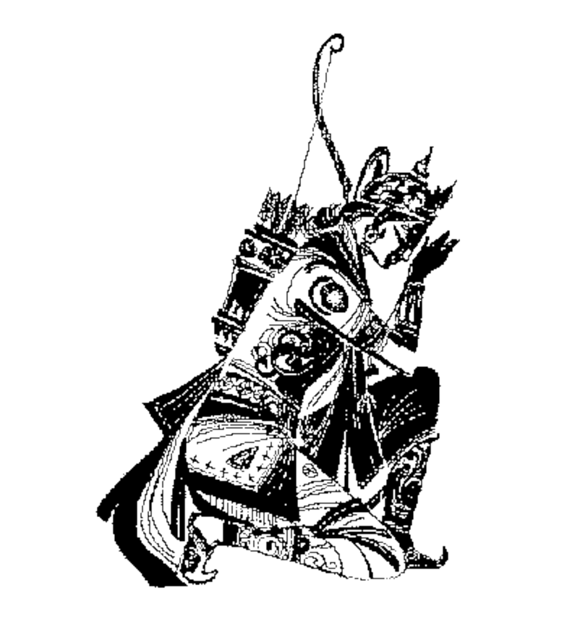

HP Bluestone Total-e-Transactions 2.2.2

Differences between 2.2.2 and 2.2

Copyright Notice:
Copyright 1998, 1999, 2000, 2001, 2002, by Hewlett Packard Corporation.
All rights reserved.
This document contains information which is protected by copyright. All Rights Reserved. Except as otherwise provided herein, no part of this work may be reproduced or used in any form or by any means-graphic, electronic, or mechanical, including photocopying, recording, taping, or information storage and retrieval systems without the permission of one of the copyright owners. All copies of this document must include the copyright and other information contained on this page.
Arjuna is a registered trademark in the UK and the US. All other products and company names listed herein may be trademarks of their respective companies.

Changes

JDK support
This version of TeT supports JDK 1.3.1_01.

Orb support
This version of Total-e-Transactions no longer supports Orbix 2000. The only ORB currently supported is HP-ORB 1.2. Support for Orbix 2000 is expected to return in a later release.
Note: this version of TeT does not support failure recovery for HP-ORB. As a result, the recovery daemon should not be run in either stand-alone or the HP-AS embedded mode.

JDBC driver support
Support for native transactional Cloudscape and Merant Sequelink has been dropped in this release. All JDBC drivers that are to be transactionally accessed must be provided via JNDI, i.e., all dynamic class capabilities have been removed.
Note, the Oracle 8.1.6/8.1.7 thin driver does not support the setting of serialisability on connections and as a result non-serialisable operations may be possible.

