JavaTM 2 Enterprise Edition

XML API for JavaTM Transactions

JSR 156

Specification Lead:
Mark Little

Technical comments:

Version 0.6
Expert Group Draft
Trademarks
Java, J2EE, Enterprise JavaBeans, JDBC, Java Naming and Directory Interface are trade-marks or registered trademarks of Sun Microsystems, Inc. in the U.S. and other countries.
Table of Contents
1. Introduction 4
1.1 Scope 5
1.2 Target Audience 5
1.3 Organization 5
1.4 Document Convention 6
1.5 J2EE XML Transactions API Expert Group 6
1.6 Acknowledgements 8
2. Overview 10
2.1 Web services transactions integration with J2EE 10
2.2 Pluggable transaction support 13
3. JAXTX architecture 16
3.1 The components and their roles 17
3.1.1 The XML context 17
3.1.2 The Container 18
3.1.3 The participant 18
3.1.4 The coordinator 18
3.2 The models and interfaces 19
3.2.1 The ACID transaction (AT) model 19
3.2.2 The Compensation Transaction (CT) model 21
4. JAXTX components 25
4.1 Atomic Transactions 25
4.1.1 Compensation Transactions (CTs) 25
5. References 30

Introduction
This document describes the system design and interfaces for XML based transactions. JAXTX is the realization, within the J2EE programming model, of work that has been conducted in various commercial, academic, and standards organizations into enabling Web Services with the critical transactional capabilities that they need.
An increasingly large number of distributed applications are constructed by being composed from existing applications. The resulting applications can be very complex in structure, with complex relationships between their constituent applications. Furthermore, the execution of such an application may take a long time to complete, and may contain long periods of inactivity, often due to the constituent applications requiring user interactions. In a loosely coupled environment like the Web, it is inevitable that long running applications will require support for fault-tolerance, because machines may fail or services may be moved or withdrawn. A common technique for fault-tolerance is through the use of atomic transactions, which have the well know ACID properties, operating on persistent (long-lived) objects. Transactions ensure that only consistent state changes take place despite concurrent access and failures.
Traditional transaction processing systems are sufficient if an application function can be represented as a single top-level transaction. Frequently this is not the case. Top-level transactions are most suitably viewed as “short-lived” entities, performing stable state changes to the system; they are less well suited for structuring “long-lived” application functions .Long-lived top-level transactions may reduce the concurrency in the system to an unacceptable level by holding on to resources (e.g., locks) for a long time; further, if such a transaction aborts, much valuable work already performed could be undone.
As has been shown elsewhere [1] there are a number of transaction models, each suited to different types of applications and services. Implementations of Web Services transactions already exist, e.g., Web Services Transactions (WS-T) [2], Web Services Transaction Management[4], or the OASIS Business Transactions Protocol (BTP) [3] and provide solutions for the specific problem domains. Other models will undoubtedly be developed to solve different application requirements. In addition, although ACID transactions may not be the solution for all transactional Web Service applications, it is likely that some applications will continue to require strict ACID semantics. Therefore, existing implementations of JTA/JTS may well require a Web Services persona.
Although at this time there is no accepted standard for Web services transactions, there is commonality between the various specifications. By concentrating solely on the relationship to J2EE, the purpose of JAXTX is to define a specific set of APIs that allows implementations based on the different Web Services transactions specifications to be plugged in.
JAXTX interfaces do not imply a specific implementation for the underlying transaction system to which they talk. It is the purpose of this specification to enable existing XML-based transaction implementations to be integrated with JAXTX without requiring them to be modified.
Note, in the rest of this document we shall use the term ACID transaction to refer to traditional transaction functionality as presented by, for example, the Java Transaction API (JTA). The term extended transaction, shall refer to models that give different functionality to ACID transactions, for example by relaxing various aspects of the ACID properties.

Scope
This document and related javadoc describes the architecture, functionality and interfaces that must be provided by an implementation of JAXTX in order to support XML transactions.
Specific implementations of transaction services (e.g., based on JTA, WS-TXM, WS-T or BTP) will be able to use the interfaces defined by JAXTX to provide a uniform and standard API for integration with the J2EE environment.

Target Audience
The target audience of this specification includes:
- Implementers of transaction services (e.g., JTA or WS-TXM) who wish to make their components available as Web services to J2EE containers and users.
- Implementers of application servers and EJB containers.
- Implementers of Web services that require some level of transactionality.

Organization
This document describes the architecture of JAXTX with its components and roles described.
Specific interfaces are described in general terms in this document and in more detail in the accompanying javadoc package.

Document Convention
A regular Times New Roman font is used for describing the architecture.
A regular Courier font is used when referencing Java interfaces and methods on those interfaces.

J2EE XML Transactions API Expert Group
The expert group consists of the following members:
Mark Little, mark.little@arjuna.com
Arjuna Technologies Ltd,
Centre for Nanotechnology,
Herschel Building,
Newcastle upon Tyne,
NE1 7RU,
England
Michael Abbot, mike@compositesw.com
15 Berenda Way Suite 300,
Portola Valley, CA 94028,
USA
Gary Tully, gary.tully@iona.com
IONA Technologies,
Shelbourne Road
Ballsbridge
Dublin 4,
Ireland
Benjamin Cotton, Ben.D.Cotton@jpmorgan.com
Individual member,
343 Thornall Street
7th Floor ECommerce
JPMorgan Chase
Edison, NJ 08837
Keith Evans, keith.b.evans@hp.com
Hewlett-Packard/Compaq Computer Corporation,
CAC16-01, Room 162100,
10100 North Tantau Avenue,
Cupertino, CA 95014,
USA
Peter Furniss, peter.furniss@choreology.com
Choreology Ltd,
13 Austin Friars,
London, EC2N 2JX,
UK
Madhav Inamati, madhav.inamti@microfocus.com
Micro Focus Ltd,
1001, W. Maude Ave.
Sunnyvale, CA 94085,
USA
Sanjay Patil, sanjay.patil@sap.com
SAP AG
3475 Deer Creek Rd,
Palo Alto, CA 94304,
USA
Greg Pavlik, greg.pavlik@oracle.com
Oracle,
500 Oracle Parkway,
MS 4op9,
Redwood Shores, 94065,
USA
Bill Pope, zpope@pobox.com
PO Box 6698,
Portsmouth NH 03801,
USA
Ian Robinson, ian_robinson@uk.ibm.com
International Business Machines,
IBM Hursley Lab,
Hursley,
Winchester,
Hant, SO21 2JN,
UK
Peter Walker, Peter.Walker@sun.com
Sun Microsystems, Inc.
901 San Antonio Road
MS USCA14-303
Palo Alto, CA 94303

Acknowledgements

Overview
Transaction processing is at the core of commerce. All businesses have the concept of a transaction, but realize the concept using various architectures. Some transactions are very simple, such as purchasing a book or transferring funds, and can be processed immediately. Other transactions are more complex, such as fulfilling a purchase order or completing an insurance claim, and may take days or even years to process. Transaction processing forms the core of enterprise information systems and often drives the business. Once developed and proven, successful TP systems stay in place for decades.
The concepts of atomic transactions have played a cornerstone role in creating today’s enterprise application environments by providing guaranteed consistent outcome in complex multiparty business operations and a useful separation of concerns in applications. While numerous multiparty business applications involve various patterns based on atomic transactions in order to solve non-trivial business problems, it was not until recently the word “business transactions” accumulated any concrete meaning. Rapid developments in Internet infrastructure and protocols have yielded a new type of application interoperation concept that makes concepts which could only previously be considered in an abstract form an implementation reality. The effects of such changes have been felt most strongly in business environments, fuelling the mindset for a transition from traditional atomic transactions to extended transaction models better suited for Internet interoperation.
Most business-to-business applications require transactional support in order to guarantee consistent outcome and correct execution. These applications often involve long running computations, loosely coupled systems and components that do not share data, location, or administration and it is thus difficult to incorporate traditional ACID transactions within such architectures. For example, an airline reservation system may reserve a seat on a flight for an individual for a specific period of time, but if the individual does not confirm the seat within that period it will be unreserved.
Atomic transactions are a well-known technique for guaranteeing consistency in the presence of failures. The ACID properties of atomic transactions (Atomicity, Consistency, Isolation and Durability) ensure that even in complex business applications consistency of state is preserved, despite concurrent accesses and failures. This is an extremely useful fault-tolerance technique, especially when multiple, possibly remote, resources are involved.

Web services transactions integration with J2EE
As Web Services have evolved as a means to integrate processes and applications both inside and outside the firewall, and as Web technologies have become firmly established and widely adopted, traditional transaction semantics and protocols have proven to be inappropriate for some Web services-based applications and services. These particular Web services-based transactions differ from traditional transactions in that they execute over long periods, they require commitments to the transaction to be “negotiated” at runtime, and isolation levels have to be relaxed.
Structuring certain activities from long-running transactions can reduce the amount of concurrency within an application or (in the event of failures) require work to be performed again. For example, there are certain classes of application where it is known that resources acquired within a transaction can be released “early”, rather than having to wait until the transaction terminates; in the event of the transaction rolling back, however, certain compensation activities may be necessary to restore the system to a consistent state. Such compensation activities (which may perform forward or backward recovery) will typically be application specific, may not be necessary at all, or may be more efficiently dealt with by the application.
There are currently three different Web Services transactions specifications:
- Web Services Transaction Management (WS-TXM): this is one of the specifications that forms part of the OASIS Web Services Composite Application Framework. It defines three transaction protocols, including ACID and compensation based, each intended for a specific use case [4].
- Web Services transactions (WS-T) protocol: the WS-T protocol defines two transaction models – atomic transactions, which are the traditional ACID transaction model to be used for short-duration tasks, and business activities, which are for long-duration tasks and allow operations to complete in their entirety and yet be undone (compensated for) later [2].
- Business transaction protocol: the OASIS Business Transaction Protocol (BTP) introduced the notion of an open-top two-phase termination protocol [3]. Work is conducted within the scope of atoms, which are similar to atomic transactions and have the same all-or-nothing guarantees. However, the outcome of atoms can be controlled by cohesions which allow their selective confirmation or cancellation by explicitly driving the two-phase protocol over a period of hours, days etc.
Despite the number of different specifications, they all share a common architecture illustrated in Figure 1, which JAXTX will also adopt:
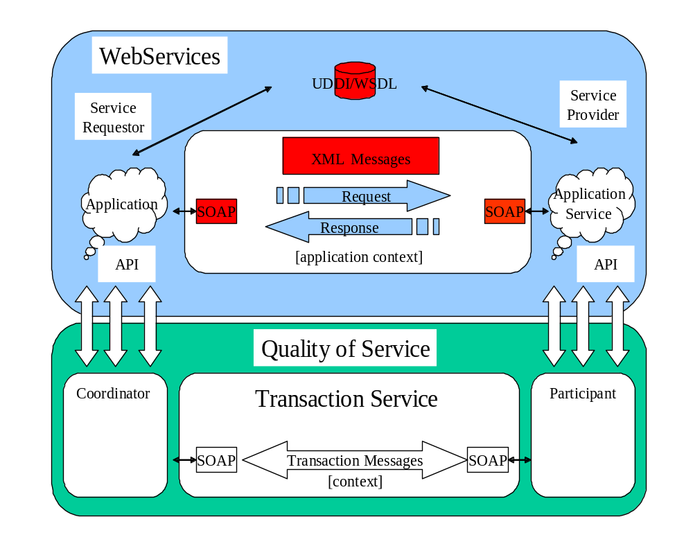
Figure 1: Web Services, transactions and contexts.
- A Transaction Service: Defines the behavior for a specific transaction model. The Transaction Service provides a processing pattern (implemented by the transaction coordinator) that is used for outcome processing. For example, an ACID transaction service is one implementation that provides a two-phase protocol definition whose coordination sequence processing includes prepare, commit and rollback. Multiple Transaction Service implementations may co-exist within the same application and processing domain. JAXTX does not specify how a Transaction Service is implemented: one service may be tied to a specific protocol, or the service could support multiple different protocols as in [1].
- A Participant: The operation or operations that are performed as part of transaction coordination sequence processing.
- The Context: this contains information necessary for distributed services to use the transaction service.
Web Services are language independent and therefore none of the specifications define an API for transaction demarcation, recovery or participant registration. Therefore it is the aim of this specification to provide the J2EE API for these specifications. JAXTX allows a user (client or service) to:
- Define demarcation points that specify the start and end points of transactional activities.
- Register participants for the activities that are associated with the application.
- Propagate transaction-specific information across the network.
Note, this specification is not meant to place additional requirements on existing Web services transactions specifications. What JAXTX does accomplish is to allow these implementations to be plugged into a common services architecture.
It is possible that other transaction models will be required for different problem domains. However, in the J2EE environment the types of transaction model that are applicable are limited (we shall examine them in the next section) and fortunately all of the specifications define compatible protocols.

Pluggable transaction support
There are currently two types of transaction protocol that make sense within a Web services enabled J2EE environment:
- ACID transactions: this model is meant to map to existing transaction standards which have a well defined behavior for atomicity (well-formed and two-phase), isolation (no dirty reads, repeatable reads) and durability (no lost data), i.e., traditional ACID semantics. Web services are for interoperability in closely coupled environments such as corporate intranets as much as they are for the Web. Interoperability between heterogeneous transaction service implementations is a requirement and yet has been difficult to achieve in practice. Traditional transaction systems already form the backbone of enterprise level applications and will continue to do so for the Web Services equivalent. Business-to-business activities will typically involve back-end transaction processing systems either directly or indirectly and being able to tie together these environments will be the key to the successful take-up of Web Services transactions. Finally, the ACID transactions model is useful if only for intra-domain environments where a customer needs to consolidate operations across any number of internal applications. For example, a merger may have resulted in the need to combine the apps of the old and new business.
- Forward compensation based transactions: most business-to-business applications require transactional support in order to guarantee consistent outcome and correct execution. These applications often involve long running computations, loosely coupled systems and components that do not share data, location, or administration and it is difficult to incorporate atomic transactions within such architectures. This model is designed specifically for these kinds of long-duration interactions, where exclusively locking resources is impossible or impractical. With this model, all work performed within the scope of an application should be compensatable such that an application’s work is either performed successfully or undone. However, how individual Web services perform their work and ensure it can be undone if compensation is required, is an implementation choice. The model simply defines the triggers for compensation actions and the conditions under which those triggers are executed. Services are requested to do work, and where those services have the ability to undo any work, they inform the coordinator such that if it later decides to cancel the work, it can instruct the service to execute its undo behavior. While the full ACID semantics are not maintained in this model, consistency can still be maintained through compensation, though the task of writing correct compensating actions (and thus overall system consistency) is delegated to the developers of the services under control of the this model. Such compensations may use backward error recovery, but will typically employ forward recovery.
All of the existing specifications for Web services transactions either define corresponding models or have protocols than can be used to support these models. Furthermore, any further Web services transaction specifications are likely to provide protocols with sufficient similarity to support these models in J2EE.
Therefore, what we want to achieve with JAXTX is to present all of the specifications to the J2EE developer in a manner that neither restricts the implementations nor exposes them to the application. We shall accomplish this through an appropriate API. The relationship between the API and the underlying Web services transaction protocol (and associated implementation) is similar to that which exists between the JTA and the underlying transaction service implementation, and is shown in Figure 2. The Application, Application Server and Participants all have different views (APIs) onto the Transaction Manager implementation.
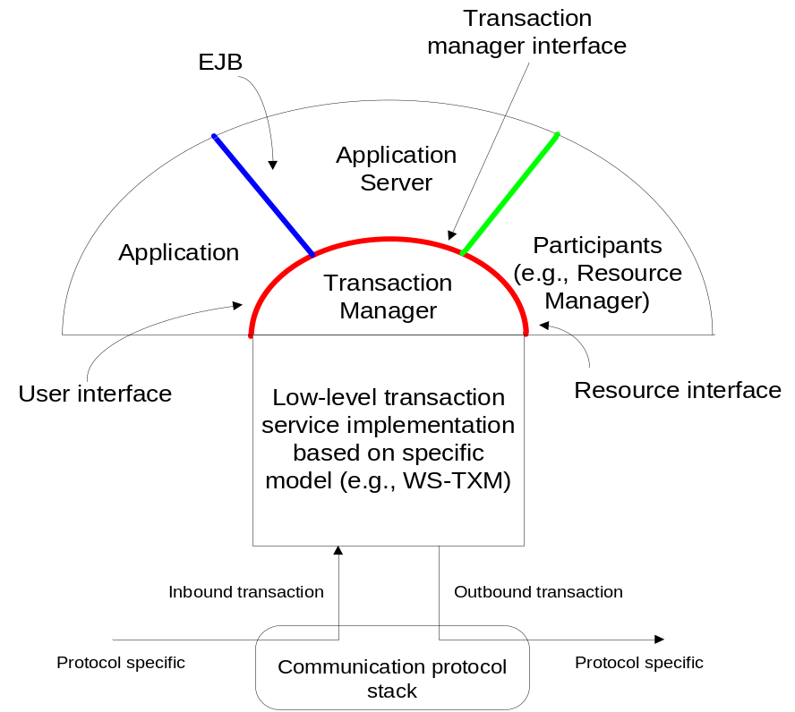
Figure 2: Relationship between JAXTX APIs and transaction service.
Definitions of interoperability characteristics between different transaction models and even between different implementations of the same model are outside the scope of this specification. It may be defined within the respective specifications or may need to be negotiated between the client and application server.

JAXTX architecture
A transaction is a unit of (distributed) work, involving one or more parties (services, components, objects). A transaction is created, made to run, and then completed. An outcome is the result of a completed transaction and this can be used to determine subsequent flow of control to other transactions. Transactions may run over long periods of time (minutes, hours, days, etc.) and can thus be suspended and then resumed later.
A very high level view of the role of JAXTX within a Web Services application is shown in Figure 3. In keeping with the J2EE model, JAXTX divides responsibilities between application component providers who focus on writing the business logic, and product providers, who focus on providing a managed system infrastructure in which the application components are deployed.
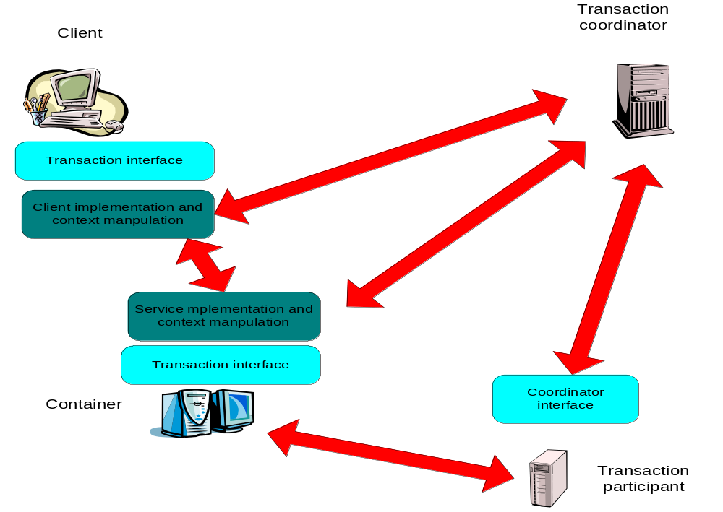
Figure 3: Applications and implementation components.
The transaction coordination service is responsible for managing transactions created by the client or container. Work done by the client may be executed under the scope of a transaction such that the coordinator will ultimately ensure that the work is performed in some manner consistent with the underlying transaction model (e.g., that it either happens or does not happen despite failures).
When a client performs an invocation on a transactional service (e.g., provided by an enterprise bean), the infrastructure in which the client is located must flow the context to the container. The container (or entities it interacts with, e.g., a JDBC driver) is then responsible for ensuring that the work is performed in such a way that any final decision on the outcome is controlled by the transaction coordinator. This normally occurs by enlisting a participant in the transaction that has control over the work, e.g., a XAResource that can issue prepare, commit or rollback on an underlying database when instructed to by the coordinator. In the figure, this participant is shown as a separate service, but will typically be located within the same container as the Web Service.
The implementations of the actual transaction protocols, including the rules governing context manipulation are provided by the other specifications that JAXTX supports. For example, WS-T defines precisely how the transaction context appears in transmitted XML documents, how coordinator specific messages are formatted, how participants behave under certain failure circumstances etc. However, since Web services specifications are language neutral they do not specify the language interfaces to these components. JAXTX provides a uniform set of interfaces for Java that are intended to indirect to the underlying implementations.

The components and their roles
Before describing the interfaces which JAXTX provides, we shall first examine the components within the JAXTX architecture.

The XML context
In order for a transaction to span a distributed number of containers/tasks, certain information has to flow between the sites/domains involved in the application. This is commonly referred to as the context and typically contains the following information:
The context typically includes the following information:
- A transaction identifier which guarantees global uniqueness for an individual activity (such an identifier can also be thought of as a “correlation” identifier or a value that is used to indicate that a task is part of the same work activity).
- The transaction coordinator location or endpoint address so participants can be enrolled.
The context information is propagated to provide a flow of context information between distributed execution environments, for example using SOAP header information. This may occur transparently to the client and application services. The context may be propagated as part of normal message interchange within an application (e.g., as an additional part of the SOAP header) or may be sent as an explicit “out-of-band” context message, e.g., where the content of the message contains the context and a handle to link it to specific application messages which will be sent separately.
Because JAXTX is concerned with defining a set of APIs for existing Web services transactions specifications, it is assumed that the exact definition of the context will already be provided by those specifications. Therefore, although JAXTX does define an interface to a context, it does not define the structure of the context.

The Container
The container hosts the Web service, e.g., the taxi booking service. Whenever a client contacts a service whose work it wishes to be under the control of a transaction, components of the transaction system are responsible for sending the context to that service. The service can then use this information to enlist a participant with the transaction.

The participant
The participant is the entity that is coordinated by the transaction service to ultimately control the work performed within the scope of the transaction. The Web service contains some business logic, but it will need to be supported by something that maintains information in a durable manner, e.g., a database. Although the service may talk to the database directly, it cannot commit or roll back any changes it makes, since these are ultimately under the control of the transaction coordinator. In order for the coordinator to be able to exercise this control, it must have some contact with the back-end resource and this is accomplished by the participant.

The coordinator
Associated with every transaction is a coordinator, which is responsible for governing the outcome of the transaction. The coordinator may be implemented as a separate service within the container or may be co-located with the user. It communicates with enlisted participants to inform them of the desired termination requirements. This communication will be an implementation specific protocol (e.g., two or three phase completion).
A transaction manager is typically responsible for managing coordinators for many transactions. The initiator of the transaction (e.g., the client) communicates with a transaction manager and asks it to start a new transaction and associate a coordinator with the transaction.

The models and interfaces
As we saw earlier, the JAXTX specification supports two transaction models for the J2EE environment:
- ACID transactions: this model is defined to allow heterogeneous ACID transaction systems to work together in a distributed environment. In J2EE this will take the form of JTA-to-JTA interoperability.
- Forward compensation transactions: this model defines a compensation transaction approach. This model is designed specifically for long-duration interactions where holding on to resources is impossible or impractical. Services are therefore required to be able to compensate for work that may have actually been performed in the scope of a compensation transaction. How services do their work and provide compensation mechanisms is not the domain of JAXTX.
In the following sections we shall examine these models in detail.

The ACID transaction (AT) model
A very simple consistency requirement is that of failure atomicity: the application either terminates normally, producing the intended results, or is aborted, producing no results at all. This failure atomicity property is supported by the AT model, which has the following familiar ACID properties:
- Atomicity: The transaction completes successfully (commits) or if it fails (aborts) all of its effects are undone (rolled back); a two-phase commit protocol is used to achieve consensus;
- Consistency: Transactions produce consistent results and preserve application specific invariants;
- Isolation: Intermediate states produced while a transaction is executing are not visible to other transactions. Furthermore transactions appear to execute serially, even if they are actually executed concurrently. This is typically achieved by locking resources for the duration of the transaction so that they cannot be acquired in a conflicting manner by another transaction;
- Durability: The effects of a committed transaction are never lost (except by a catastrophic failure).
A transaction can be terminated in two ways: committed or aborted (rolled back). When a transaction is committed, all changes made within it are made durable (forced on to stable storage such as disk). When a transaction is aborted, all changes made during the lifetime of the transaction are undone. In addition it is possible to nest atomic transactions; where the effects of a nested action are provisional upon the commit/abort of the outermost (top-level) atomic transaction.
It is assumed that all services (and associated participants) provide ACID semantics and that any use of atomic transactions occurs in environments and situations where this is appropriate: in a trusted domain, over short durations.
There are several variants to the standard two-phase commit protocol that can have significant impact on performance and failure recovery. The AT model assumes the following optimizations are implemented by the underlying transaction service:
- Presumed abort: the transaction log does not needs to be written by the coordinator until it has decided to commit; any failure prior to this point will be assumed (by participants and the recovery subsystem) to be an abort of the transaction.
- One-phase: if there is only a single participant involved in the transaction, the coordinator need not drive it through two-phase commit. The participant will simply be told to commit and (in some variants) the transaction coordinator need not record information about the decision since the outcome of the transaction is solely down to the participant.
- Read-only: when a participant is asked to prepare, it can indicate to the coordinator that it is not responsible for any modified state. Such a read-only participant and is not informed about the outcome of the transaction since the fate of the participant has no affect on the transaction.
Most transaction processing systems admit the possibility of heuristic outcomes: participants that have got past the prepare phase are allowed to make autonomous decisions as to whether they commit or rollback, for example in the event that the coordinator fails. Such a participant must record this decision in case it is eventually contacted to complete the original transaction. If the transaction outcome matches the choice the participant made, then there is no problem. However, if it is contrary, then a heuristic outcome has occurred. The AT model allows (though does not require) heuristic outcomes.
The possible heuristic outcomes are:
- Heuristic rollback: the commit operation failed because some or all of the participants unilaterally rolled back the transaction.
- Heuristic commit: an attempted rollback operation failed because all of the participants unilaterally committed. This may happen if, for example, the coordinator was able to successfully prepare the transaction but then decided to roll it back (e.g., it could not update its log) but in the meanwhile the participants decided to commit.
- Heuristic mixed: some updates (participants) were committed while others were rolled back
- Heuristic hazard: the disposition of some of the updates is unknown. For those which are known, they have either all been committed or all rolled back
In addition to the traditional two-phase commit protocol, the AT model also assumes the existence of a synchronization protocol. Synchronizations are informed that a transaction is about to commit, so they can, for example, flush volatile (cached) state, which may be being used to improve performance of an application, to a recoverable object or database prior to the transaction committing. They are then informed when the transaction has completed and in what state it completed.
Synchronizations essentially turn the two-phase commit protocol into a four-phase protocol:
- Before the transaction starts the two-phase commit, all registered Synchronizations are informed. What they do will obviously depend upon the specific implementation, but as we’ve seen, typically an implementation will flush a cached copy of some transactional object state to a database or other repository where its ultimate fate will be controlled by a participant in the two-phase commit protocol. Any failure at this point (the Synchronization fails to flush the state, for example) will cause the transaction to roll back.
- The coordinator then conducts the normal two-phase commit protocol. This protocol does not involve the Synchronizations.
- Once the transaction coordinator has finished the two-phase commit protocol (has terminated), all registered Synchronizations are informed. However, this is a courtesy invocation because any failures at this stage are ignored: the transaction has terminated so there’s nothing to affect.
Systems that conform to the Java Transaction API (JTA) or Java Transaction Service (JTS) specifications are examples of possible implementations of the AT model.

The Compensation Transaction (CT) model
The CT protocol is designed for those business interactions (business activities) that are long in duration. A business activity may be partitioned into scopes, where a scope is a business task or unit of work using a collection of Web services. Such scopes may be nested, forming parent and child relationships, where a parent scope has the ability to select which child tasks are to be included in the overall outcome protocol for a specific business activity and so clearly non-atomic outcomes are possible. In a similar manner to traditional nested transactions, if a child task experiences an error, it can be caught by the parent who may be able to compensate and continue processing.
Within this model, all work performed within the scope of a CT should be compensatable. Therefore, a service’s work is either performed successfully or undone. How individual Web Services perform their work and ensure it can be undone if compensation is required, is an implementation choice. The CT model simply defines the triggers for compensation actions and the conditions under which those triggers are executed.
As with most transaction models, the CT model is concerned only with ensuring participants obey the protocol necessary to make an activity compensatable; semantics of the business interactions are not part of CT model. Issues such as isolation of services between potentially conflicting activities and durability of service work are assumed to be implementation decisions. The coordination protocol used to ensure an activity is completed successfully or compensated is not two-phase and is intended to better model business-to-business interactions. Although this may result in non-atomic behavior for the overall business activity, other activities may be started by the application or service to attempt to compensate in some other manner.
The CT model defines a protocol actor called a Compensating Participant (Compensator) that operates on behalf of a service to undo or terminate the work it performs within the scope of a CT. When a service performs work that may have to be later compensated within the scope of a CT, it enlists a Compensator with the transaction coordinator. The service may delist this participant at any time prior to the completion of the CT if it decides that the work cannot or need not be compensated, or that it no longer wishes to be involved in the activity.
The CT will terminate in either a success or failure state, which will have the following effect on any registered participants:
- Success: the activity has completed successfully. If the activity is nested then participants may have to be propagated to the enclosing CT.
- Fail: the activity has completed unsuccessfully. All participants that are registered with the CT will be invoked. Depending upon the state of the business service on whose behalf the participant works, this may require the participant to execute some compensation activity or simply to cancel the current business activity.
A task within a CT can specify its outcome to the coordinator directly without waiting for an explicit request. This feature is useful when tasks fail such that the notification can be used by business activity exception handler to modify the goals and drive processing forward without having to wait until the end of the transaction to admit to having failed.
In the CT model, each activity is bound to the scope of a compensation interaction. For example, when a user reserves a seat on a flight, the airline reservation centre may take an optimistic approach and actually book the seat and debit the users account, relying on the fact that most of their customers who reserve seats later book them; the compensation action for this activity would obviously be to un-book the seat and credit the user’s account. Work performed within the scope of a nested CT must remain compensatable until an enclosing activity informs the service(s) that it is no longer required.
As in any business interaction, application services may or may not be compensatable. Even the ability to compensate may be a transient capability of a service. Each service is required to log sufficient information in order to ensure (with best effort) that compensation is possible. Individual compensators may be subordinate coordinators to improve performance or to federate a distributed environment into separate domains.
Each compensator or subordinate coordinator is responsible for ensuring that sufficient data is made durable in order to undo the CT in the event of failures. Interposition and check pointing of state allow the system to drive a consistent view of the outcome and recovery actions taken, but allowing always the possibility that recovery isn’t possible and must be logged or flagged for the administrator. In a large scale environment or in the presence of long term failures, recovery may not be automatic. As such, manual intervention may be necessary to restore an application’s consistency.

JAXTX components
The features provided by JAXTX to support the plugging of different transaction implementations within the architecture. More information can be found in the associated javadoc.
In the following sections we shall examine how specific transaction models may be mapped into a JAXTX environment. These models may define new client-side interfaces and service-side interfaces.

Atomic Transactions
In J2EE is makes sense to map the Atomic Transaction model from Web Services onto the JTA. As such, the interfaces defined in the JTA specification and that appear in the javax.transaction package are assumed to be available to Web Services developers who wish to make use of this model. In the diagram on page 8 of the JTA specification, it is envisioned that a Web Services transaction implementation supporting the Atomic Transaction protocol would simply fit below the JTA interface line. This means that no additional interfaces are required by J2EE providers.
The following mapping between JAXTX components (illustrated in Figure 3) and JTA interfaces is assumed:
JAXTX component | JTA interface
Application (client) API | javax.transaction.UserTransaction
Container API | javax.transaction.TransactionManager
Coordinator API (for participant registration) | javax.transaction.TransactionManager
Participant interface | javax.transaction.XAResource

Compensation Transactions (CTs)
The compensation transaction interfaces and classes occur within the javax.jaxtx.compensation package.
Compensation transactions for Web Services may be utilized within the scope of workflow systems, such as those based on the Web Services Business Process Execution Language [6]. These implementations will have their own demarcation APIs for compensation scopes. Therefore, although JAXTX defines its own demarcation APIs, they are not mandated for a conformant implementation.

UserCompensationTransaction
The UserCompensationTransaction interface provides applications with the ability to demarcate transactions programmatically. The interface may be used by client programs or EJBs.
The UserCompensationTransaction is obtained via JNDI lookup of java:comp/UserCompensationTransaction. UserCompensationTransaction does not represent a specific transaction, but rather is responsible for providing access to an implicit per-thread transaction context. Therefore, all of the UserCompensationTransaction methods implicitly act on the current thread of control.
The UserCompensationTransaction.begin method starts a new transaction and associates it with the invoking thread. The thread-to-transaction association is managed transparently by the implementation. Support for nested transactions is not required and in which case the NotSupportedException will be thrown by the implementation if the calling thread is already associated with a transaction.
The transaction may terminate in one of the following ways:
- confirm: using the UserCompensationTransaction.confirm method, the transaction informs the participants that they should make permanent any changes that occurred within the scope of this transaction.
- cancel: using the UserCompensationTransaction.cancel method, the transaction informs the participants that they should make undo any changes that occurred within the scope of this transaction.
In the event of a failure to be able to complete the operation, an appropriate exception will be thrown to indicate the reason for the failure. Both methods implicitly disassociate the terminated transaction from the calling thread.
An application may wish to inform participants that it will not be requesting them to do further work within the transaction. It does this by using the UserCompensationTransaction.complete method.
The status of the transaction can be obtained from the UserCompensationTransaction.status method. This will be one of the values from the javax.jaxtx.compensation.Status class.
Each transaction may have a timeout value associated with it, such that if the transaction has not begun to terminate before this timeout elapses, the underlying service implementation will automatically roll it back. The timeout value is set on a per invoking thread basis via the UserCompensationTransaction.setTimeout method. A value of 0 means that no application specific timeout should be used and this may be interpreted in an implementation specific manner.
The timeout associated with the invoking thread can be obtained from the UserCompensationTransaction.getTimeout method. This need not be the timeout currently associated with any active transactions.

CompensationTransactionManager
The javax.jaxtx.CompensationTransactionManager interface allows the container to control transaction boundaries on behalf of the application being managed. The container uses the CompensationTransactionManager interface to demarcate transaction boundaries where operations affect the calling thread transaction context.
The CompensationTransactionManager is obtained via JNDI lookup of java:comp/CompensationTransactionManager. CompensationTransactionManager does not represent a specific transaction, but rather is responsible for providing access to an implicit per-thread transaction context. Therefore, all of the CompensationTransactionManager methods implicitly act on the current thread of control.
The implementation maintains the transaction context associated with threads as part of an internal data structure. A thread-to-transaction association may either be null or it refers to a specific transaction. Multiple threads may be associated with the same transaction concurrently. Support for nested transactions is allowed but is not required.
Each transaction context is encapsulated by a javax.jaxtx.compensation.CompensationTransaction object, which can be used to perform operations on the specific target transaction irrespective of the calling thread’s transaction association.
A transaction is started via the CompensationTransactionManager.begin method, which also associates the transaction context with the calling thread. If the implementation does not support nested transactions then the NotSupportedException will be thrown if the thread is already associated with a transaction.
CompensationTransactionManager.confirm completes the transaction currently associated with the calling thread. When the method returns, the transaction will no longer be associated with the thread. If confirm is called when the thread is not associated with a context then the NoTransactionException will be thrown.
CompensationTransactionManager.cancel completes the transaction currently associated with the calling thread. When the method returns, the transaction will no longer be associated with the thread. If cancel is called when the thread is not associated with a context then the NoTransactionException will be thrown.
An application may wish to inform participants that it will not be requesting them to do further work within the transaction. It does this by using the UserCompensationTransaction.complete method.
The CompensationTransactionManager.getTransaction method returns the CompensationTransaction object that represents the transaction currently associated with the calling thread, or null if there is no thread-to-transaction association.
The thread-to-transaction association may be temporarily suspended through the CompensationTransactionManager.suspend method. If the thread is not associated with any transaction then null is returned, otherwise a valid CompensationTransaction object is returned. The object can later be passed to the CompensationTransactionManager.resume method to reinstate the association. If resume is invoked when the calling thread is already associated with a transaction, then the IllegalStateException is thrown.
The status of the transaction can be obtained from the CompensationTransactionManager.status method. This will be one of the values from the javax.jaxtx.compensation.Status class.
Each transaction may have a timeout value associated with it, such that if the transaction has not begun to terminate before this timeout elapses, the underlying service implementation will automatically roll it back. The timeout value is set on a per invoking thread basis via the CompensationTransactionManager.setTimeout method. A value of 0 means that no application specific timeout should be used and this may be interpreted in an implementation specific manner.
The timeout associated with the invoking thread can be obtained from the CompensationTransactionManager.getTimeout method. This need not be the timeout currently associated with any active transactions.

CompensationTransaction
The CompensationTransaction interface allows operations to be performed on a specific transaction. Every transaction is associated with one CompensationTransaction object, which can be used to:
- Enlist compensation participants.
- Confirm, cancel or complete the transaction.
- Obtain the transaction status.
A compensation participant (an implementation of the javax.jaxtx.compensation.CompensationParticipant interface) can be enlisted with the transaction through the CompensationTransaction.enlistParticipant method. A javax.jaxtx.compensation.CompensationParticipantManager instance may be returned which can be used later by the participant or a separate failure recovery process acting on its behalf in the event of failures. In the event of failure, this object can be used to contact the transaction coordinator (or the failure recovery process acting on its behalf) to inform it that recovery may be necessary on behalf of this participant. The CompensationParticipantManager can also be used by the participant to inform the coordinator that it has exited the activity, or that it is finished its work and is awaiting the final outcome of the transaction.
The application may put the transaction in a state where the only possible outcome is for it to cancel through the CompensationTransaction.setUndoOnly method. If the transaction has already begun to terminate, then the WrongStateException will be thrown.
CompensationTransaction.confirm completes the transaction currently associated with the target object. The thread need not be associated with this transaction. When commit returns it does not change any thread-to-transaction association.
CompensationTransaction.cancel completes the transaction currently associated with the target object. The thread need not be associated with this transaction. When rollback returns it does not change any thread-to-transaction association.

References
[1] Additional Structuring Mechanisms for the OTS Specification - OMG document orbos/2001-11-08 (http://www.omg.org/cgi-bin/doc?orbos/2001-11-08).
[2] The Web Services Transactions specifications, IBM, Microsoft and BEA joint submission, http://msdn.microsoft.com/library/default.asp?url=/library/en-us/dnglobspec/html/wsat.asp and http://msdn.microsoft.com/library/default.asp?url=/library/en-us/dnglobspec/html/wsba.asp, 2004.
[3] OASIS BTP Committee Specification, http://www.oasis-open.org/committees/business-transactions/, April 2002.
[4] Web Services Transaction Management specification, part of the OASIS WS-CAF specifications, http://www.oasis-open.org/committees/documents.php?wg_abbrev=ws-caf, 2003.
[5] X/Open CAE Specification – Distributed Transaction Processing: The XA Specification, X/Open Document No. XO/CAE/91/300 or ISBN 1 872630 24 3.
[6] Web Services Business Process Execution Language, http://www.oasis-open.org/committees/tc_home.php?wg_abbrev=wsbpel

The original WS-T specification from IBM, Microsoft and BEA has been separated into two specifications, WS-AtomicTransaction and WS-BusinessActivity. However, for simplicity we shall continue to refer to the two models collectively as WS-T.

