Creating First Qt Form:
- Open the Qt Creator
- Click on the User Interface icon.
- Click on File->New File or Project->Qt Widgets Application/Qt GUI Application
- Click Choose.
- Give a name to your project. Select a workspace.
- Press Next->Next->Finish.
- Your first Qt project is created.
- Create a GUI as per the need.

- If you encounter No kits found error :
  - Click on the options link.
  - Select Build and Run.
  - Click on Desktop.
  - Change version from none to 4.8.5.
  - Restart Qt and create the Qt GUI Application Project.

Testing a small example

This example demonstrates to display window on screen using Qt.

We start with a very simple example.

#include <QApplication>
#include <QWidget>

int main(int argc, char *argv[])
{
QApplication app(argc, argv);

QWidget window;

window.resize(250, 150); //resize draws window with width and height
window.setWindowTitle("Simple example"); //add title on window
window.show(); //shows the window

return app.exec();
}
We will show a basic window on the screen.
#include <QApplication>
#include <QWidget>
We include necessary header files.

QApplication app(argc, argv);
This is the application object. Each application programmed in Qt4 must have this object. Except for console applications.
QWidget window;
This is our main widget.
window.resize(250, 150);
window.setWindowTitle("Simple example");
window.show();
Here we resize the widget. Set a title for our main window. In this case, the QWidget is our main window. And finally show the widget on the screen.
return app.exec();
We start the main loop of the application.

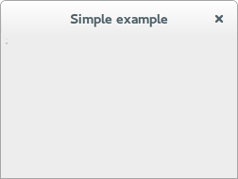

Figure: Simple example

This example demonstrates to display pixel on screen using qt

#include "mainwindow.h"
#include <QApplication>
#include<QtGui>
int main(int argc, char *argv[])
{
QApplication a(argc, argv);
MainWindow w;
QImage image(300, 300, QImage::Format_RGB888);
QRgb value;
value=qRgb(0,255,0); //set color of pixel as green
image.setPixel(50,50,value); //draws pixel with value
image.setPixel(150,150,qRgb(255,255,255)); //draws pixel in white color at x,y
//position.
QLabel l; //shows pixel on screen
l.setPixmap(QPixmap::fromImage(image));
l.show();

return a.exec();
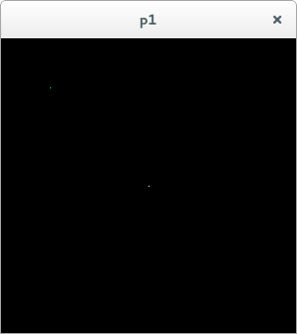
}

This example demonstrates to draw a line with pixel using qt
include the following lines in main.cpp

QImage image(300, 300, QImage::Format_RGB888);
QRgb value;
value=qRgb(0,255,0);
//draws a line using setPixel() function
for(int x=50;x<250;++x){
image.setPixel(x,100,value);
}
QLabel l;
l.setPixmap(QPixmap::fromImage(image));
l.show();

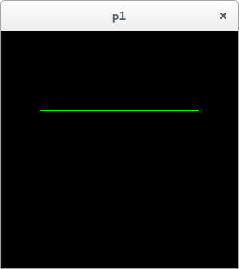

figure. Draws a line

