NM DarkSky Outdoor Lighting Demonstration Modules

As a part of NMDS education/outreach, Jim Price and Derek Wallentinsen have constructed four lighting modules. Here are members of the First Generation!
Glaring Light Blinds and Hides  Here our demo shows a very common jelly jar porch light and why it’s such a bad choice in terms of light trespass, glare and poor contrast lighting. | 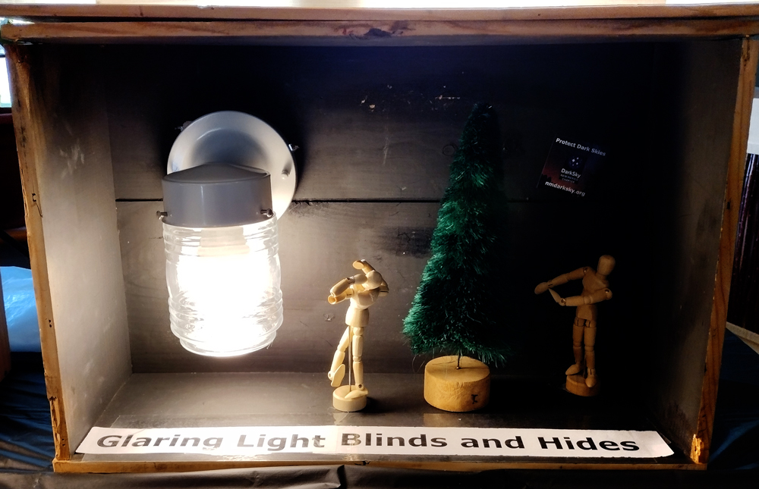
Color Matters  Color temperature and its closely related indexes like CRI and CCT matter both for light pollution and color perception. This module puts the same colors under a 2700K and 5000K lights to demonstrate differences. | 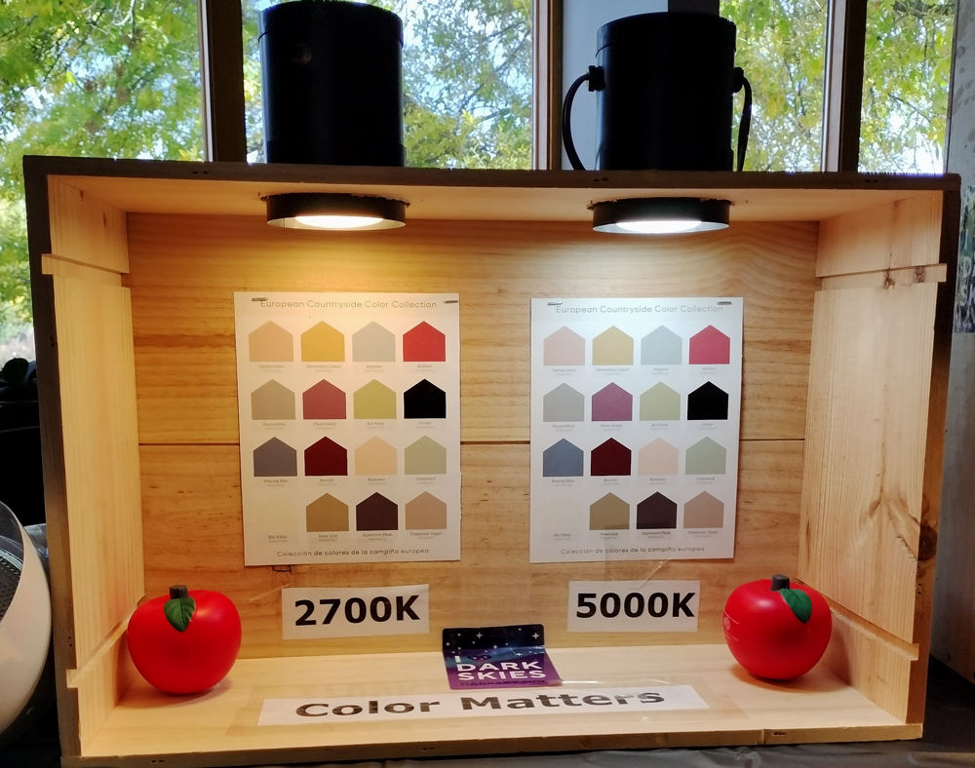
Great Lights = Fixture + Bulb  Even a night sky friendly fixture needs the appropriate bulb to truly be a responsible outdoor light. Combining an attractive shield with a recessed bulb does the great lighting trick! | 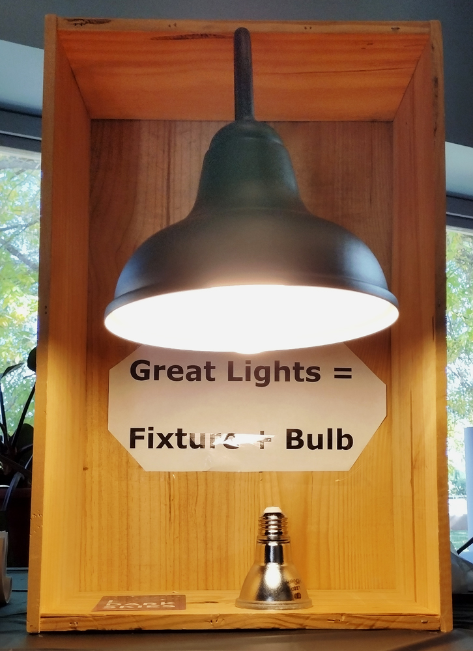
Motion Detectors: Sensible and Senseless  This demo literally highlights overly bright, overly blue night-sky unfriendly motion detecting lights that are widely sold and available from big box stores.  A three-source, 4000-lumens, 5000K monster that’s designed to show a bad light and talking points about what’s wrong with it. | 