Supplementary information:

Seasonal dynamics of ectomycorrhizal fungi are driven by shorter distance exploration types and deciduous host tree leaf habit associations

Structure below mirrors that of the original paper, as suggested by (**greenbaum2017?**). Statistical GAM output tables are organized and presented using the *‘flextable’* R package.

**Results**

## Abundance

### **Table S1**. Output showing generalized additive models (GAM) of quantitative soil fungal 18S rDNA amplification, subset by the total proportion of sequenced DNA reads matching to ectomycorrhizal fungal lifestyles in the FungalTraits database (**polme2020?**).

| qPCR result,   GAM with tweedie tw(theta = 1.9) distribution family | | | | | | |
| --- | --- | --- | --- | --- | --- | --- |
| Component | Term | Estimate | Std Error | t-value | p-value |  |
| A. parametric coefficients | (Intercept) | 10.019 | 0.054 | 187.144 | < 0.001 | *** |
| LeafHabitEvergreen | 2.272 | 0.132 | 17.154 | < 0.001 | *** |
| PLOT_G.sppQ. alba | 2.755 | 0.132 | 20.855 | < 0.001 | *** |
| PLOT_G.sppP. strobus | -0.019 | 0.218 | -0.085 | 0.932 |  |
| PLOT_G.sppC. ovata | 2.954 | 0.131 | 22.535 | < 0.001 | *** |
| PLOT_G.sppQ. bicolor | 2.038 | 0.133 | 15.381 | < 0.001 | *** |
| Component | Term | edf | Ref. df | F-value |  |  |
| B. smooth terms | s(WEEK) | 1.001 | 1.002 | 2.703 | 0.108 |  |
| s(WEEK):LeafHabitDeciduous | 0.001 | 6.000 | 595.249 | 0.048 | * |
| s(WEEK):LeafHabitEvergreen | 2.567 | 6.000 | 0.391 | 0.008 | ** |
| s(SUBPLOT) | 3.860 | 6.000 | 32.335 | < 0.001 | *** |
| t2(Moisture1_7d_avg,Temp1_7d_avg) | 3.001 | 3.001 | 1.182 | 0.318 |  |
| Signif. codes: 0 <= '***' < 0.001 < '**' < 0.01 < '*' < 0.05 | | | | | | |
|  | | | | | | |
| Adjusted R-squared: 0.0709, Deviance explained 0.156 | | | | | | |
| -REML : 4090.683, Scale est: 1.437, N: 269 | | | | | | |

## Diversity

### *Richness*

#### **Table S2**. Output showing the generalized additive model (GAM) of ectomycorrhizal species (ASV) richness, using week of year and host tree species leaf habit as main predictors.

| Diversity: Richness,   GAM with poisson distribution family | | | | | | |
| --- | --- | --- | --- | --- | --- | --- |
| Component | Term | Estimate | Std Error | t-value | p-value |  |
| A. parametric coefficients | (Intercept) | 3.301 | 0.017 | 190.332 | < 0.001 | *** |
| PLOT_G.sppQ. alba | -0.169 | 0.030 | -5.714 | < 0.001 | *** |
| PLOT_G.sppQ. bicolor | -0.093 | 0.029 | -3.230 | 0.001 | ** |
| PLOT_G.sppP. abies | -0.091 | 0.020 | -4.571 | < 0.001 | *** |
| PLOT_G.sppP. strobus | -0.230 | 0.020 | -11.365 | < 0.001 | *** |
| LeafHabitEvergreen | -0.321 | 0.018 | -17.812 | < 0.001 | *** |
| Component | Term | edf | Ref. df | F-value |  |  |
| B. smooth terms | s(WEEK) | 1.000 | 1.000 | 1.702 | 0.188 |  |
| s(WEEK):LeafHabitDeciduous | 3.339 | 6.000 | 2.478 | 0.019 | * |
| s(WEEK):LeafHabitEvergreen | 0.001 | 6.000 | 3,967.267 | 0.144 |  |
| t2(Temp1_7d_avg,Moisture1_7d_avg) | 5.157 | 5.661 | 14.489 | 0.032 | * |
| s(SUBPLOT) | 4.707 | 6.000 | 259.137 | < 0.001 | *** |
| Signif. codes: 0 <= '***' < 0.001 < '**' < 0.01 < '*' < 0.05 | | | | | | |
|  | | | | | | |
| Adjusted R-squared: 0.401, Deviance explained 0.456 | | | | | | |
| UBRE : 1.408, Scale est: 1.000, N: 268 | | | | | | |

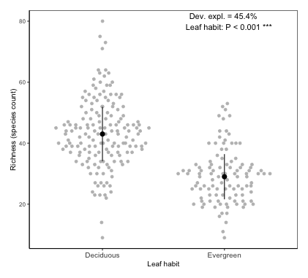

#### **Fig. S1.** Richness by tree leaf habit

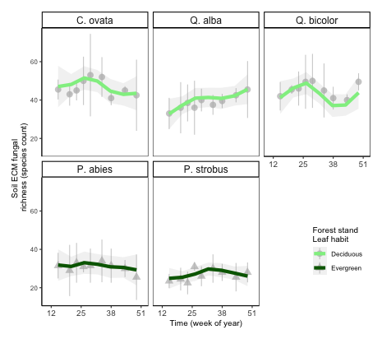

#### **Fig. S2**. Richness by tree stand

### *Entropy*

**Table S#**. Output showing the generalized additive model (GAM) of ectomycorrhizal species (ASV) diversity (Shannon entropy), using week of year and host tree species leaf habit as main predictors.

| Diversity: Richness,   GAMM with poisson distribution family | | | | | | |
| --- | --- | --- | --- | --- | --- | --- |
| Component | Term | Estimate | Std Error | t-value | p-value |  |
| A. parametric coefficients | (Intercept) | 0.698 | 0.022 | 31.203 | < 0.001 | *** |
| PLOT_G.sppQ. alba | 0.021 | 0.036 | 0.571 | 0.569 |  |
| PLOT_G.sppQ. bicolor | -0.015 | 0.036 | -0.403 | 0.687 |  |
| PLOT_G.sppP. abies | -0.100 | 0.024 | -4.195 | < 0.001 | *** |
| PLOT_G.sppP. strobus | -0.089 | 0.023 | -3.798 | < 0.001 | *** |
| LeafHabitEvergreen | -0.189 | 0.022 | -8.498 | < 0.001 | *** |
| Component | Term | edf | Ref. df | F-value |  |  |
| B. smooth terms | s(WEEK) | 1.000 | 1.000 | 0.256 | 0.613 |  |
| s(WEEK):LeafHabitDeciduous | 0.000 | 6.000 | 9.904 | 0.577 |  |
| s(WEEK):LeafHabitEvergreen | 0.001 | 6.000 | 5.448 | 0.576 |  |
| t2(Temp1_7d_avg,Moisture1_7d_avg) | 3.000 | 3.000 | 0.251 | 0.861 |  |
| s(SUBPLOT) | 4.325 | 6.000 | 7.465 | < 0.001 | *** |
| Signif. codes: 0 <= '***' < 0.001 < '**' < 0.01 < '*' < 0.05 | | | | | | |
|  | | | | | | |
| Adjusted R-squared: 0.374, Deviance explained 0.390 | | | | | | |
| -REML : 161.184, Scale est: 0.079, N: 268 | | | | | | |

## Exploration type

### **Table S3.** Output showing the generalized additive model (GAM) of ectomycorrhizal fungal exploration type abundances, using week of year and host tree species leaf habit as main predictors.

| Exploration type, GAM with neg. binom. nb(0.439) distribution family | | | | | | |
| --- | --- | --- | --- | --- | --- | --- |
| Component | Term | Estimate | Std Error | t-value | p-value |  |
| A. parametric coefficients | (Intercept) | 8.354 | 0.117 | 71.691 | < 0.001 | *** |
| ETShort-dist. delicate | 0.656 | 0.131 | 4.998 | < 0.001 | *** |
| ETShort-dist. coarse | -1.016 | 0.131 | -7.743 | < 0.001 | *** |
| ETMedium-dist. fringe | -0.252 | 0.131 | -1.925 | 0.054 | . |
| ETMedium-dist. smooth | -0.523 | 0.131 | -3.988 | < 0.001 | *** |
| ETLong-dist. | -1.999 | 0.131 | -15.239 | < 0.001 | *** |
| ETMat | -5.257 | 0.133 | -39.645 | < 0.001 | *** |
| ETUnknown | -7.141 | 0.139 | -51.220 | < 0.001 | *** |
| LeafHabitEvergreen | -0.222 | 0.068 | -3.259 | 0.001 | ** |
| Component | Term | edf | Ref. df | F-value |  |  |
| B. smooth terms | s(WEEK):ETContact | 1.003 | 1.005 | 2.981 | 0.085 | . |
| s(WEEK):ETShort-dist. delicate | 1.001 | 1.003 | 5.469 | 0.019 | * |
| s(WEEK):ETShort-dist. coarse | 2.533 | 3.139 | 50.761 | < 0.001 | *** |
| s(WEEK):ETMedium-dist. fringe | 1.002 | 1.004 | 1.123 | 0.290 |  |
| s(WEEK):ETMedium-dist. smooth | 1.002 | 1.004 | 7.454 | 0.006 | ** |
| s(WEEK):ETLong-dist. | 2.171 | 2.705 | 7.752 | 0.055 | . |
| s(WEEK):ETMat | 4.286 | 5.052 | 203.571 | < 0.001 | *** |
| s(WEEK):ETUnknown | 5.292 | 5.799 | 100.009 | < 0.001 | *** |
| te(Temp1_7d_avg,Moisture1_7d_avg) | 3.002 | 3.004 | 7.789 | 0.051 | . |
| s(SUBPLOT) | 0.879 | 1.000 | 7.164 | 0.004 | ** |
| Signif. codes: 0 <= '***' < 0.001 < '**' < 0.01 < '*' < 0.05 | | | | | | |
|  | | | | | | |
| Adjusted R-squared: 0.289, Deviance explained 0.510 | | | | | | |

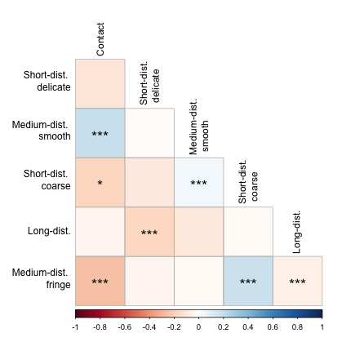

### **Fig. S3** Correlation plot among ECM fungal exploration types, using data across all host tree stands, subplots, and time points. Correlations use the spearman method showing positive (blue) and negative (red) magnitudes with significance denoted by stars (p < 0.05 *, < 0.01 **, < 0.001 ***).

## Taxonomy

### **Table S4.** Output showing the generalized additive model (GAM) of ectomycorrhizal fungal genus abundances, using week of year and host tree species leaf habit as main predictors.

| Taxonomy,   GAM with neg. binom. nb(p=0.16) distribution family | | | | | | |
| --- | --- | --- | --- | --- | --- | --- |
| Component | Term | Estimate | Std Error | t-value | p-value |  |
| A. parametric coefficients | (Intercept) | 8.478 | 0.160 | 52.898 | < 0.001 | *** |
| LeafHabitEvergreen | -0.983 | 0.009 | -103.853 | < 0.001 | *** |
| PLOT_G.sppQ. alba | -1.618 | 0.009 | -170.867 | < 0.001 | *** |
| PLOT_G.sppQ. bicolor | -2.011 | 0.010 | -211.428 | < 0.001 | *** |
| PLOT_G.sppP. abies | -0.373 | 0.009 | -39.404 | < 0.001 | *** |
| PLOT_G.sppP. strobus | 0.000 | 0.000 |  |  |  |
| GenusCortinarius | -1.761 | 0.013 | -131.589 | < 0.001 | *** |
| GenusElaphomyces | -1.071 | 0.013 | -80.068 | < 0.001 | *** |
| GenusHygrophorus | -2.223 | 0.013 | -166.094 | < 0.001 | *** |
| GenusInocybe | 0.270 | 0.013 | 20.206 | < 0.001 | *** |
| GenusRussula | 0.802 | 0.013 | 59.924 | < 0.001 | *** |
| GenusSebacina | -0.581 | 0.013 | -43.418 | < 0.001 | *** |
| GenusTomentella | 0.164 | 0.013 | 12.283 | < 0.001 | *** |
| GenusTuber | 0.208 | 0.013 | 15.569 | < 0.001 | *** |
| GenusWilcoxina | -0.934 | 0.013 | -69.834 | < 0.001 | *** |
| Component | Term | edf | Ref. df | F-value |  |  |
| B. smooth terms | s(WEEK):GenusAmphinema | 5.892 | 6.000 | 405.531 | < 0.001 | *** |
| s(WEEK):GenusCortinarius | 5.962 | 6.000 | 345.024 | < 0.001 | *** |
| s(WEEK):GenusElaphomyces | 5.682 | 6.000 | 144.928 | < 0.001 | *** |
| s(WEEK):GenusHygrophorus | 5.940 | 6.000 | 90.586 | < 0.001 | *** |
| s(WEEK):GenusInocybe | 5.868 | 6.000 | 102.133 | < 0.001 | *** |
| s(WEEK):GenusRussula | 4.767 | 6.000 | 27.953 | < 0.001 | *** |
| s(WEEK):GenusSebacina | 5.930 | 6.000 | 138.949 | < 0.001 | *** |
| s(WEEK):GenusTomentella | 4.980 | 6.000 | 255.673 | < 0.001 | *** |
| s(WEEK):GenusTuber | 5.861 | 6.000 | 991.201 | < 0.001 | *** |
| s(WEEK):GenusWilcoxina | 5.803 | 6.000 | 1,935.200 | < 0.001 | *** |
| t2(Temp1_7d_avg,Moisture1_7d_avg) | 0.009 | 8.000 | 0.000 | 1.000 |  |
| s(SUBPLOT) | 4.998 | 5.000 | 2,825.776 | < 0.001 | *** |
| Signif. codes: 0 <= '***' < 0.001 < '**' < 0.01 < '*' < 0.05 | | | | | | |
|  | | | | | | |
| Adjusted R-squared: -0.495, Deviance explained 0.100 | | | | | | |
| fREML : 937182.044, Scale est: 1.000, N: 702250 | | | | | | |

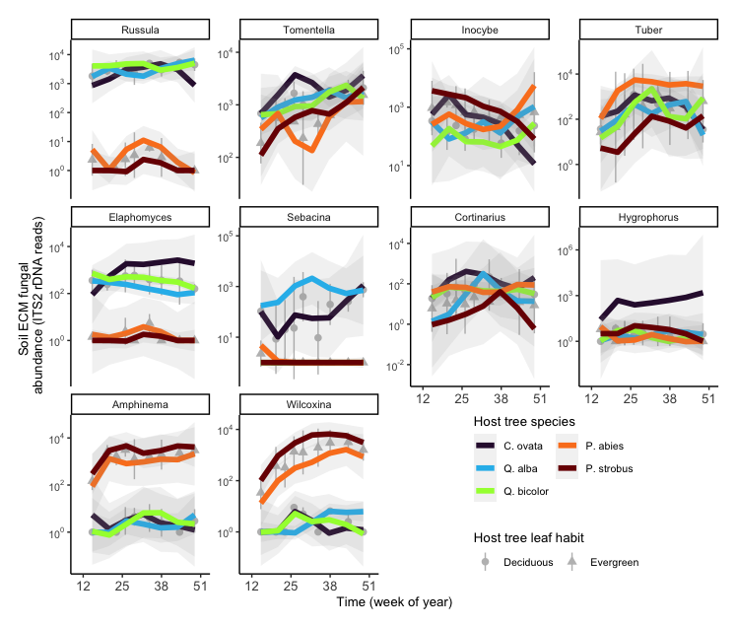

### **Fig. S4** Phenology of each ectomycorrhizal fungal genus for each of five temperate monodominant forest stands, color coded by fungal genus. Lines show smooth loess curves (n = 6) across mean values among subplots ± 1 SE per sampling date. Dates (week of year) indicate approximately monthly sampling times throughout the year 2023, with nine dates in total.

### 

### **Fig. S5** Phenology by ECM genus and plot

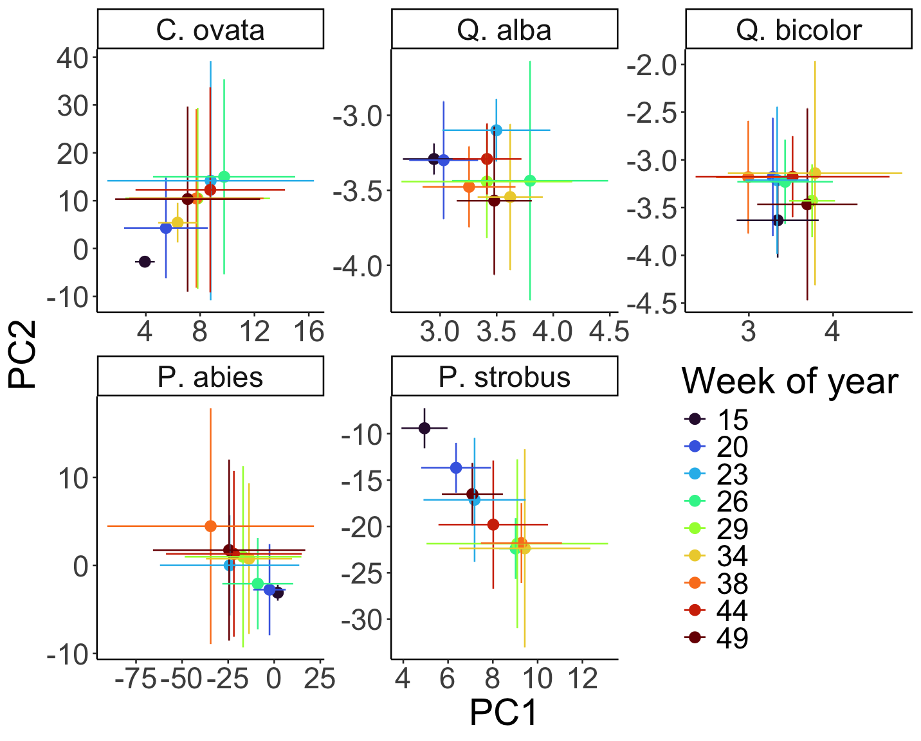

### **Fig. S6** Phase diagram using Principal Component Analysis (PCA) ordination coordinates of ectomycorrhizal community composition across five temperate host tree forest stands. Colors show approximately monthly sampling sessions, totaling nine time points. Ellipses show centroids and dispersion among points.