Dear Editor:

We are pleased to offer our article entitled “Tillage Method and Cover Crop Mix Effects on Urban Soil Performance”. Our article highlights lessons learned after one/two years of sustainable agricultural production at an urban agriculture site managed by Michigan State University Extension in Detroit, MI, USA. Our study focused on improving the soil on a property where a building was recently demolished, which is representative of the thousands of lots across Detroit and U.S. cities. We tested how cover crops and different tillage methods urban farmers employ affect soil compaction, infiltration, weed suppression, and yield.

Our results highlight that tractor tillage reduced compaction within one growing season more than no-till or rototill, while rototilling optimized peak summer soil infiltration rates. Additionally, our results revealed specific cover crop mixes varied in response to tillage, and that the mix of sorghum-sudangrass, buckwheat, and cowpea effectively suppressed both weed density and weed species richness. Finally, we show that no-till soils had higher radish yield than the mechanized tillage groups. We highlight that different management strategies should be applied to achieve certain outcomes for crops.

We thank you for your consideration, and look forward to your response!

Sincerely,

Authors

Core ideas:

1. Tillage reduced urban soil compaction
2. Rototill improved water infiltration
3. Buckwheat, cowpea, sorghum-sudangrass mix reduced weed density and diversity
4. No-till soils had larger crop yield

**Tillage and Cover Crop Mix Effects on Urban Soil Performance**

Author list and affiliations: Blind for submission.

Abbreviations: DPFLI, Detroit Partnership for Food Learning and Innovation; MSU, Michigan State University

**ABSTRACT**

Urban soils are highly disturbed, resulting in the loss of vegetation, organic matter, and increased compaction. Urban farmers rely on compost to improve degraded soil, but an integrated strategy may enhance soil quality more than simply apply compost. This study examined how various tillage methods and cover crop mixes affected soil attributes such as compaction, water infiltration rate, herbaceous weedy plant emergence, and crop yield. Tractor tilled plots relieved compaction to significantly greater depths compared to no-till (minimal disturbance) and rototilled (moderate disturbance) plots. Rototilled soils infiltrated water at a higher rate rate than the no-till and tractor tilled soils, challenging cited benefits expected from extensive tillage. Cover crops varied in yield across tillage treatments and the average root mass of forage radish was greater no-till plots but not significantly different, despite that tillage group having lower water infiltration rates and higher compaction. The weed suppression cover crop mix (sorghum-sudangrass, buckwheat, and cowpea) had fewer weeds than the other two cover crop mixes. We posit that integrated approaches to soil management can improve soil function better than simply adding compost.

**INTRODUCTION**

Urban areas are the fastest growing regions of the world and soils within cities are often degraded due to human activity (Oldeman, 1991). Soil plays a significant role in ecosystem health, and urban soil restoration has implications for carbon sequestration, stormwater management, forestry, and agriculture (Pavao-Zuckerman, 2008). However, soil quality proves to be an obstacle to urban initiatives related to agriculture and green space. Urban farmers in particular invest large amounts of money and time into amending soil for vegetable production, yet strategies to improve urban soil quality for production has scarcely been studied. Thus, it is critical to study methods that can be applied within cities to improve the health of soils.

Urban soils are characterized by compaction, low organic matter, high pH, and contamination from pollution and debris (Beniston & Lal 2011). This renders them less practical for agricultural and landscaping projects because they are difficult to manage and support vigorous plants. Nonetheless, urban farmingcontinues to expand as communities work the soil to improve access to healthy food and creates a cleaner and safer environment (Heckler, 2012). The value of local food production and benefits of urban green space make it critical to study management practices that can improve the quality of urban soils to support the viablesoil-based projects.

Applying compost is common and can improve physical, chemical, and biological soil properties of soil. However, persistent focus on compost use leads to excessive phosphorus and nutrient imbalance in garden soils (Small et al. 2019), making this management strategy limting. Instead, compost application should be combined with additional sustainable agriculture techniques that directly address the spectrum of challenges facing urban soils.

Tilling is one technique that is widely used to combat soil compaction (Badalíková, 2009), incorporate compost, and reduce weed pressure, especially rototilling on smaller operations. Other benefits of tilling include creating larger soil pores which enhance infiltration and drainage (Hill et. al, 1985), but excessive tilling can weaken soil structure (Catania et. al, 2018) and increase dependence on tillage technology for management.

In response to the detrimental aspects of tillage, no-till farming has been promoted as a more sustainable alternative (Xiao-Bin, 2006; Roger-Estrade et al. 2010) although it’s application in cities has been scarcely studied. Quantifying the short-term (1-2-year) benefits can support small-scale (e.g 232 m2 or 2,5000 ft2) farmers in developing effective and informed strategies to enhance soil performance.

Cover cropping can also be combined with tilling to build soil organic matter, lower pH, suppress weedy plants and insect pests, and/or alleviate compaction. Based on species characteristics, plant mixes can be tailored to specific agricultural functions such as building soil, scavenging nutrients, fixing nitrogen and loosening soil. Cover cropping is also recommended for reducing soil erosion and water runoff, which are issues for rural agricultural landscapes in the US Midwest as well as soils affected by sealed surfaces in urban settings (National Science and Technology Council, 2017).

In this study, we investigated how different tillage techniques and cover crop mixes affected soil quality over the course of one growing season, with longer term effects anticipated. The tillage methods ranged from high disturbance using a tractor and implements to minimal disturbance with a broadfork. Cover crop mixes were selected based on target functions including reducing compaction, suppressing weeds, and accumulating organic matter. We expected rototilling, a moderate soil disturbance, to be the most effective method for decreasing compaction and weed pressure. We also expected the compaction cover crop mix to have higher water infiltration rates than the other mixes due to the roots of those species facilitating infiltration into the soil. Finally, we documented how cover crop species and mixes performed in general regarding plant vigor.

**MATERIALS AND METHODS**

**Study site**

The study site was located at the Michigan State University (MSU) - Detroit Partnership for Food, Learning, and Innovation (DPFLI) (42.4119979˚N, -83.2627370˚W), an urban agriculture center in Detroit, MI, USA. Mean annual temperature is 9.5˚C and precipitation is 787 mm. The site was formerly a school property where the building was demolished in 2016. The site’s history is similar to that of many parcels across Detroit and other cities where urban decline has led to increased vacant land with degraded soil.

The DPFLI is characterized by upland wetland properties with a relatively shallow A horizon (Fig. 1a) and artifacts from previous human construction. Soils have mostly clay texture (~37%), with some areas higher in silt and sand. Soil organic matter within the research plots is low (1.6-2.5%), the pH is alkaline (8.5), and aggregate stability is low (Table 1). Soil samples revealed concentrations of common contaminants and heavy metals below government direct contact standards. Various metals including Pb, Zn, Cu were found in the soil but at levels below the Environmental Protection Agency direct contact standards (Angelone, 2002).

**Table 1. Baseline soil properties in study plot (2018 Cornell Soil Health Lab, NY, USA; 2019 Michigan State University Soil Test Lab).**

| **Type** | **Soil Indicator** | **Value** | **Comparison** | **Issues** |
| --- | --- | --- | --- | --- |
| Biological | Organic matter (%) | 2.8 | Very low | Ion exchange |
|  |  |  |  | Water retention |
|  |  |  |  | C storage |
|  | Respiration (mg CO2 d-1) | 0.2 | Excellent |  |
| Physical | Aggregate Stability (%) | 16.9 | Very low | Compaction |
|  |  |  |  | Infiltration |
|  |  |  |  | Runoff/Erosion |
| Chemical | pH | 8.5 | Very high | Plant toxicity |
|  |  |  |  | Nutrient availability |
|  | Extractable P (ppm) | 2.2 | Optimal |  |
|  | Extractable K (ppm) | 107.8 | Optimal |  |
|  | Minor elements |  | Optimal |  |
|  | Magnesium (Mg, mg kg-1) | 468.8 |  |  |
|  | Iron (Fe, mg kg-1) | 6.5 |  |  |
|  | Sodium (Na, mg kg-1) | 47.8 |  |  |
|  | Zinc (Zn, mg kg-1) | 2.6 |  |  |
|  | Heavy metals |  | Safe |  |
|  | Arsenic (As, mg kg-1) | 6.9 |  |  |
|  | Aluminum (Al, mg kg-1) | 9283 |  |  |
|  | Calcium (Ca, mg kg-1) | 45970 |  |  |
|  | Copper (Cu, mg kg-1) | 0.7 |  |  |
|  | Nickel (Ni, mg kg-1) | 18.2 |  |  |
|  | Lead (Pb, mg kg-1) | 58.0 |  |  |

**Field experimental design**

The study area was a 278 m2 (3,000 ft2) plot divided into 36 separate 4.6 m2 (50 ft2) sub-plots (Fig. 1b). Sub-plots were sectioned into 9 rows with 4 columns (Fig. 1c). There were 12 plots per tillage group, and we submitted one aggregated soil sample from the entire plot to the Cornell soil lab to establish a baseline. One aggregated sample per tillage group was collected and analyzed for chemistry using modified Morgan extractable protocols at the MSU soil test lab (Moebius-Clune et al. 2016). Approximately 0.24 m3 (8.5 ft3) of compost was incorporated into each plot and analysis was also conducted on the compost.

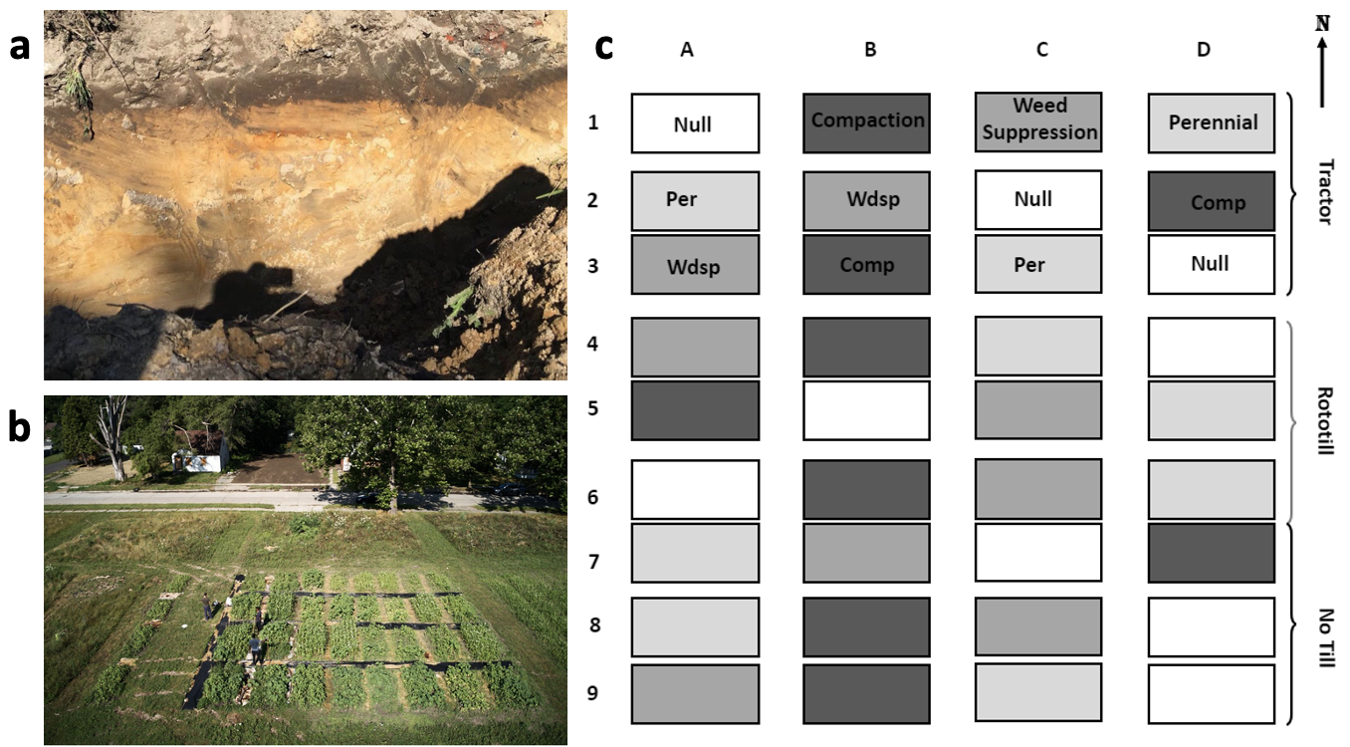

**Figure 1**. (a) Soil profile of an area near the research plots at the MSU-DPFLI. (b) Research plot five weeks after seeding, and (c) Diagram of research plot (1.5 x 3 m2, or 5 x 10 ft2)by tillage group and cover crop mix: Null = no mix added, Compaction (Comp), Weed Suppression (Wdsp), Perennial (Per).

**Tillage**

We tested three tillage techniques: 1) no-till with a broadfork (NT) , 2) moderate with a rototiller (RT), and 3) intensive tractor till (TT) with implements. TT plots were worked with a subsoiler, moldboard plow, and rototiller attached to a tractor up to 30 cm (12 inches) deep. RT plots were tilled with a rototiller implement up to 20 cm (8 inches) deep. NT plots were worked with a broadfork up to 10 cm (4 inches) deep. These methods represent a spectrum of soil management practices for small scale agriculture and were selected based on varying tillage philosophies, costs of implementation, and degree of mechanization.

**Cover crop mixes**

Cover crop mixes were selected based on targeted outcomes associated with specific plant varieties. We tested the performance of three mixes composed of three different plant species (see Table 2). The compaction mix of crimson clover, forage radish, and cereal ryegrass contains plants with roots that penetrate and loosen soil (Williams & Weil 2004). The weed suppressionmix consisted of heat- and drought-tolerant crops that grow rapidly, allowing them to outcompete other plants. Lastly, the perennial mix was made up of plants that would survive beyond one growing season and return in the spring, adding additional biomass and outcompeting early season weeds. We also had a null group consisting of established vegetation within the plot, where no additional seeds were sown.

**Table 2. Cover crops used in each mix with targeted function for a temperate urban agriculture site.**

| **Name / Function** | **Cover crop mix** |
| --- | --- |
| Perennial | Hairy vetch (*Vicia villosa*) |
|  | Red clover (*Trifolium pratense*) |
|  | Wheat (*Triticum aestivum*) |
| Compaction | Crimson clover (*Trifolium incarnatum*) |
|  | Forage radish (*Raphanus sativus*) |
|  | Cereal Ryegrass (*Secale cereale*) |
| Weed suppression | Buckwheat (*Fagopyrum esculentum*) |
|  | Cowpea (*Vigna unguiculata*) |
|  | Sorghum-Sudangrass (*Sorghum bicolor x* *S. bicolor var. sudanese)* |
| Null | Established vegetation / soil seed bank |

**Data Collection**

**Compaction**

Soil compaction was measured with a penetrometer (AgraTronix Soil Compaction Tester 08180) in four randomly selected spots within each quarter of every sub-plot, which were later averaged at the plot level based on cover crop mix and tillage group. Readings were taken as the depth at which the penetrometer read 300 pounds per square inch (psi), or 2 MPa, since roots typically cannot penetrate with 2 MPa of force (Duiker 2002). Sampling was conducted at two separate time periods, in July (“Early”) and October (“Late”) 2019. Samples were taken on dry days and recorded to the nearest inch.

**Infiltration**

We measured the water infiltration rate to determine the soil’s capacity to drain water, which has implications for managing stormwater runoff and holding water for plant roots. The infiltration rate was calculated by recording the amount of time it took for 32 fluid ounces (946 mL) to drain into the soil, which is similar to the amount of typical rainfall on 0.092 m2 (1 ft2) per rain event (United States Geological Services, n.d.). We cleared the soil surface of debris and cut vegetation low enough to observe the surface. Then, we pressed a 1.4 kg (48 ounce) aluminum can about 2.5 cm into the soil and poured the water in. The maximum time allowed was 160 seconds.

**Weed density and species richness**

We quantified weed species richness and overall density within each sub-plot by counting the number of weed species present and relative abundance of the most common species. Weed species richness was measured by counting the number of plant species excluding the cover crop mix in a sub-plot. Weed density was measured as the relative cover of the two most abundant weed species, pigweed (*Palmer amaranth*) and velvetleaf (*Abutilon theophrasti*), using a comparative scale of 0-5 (in increments of 10 individuals) with 0 indicating neither species present and 5 indicating 50 or more individuals of either species. Weed species richness was estimated as the relative abundance of weed species within a plot using a scale of 1-10 with one indicating only one species observed to 10 being 10 species present.

**Yield**

Five forage radish (*Raphanus sativus*) roots were randomly selected per sub-plot and measured for length (individually) and wet weight with foliage attached (bunched together). The length of a radish root was measured from the hypocotyl, or root cap, to where the root became ~6 mm (1⁄4 inch) wide.

**Statistical analyses**

An Analysis of Variance (ANOVA) was performed on plot-level compaction data, averaged by cover crop mix and tillage group, with a tillage-mix interaction and additional independent effect of season, and followed by a post-hoc test, using the base ‘aov’ function and standard pairwise function in the ‘emmeans’ package (v1.5.5.1, built from R 3.6.2) in RStudio v1.2.1335 (R Core Team 2019).

Kruskal-Wallis tests were run on infiltration,

weed abundance, and richness, and radish yield data; with independent tests of tillage, mix, and season.

Radish yield and longest root length were correlated, so they were analyzed using a MANOVA with tillage the independent factor, since these data were from compaction plots.

**RESULTS**

**Compaction**

Tilling and cover crop mixes both had significant effects on compaction, but tilling had effects that were nearly twice as strong in most cases, while cover crops had effects that were pronounced only under no-till conditions (Fig. 2). Specifically, tractor tilling (TT) significantly decreased compaction (i.e. lowered the hardpan depth) from 7.5 cm (3”), down to 20 cm (8”) depth (*F2,59* = 61.05, *p* < 0.001), which was approximately a 50% reduction on average compared to no-till, independent of cover crop mix (*t59* = -10.21, *p* < 0.0001). Rototilling, however, did not have a significant effect on compaction depth compared to no-till (t59 = -1.44, p = 0.33), with hardpan staying at 12 cm (5”) on average in both groups.

There was also a significant interactive effect of tilling and cover crop mixtures (*F6,59* = 3.88, *p* = 0.0025). Broadly, tilling effects tended to be slightly more pronounced under the perennial mix compared to other crop mixes (Fig. 2). Furthermore, the perennial and compaction mixes both had notably lower compaction depths compared to the null mix, but these differences were only observed within the no-till group. The perennial mix had the strongest effect, with an increase in compaction depth of 3 cm (~1”) (*t59* = 4.62, *p* = 0.0001), and the compaction mix was associated with a change in compaction depth of 1.5 cm (~0.5”) (*t59* = -2.6, *p* = 0.058). Finally, there appeared to be more variation in compaction depth among crop mixes under no-till plots, which ranged 7-20 cm (3-8”) and included the most compacted plots, [whereas tilling tended to homogenize these cover crop effects]. Finally, there were no general differences between sampling dates, though there was a tendency for compaction to increase slightly by 1-2.5 cm (0.5-1”) (*F1,59* = 1.82, *p* = 0.183).

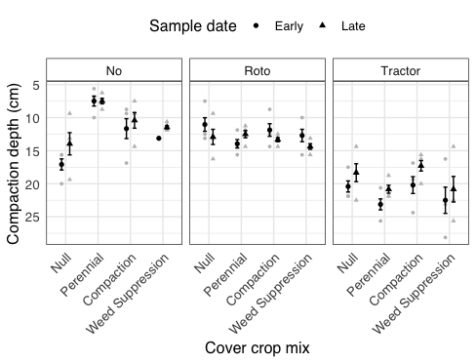

**Figure 2**. Observed (gray) and mean ±1 SE (black) depths to effective soil hardpan measured using a penetrometer (to 2 MPa) for different tillage methods and cover crop treatments (*n* = 3-4), and sample dates, in a temperate clayey urban agriculture site.

**Infiltration**

Overall, infiltration was detectably affected by tilling, while cover cropping appeared to but did not yet significantly affect infiltration. Among all measurements throughout the season, infiltration varied significantly by tillage group (*x*22 = 8.51, p = 0.014), with rototilling showing the fastest infiltration on average, ~0.5 mL sec-1 faster than no-till and tractor-tilling (Fig. 3a). In this case, season also very significantly affected infiltration (*x*22 = 15.02, p = 0.0001), with summer rates being 0.5-1 mL sec-1 (~0.5-1 gal hr-1) faster than autumn (dropping to ~0.25 gal hr-1 or slower, beyond observation period), and early season rates appeared to underlie observed management effects (Fig. 3a). While cover cropping did not affect infiltration detectably here (*x*23 = 5.93, p = 0.11), mixes designed for perenniality and weed suppression appeared to begin showing somewhat faster infiltration compared to other groups (Fig. 3b).

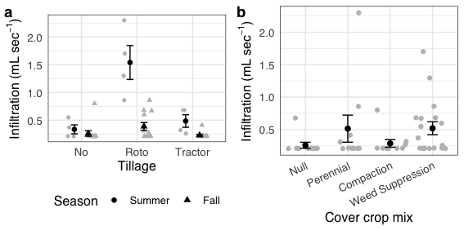

**Figure 3**. Observed (gray) and mean ±1 SE (black) field soil infiltration rates for different (a) tillage treatments by season, and (b) cover crop mixes with targeted functions, in a temperate clay-rich urban agriculture site.

**Weed density and richness**

Weed density was significantly affected by cover crop mix (*x*23 = 20.07, p = 0.0002) and significantly by the tillage method (*x*22 = 6.47, p = 0.04) (Fig. 4). Similarly, weed richness was significantly affected by cover crop mix (*x*23 = 30.97, p << 0.0001), yet not by tillage method (*x*22 = 1.64, p = 0.44) (Fig. 3b). The weed suppression cover crop mix had the strongest effect on both weed species density and richness. This mix of sorghum-sudangrass, buckwheat, and cowpea reduced the presence of the two focal common weeds, pigweed (*Palmer amaranth*) and velvetleaf (*Abutilon theophrasti*), regardless of tillage treatment. The perennial cover crop mix seemed to show weed density that increased most consistently with tilling method intensity.

We also monitored weed species presence and diversity in the spring of the following growing season, and the weed suppression mix plots had fewer early season weeds than the other plots as well (*x*23 = 10.00, p = 0.02; *x*22 = 0.17, p = 0.92). From June to September, the other cover crop mixes did not significantly reduce weed pressure and actually performed similarly to our null group plots that only had weed seeds in them (Fig. 4). However, the wheat, rye, vetch, and clovers continued to grow from the Fall into the following Spring and did reduce weed presence compared to the null group in the spring. Thus, although the other mixes did not reduce weeds in the summer or warm season, they were more effective at suppressing cool season weeds.

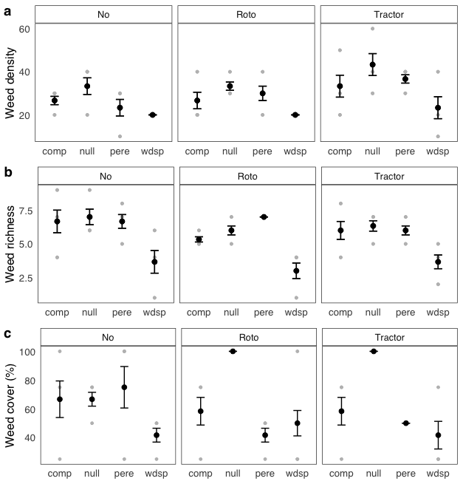

**Figure 4**. Observed (gray) and mean (black) ±1 SE (a) density, and (b) richness of weed species per plot from different cover crop and tillage treatments (*n* = 3) in a temperate clay-rich urban agriculture site. Density is the frequency of the two most abundant weed species: pigweed (*Palmer amaranth*) and velvetleaf (*Abutilon theophrasti*). Richness is the diversity (number) of different weed species within a plot. “comp”: compaction; pere: perennial; wdsp: weed suppression.

**Radish Yield**

Tilling did not significantly affect radish yield or length (F2,5 = 1.22, p = 0.36), despite the appearance of some tendencies in difference (Fig. 5).

Average forage radish plant weight and root length did not vary significantly among tillage treatments (*x*22 = 1.44, p = 0.49; *x*22 = 2.87, p = 0.24). However, radish plants did tend to grow the largest in no-till plots (Fig. 5). The longest radishes grew close to 21.6 cm or 8.5 inches, and the average length of all sampled radishes was 11.68 cm or 4.6 inches. Forty percent of radishes sampled grew past the average compaction depth 11.43 cm (4.5 inches) in the no-till and tractor till plots.

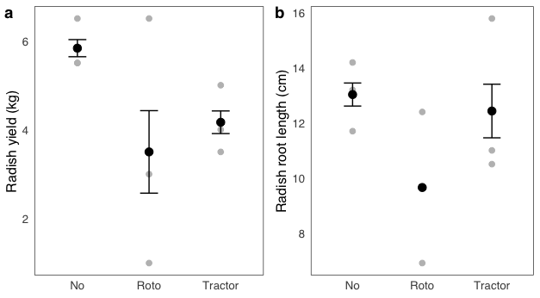

**Figure 5**. Observed (gray) and mean (black) (a) yield, and (b) maximum root length of forage radish from different tillage treatments in a temperate clayey urban agriculture site.

**DISCUSSION**

Our data indicated that tilling significantly reduced compaction over a single growing season in both rototilled and tractor tilled plots (Fig. 1). However, several no-till plots reached similar depths to rototilled plots, which suggests rototilling is not significantly more effective than no-till at reducing compaction. Forage radish plant weight with foliage responded better in no-till plots that rototill and tractor tilled plots and average weights in the tilled groups were similar . This was supported by detecting significantly higher radish yields in no-till compared to rototill and tractor till plots, while simultaneously measuring faster infiltration in rototill plots. We also observed significant suppression of weed species diversity and overall density in the cover crop mix plots named for that targeted function, showing that the weed suppression mix used in this study can directly be applied in soils like these.

**Tillage**

Two reasons for tilling soil are reducing compaction and killing weeds. In this experiment, both tractor and rototilling reduced compaction, loosening soil at lower depths than the no-till method (Fig. 2). Tractor tilling with a subsoiler, moldboard plow, and rototiller likely created a high soil disturbance from the soil surface to depths as low as 30.48 cm or 12 inches. The data show that greater levels of soil disturbance increased the density of the two most common weeds, velvet leaf (*Abutilon theophrasti*) and pigweed (*Palmer amaranth*), and decreased the diversity of other weed species (Fig. 4).

The results show that the intensity of tillage corresponds negatively to compaction depth. This effect also lasts throughout the growing season, even though the average depth of compaction tended to decrease over the growing season (Fig. 2). Specifically, tractor tilled soils appeared to have a greater loss in compaction depth compared to no-till soils. This is probably a combination of the natural tendency for clay soils to increase in compaction over time and weather conditions, limiting plant root penetration of soil to depths that would maintain soil looseness (Boswell et al. 2020) Our data align with our previous predictions and other studies (Özpinar & Çay, 2005).

Depending on what crops are grown, addressing compaction may not be an immediate issue. Multiple crops have shallow root systems or are harvested before roots grow over 10.16 cm or 4 inches into the soil. If crops do not require deep root systems, a no-till method may suffice (Krause & Black, 1995), eliminating the time, energy, and costs of tilling. An important observation for urban soil management was that rototilling and tractor tilling in particular exposed and removed debris from soil that would have remained in place with a no-till system. The debris consisted of construction materials like rebar, wires, cables, bricks, cinder blocks, and pipes as well as other refuse.

Finally, the reduction in compaction in the rototilled plots (Fig. 2) may indicate that plant roots from both cover crops and weeds can reduce compaction. Over multiple seasons, if crops with deep root systems are used, tilling may loosen soils at lower depths and facilitate deeper roots to establish more quickly than no-till. Roots that penetrate to lower depths in soil allow plants to increase their access to nutrients and the water (Arshad, 1990).

**Infiltration**

Soil’s ability to absorb water is critical for stormwater management, minimizing erosion, and making water available to plant roots. Rototilled plots had the fastest infiltration early in the growing season (Fig. 3). This coincides with predictions compared to no-till plots, but is the opposite of what we expected when compared to more deeply disturbed tractor tilled plots. This may be explained by how compost was incorporated into the plots.

For the no-till plots, compost was simply mulched on the surface, and after passing through this layer, water accumulated on the more compacted layer beneath. In rototilled plots, compost was incorporated into the top six inches creating a more porous soil with organic matter throughout. Compost in the tractor tilled plots was mixed in deeper than the other two treatments and may have become too sparse. Thus, these more clayey soils were not porous enough to infiltrate water at high rates. The infiltration rate decreased regardless of tillage treatment between the sampling dates, which was consistent with the pattern of increased compaction throughout the season. The rate was so slow in the no-till and tractor till plots that these soils were draining less than one hundredth of a gallon in one minute. This suggests that most water from a one inch rain event would result in runoff. We posit that maintaining porosity and deeper compaction depths will allow soils to infiltrate water at rates that can absorb 2.54 cm or 1 inch rain events. Based on our findings, rototilling and incorporating additional compost, may be an effective method to improve water infiltration during the driest time of year. Rototilling disturbed the soil enough to reduce compaction, but not to the extent where organic matter was lost or highly dispersed.

**Weed suppression**

Overall weed density tended to be highest in tractor-tilled plots (Fig. 4). This was likely due to increased soil disturbance exposing seeds in the soil seed bank and creating open space for weeds to emerge. Higher weed density is an additional downside to the tillage of similar soils by tractor, along with lower infiltration rates. Regardless of tillage treatment, the weed suppression mix of sorghum-sudangrass, buckwheat, and cowpea significantly reduced both weed density and species richness by more than a factor of two in some plots compared to the other cover crop mixes. This result is supported by recommendations from other studies that pair buckwheat and sorghum-sudangrass (Smith et. al, 2015). Weed richness may have decreased due to competitive exclusion by sorghum-sudangrass via allelopathy, and by buckwheat via better phosphorus mining and use (Jabran 2017; Zhu et al. 2002).

The weed suppression mix can be utilized to frame crop beds, keeping out encroaching weeds, or to reduce weed pressure in an area that will be planted in the fall or following season. The buckwheat and sorghum-sudan grass grows quickly in poor soils and even dry conditions. These plants accumulate a lot of biomass, which allows them to shade out weeds. They also can be mowed to prevent re-seeding and winter-kill, making them easier crops to manage than crops that require more maintenance. This experiment was designed to require no management after seeding (i.e. no irrigation, weeding, or mowing). Under these conditions, most of the cover crops did not perform well, and were probably inhibited by the warm and dry summer conditions. Crops in other mix treatments used here usually prefer to be sown in the cooler early season (United States Department of Agriculture, 2015). This experiment highlighted crops could be used in clayey soils under these conditions: forage radish, buckwheat, cowpea, and sorghum-sudangrass. Aside from reducing weeds for crop production, weed suppression can reduce pollen counts and the likelihood of direct contact with people (Katz et al. 2014; Katz & Carey 2014). In urban areas this has implications for serving communities where asthma and respiratory illness is common, as well as preventing exposure to weeds that may cause irritation. Under managed landscapes could have cover crops sowed to alleviate some of these urban issues.

**Yield and root length**

Forage Radish tended to grow the most in no-till plots, which was unexpected based on the higher compaction in these plots. We posit that the radishes benefited from having more access to the nutrients in the compost that was simply mulched on the top two inches of the no-till plots. The compost in the other tillage treatments was incorporated throughout the soil of other plots and less available. It was also surprising that yield did not correspond with faster infiltration, since no-till plots had slower infiltration compared to rototilled plots. This suggests a more nuanced relationship between infiltration and root crop yield unlike the relationship between infiltration and compaction. Yield responds more to more stable or longer-term reservoirs of water and nutrients, such as those in mulched compost, than to shorter-term or more transient influxes brought by infiltration processes (Schlegel & Havlin 2017). Furthermore, more stable reservoirs of water and nutrients may also foster more productive associations with soil microbes, which serve as an additional source of available nutrients for plant roots. In these cases, soil microbe availability might depend less on pH. These data suggest that similar alternative soil management practices like no-till combined with compost and mulching application gives better yields. Thus, forage radish can be an effective cover crop in reducing compaction and building soil structure, with minimal or no mechanical tillage (Chen, 2010). Our study also warrants future studies on the processes tying yield to land management in similar soils.

**ACKNOWLEDGEMENTS**

Hidden for submission.

**REFERENCES**

Alvarez‐Campos, O. and Evanylo, G.K. (2019). Biosolids Improve Urban Soil Properties and Vegetable Production in Urban Agriculture. *Urban Agriculture & Regional Food Systems* 4: 1-11 190002. <https://doi.org/10.2134/urbanag2019.04.0002>

Arshad, M.A., Schnitzer, M., Angers, D.A, Ripmeester, J.A. (1990). Effects of No-Till on The Quality of Soil Organic Matter. *Soil Biology and Biochemistry*. 22(5): 595-599. <https://doi.org/10.1016/0038-0717(90)90003-I>

Badalíková, B. (2009). Influence of Soil Tillage on Soil Compaction. *Soil Engineering* 20: 19-30. <https://doi.org/10.1007/978-3-642-03681-1_2>

Blesh, J. (2019). Feedbacks between nitrogen fixation and soil organic matter increase ecosystem functions in diversified agroecosystems. *Ecological Applications*. 29(8): e01986.

Catania, P. Badalucco, L. Laudicina, V.A., Vallone, M. (2018). Effects of Tillage Methods on Soil Penetration Resistance, Organic Carbon and Water Stable Aggregates In A Vineyard of Semiarid Mediterrnian Environment. *Environmental Earth Sciences* **77**, 348. <https://doi.org/10.1007/s12665-018-7520-5>

Chen, G., Weil, R.R. (2010). Penetration of cover crop roots through compacted soils. *Plant Soil* 331: 31–43. https://doi.org/10.1007/s11104-009-0223-7

De Kimpe, C. R., & Morel, J. (2000). URBAN SOIL MANAGEMENT: A GROWING CONCERN. *Soil Science.* 165(1): 31-40. Retrieved July 2, 2020, from <https://journals.lww.com/soilsci/Abstract/2000/01000/URBAN_SOIL_MANAGEMENT__A_GROWING_CONCERN.5.aspx>

Duiker, Sjoerd W. (2002). Diagnosing Soil Compaction Using a Penetrometer. *Penn State Extension: Agronomy Facts 63*. Retrieved July 2, 2020, from <https://extension.psu.edu/diagnosing-soil-compaction-using-a-penetrometer-soil-compaction-tester>

Gómez, J. A., Campos, M., Guzmán, G., Castillo-Lanque, F., Vanwallenghem, T., Lora, A., Giráldez, J. V. (2018). Soil erosion control, plant diversity, and arthropod communities under heterogeneous cover crops in an olive orchard. *Environ Sci Pollut Res* 25:977-989.

Grant, R.F. (1993). Simulation Model of Soil Compaction and Root Growth. *Plant and Soil*. 150 :1–14. <https://doi.org/10.1007/BF00779170>

Heckler, Susanne, A. (2012). A Right to Farm in the City: Providing a Legal Framework for Legitimizing Urban Farming in American Cities. *Valparaiso University Law Review.* 44:217-266. <https://scholar.valpo.edu/cgi/viewcontent.cgi?article=2259&context=vulr>

Hill, R.L., Horton, R., Cruse, R.M. (1985). Tillage Effects on Soil Water Retention and Pore Size Distribution of Two Mollisols. *Soil Science Society of America Journal.* 49(5): 1264-1270. <https://doi.org/10.2136/sssaj1985.03615995004900050039x>

Jabran, K. (2017). Sorghum Allelopathy for Weed Control. Manipulation of Allelopathic Crops for Weed Control*.* pp. 65-75.

Katz, D.W, Connor Barrie, B.T, Carey T.S. (2014). Urban Ragweed Populations in Vacant Lots: An Ecological Perspective on Management. *Urban Forestry & Urban Greening*. 13(4): 756-760. <https://doi.org/10.1016/j.ufug.2014.06.001>

Katz, D.W., Carey, T.S. (2014). Heterogeneity in Ragweed Pollen Exposure is Determined by Plant Composition at Small Spatial Scales. *Science of the Total Environment.* 485-486: 435-440. <https://doi.org/10.1016/j.scitotenv.2014.03.099>

Krause M. A., Black, J.R. (1995). Optimal Adoption Strategies for No-Till Technology in Michigan. Review of Agricultural Economics. 17(3):299-310. Retrieved July 14, 2020 from www.jstor.org/stable/1349575

Manta, D., Angelone, M., Bellanca, A., Neri, R., and Sprovieri, M. (2002). Heavy Metals in Urban Soils: A Case Study From The City of Palermo (Sicily), Italy. *Science of The Total Environment* 300(1-3): 229-243. <https://doi.org/10.1016/S0048-9697(02)00273-5>

Moebius-Clune, B.N., D.J. Moebius-Clune, B.K. Gugino, O.J. Idowu, R.R. Schindelbeck, A.J. Ristow, H.M. van Es, J.E. Thies, H.A. Shayler, M.B. McBride, K.S.M Kurtz, D.W. Wolfe, and G.S. Abawi, 2016. Comprehensive Assessment of Soil Health – The Cornell Framework, Edition 3.2, Cornell University, Geneva, NY.

Nakatani, K., Y. Fuji. (2013). Influence of the nitrogen form on in vitro organogenesis in Equisetum arvense. Weed Biology and Management, 13(4): 151-155.

National Science and Technology Council. Subcommittee on Ecological Systems, Committee on the Environment, Natural Resources, and Sustainability. (2016). *Framework for a Federal Strategic Plan for Soil Science*. Washington DC.

Oldeman, L.R. (1991). Global Extent of Soil Degradation. *ISRIC Bi-Annual Report*. 19-36. Retrieved July 10, 2020, from <https://library.wur.nl/WebQuery/wurpubs/fulltext/299739>

Özpinar S., Çay A. (2005). Effects of Minimum and Conventional Tillage Systems on Soil Properties and Yield of Winter Wheat (Triticum aestivum L.) in Clay Loam in the Çanakkale Region. Retrieved July 14, 2020, from <http://journals.tubitak.gov.tr/agriculture/issues/tar-05-29-1/tar-29-1-2-0403-2.pdf>

Pavao-Zuckerman, M. A. (2008). The Nature of Urban Soils and Their Role in Ecological Restoration in Cities. 16(4): 642-649. <https://doi.org/10.1111/j.1526-100X.2008.00486.x>

Roger-Estrade, J., Anger, C., Bertrand, M., and Richard G. (2010). Tillage and soil ecology: Partners for sustainable agriculture. 111(1): 33-40. <https://doi.org/10.1016/j.still.2010.08.010>

Schlegel, A.J., Havlin, J.L. (2017). Corn Yield and Grain Nutrient Uptake from 50 Years of Nitrogen and Phosphorus Fertilization. *Agronomy Journal* 109(1): 335-342. <https://doi.org/10.2134/agronj2016.05.0294>

Smith, R.G., Atwood, L.W., Pollnac, F.W., Warren, N.D. (2015). Cover- Crop Species as Distinct Biotic Filters in Weed Community Assembly. *Weed Science* 63(1): 282-295. <https://doi.org/10.1614/WS-D-14-00071.1>

Small, G., Shrestha, P., Metson, Polsky, K., Jiménez, I., Kay, A. (2019). Excess phosphorus from compost applications in urban gardens creates potential pollution hotspots. *Environmental Research Communications* 1. https://doi.org/10.1088/2515-7620/ab3b8c

United States Geological Service. (n.d.). *Rain and Precipitation.* Retrieved July 2, 2020, from <https://www.usgs.gov/special-topic/water-science-school/science/rain-and-precipitation?qt-science_center_objects=0#qt-science_center_objects>

United States Department of Agriculture. (2015). Cool Season Cover Crop Species and Planting Dates and Techniques. TX-PM-15-03. Natural Resources Conservation Service, United States. Available at <https://www.blogs.nrcs.usda.gov/Internet/FSE_PLANTMATERIALS/publications/etpmctn12683.pdf> [Verified August 2015]

University of Missouri. (n.d.). Growing Buckwheat for Grain or Cover Crop Use [PDF]. University of Missouri Extension. <https://mospace.umsystem.edu/xmlui/bitstream/handle/10355/67451/GrowingBuckwheatforGrainorCoverCropUse.pdf?sequence=1>

Xiao-Bin, W., Dian-Xiong, C., Hoogmoed, W.B., Oenema O., Perdok, U.D. (2006). Potential Effect of Conservation Tillage on Sustainable Land Use: A Review of Global Long-Term Studies. *Pedoshere*. 16(5): 587-595. <https://doi.org/10.1016/S1002-0160(06)60092-1>

Weil, R., White , C., & Lawley , Y. (n.d.). Forage Radish: New Multi-Purpose Cover Crop for the Mid-Atlantic [PDF]. *University of Maryland*. http://notillveggies.org/UMD%20fact%20sheet%20824%20radish.pdf

https://mospace.umsystem.edu/xmlui/bitstream/handle/10355/67451/GrowingBuckwheatforGrainorCoverCropUse.pdf?sequence=1

Williams and Weil. (2004). Crop Cover Root Channels May Alleviate Soil Compaction Effects on Soybean Crop. *Soil Science Society of America Journal* 68(2): 1403-1409. <https://doi.org/10.2136/sssaj2004.1403>

<https://journals.tubitak.gov.tr/agriculture/abstract.htm?id=7333>