Natural regeneration of a tropical timber plantation

Nicholas Medina

# Outline

* Introduction
* Methods
* Results
* Discussion

# I–Global forests are regenerating, but how?

* ~Half of forests are tropical, and over half of all forests globally are secondary *(FAO 2020)*
* Services like timber and biodiversity depend on natural and managed regeneration patterns
* Regeneration dynamics (e.g. associated biodiversity) should be better understood to optimize sustainable management and service provision

# I–Forest regeneration is overall both quick and inconsistent

* Biomass recovers 90% in 66 yrs *(Poorter et al. 2016)*
* Taxonomic richness recovers quickly *(Rozendaal et al. 2019)*
* Community composition may take centuries to recover, if at all *(Norden et al. 2015)*

# I–Habitat edges shape regeneration

* 70% forests are <1 km from a habitat edge *(Haddad et al. 2015)*
* Edge effects reduce biodiversity 13 - 75%
  + more so in small and isolated fragments

# I–Edge effects may differ in wet tropical plantations

* 7% of global forests are planted and planted area has increased over last 30 yrs *(FAO 2020)*
  + Often dense with fast-growing, shade-intolerant taxa
* Wet tropical forest regeneration tends to be light-limited, based on tree functional traits *(Poorter et al. 2021)*
* Existing plantation demography and shade may skew/buffer edge effects toward net positive instead of negative

# I–This study

* Question – How is wet tropical secondary forest regeneration affected by former plantation status and edges with road and primary forest?
* Hypothesis –
  + Former plantation status facilitates succession by allowing shade-intolerant taxa to grow better due to **denser canopies**
  + Forest edges promotes regeneration by faciltating **dispersal** of shade-tolerant taxa
* Predictions – Distance away from primary forest edge is associated with –
  + lower stand biomass
  + lower tree diversity
  + lower shade-tolerant taxa

# II–Study site

* Wet tropical rainforest in Osa Peninsula, SW Costa Rica
* 20 ha plantation of dry forest timber, abandoned in ~2003 into NRDC preserve
* Area surrounded by primary forest on two sides and road on third

# II–Census design

* Random stratified forest biomass inventory sampling design –
  + divided 300 m range into six 50 m strata, from forest to road edge, using QGIS and ArcGIS
  + 30, 21 x 21 m plots randomly distributed, but quantity roughly proportional to stratum area
  + All plots covered 1 ha total, 5% of entire plantation

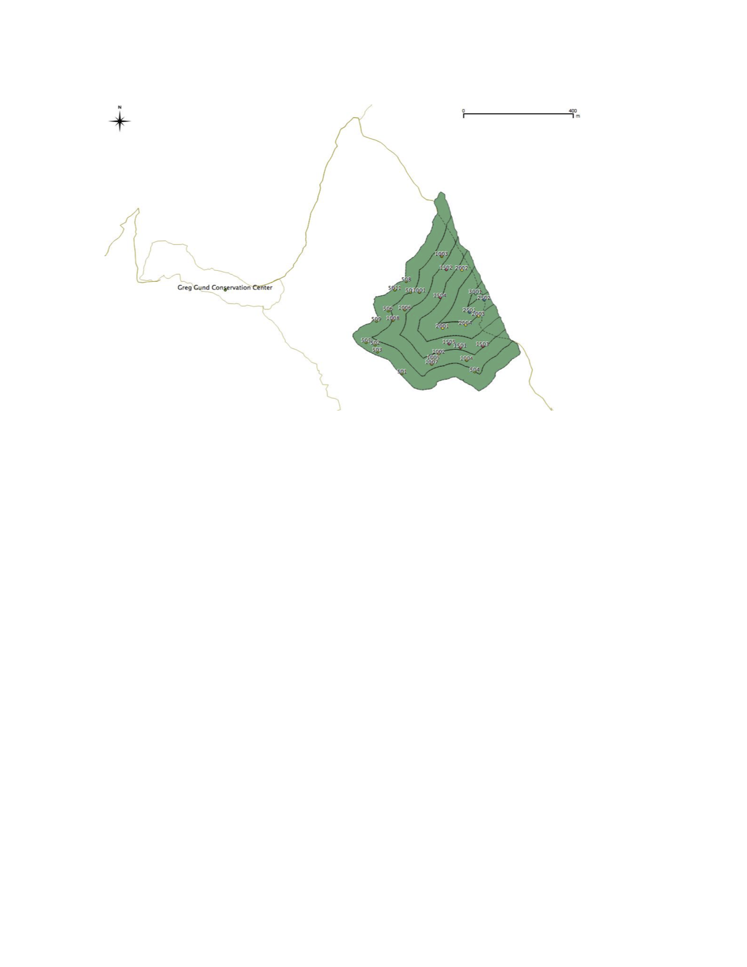

# II–Census measurements

* Stems ≥10 cm were measured for DBH and height using rangefinder *(Bushnell, Forestry Suppliers, Inc)*
* Taxa were ID’d with help from local field guides
* Plot canopy closure was measured with densiometer

# II–Statistical analysis

* For all variables–
  + Trend lines follow median values of all plots in distance stratum
* Traits obtained from literature and compared to TRY database *(Kattge and Str 2019)*
* Computations done with R 4.1.3 depending on *BIOMASS* 2.1.7, *vegan* 2.5.7, and *tidyverse* 1.3.1 packages

# III–Stand regeneration

* Further from primary forest edge–
  + Biomass and wood density tended to increase
  + Stem density decreased then increased
  + Neither canopy light nor height (not shown) tended to change
* Distance from forest edge tended to explain variation–
  + 10% in wood density
  + ~20% in stem density

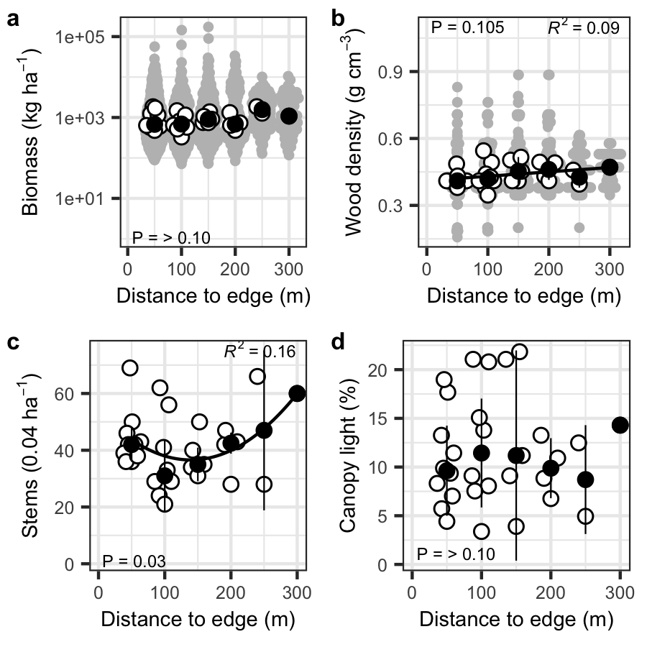

# III–Composition regeneration

* Further from forest edge–
  + Richness tended to increase
  + Diversity decreased steeply
  + Composition varied notably, toward PC1
  + Of abundant taxa biomass–
    - *Vochysia* tended to decrease
    - *Ficus* decreased

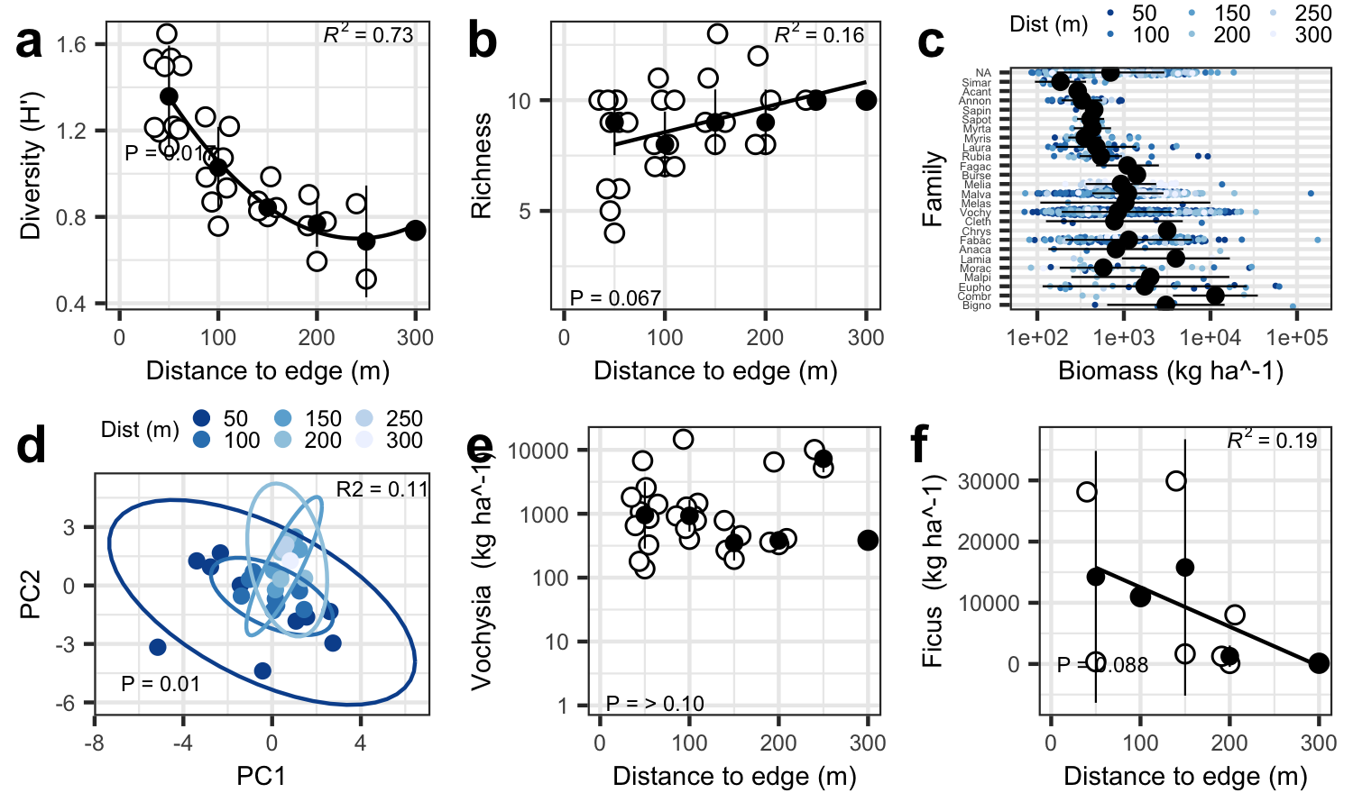

# III–Functional regeneration

* Away from forest edge–
  + Biomass of taxa often found in both successional stages decreased
  + Biomass based on dispersal mode remained constant

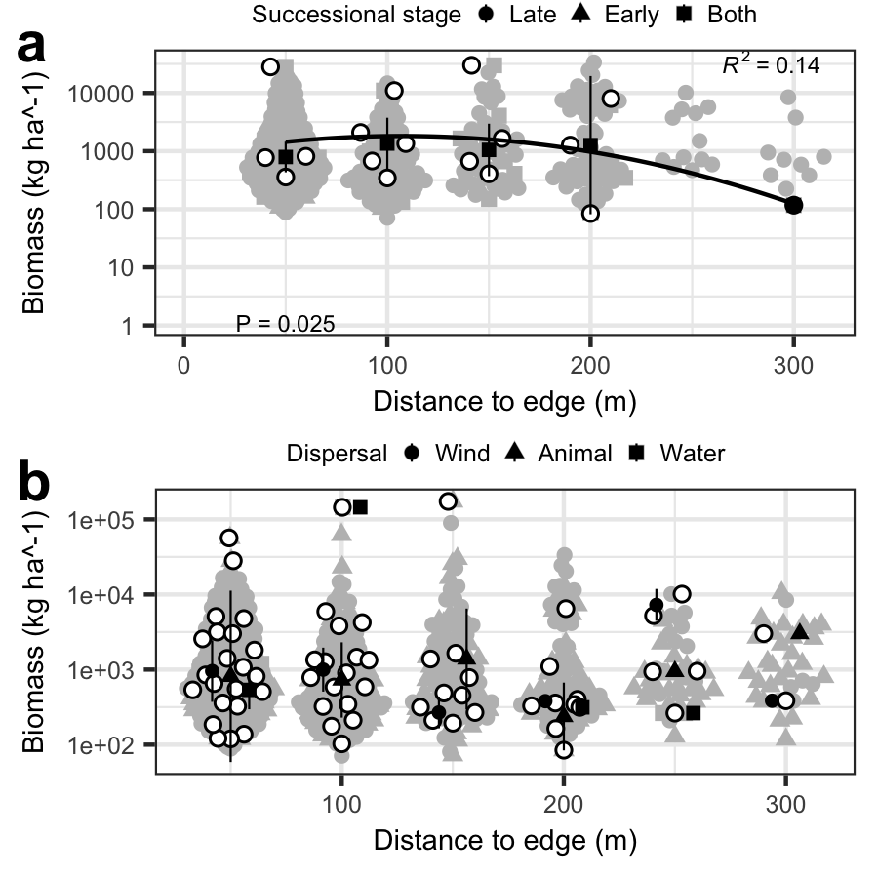

# IV–Hypothesis check

* Stand biomass is more resilient than biodiversity
  + Further from forest–
    - No trends in biomass
    - Diversity decreased
    - Composition tended to change
* Forest edge associated with tree diversity

# IV–Processes underlying patterns

* Not shade, perhaps given high absolute value and/or evenness of original timber planting
* Forest edge may associate with faster succession, given drop in generalist tree taxa with distance
* No signal of dispersal mode detected

# IV–Compare to similar studies

* Aligns well with several recent studies suggesting that–
  + Tree diversity regenerates quicker than taxonomic composition *(Poorter et al. 2016)*
  + Habitat edges lower diversity and generally slow regeneration, like via less seed consumption *(Hohlenwerger, Tambosi, and Metzger 2022)*
  + Taxa indiscriminate to successional stage are minimally affected by disturbance, like from edges *(Bongers et al. 2009)*

# IV–Future studies

* Compare wet tropical plantations at different stages of regeneration
* Compare forests with different initial composition but in similar region (i.e. realized vs. fundamental niches)
* Study ecological dynamics under various management conditions

# References

Bongers, Frans, Lourens Poorter, William D. Hawthorne, and Douglas Sheil. 2009. “The Intermediate Disturbance Hypothesis Applies to Tropical Forests, but Disturbance Contributes Little to Tree Diversity.” *Ecology Letters* 12 (8): 798–805. <https://doi.org/10.1111/j.1461-0248.2009.01329.x>.

Haddad, Nick M., Lars A. Brudvig, Jean Clobert, Kendi F. Davies, Andrew Gonzalez, Robert D. Holt, Thomas E. Lovejoy, et al. 2015. “Habitat Fragmentation and Its Lasting Impact on Earth’s Ecosystems.” *Science Advances* 1 (2): e1500052. <https://doi.org/10.1126/sciadv.1500052>.

Hohlenwerger, Camila, Leandro Reverberi Tambosi, and Jean Paul Metzger. 2022. “Forest Cover and Proximity to Forest Affect Predation by Natural Enemies in Pasture and Coffee Plantations Differently.” *Agriculture, Ecosystems & Environment* 333 (August): 107958. <https://doi.org/10.1016/j.agee.2022.107958>.

Kattge, Jens, and Hans Knöll Str. 2019. “TRY Plant Trait Database Enhanced Coverage and Open Access,” 70.

Norden, Natalia, Héctor A. Angarita, Frans Bongers, Miguel Martínez-Ramos, Iñigo Granzow-de la Cerda, Michiel van Breugel, Edwin Lebrija-Trejos, et al. 2015. “Successional Dynamics in Neotropical Forests Are as Uncertain as They Are Predictable.” *Proceedings of the National Academy of Sciences* 112 (26): 8013–18. <https://doi.org/10.1073/pnas.1500403112>.

Poorter, Lourens, Frans Bongers, T. Mitchell Aide, Angélica M. Almeyda Zambrano, Patricia Balvanera, Justin M. Becknell, Vanessa Boukili, et al. 2016. “Biomass Resilience of Neotropical Secondary Forests.” *Nature* 530 (7589): 211–14. <https://doi.org/10.1038/nature16512>.

Poorter, Lourens, Dylan Craven, Catarina C. Jakovac, Masha T. van der Sande, Lucy Amissah, Frans Bongers, Robin L. Chazdon, et al. 2021. “Multidimensional Tropical Forest Recovery.” *Science* 374 (6573): 1370–76. <https://doi.org/10.1126/science.abh3629>.

Rozendaal, Danaë M. A., Frans Bongers, T. Mitchell Aide, Esteban Alvarez-Dávila, Nataly Ascarrunz, Patricia Balvanera, Justin M. Becknell, et al. 2019. “Biodiversity Recovery of Neotropical Secondary Forests.” *Science Advances* 5 (3). <https://doi.org/10.1126/sciadv.aau3114>.