TITLE
_______________________________________

Week1
0. Introduction to the course
1. what is python?
2. instalar python
- windows 10
- ubuntu
3. instalar VS Code | abrir folder, crear archivo, guardar.. archivos extensión.py
- windows 10
- ubuntu
4. variables
(don’t use space “use_this_for_variables”) (actúan como contenedores?) (compuesta de un nombre y su valor)
5. Comments
(para otros para entender que es lo que hace tu código, serás como si no existiera cuando corras el código)(poner comentarios antes de funciones y métodos para recordar que hacen)
CTRL + K + C (para comentar) | CTRL + K + U (uncomment)
6. use print and input and blank lines | control S to save file | mathematic functions con variables
7. Strings
usar single or double quotes, debes ser consistente al usar las que prefieras
combinar strings usando “+”, declarar una variable y luego otra y sumarlas
print(first_name.upper())
print(first_name.title())
print(first_name.lower())
print(first_name.capitalize())
print(first_name.count("a")) #contar las letras A en la variable first_name
8. data types (strings) review data type number (use number to mathematical formulas and expressions)
need to convert string to numbers?
store numbers in variables
pi = 3.141516
print(pi)
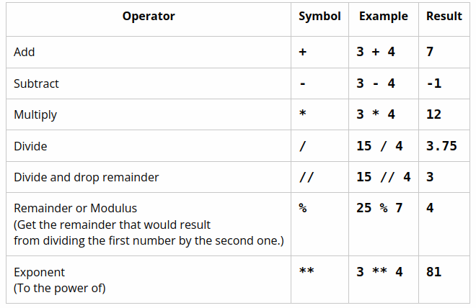

combine data types will bring errors
str() function to convert data types to strings
first_num = ‘5’ → number stored as string, not as number
input return strings by default
int() converts strings integer (whole number)
float() converts to float (number with point)
converting data from one type to another is called type-casting or “casting”
9. round
print(f“Round {number:.1f} please”) (:.1f the number indicates the # of decimals to round)
print(f”Write {big_number:,}”) (:, → will write the number as 10,300,300 (with commas))
print(f”Write {big_number:_}”) (:, → will write the number as 10_300_300 (with underscores))
10. Use libraries (math library)
import math (at the top of the program)
math.pi
math.ceil(value)—Rounds value up to the next whole number, the "ceiling."
math.floor(value)—Rounds value down to the next whole number.
math.exp(value)—Raises e to the power of value.
math.sin(value)—Computes the trigonometry sine function of value in

11. conditional logic
indentation in if statements is 4 spaces
== equal to
!= not equal to
|if something:
| do this thing
|else:
| do this other thing
|be careful when comparing strings
use elif, to check if one condition is true if not, pass to the other
add else statement for anything else that’s not inside the elif
if condition1 == “yes” or condition2 == “no” #if any of them is true
do this
if condition1 == “yes” and condition2 == “no” #both of them have to be true
do this
if (x > 5 or x < -5) and y > 10: #parenthesis go first
it is a good idea to use parenthesis for complicated statements
x = True ...if not x: print(“it is false) #to check if a boolean variable is not True
boolean variables names → is_adult … has_hair … can_jump...etc

12. Loops
create variables outside the body, not inside an if or while etc
while: keep running this code as long as this code is TRUE
initialize unused integers to 0 or -1
initialize strings variables to “”
initialize boolean variables to False
initializing variables will help to use them outside the if, while, for, etc

13. working with images in python
images are made of pixels, each pixel can be represented as red, green, and blue (RGB)
values range from 0 to 255

14. Installing a python library
pre-built library→ python code written by others that you can use in your program
https://www.youtube.com/watch?v=tmyjalzSvPM&ab_channel=OSPY

