CSE 111
_______________________________________

Content and notes
0. Introd
0. Select interpreter https://stackoverflow.com/questions/50993566/vscode-there-is-no-pip-installer-available-in-the-selected-environment
0. para actualizar a python 3.10: sudo update-alternatives --install /usr/bin/python3 python3 /usr/bin/python3.10 1
0. Introduction, concepts to remember:
-Comments (#)
-User input (input() function) … it always return a string
-Variables
-Data types
-str (string)
-bool (boolean variable)
-int (integer)
-float (floating point number)
-list (collection of value) …. color = [“red”, “yellow”]
-dict (dictionary. Collection of values)(each item is key value pair)
students = {“key1”: “value1”,“key2”: “value2”,“key3”: “value3”}
-convert data types: str(), int(), float()
-print()
- f-string
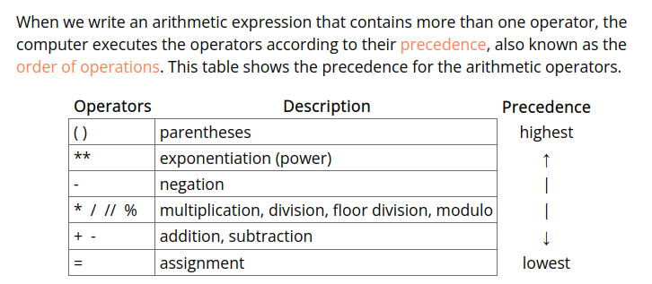
- Shorthand operators:
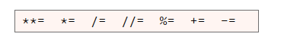

- if statements (also called selection statements) (use : and indentation)
we can use 6 comparison operators in an if statement
< less than
<= less than or equal
> greater than
>= greater than or equal
== equal to
!= not equal to

-if...elif...else statements
-logical operators (and , or, not)
-used to combine two comparisons

1. Note that in a Python program, a triple quoted string at the top of the file acts as a comment for the entire program.
1.2 A parameter is a piece of data that a function needs in order to complete its task. In the online reference for the input function, we see that the input function has one parameter named prompt.

1.3 An argument is the value that is passed through a parameter into a function. In other words, parameters are listed in a function's documentation, and arguments are listed in a call to a function.
2.0. A function is a group of statements that together perform one task.

2. Built-in functions: Python includes many built-in functions such as: input, int, float, str, len, range, abs, round, list, dict, open, and print. These are called built-in functions because you don't have to import any module to use them. They are simply a built-in part of the Python language.

3. Standard library functions: A Python module is a collection of related functions. The Python standard library includes many modules which have more functions, such as the math module—which includes the floor, ceil, and sqrt functions and the random module—which includes the randint, choice, and shuffle functions.

4. Third-party functions
5. User-defined functions
-advantages of writing your own functions:
-making your code more reusable
-making your code easier to understand and debug
-making your code easier to change and add capabilities
-The function name must start with a letter or the underscore (_). The rest of the name must be made of letters, digits (0–9), or the underscore
-A function name cannot include spaces or other punctuation.
-is a good idea to limit functions to less than 20 lines of code.
-The most reusable functions are ones that take parameters, perform calculations, and return a result but do not perform user input and output.

-When you need to repeat something, you can create a function and call it everytime instead of writing the same code over and over again
-return: passes back a value...so you need a place to put what is returned back
-functions must be declared before the line of code where the functions is called
-positional-notation: the order does matter
-named-notation: makes your code more readable. with this notation the order doesnt matter.. you can specify parameters in any order
first_name_initial = get_initial(force_uppercase=False, name=first_name)
-you can use default values in parameters
def get_initial(name, force_uppercase = True):

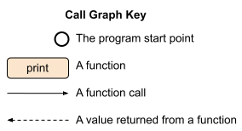

6. Function details:
-The scope of a variable determines how long that variable exists and where it can be used. Within a Python program, there are two categories of scope: local and global. A variable has local scope when it is defined (assigned a value) inside a function. A variable has global scope when it is defined outside of all functions.
-Parameters have local scope because they are defined within a function
-to pass a variable from one function to another, you can add a parameter to the function you want it to pass to:
import math

def main():
radius = float(input("Enter the radius of a circle: "))
area = circle_area(radius)
print(f"area: {area:.1f}")

def circle_area(radius):
area = math.pi * radius * radius
return area

main()

-you can add default parameter values and optional arguments
-def arc_length(radius, degrees=360):
-the argument for a parameter that has a default value is optional.

7. Function design:
-A good function is understandable by other programmers.
-write a documentation string at the top of the function's
-write comment in the body of the function as needed
-A good function performs a single task that the programmer can describe, and the function's name matches its task.
-A good function is relatively short, perhaps fewer than 20 lines of code.
-A good function has as few decision points (if statements and loops) as possible. Too many decision points in a function make a function error prone and difficult to test.
-A good function is as reusable as possible. Functions that use parameters and return a result are more reusable than functions that get input from a user and print results to a terminal window.

8. Testing functions:
-if I want to test “student.py” call the test file “test_student.py”
-an assertion is a statement that causes the computer to check if a comparison is true. When the computer checks the comparison, if the comparison is true, the computer will continue to execute the code in the program.
- The Python keyword to write an assertion is assert.
- pytest allows a programmer to write simple test functions that use the Python assert statement to verify that a function returns a correct result.
-The pytest module contains a function named approx to help us compare floating point numbers.
- assert math.sqrt(5) == approx(2.24, 0.01)

- How to test a function?
- 1. Write a function that is part of your normal Python program.
- 2. Think about different parameter values that will cause the computer to execute all the code in your function and will possibly cause your function to fail or return an incorrect result.
- 3. In a separate Python file, write a test function that calls your program function and uses an assert statement to automatically verify that the value returned from your program function is correct.
- 4. Use pytest to run the test function.
- 5. Read the output of pytest and use that output to help you find and fix mistakes in both your program function and test function.

- It is a good idea to separate test functions and program functions because the separation makes it easy to release a program to users without releasing the test functions to them.
- To import function from one program to another
-from file_name import function_1, function_2, … function_N
- Writing the if statement above the call to main() is the correct way to write code to start a program. The Python programming language guarantees that when the computer imports the program functions (in order to test them), the comparison in the if statement will be false, so the computer will skip the call to main().
- if __name__ == "__main__":
main()
- For pip to work correctly python3 -m pip install --user --upgrade pip setuptools wheel
- Install pytest python3 -m pip install --user pytest

8. Troubleshooting functions:
- Types of mistakes: There are 2 types of mistakes or errors.
1. Syntax errors: mistake made by a programmer that violates the rules of a programming language such as misspelling a keyword, forgetting to type a closing parenthesis, or forgetting to type a colon (:) at the end of an if statement.
2. Logic errors: a mistake made by a programmer that causes the computer to produce the wrong results.
- Error messages:
1. Read and understand the error message
- EOL: end of line
- EOF: end of file
- EOT: end of transmission
- Print statements: you could add print statements to your program in strategic locations to help you find the mistakes. These print statements should print the value of the variables in your program so that you can examine the values to ensure they are correct.

- Test functions: write programs to test functions instead of testing them manually
- Using a debugger: a debugger is a software development tool that allows a programmer to watch the computer execute the statements in a program.
- Insert a breakpoint: tells the computer where to stop and wait for us to tell it what to do. The red dot that shows next to the line numbers in VS Code

