Nefi Melgar
Final Exam
array_1 ← [1…N]

sum_numbers ← 0 // A
FOR number_1 in range(1, len(array_1)+2) // B
sum_numbers += number_1 // C

pre_result ← 0 // D
FOR number_2 in array_1 // E
pre_result += number_2 // F

missing_number ← sum_numbers – pre_result // G
PRINT the missing number is missing_number

The following example will use an array from 1 to 5, where the missing number is 4 . array_1 = [1, 3, 2, 5]

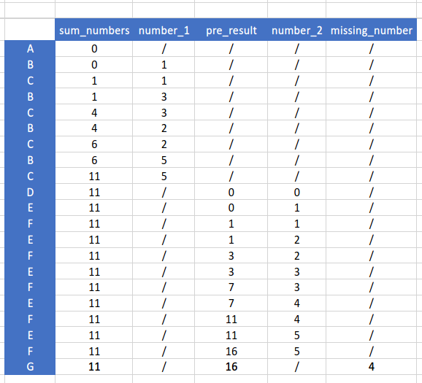

It has an algorithm efficiency of O(n), at this point the performance of the algorithm will have a direct relationship to the amount of input into the algorithm. Maybe the teacher will not have so many students to make the algorithm to work so bad.

