DATA TYPES
boolean = True
number = 1.1
string = "Strings can be declared with single or double quotes."
list = ["Lists can have", 1, 2, 3, 4, "or more types together!"]
tuple = ("Tuples", "can have", "more than", 2, "elements!")
dictionary = {'one': 1, 'two': 2, 'three': 3}
variable_with_zero_data = None
FUNCTIONS?

CLASSES?

EFFICIENCY = COMPLEXITY → how well are you using your computer resources to get a particular job done ( space | time ) … if you can get the same result by doing less, have in mind the goal of reducing repetition

ALGORITHM = series of steps for solving a problem

What is more important the time of the person using your code or is the amount of memory needed is more important?

We can describe efficiency of code using
BIG-O NOTATION: O(n) || (n→ mathematical function)
n => length of an input to your function (numero o tamaño del conjunto)(numero de inputs)
you CAN use other variables not just n letter
BIGO => HOW TIME SCALES WITH RESPECT TO THE INPUT VARIABLES

n (scales linearly, time increases linearly with the amount of data(input)) (twice amount the data takes twice the amount of time) (linear complexity)

Entre más datos se tienen que transferir, más tiempo se toma el internet en transferirlos

1. Different steps get added
2. Drop constants
3. Different inputs => different variables
4. Drop non-dominate terms
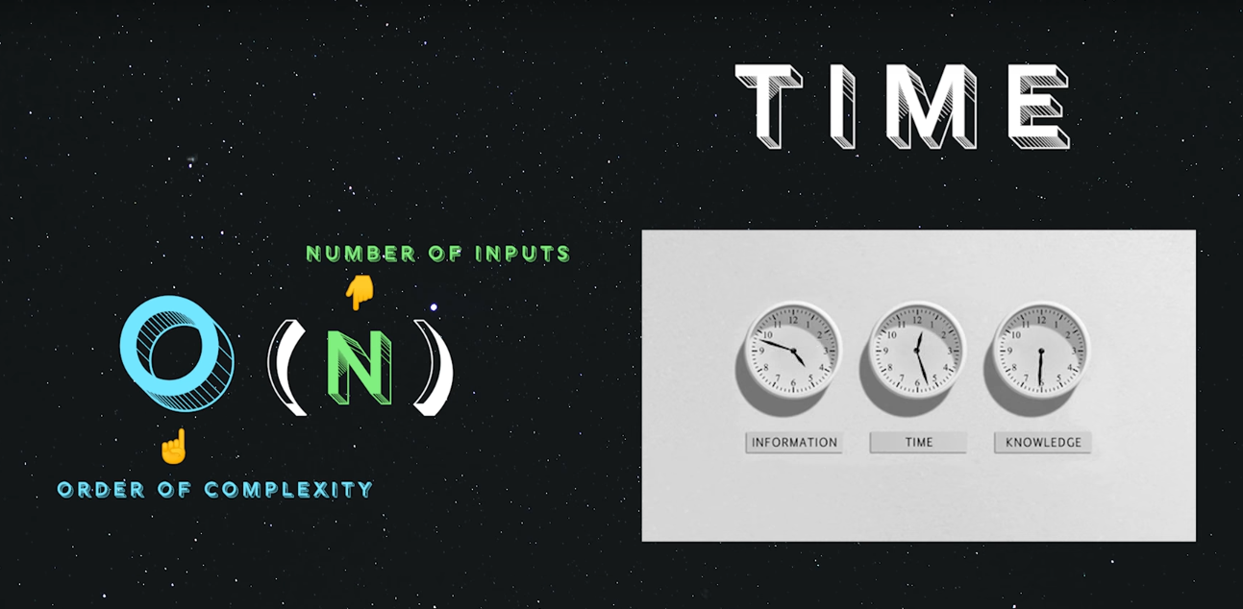
if it takes more space is space complexity

Big O notation tells you how fast an algorithm is. For example, suppose you have a list of size n. Simple search needs to check each element, so it will take n operations. The run time in Big O notation is O(n).

Simple Search: ( it will take n steps)
You need to find an username, letter, name, number, etc
-It starts at 1 and then 2, 3, 4, 5…. etc until finding the element

Binary Search: ( it will take log₂ n steps)
You need to find an username, letter, name, number, etc
Its input is a sorted list of elements, if the element is in the list, it will return the position where it’s located, otherwise it will return NULL
-It starts at some point on the middle of the list and start eliminating elements until reaching the desired element
So binary search will take 18 steps—a big difference! In general, for any list of n, binary search will take log 2 n steps to run in the worst case, whereas simple search will take n steps.
Binary search only works when your list is in sorted order.

Logarithms
Log₁₀ 100 → how many 10s do we multiply together to get 100? answer is 2 (10x10),
So, Log₁₀ 100 = 2
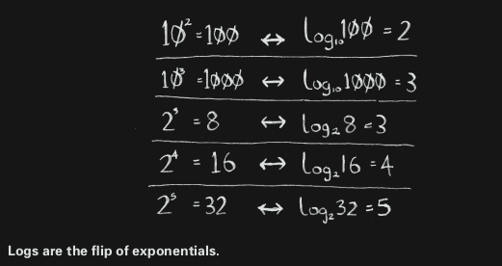

Talking about running time in Big O notation log always means log 2.
A list of 8 elements, log 8 == 3, because 2³ == 8. So for a list of 8 numbers, you would have to check 3 numbers at most. For a list of 1,024 elements, log 1,024 = 10, because 2¹⁰ == 1,024.

CONTINUE PAGE 10

Strings
