Project: | Assignment 4.2
Course: | CSD 380
Description: | Test plan for todo application
Date: | 2025/06/17
.
TABLE OF CONTENTS
Create a new todo task item 2
Delete a todo task item 2
For invalid URLs, provide users with a custom 404 error page 3
Prevent users from submitting a task form without entering a todo item 4
Prevent users from submitting the edit form without entering a todo item 5

For each test, the developer should: provide a test description, a test objective, the developer name and date tested. For each step, fill out the actions to be taken and describe the expected results, and indicate yes or no for each step depending upon the result. The peer tester should provide their name, date tested, indicate yes or no for each step depending upon the result, and a screenshot (thumbnail) of the result.

Test 1 | Create a new todo task item
 | Test Objective: Verifies that creating a new task item adds it to the list | Developer: Megan Wheeler  Date tested: 2025/06/17 | Peer tester: Nima Memarzadeh  Date tested: 2025/06/18
Step | Action | Expected results: | Developer pass/fail | Tester pass/fail  + Screenshot
1 | Open Web browser and go to https://buwebdev.github.io/todo/ | Todo application loads successfully with an empty task list or existing tasks displayed | yes | Yes  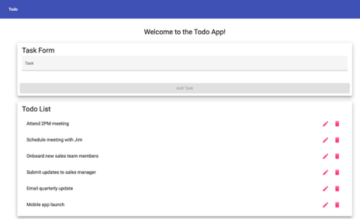
2 | Find the text input field where new todo items can be entered | Input field is visible and accessible for text entry | Yes | Yes  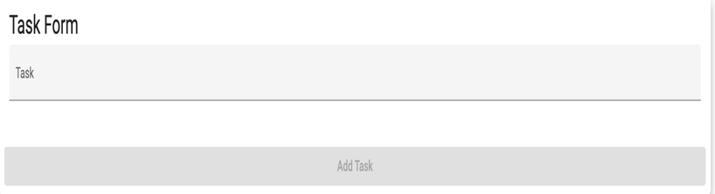
3 | Type a new todo item text (e.g., "Buy groceries") into the input field | Text appears in the input field as typed | Yes | Yes  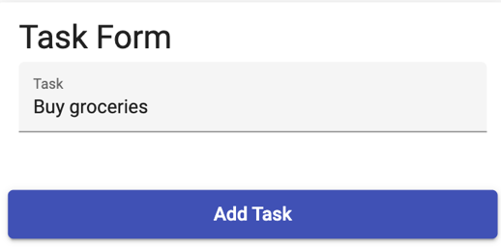
4 | Click the "Add Task" button | New todo item appears in the task list below the input field | yes | Yes  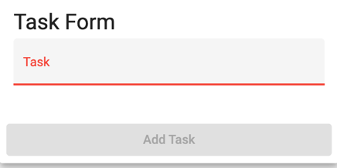
5 | Check that the new todo item is displayed in the list with appropriate formatting | Todo item is visible in the list, typically with a checkbox and the entered text | yes | Yes  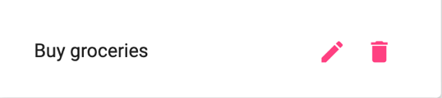
Comments | The test is well-organized and clearly verifies the core functionality of adding a new todo item. All steps were easy to follow and worked as expected, with helpful screenshots included. For improvement, consider adding a check for edge cases like empty input to ensure proper validation.

Test 2 | Delete a todo task item
 | Test Objective: Verifies that a task item on the todo list can be deleted | Developer: Megan Wheeler  Date tested: 2025/06/17 | Peer tester: Nima Memarzadeh  Date tested: 2025/06/18
Step | Action | Expected results: | Developer pass/fail | Tester pass/fail
1 | Open Web browser and go to https://buwebdev.github.io/todo/ | Todo application loads successfully with an empty task list or existing tasks displayed | yes | Yes  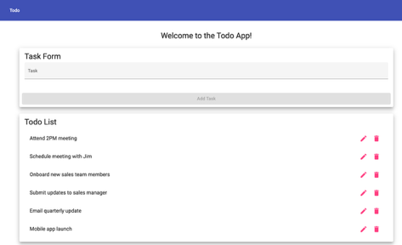
2 | Either create a new todo item or locate an existing one in the list | At least one todo item is present in the list | yes | Yes  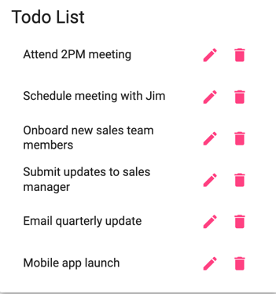
3 | Look for the trash icon associated with the todo item | Icon is visible and clickable | yes | Yes  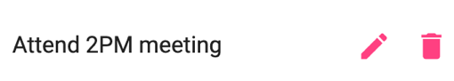
4 | Click the icon for the selected todo item | Todo item is removed from the list immediately | yes | Yes  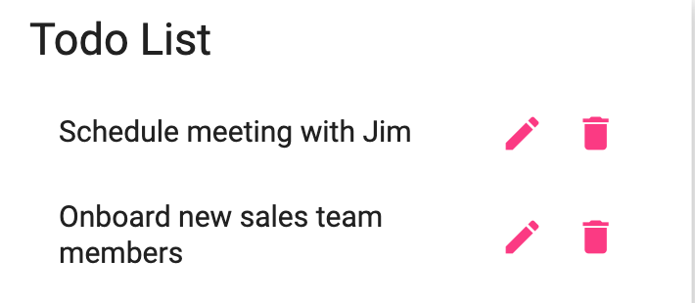
5 | Confirm the todo item is no longer visible in the task list | Deleted item is completely removed from the display | yes | Yes  
Comments | The test effectively confirms the delete functionality works as intended, with each step clearly outlined and supported by accurate screenshots. The UI elements, like the trash icon, were easy to identify and functioned correctly. For improvement, consider checking if a confirmation step or undo option exists, which could enhance usability and prevent accidental deletions.

Test 3 | For invalid URLs, provide users with a custom 404 error page
 | Test Objective: Verifies that an invalid URL displays a custom 404 error page | Developer: Megan Wheeler  Date tested: 2025/06/17 | Peer tester: Nima Memarzadeh  Date tested: 2025/06/18
Step | Action | Expected results: | Developer pass/fail | Tester pass/fail
1 | Open Web browser and go to https://buwebdev.github.io/todo/ | Todo application loads successfully with an empty task list or existing tasks displayed | yes | Yes  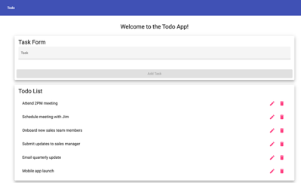
2 | Modify the URL to include an invalid path (e.g., https://buwebdev.github.io/todo/invalid-page) | Custom 404 error page is displayed instead of a generic browser 404 | yes | Yes  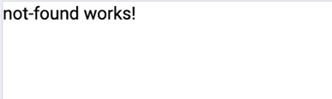
3 | Try accessing a non-existent subdirectory (e.g., https://buwebdev.github.io/todo/admin/nonexistent) | Custom 404 error page is displayed | no | No  
4 | Try accessing a file that doesn't exist (e.g., https://buwebdev.github.io/todo/random.html) | Custom 404 error page is displayed | no | No  
5 | Check the content and styling of the displayed 404 page | Page shows custom branding, helpful message, and navigation back to main application | no | No  
Comments | The test identifies important gaps in how the custom 404 page is implemented. While one invalid URL correctly displays the custom message, other broken paths return only a plain message with no styling, branding, or helpful navigation. I recommend ensuring consistent behavior across all invalid routes and enhancing the error page with user-friendly design and links back to the main application.

Test 4 | Prevent users from submitting a task form without entering a todo item
 | Test Objective: Verifies that users cannot submit a task form without a todo item | Developer: Megan Wheeler  Date tested: 2025/06/17 | Peer tester: Nima Memarzadeh  Date tested: 2025/06/18
Step | Action | Expected results: | Developer pass/fail | Tester pass/fail
1 | Open Web browser and go to https://buwebdev.github.io/todo/ | Todo application loads successfully with an empty task list or existing tasks displayed | yes | Yes  
2 | Leave the input field empty and press Enter or click submit button | Form submission is prevented, no new empty item is added to the list | yes | Yes  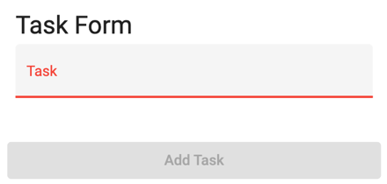
3 | Enter only spaces or tabs in the input field and attempt to submit | Form submission is prevented, whitespace-only items are not added | no | No  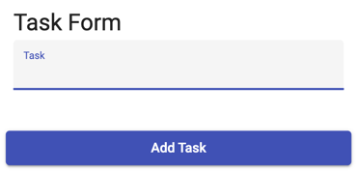
4 | Enter only special characters (e.g., "!!!") and attempt to submit | Form either accepts valid special characters or prevents submission based on validation rules | no | No  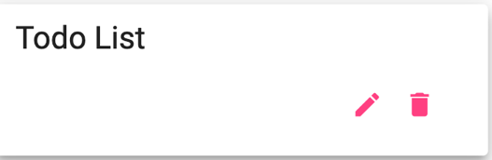
5 | Check if any error message or visual feedback is provided when submission is prevented | User receives clear feedback about why submission failed (if applicable) | no | No  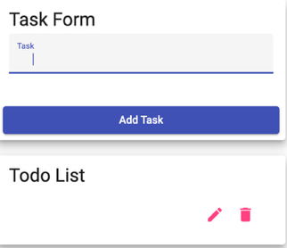
Comments | This test highlights key validation issues in the task submission form. While the form correctly blocks completely empty submissions, it fails to prevent whitespace-only or special-character-only entries, and there is no feedback to inform the user why submission failed. Improving input validation and providing user-friendly error messages would significantly enhance the form's reliability and usability.

Test 5 | Prevent users from submitting the edit form without entering a todo item
 | Test Objective: Verifies that a user cannot submit the edit form without a todo item | Developer: Megan Wheeler  Date tested: 2025/06/17 | Peer tester: Nima Memarzadeh  Date tested: 2025/06/18
Step | Action | Expected results: | Developer pass/fail | Tester pass/fail
1 | Open Web browser and go to https://buwebdev.github.io/todo/ | Todo application loads successfully with an empty task list or existing tasks displayed | yes | Yes  
2 | Either create a new todo item or locate an existing one in the list | At least one todo item is present in the list | yes | Yes  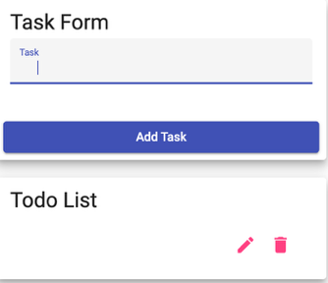
3 | Click on the todo item edit button to enable editing | Todo item becomes editable | yes | Yes  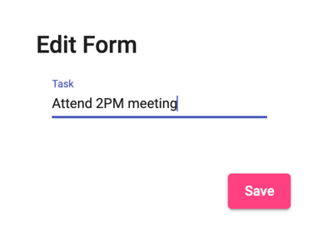
4 | Delete all text from the todo item, leaving it empty | Input field becomes empty | yes | Yes  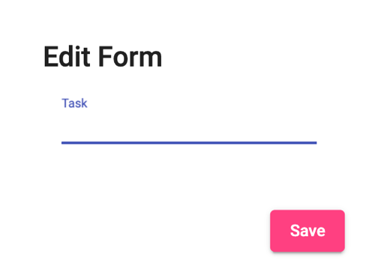
5 | Click save button while the field is empty | Edit submission is prevented, empty todo item is not saved | no | No  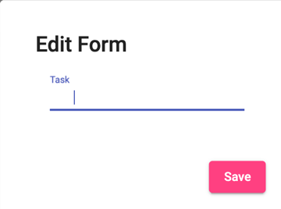
6 | Enter only spaces in the edit field and attempt to save | Edit submission is prevented, whitespace-only content is not saved | no | No  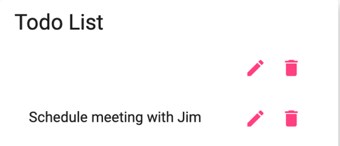
7 | Check if any error message or visual feedback is provided when edit submission is prevented | User receives clear feedback about why the edit failed to save | no | No  
Comments | The test clearly shows that the edit form lacks proper input validation. It allows empty or whitespace-only edits to be submitted, and provides no feedback when the submission fails, which can confuse users. Implementing validation rules and clear error messages would greatly improve the reliability and user experience of the edit functionality.

