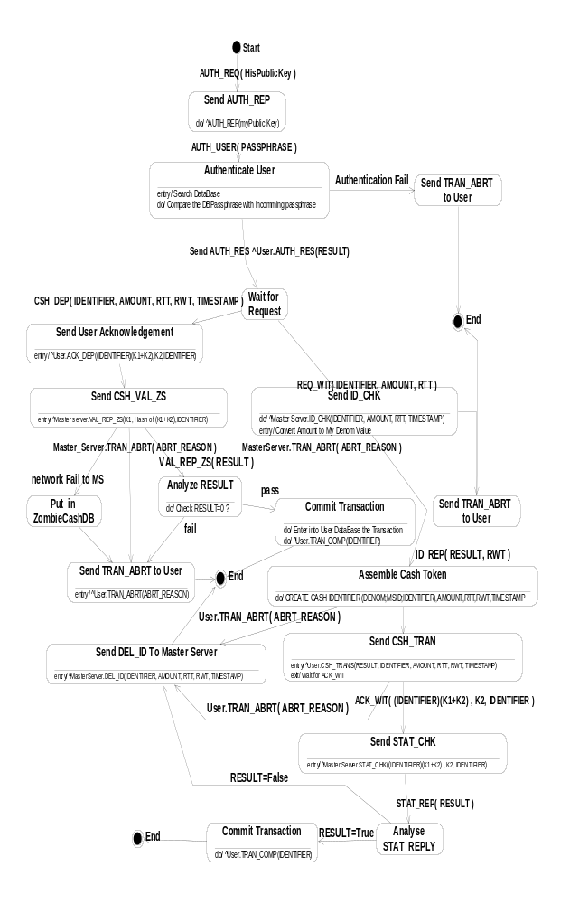
Figure 4.3.The Complete Zone Server State Diagram

