Final Project Presentation

Abstract

Online Electronic Payment System Using PREDICT II Protocol

Nishanth Menon
(98M11)

3rd October 2001.
1 The Problem Statement
The objective of this project is to create a scalable model of an online Electronic Payment System, allowing authorized users to access and utilize their wealth anywhere from the Internet using the PRotocol Enhancement of DIgital Cash Transaction- II protocol.

  - System Inputs
(1) User Information – name, Pass Phrase etc.
  - Amount of Cash to be transacted.
  - The IP of the Zone Server.
  - The IP and optionally the port of the Server socket of the remote client software.
  - The Key Generation information (including no: bits RSA Key, Hashing algorithm for the password storage, Hashing algorithm for encrypting the RSA Key, Encryption algorithm for storing the RSA Key, other configuration information).

  - System Outputs
- Transaction Result–Whether completed or failed etc.
- Passbook format Transaction information.
- Complete transaction information.
- Personal information of authorized client users.

      - Functional Requirements
- Creating an account The System should be able to create an account with the Zone Server for each authorized users.
- Deleting an account The System should be able to delete an account with the Zone Server of an authorized user.
- Requesting Passbook Information The System should provide Information in Passbook format for an authorized client.
- Requesting Transaction History The System should provide an authorized client, on request, information about past transactions.
- Change of Personal Information The System should provide ability for a valid client to change his personal information.
- Deciding on the amount of cash to be transacted The client has the ability to decide on the amount of cash to be transacted in the system.
- Sending Cash token. The Client must be able to send cash token to a remote client.
- Receipt of Cash token The Client must be able to receive the cash token from a remote client.
- Cash transaction Policing The government must be able to set up policing of cash transaction for the ability of controlling the cash transactions.

3. Design
3.1 The Protocol Design
The Protocol Used in this project is represented in Figure 1.
3.2 System Use-Case diagram
The Use Case Diagram represents the functionality of the system. The Entire System Use case is presented below in Figure 2.

Zone 1
SERVER

MASTER
SERVER

Zone 2
SERVER
Receiver
Sender
1
Cash Transmit
(REQ_WIT)
6
Deposit Confirm
(CSH_TRANS)

2
Cash Forward
(CSH_FWD)
3
Cash Deposit
(CSH_DEP)
4
Deposit Acknowledge
(ACK_DEP)
5
Deposit Acknowledge Forward (ACK_FWD)
9
Confirm Request
(CSH_VAL_ZS)
10
Confirm Acknowledge
Or
Reject Confirm
(VAL_REP_ZS)
7
Reject / Status Check
(ID_CHK)
(STAT_CHK)
11
Transact Complete
(TRAN_COMP)
11
Transact Complete
(TRAN_COMP)
8
Status Confirm
(STAT_REP)
Figure 1. The PREDICT II Protocol

4. Implementation
Following Software and scripts have been developed (total – 12905 lines of Java Code without comments and blank lines) and platform was JDK1.3.1 on RH Linux 7.1.
i) Kuchelan – the Client Software used to access the wealth and other Client Software.
- Kuberan - the Zone Server Software offering the Services that are provided by the Zone Server.
- Brahma – the Master Server Software offering Services that are provided by the Master Server.
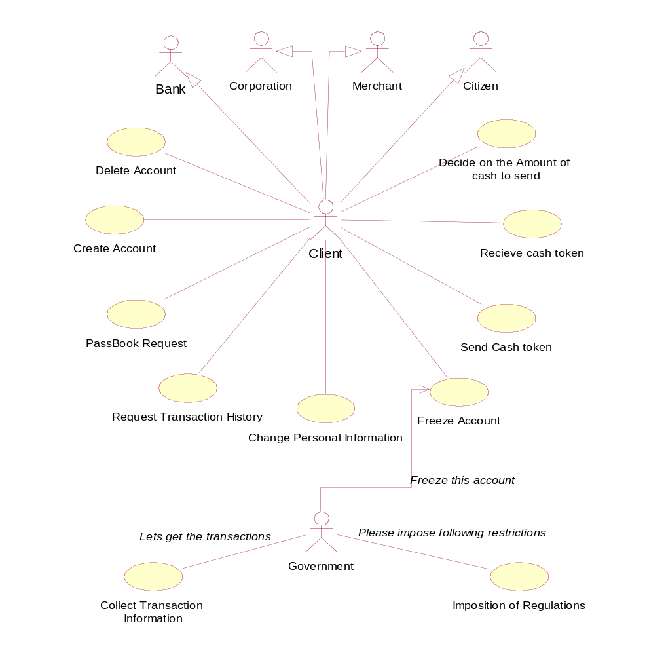
- Web Server Scripts- These are CGI-Perl Scripts and java that provide the information to authorized client users using HTTPS.
Figure 2. Complete System Use Case Diagram

5. Testing
Testing was done by ‘main’ function in each and every class in the project. This allowed unit testing and integration testing of the system to be done. Final testing was done by simulation of network time delays by in-code sleep statements (later removed). Structure testing was not done due to time restrictions.

