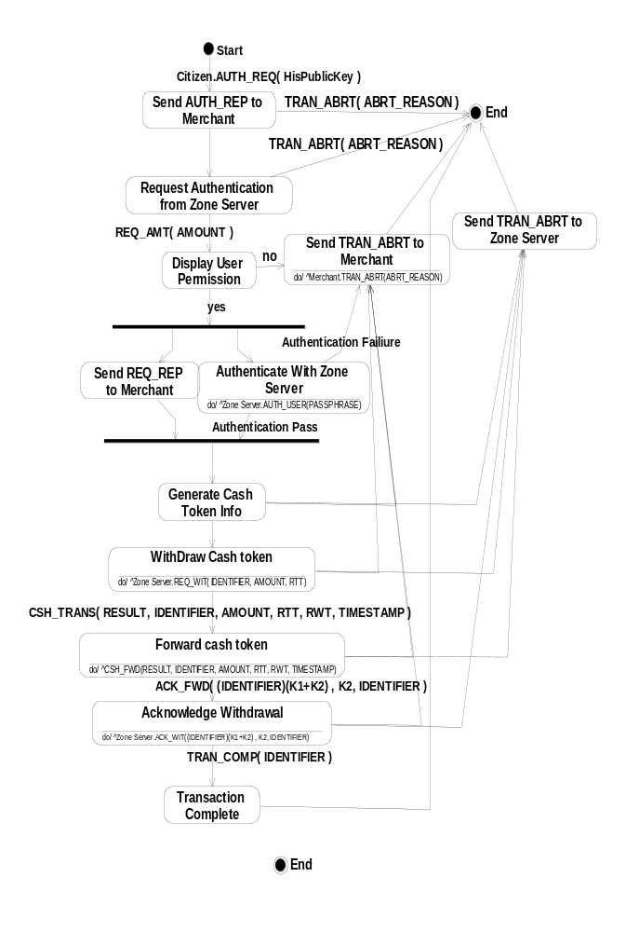
Figure 4.1 The State Diagram for the Citizen part of the Client Software

