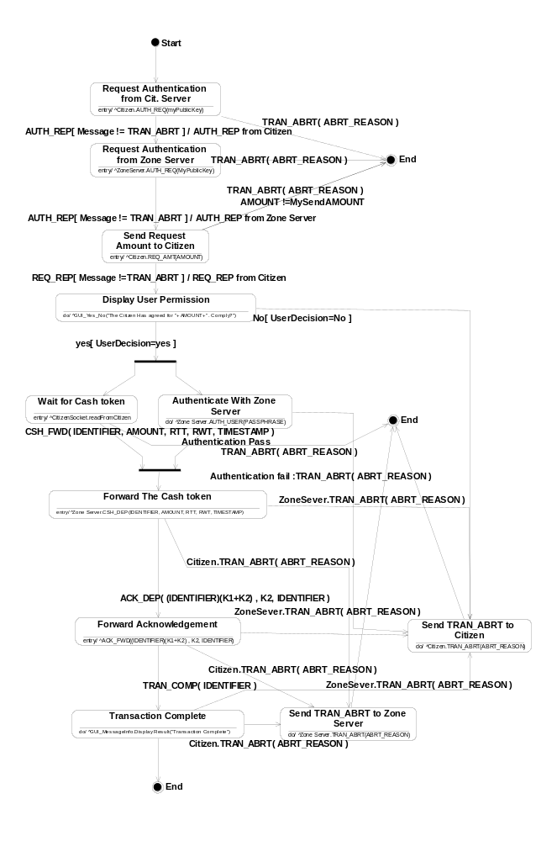
Figure 4.2 The state diagram for the Merchant part of the Client Software

