**JETS User Manual**

**Background**

The subject application has been developed as a framework for a general JPSS telemetry and science data analysis tool. This is specifically aimed at aiding JPSS personnel in substantive data analysis of JPSS payload instruments while a JPSS spacecraft is being tested at the spacecraft vendor or at the launch site. In certain cases, this tool set can also be used to evaluate some data sets taken from instrument level testing. This manual provides a detailed layout, as well as instructions for JETS (JPSS Evaluation Tools Suite).

_____________________________________________________________________________________

**Table of Contents**

1 Top Level

1.1 General Functionality

1.1.1 Data format

1.1.1.1 Description

1.1.2 Database usage

1.1.2.1 Description

1.1.2.2 Decomm

1.1.2.3 Calibration Curves

1.1.2.4 Telemetry Descriptions

1.1.2.5 Instructions

1.1.3 Offline Decomm Tool

1.1.3.1 Description

1.1.3.2 Instructions

1.2 Main Window

1.2.1 Description

1.2.2 Instructions

2 Real Time Emulation Module

2.1 Description

2.2 Online OMPS Window

2.2.1 Description

2.2.2 Instructions

3 CAT Module

3.1 Description

3.2 Dashboard Window

3.2.1 Description

3.2.2 Instructions

3.3 Science EMI Window

3.3.1 Description

3.3.2 Instructions

3.4 Dwell FFT Window

3.4.1 Description

3.4.2 Instructions

3.5 Frequency GUI Window

3.5.1 Description

3.5.2 Instructions

_____________________________________________________________________________________

**1 Top Level**

**1.1 General Functionality**

1.1.1 Data Format

1.1.1.1 Description

JETS requires, at the lowest level, data in CCSDS packet format. This can include segmented packets (i.e. in OMPS science format) or single packets. The CAT module can handle both raw CCSDS packet files (.PDS files), or CCSDS packets stored in hdf5 files. The Real Time Emulation module can currently only use hdf5 files to simulate a real time data feed, using real data.

1.1.2 Database usage

1.1.2.1 Description

Databases from the JPSS ground team are used to keep track of important aspects of data in the CCSDS packets, such as location in a packet, byte/bit size, mnemonic, description, calibration coefficients, and units. JETS can ingest these databases for telemetry and science data. The tools will append any selected science or telemetry databases together into one large database for various usage.

The databases can be either in XML format, or in an Excel spreadsheet (NPP telemetry only). The database is ingested in its original form only once throughout the lifetime of the software (assuming the database is not deleted), and stored in a common csv format. CSVs yield faster reading times for the entire database than either original form, and allow for different database types to be used by all of the modules. Once the entire database is read, it is much faster to extract information from it, as there is no file i/o, only RAM memory accesssing.

1.1.2.2 Decomm

All of the CCSDS packet decomm (binary data parsing) performed in JETS requires the knowledge of the location, size, an data type of each data point in a CCSDS packet. The JETS decomm engines (offline and online) use a user-selected database (in the previously mentioned format) to find out this information about each packet, and extract only the necessary data.

1.1.2.3 Calibration Curves

Each database also contains calibration coefficients, which can transform raw sensor counts into values with units (i.e. Volts, Amps, Deg/Sec, etc.). The calibration coefficients are stored in the form (‘c0=<num> c1=<num> ...’), and can contain any number of coefficients. The coefficients are applied as an inner product

1.1.2.4 Telemetry Descriptions

The databases contain descriptions of each data point for each mnemonic in an APID. It is useful to view these descriptions to better understand the data being viewed. The Dashboard window in the CAT module has the capability to view the descriptions of the data being plotted, and the Real Time Emulator uses the descriptions as the plot title.

1.1.2.5 Instructions

Any time a new database, in any form, is acquired, place it in either the <PATH_TO>JPSS_tools/Matlab_tools/DBD_XML folder for XML databases, or the <PATH_TO>JPSS_tools/Matlab_tools/DBD_XLS folder for Excel databases (NPP telemetry only). The databases can be placed elsewhere on your computer, but the database selection always points to either one of those directories, which makes keeping track of databases much easier.

Each function that requires database usage, such as running the decomm engine, calibrating data, running the real time emulation, or showing telemetry descriptions, will run the user through a similar set of steps from the same database retrieval function. These steps will be explained here.

If there is no database loaded into memory, or a new database button is pressed, the user will be prompted with several options.

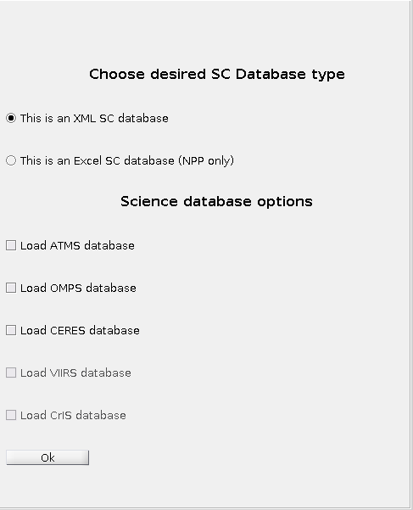

Choose the database type, which will prompt for the database file (Excel) or root directory (XML). There are options for science databases as well, which will prompt for the selected science databases.

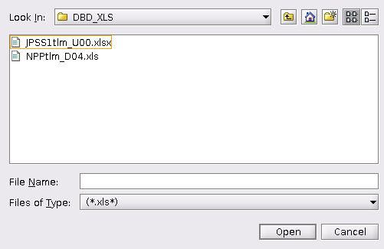

If the Excel option is chosen, the user will be pointed to the DBD_XLS directory containing the XLS databases placed there. Simply select the desired file, and click open. If the database has been used before, it will be read in from a separate source in the common JETS format.

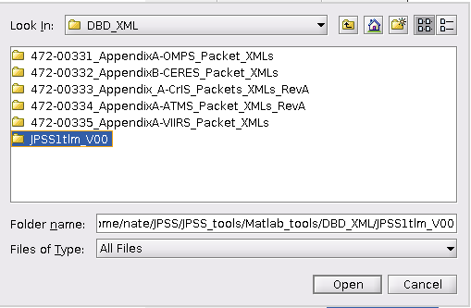 If the XML spacecraft database is chosen, the user will be prompted to choose the root directory of the XML database, from the databases placed in DBD_XML. Simply select the database directory, then select open. Note that only one database can be chosen here. If a science database is chosen, JETS can the format, and will start the prompting process again.

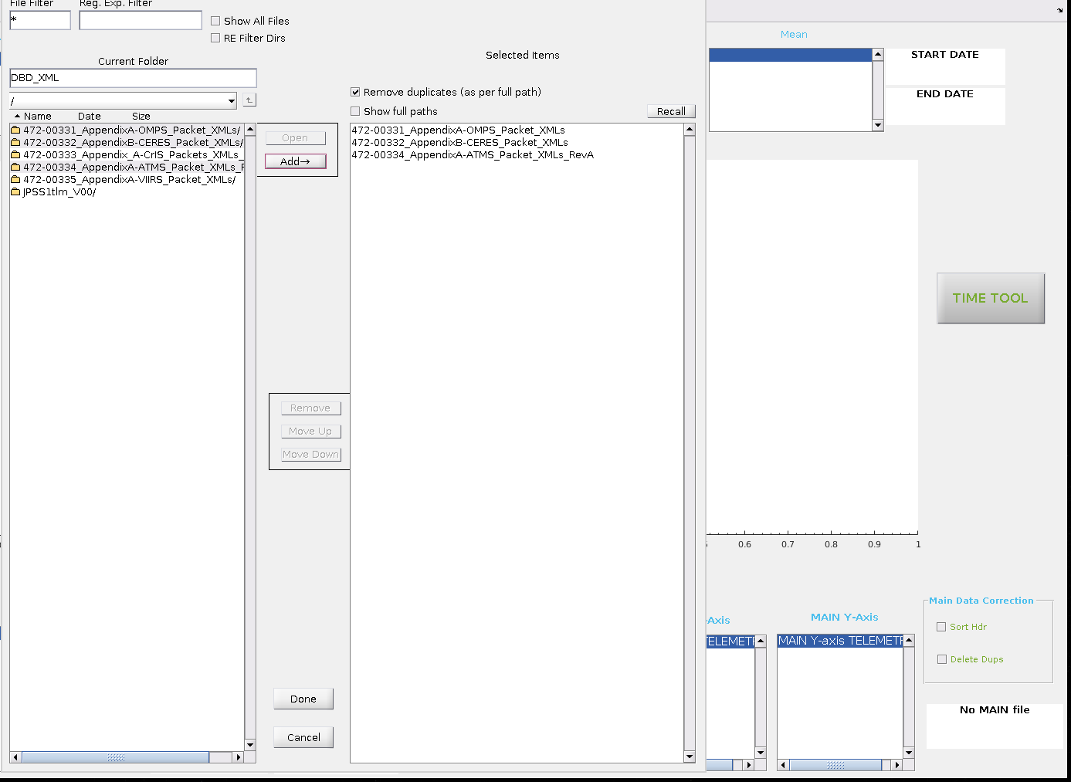

If any science databases are chosen, or the user is running the decomm engine and any of the science databases don’t exist in the databases folder, the user will be prompted with this screen to select multiple science databases. Simply control click the desired databases, click add, then click done to start loading those databases.

1.1.3 Offline Decomm Tool

1.1.3.1 Description

The offline decomm tool is part of CAT. It is a fast, parallelized utility for transforming raw CCSDS packets into a human-readable csv, which is used in the Matlab part of CAT.

This tool utilizes the afore mentioned databases to retrieve data from the packets. There is currently support for hdf5 files containing CCSDS packets, and PDS files. Currently there is support for all HK, and CERES, OMPS, and ATMS science data.

1.1.3.2 Instructions

Upon clicking any ‘Process Binary’ button in CAT, the user will be presented with the opening screen of the decomm utility.

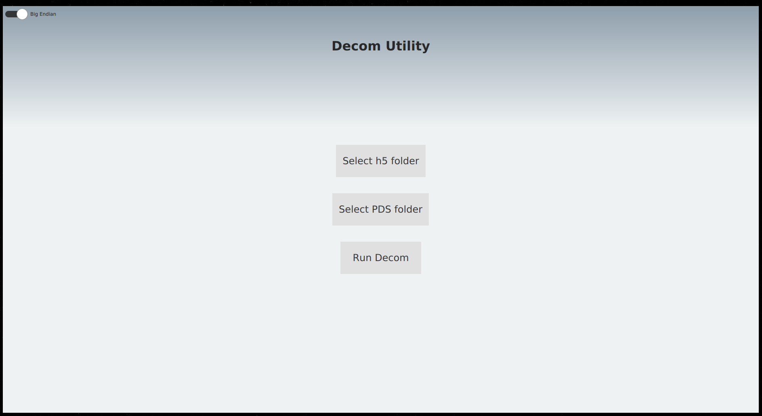

Click ‘Select h5 Folder’ if your data is in hdf5 format, or ‘Select PDS Folder’ if you have raw CCSDS packets with the .PDS extension. Note the ‘Big Endian’ switch at the top. For those who are not familiar with the term, ‘big endian’ refers to the most-significant bit being on the left, which is the same way we read base 10 numbers. If base 10 numbers were little endian, ‘01’ would be the number ten. This switch is there due to the fact that some servers store JPSS data as little endian. This is up to the user to decide. GRAVITE stores data as the default big endian.

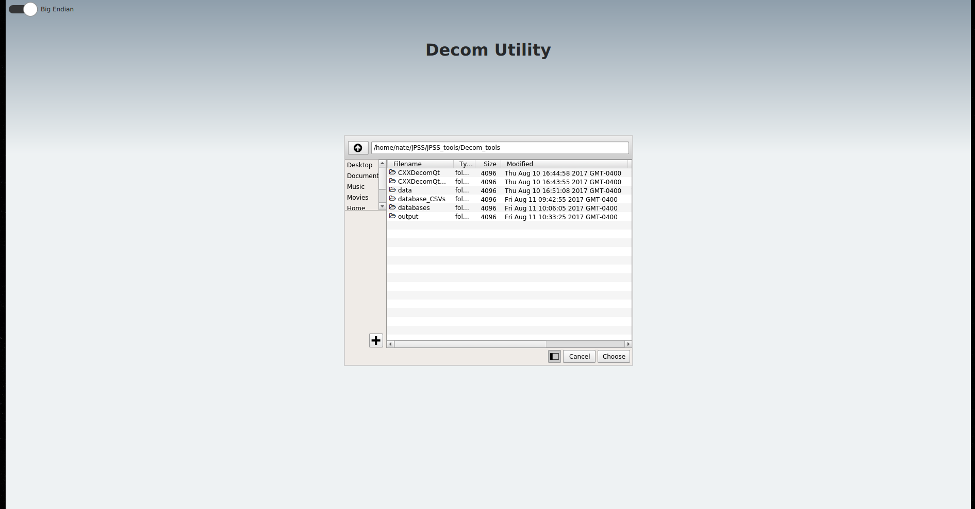

To select data, simply find the directory containing your data files, select it, then press ‘choose’.

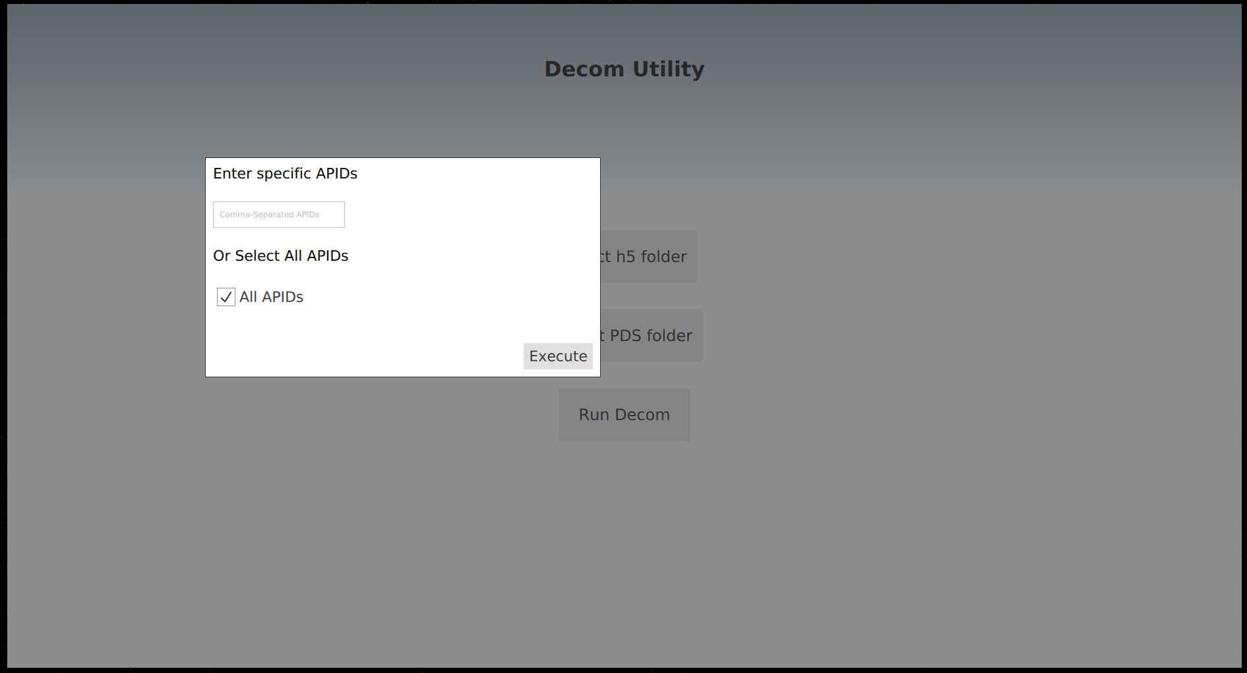

Once the data is selected, the data to be extracted can be filtered by APID by entering a comma-separated list of the desired APIDs. One can also choose to extract all APIDs in the packets. If an APID chosen is not found, the decomm utility will simply skip it.

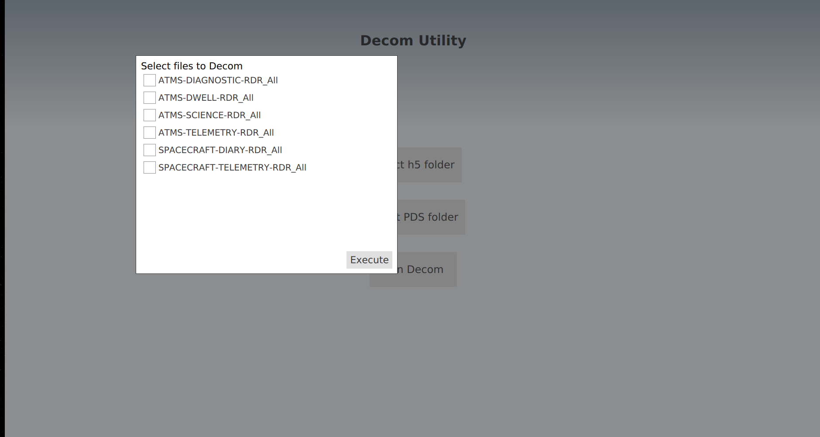

Finally, the user can choose specifically which data to extract based on the RDR name.

After pressing ‘Execute’ the decomm will commence. The user can be assured that there were no errors when the dialog ‘Decom has finished’ pops up.

**1.2 Main Window**



**Figure 1** The JETS main window display

1.2.1 Description

The main window is is the central point to access both the Real Time Emulator and CAT, as well as this documentation.

1.2.2 Instructions

The list of instruments on the left is a link to the Real Time Emulator tool. Only the OMPS version is currently working. The button that says CAT is a link to the CAT module. The Doc button will launch this manual.

**2 Real Time Emulation Module**

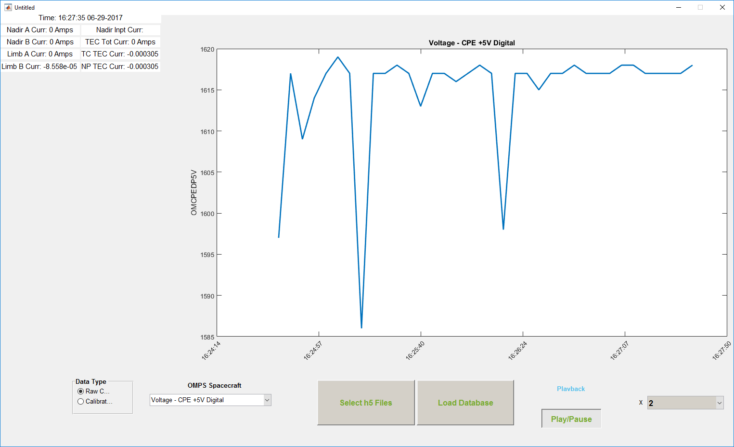**Figure 2** The Real Time Emulator OMPS Window

**2.1 Description**

The Real Time Emulation tool is a transition tool between offline post processing of data, and real time feed. This tool gathers files in hdf5 format, and loops through them in a timed manner to emulate a real time feed. The end goal is to use a similar back end, and the same database usage techniques for a final tool product that can handle a real time feed via ethernet port.

**2.2 Online OMPS Window**

2.2.1 Description

The Online OMPS Window is the only functional submodule for the Real Time Emulation module. It is specially designed to display OMPS HK data.

2.2.2 Instructions

1. Upon opening the window, click ‘Select h5 Files’ to choose the directory containing spacecraft telemetry h5 files.

2. Click ‘Load Database’ to load the correct spacecraft telemetry database based on the time frame of the data being used. See section 1.1.2.5 for how to do this

_____________________________________________________________________________________

**3 CAT Module**

**3.1 Description**

The CAT Module is used for offline processing of any JPSS HK data, and some science data. The currently supported science data for viewing are OMPS and ATMS. CERES data can be decommed into csv format, but there is no functionality to view it in a useful format yet.

CAT includes tools for viewing time series, 3D science surface plots, Discrete Fourier Transforms with or without Hanning windows, telemetry descriptions, numerical time derivatives of HK time series and calibrated plots with units.

This section will instruct the user in utilizing the full capabilities of CAT.

**3.2 Dashboard Window**

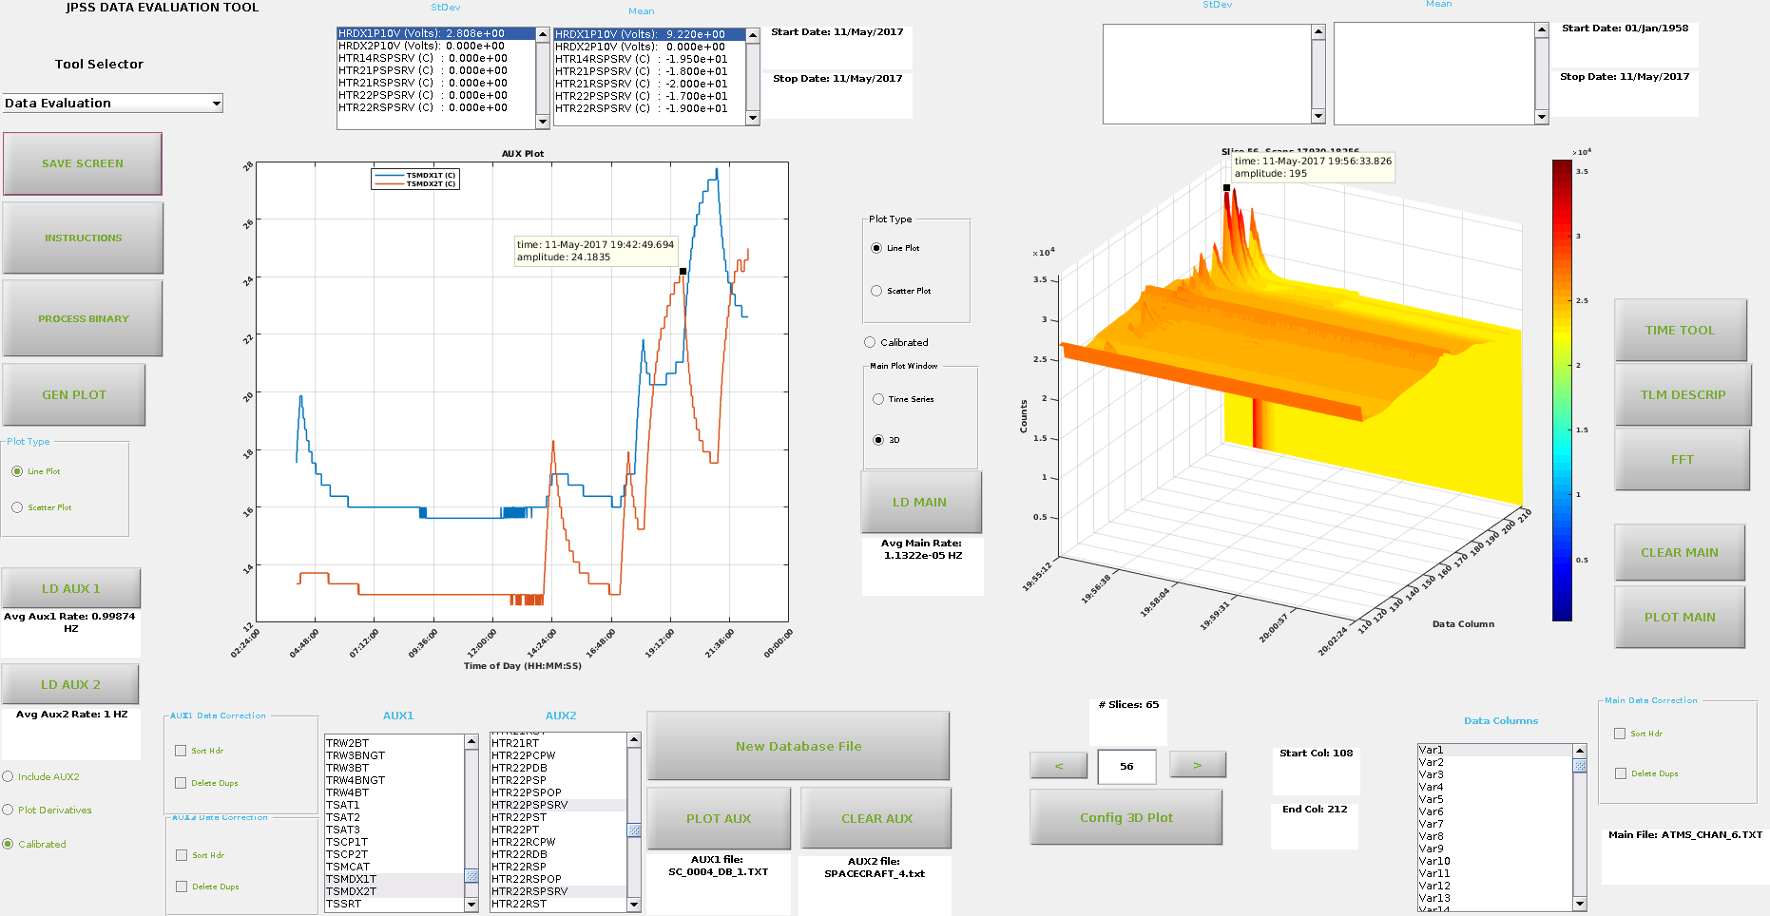**Figure 3** The dashboard window, with ATMS science and HK data

3.2.1 Description

The window is divided into several areas:

1. There are two plotting windows – one on the left and one on the right. They are each independent. That means that each can display different data.
   1. The rightmost plot area is termed the ‘Main’ window. This window can display most any data that is anticipated at this time. This can be either some form of science or any Housekeeping data.
   2. The leftmost plot area is termed ‘Aux’, as it is intended to display supporting data used for comparison purposes. This plot window can display data from any Housekeeping APID (instrument or spacecraft ). It is currently to enable the superposition plotting of two different APID files – FROM THE SAME TIME PERIOD. That means the files chosen for display in this plot window have to be selected from the same time based directory.
2. Each plotting window is supported by each own set of ‘pushbutton’ functionality such as ‘File Load’, ‘Plot’, ‘line plot’, ‘scatter plot’, ‘calibration’ and others.
3. On the left of the main window is a set of pulldown menus aimed at initiating specific tools for deeper analysis of individual payload instruments. Currently, only ATMS has significant processing capability apart from this top level tool.

3.2.2 Instructions

The first decision upon entering this tool is to determine if this ‘top level’ tool itself will be used to do some analysis or will it only be used to start a more detailed tool. If the top level tool is to be used for analysis or plotting, press the ‘GEN PLOT’ button on the top left. This will enable features in the window to Load file(s) for both the left and right plot windows.

If there is no processed data available, the tool has the capability to process raw binary data in the *.h5 or *.PDS file formats. This can be done by pressing the ‘Process Binary’ button. See 1.1.3 for how to go about the dcomm utility that this button launches. The files will be placed in the ‘data’ directory, in a sub directorybased on the SCID, the time in the data, and the data type.

Once the ‘GEN PLOT’ button is pushed, the file load functionality is enabled. Next to the right plot window, the ‘LD MAIN FILE’ button appears. Pushing this button will start a file explorer window to allow for the selection of the desired file. This file can be from any time period, and can be either science or HK data. The data is anticipated to be time ordered column format, which is what the decomm tool outputs.

Once the file is loaded, the column text headers (first row of data columns) are placed in the ‘list boxes’ at the bottom of the plot window.

Each file opened will result in the population of file data/time information, such as start and end time/data of the contents of the file. The time information embedded within the file will be decoded and displayed in small text window above the respective plotting windows, along with the x axis of the plots.

The AUX plotting window is only a ‘time based’ window. It will plot the selected parameters from either of the AUX1 or AUX2 files and label the plots. There is a ‘Zoom’ feature within the Matlab window to be able to zoom into a point of the plot that is of interest. Additionally, one can use the data cursor Matlab tool to see the exact time and amplitude of a data point, and the pan tool to move the plots.

Standard Deviation and Means are calculated for each plot and presented in separate windows. Separate windows are provided for the AUX and Main plot windows. Some data can be calibrated using the ‘Calibrated’ option. A database file is necessary for this, which is the Excel file or xml folder containing all relevant information about the APIDs. Currently only polynomial calibrations are available, excluding piece-wise polynomials. If an engineering data from a science file is to be calibrated, the user must select the corresponding science database as well.

For the ‘Main’ plotting window, a 3D plotting capability is incorporated to allow the rendering of instrument science data. The use of this function requires some knowledge on the part of the user, especially knowledge of the format and content of the data that is displayed. For example, ATMS science data is written to the files with each row being one lateral scan. Columns 1-109 are scan angle information, and after that are the scan data. The user must know this to choose which columns to plot in the 3D plotting window

**3.3 Science EMI Window**

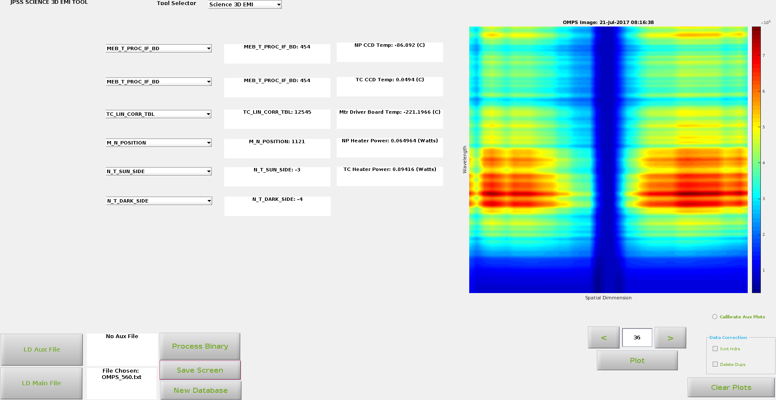**Figure 4** The Science 3D EMI tool showing raw OMPS data.

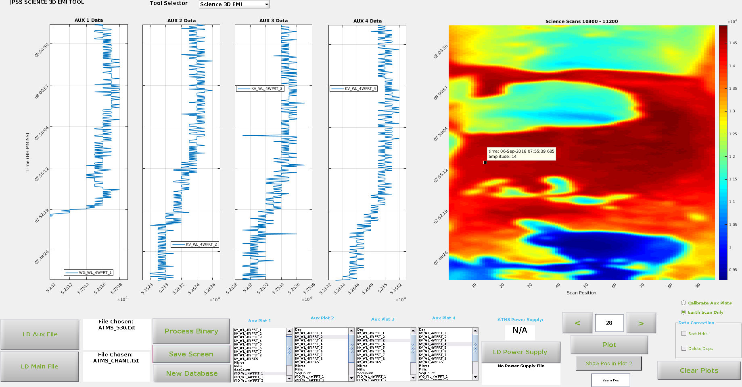**Figure 5** The Science 3D EMI tool viewing ATMS science data

3.3.1 Description

The Science 3D EMI tool is useful for viewing science data and HK at the same time, with the same time period being displayed across the horizaontal.

3.3.2 Instructions

One must first load data. The Main file refers to the science file, an the aux file refers to the HK file. Load one or both, then press plot. The data can be iterated through with the arrows under the plot window. The data is sliced up to create viewable images from one long continuous image.

The layout of the tool will change based on the instrument science loaded. See Figure 4 an Figure 5 to see this. This is due to the fact that each OMPS image comes from one time stamp, so there would only be one point in each plot on the left if the layout stayed the same.

For ATMS there is the option to view which power supply is being used. This functionality will be expanded to other instruments as well. To do this simply select ‘LD Power Supply’, then choose the fie containing the ATA1PW and ATB1PW mnemonics. This will then display ‘A’ or ‘B’ in the corresponding text window based on which power supply is being used at the start of the plot window.

**3.4 Dwell FFT Window**

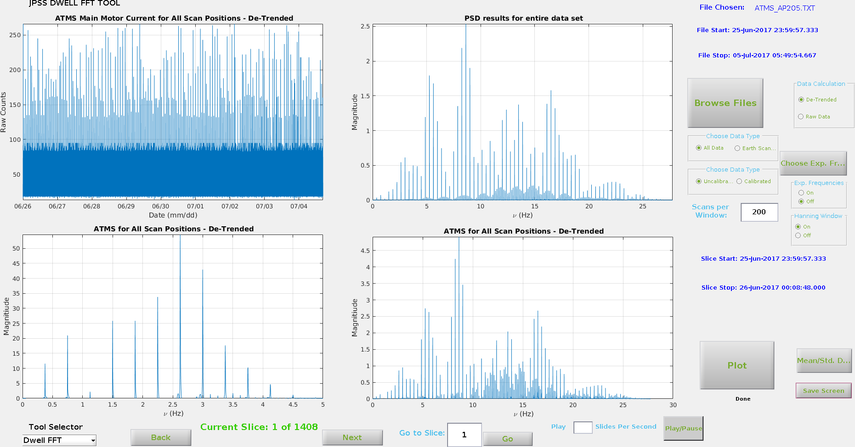**Figure 6** The Dwell FFT Tool displaying ATMS dwell data with a Hanning window

3.4.1 Description

The Dwell FFT Tool is a tool for Fourier analysis of dwell data. The top windows display raw and transformed data for the entire loaded dataset, while the bottom windows display data for a certain window in time.

3.4.2 Instructions

Load data as usual. Then an initial plot can be made. The number of scans in a slice for the bottom windows can be chosen with the ‘Scans per Window’ edit box. Iterate through the time windows with either the ‘next’ and ‘back’ buttons, or the Play/Pause button (which iterates automatically).

The Hanning window and expected frequencies can be turned on and off with their respective radio buttons. Additionally, the expected frequencies can be chosen using the ‘Choose Exp Freq’ button.

**3.5 Frequency GUI Window**

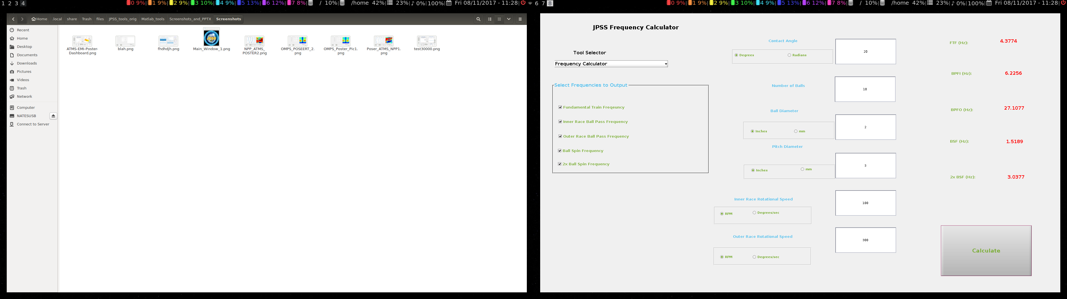

**Figure 7** The Frequency GUI Window

3.5.1 Description

The frequency GUI does not use external data. This tool is useful for calculating frequencies of motors spinning with information such as bearing dimensions known.

3.5.2 Instructions

Simply type all known values into the text boxes, with correct units, and press calculate.