**Making an Arduino Piano**

**The Wiring**

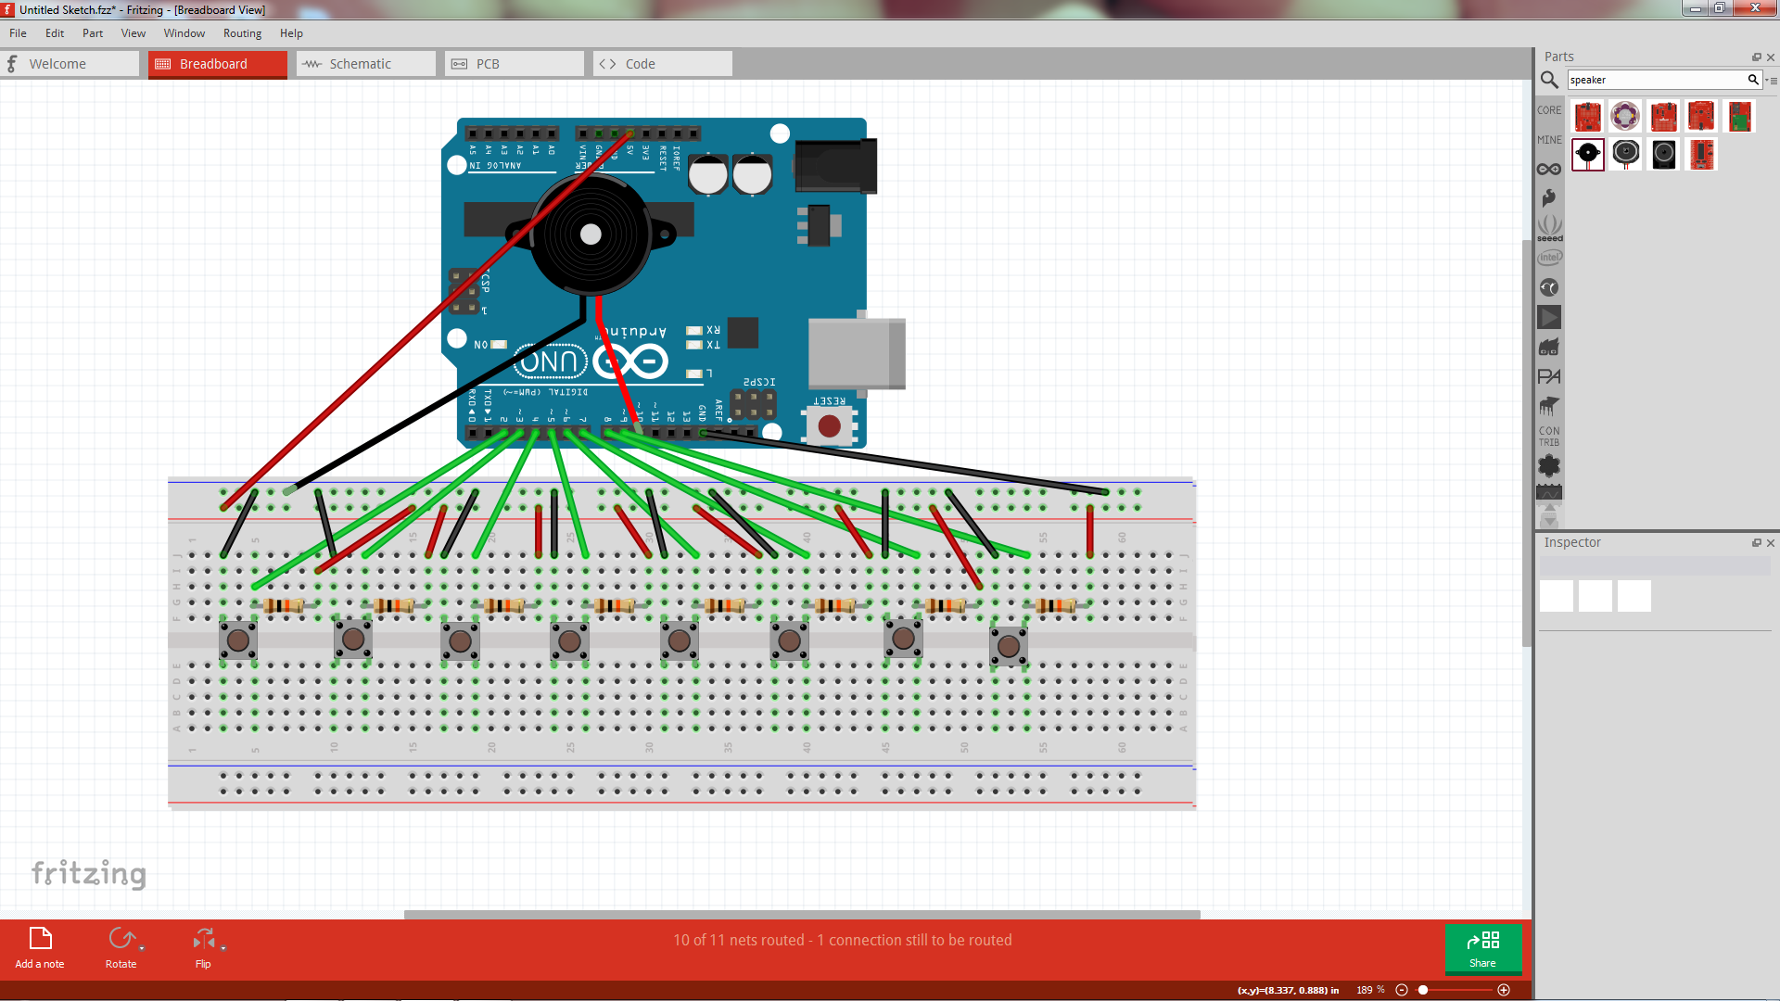

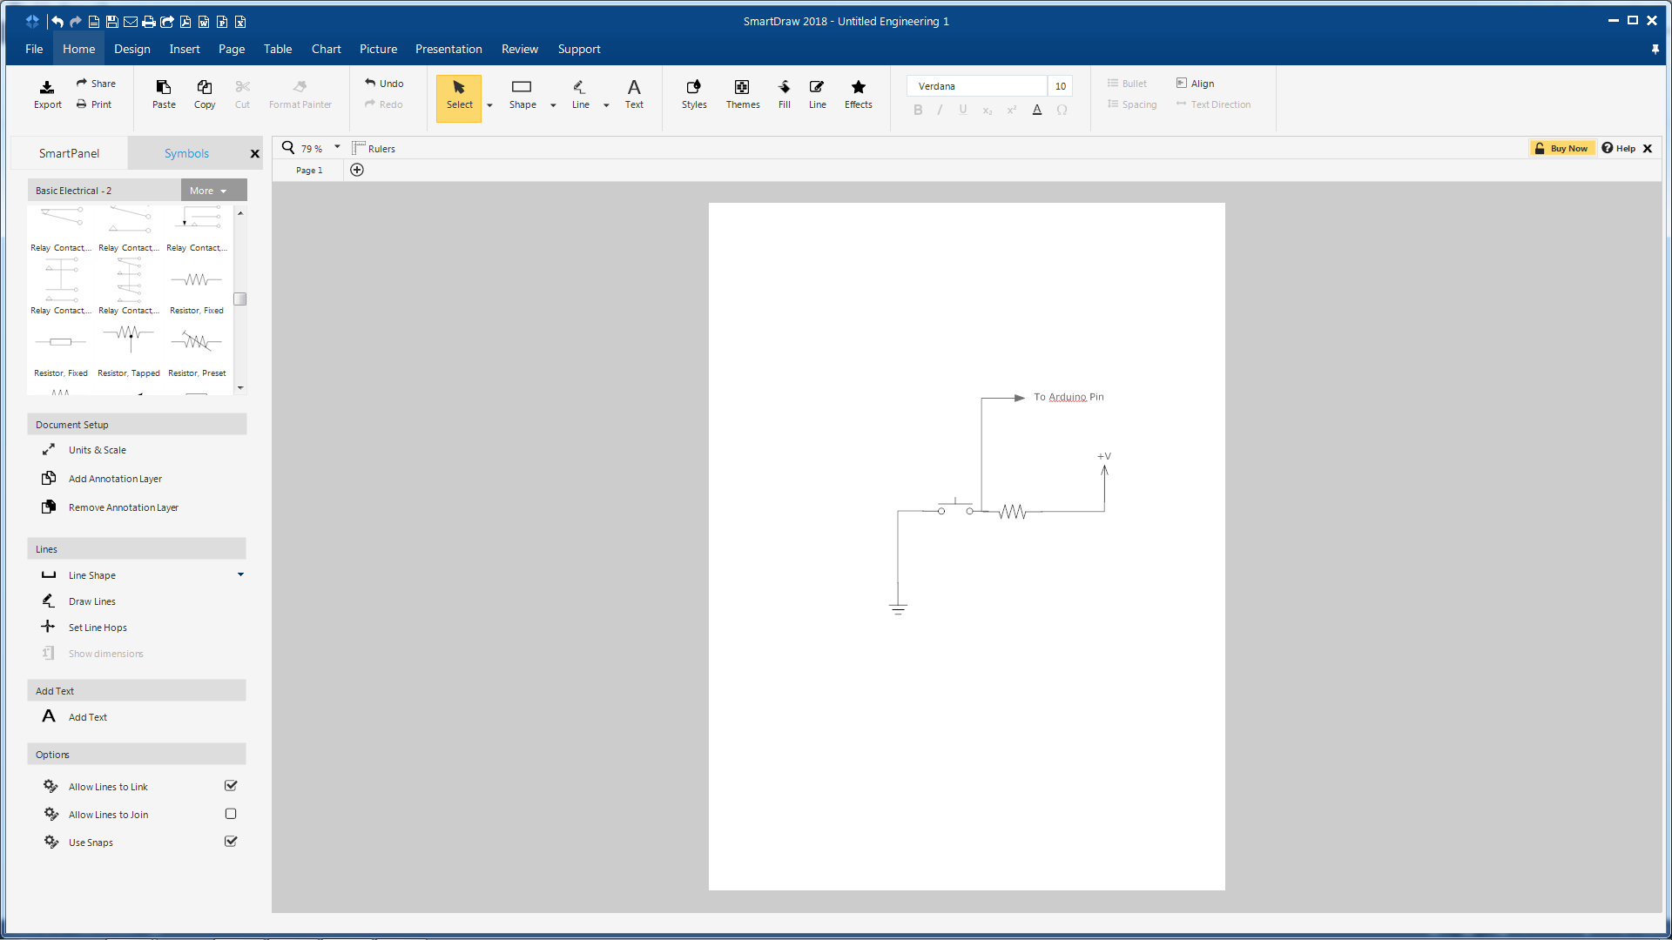

Pushbutton Switch Hookup

The pushbutton switches are hooked up with one side of the switch connected to ground and the other side of the switch connected to a 10 KΩ resistor. Arduino pins (2 through 9) are hooked up to their respective pushbuttons.

**The Code**

void setup(){

pinMode(10,OUTPUT); //Set speaker as an OUTPUT

pinMode(2,INPUT_PULLUP); //Button 2 as an INPUT_PULLUP

pinMode(3,INPUT_PULLUP); //Button 3 as an INPUT_PULLUP

pinMode(4,INPUT_PULLUP); //Button 4 as an INPUT_PULLUP

pinMode(5,INPUT_PULLUP); //Button 5 as an INPUT_PULLUP

pinMode(6,INPUT_PULLUP); //Button 6 as an INPUT_PULLUP

pinMode(7,INPUT_PULLUP); //Button 7 as an INPUT_PULLUP

pinMode(8,INPUT_PULLUP); //Button 8 as an INPUT_PULLUP

pinMode(9,INPUT_PULLUP); //Button 9 as an INPUT_PULLUP

}

void loop(){

if(digitalRead(2)==LOW){ //if button 2 is sending a low signal...

tone(10,523); //...play a tone of 523 hertz on the speaker (C5)

}

else if(digitalRead(3)==LOW){ //if button 3 is sending a low signal...

tone(10,587); //...play a tone of 587 hertz on the speaker (D5)

}

else if(digitalRead(4)==LOW){ //if button 4 is sending a low signal...

tone(10,659); //...play a tone of 659 hertz on the speaker (E5)

}

else if(digitalRead(5)==LOW){ //if button 5 is sending a low signal...

tone(10,698); //...play a tone of 698 hertz on the speaker (F5)

}

else if(digitalRead(6)==LOW){ //if button 6 is sending a low signal...

tone(10,783); //...play a tone of 783 hertz on the speaker (G5)

}

else if(digitalRead(7)==LOW){ //if button 7 is sending a low signal...

tone(10,880); //...play a tone of 880 hertz on the speaker (A5)

}

else if(digitalRead(8)==LOW){ //if button 8 is sending a low signal...

tone(10,987); //...play a tone of 987 hertz on the speaker (B5)

}

else if(digitalRead(9)==LOW){ //if button 9 is sending a low signal...

tone(10,1046); //...play a tone of 1046 hertz on the speaker (C6)

}

else{ //in all other cases (buttons not sending a low signal)...

noTone(10); //send a noTone command to the speaker

}

}