[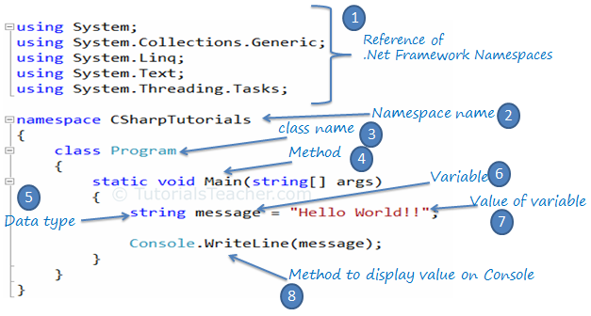](http://www.tutorialsteacher.com/Content/images/csharp/csharp-code-structure.png)C# Program

Explanation of above points:

1. Every .NET application takes the reference of the necessary .NET framework namespaces that it is planning to use with the "using" keyword e.g. *using System.Text*
2. Declare the namespace for the current class using the "namespace" keyword e.g. *namespace CSharpTutorials*
3. We then declared a class using the "class" keyword: *class Program*
4. The Main() is a method of Program class which is the entry point of the console application.
5. String is a data type.
6. 'message' is a variable, that holds a value of a specified data type.
7. "Hello World!!" is the value of the message variable.
8. Console is a .NET framework class. WriteLine() is a method which you can use to display messages to the console.

**Note :** Every line or statement in C# must end with a semicolon (;).