**Introduction**

[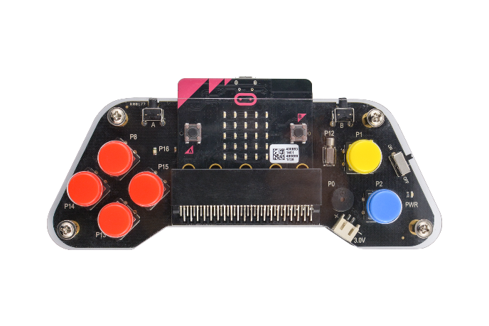](https://www.dfrobot.com/product-1711.html)

Micro:bit gamepad is an expansion gamepad based on micro:bit. You only need to plug in the micro:bit, it will turn into a wireless remote controller or a wireless game console. This product packaged with acrylic plate, that giving it a good feel and no longer feels like a bare circuit board. The gamepad has a total of 8 buttons, the left side have up, down, left, right four buttons, the right side has X, Y two buttons, and two buttons A, B are in the front of the gamepad. The gamepad also has programmable built-in vibration motor, buzzer, and LED. Using graphical programming, it will turn into a multimedia vibration controller or multimedia interactive game console instantly. The programming platform supports MakeCode graphical programming and python. It is a very suitable tool for both beginners and masters.

**Specification**

* Operating Voltage: 3VDC (2 AAA batteries)
* Number of Buttons: Up, Down, Left, Right, X, Y, A, B Total 8 programmable buttons
* Onboard Vibration motor × 1
* Onboard LED × 1
* Onboard Buzzer × 1
* Acrylic Floor x 1
* Acrylic Panel × 1
* Battery Box with Cover × 1
* Velcro × 2
* Copper Cylinder × 4
* Screw × 8
* Big Button ×6
* Small Button× 2
* Dimension:148x57(mm)/ 5.83*2.24in

**Board Overview**

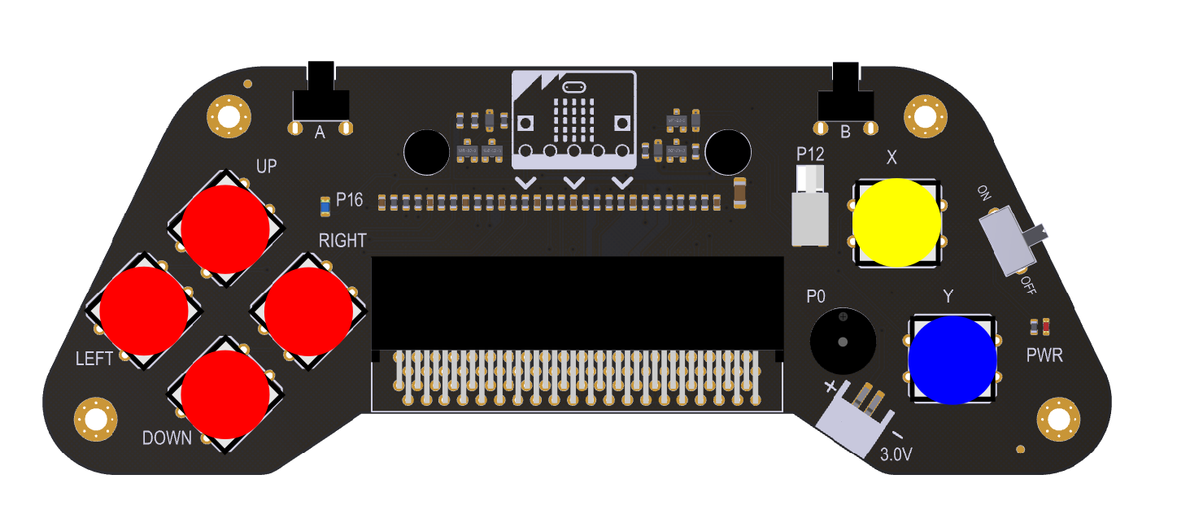

| **Function** | **Description** |
| --- | --- |
| LED | Control pin P16 |
| Vibration Motor | Control pin P12 |
| Buzzer | Control pin P0 |
| PWR | Power Indicator |
| Switch | Turn off the power |
| Opearting Voltage | 3V~3.7V（2x AAA batteries） |
|  |  |

**Tutorial**

**MakeCode Graphical Programming**

The basic tutorial of MakeCode:

* The library of gamepad: <https://github.com/DFRobot/pxt-gamePad>

1. Enter [MakeCode](https://makecode.microbit.org/)
2. Find **Advanced** > **Add package**
3. Copy the library link and paste it in the option box
4. Click the gamepad, and you can find a new icon on the right.

**The programming of event trigger**

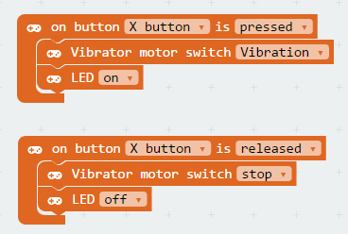

Result: When the X is pressed, the vibration motor vibrates and the LED lights up; when the X is released, the vibration motor stops and the LED turns off. 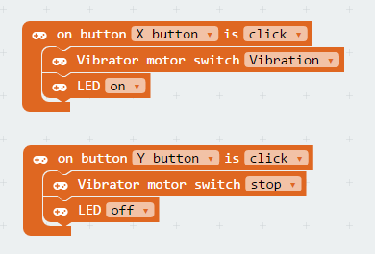

Result: When the X is pressed, the vibrating motor vibrates and the LED lights up; when the Y is pressed, the vibrating motor stops and the LED turns off.

**The Programming of Cyclic Query**

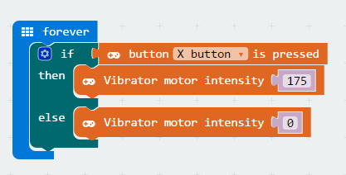

Result: When the X is pressed, the vibration motor vibrates at the strength of 175, and when the X is released, the vibration motor stops vibrating.

**Rock-Paper-Scissors**

Graphical source program: [Rock-Paper-Scissors](https://makecode.microbit.org/87049-10298-77800-67660) 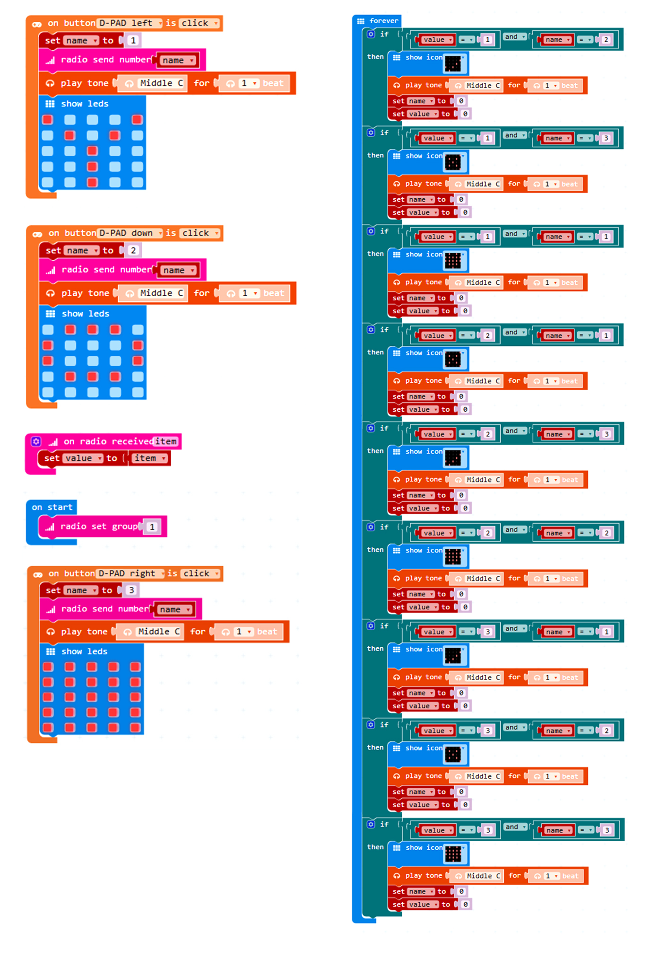Execution of the Program:

1. First, you should set the two main boards are in the 1th wireless group, so that they can communicate with each other.
2. When the left button is pressed, LED dot matrix displays the scissors, and sends the number 1.
3. When the down button is pressed, LED dot matrix displays the rock, and sends the number 2.
4. When the right button is pressed, LED dot matrix displays the paper, and sends the number 3.
5. In the infinite loop, compare the wireless received numbers with your own Numbers;if you lost,it will display “×", if you win, it will show "√".
6. After showing the result, clear all data.

**Yacht**

Graphical source program: [Dice Game](https://makecode.microbit.org/88613-07172-15323-53378) 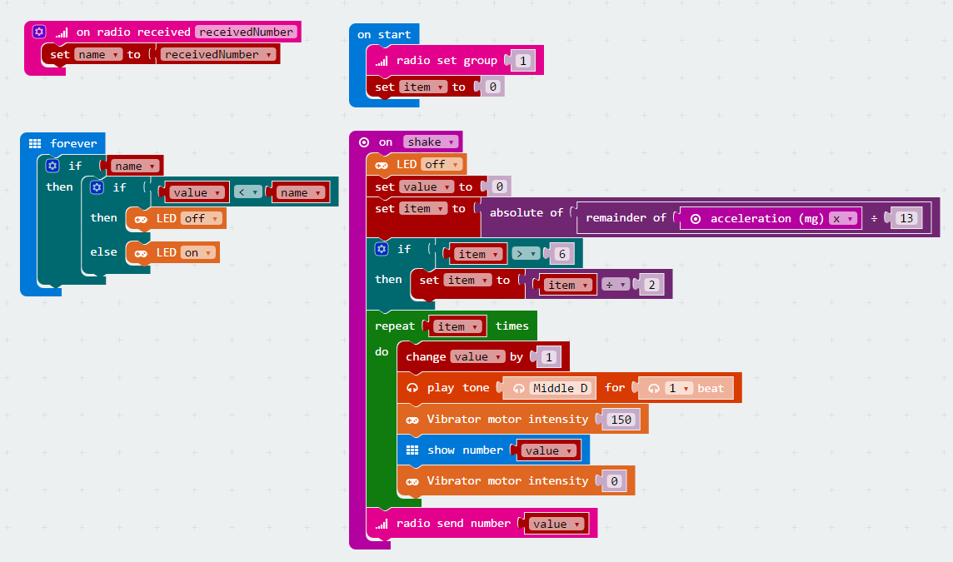 Execution of the Program:

1. Set the wireless to group 1 when booting, and initialize item to 0.
2. When the vibration is detected, turn off the LED and initialize the value to 0, and use the acceleration value to produce a random number between 1 and 6.
3. Incremental display from 0 to randomly generated number on the LED dot matrix, play the pitch and vibrate motor.
4. Send 1~6 random numbers to other main boards via wireless.
5. Comparing the random number with the received number. If it is less than the received number, turn off the light, otherwise turn on the light.

**Remote Control Handle**

Graphical source program of handle: [Gamepad](https://makecode.microbit.org/_Txyh7tPzs5F9) Graphical source program of car: [Mobile Platform](https://makecode.microbit.org/_A8uim74TxXKk)

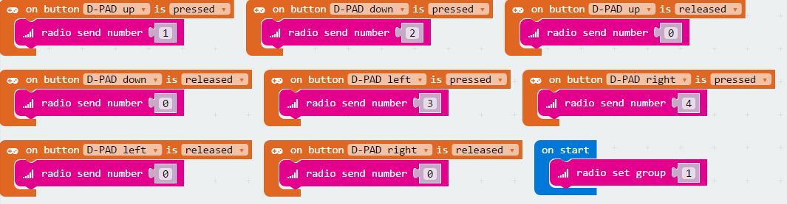 Execution of the Program:

1. Set the wireless to group 1.
2. When different buttons are pressed, send different numbers to let the car performs different actions.
3. When the button is released, the number 0 is sent to make the car stop.

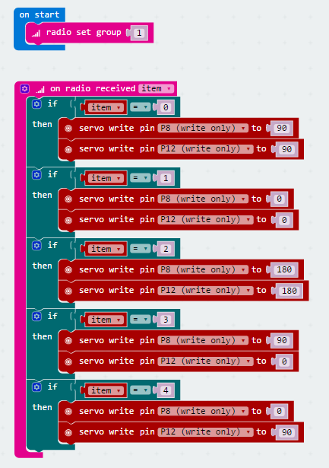 Execution of the Program:

1. Set the wireless to group 1.
2. When receiving different numbers, let the car perform different actions such as forward, backward, turn left, turn right

