alt-text examples

## R Markdown

For html: This code will produce alt text and a separate figure caption. Screen readers will be able to interpret nicely (so says stackoverflow).

Figure caption

Below also makes alt-text separate from the figure caption but only for html. Pandoc does make alt-text with this code in Word but ignores fig.alt and uses fig.cap for both the alt-text and caption.

knitr::include_graphics("fig.png")

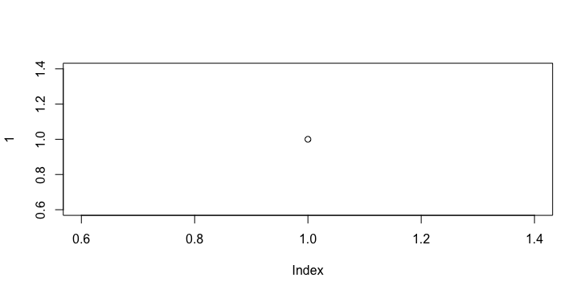

Fig 1 this is the caption.

Pandoc understands this command and puts the alt-text into the Word alt-text. Sadly it also puts the figure caption there too. So it will read twice (in alt-text and again in caption).

![Figure 1: Caption](fig.png "this is the alt-text")



Figure 1: Caption

You can get around the caption appearing in the alt text for the Word doc by leaving the caption bit blank and including the caption underneath. If you are using a Word template, you’d need to use “Heading 4” only for Figure captions if you are applying a style for figure captions (like centered).

![](fig.png "this is the alt-text")  
  
#### Figure 1. this is a caption.



#### Figure 1. this is a caption.

Obviously this is a bit irritating if you wanted to use R code to generate a figure and not save the figure to a file first.