**Stock Synthesis   
GUI User Guide**

**Version 3.3.10 beta**

February 8, 2018

Courtney Butler  
and Neal Schindler

NOAA Fisheries   
Seattle, WA USA

## Contents

Contents i

1 Introduction 1

2 New Features Available in Version 3.3.10 1

3 Setup 1

4 Starting up 1

5 Files 2

5.1 Input File Settings 2

5.2 Output File Settings 2

6 Configuration 2

6.1 Dimensions 2

6.2 Settings 2

6.3 Composition Setup 2

6.4 Environmental Variables 2

6.5 Tag Data 2

6.6 Blocks 2

6.7 Additional Reporting 2

7 Fleet Data 3

7.1 Basic Data 3

7.2 Observations 3

7.3 Compositions 3

7.4 Catchability 3

7.5 Selectivity 3

7.6 Lambdas 3

8 Population 4

8.1 Growth 4

8.2 Recruitment 4

8.3 Maturity/Fecundity 4

8.4 Movement 4

8.5 Natural Mortality 4

8.6 Fishing Mortality 4

8.7 Seasonal Effects 4

9 Forecast 5

9.1 Specification 5

9.2 Controls 5

9.3 Catch 5

10 Running SS 6

10.1 Executable 6

10.2 Directory 6

10.3 Options 6

10.4 Outputs 6

10.4.1 Normal Output 6

10.4.2 Error Output 6

10.5 Viewing Files 6

11 Appendix A – Running SS_trans 7

1. Introduction

This is a guide for the Stock Synthesis GUI. The GUI enables new or occasional users to work with existing models, save changes, create new models, run Stock Synthesis and view some output graphs.

This document will not cover basic details covered elsewhere. See the “Getting Started with Stock Synthesis” PowerPoint presentation for basic information, the “Introduction to Stock Synthesis” for a broad overview, or the User Manual for more detail on each file’s contents.

1. New Features Available in Version 3.3.10

This version is compatible with Stock Synthesis 3.30.10, the most important feature. For changes to Stock Synthesis, see the User Manual.

Graphs for Selectivity options are added (see Fleets > Selectivity section).

1. Setup

The GUI is currently available for Windows 7 and later; it may run on earlier versions of Windows, but this has not been tested. Versions for Linux and OSX are not available but may be in the future.

It is available through the Stock Synthesis VLab site, https://vlab.ncep.noaa.gov/group/stock-synthesis.

It may be easiest to download the ss_gui.exe file and move it to your Stock Synthesis directory (where the other executable files reside).

A desktop shortcut may be created from ss_gui.exe by right clicking on the desktop, selecting New > Shortcut. Browse to the directory where you have copied the file and select it.

1. Starting up

Double click on the executable file name in a file browser window or on the desktop icon (if you created one), or run the command line from a terminal or command window.

There are five main windows accompanied with occasional dialog boxes: Files, Configuration, Fleet Data, Population, and Forecast. Each of these is covered in its own section below.

1. Files

Upon starting up, the GUI shows Files with the Input File Settings visible.

* 1. Input File Settings

The four main files are given names that may not exist in the current directory. When a model is read in, they will change to reflect the directory of that model.

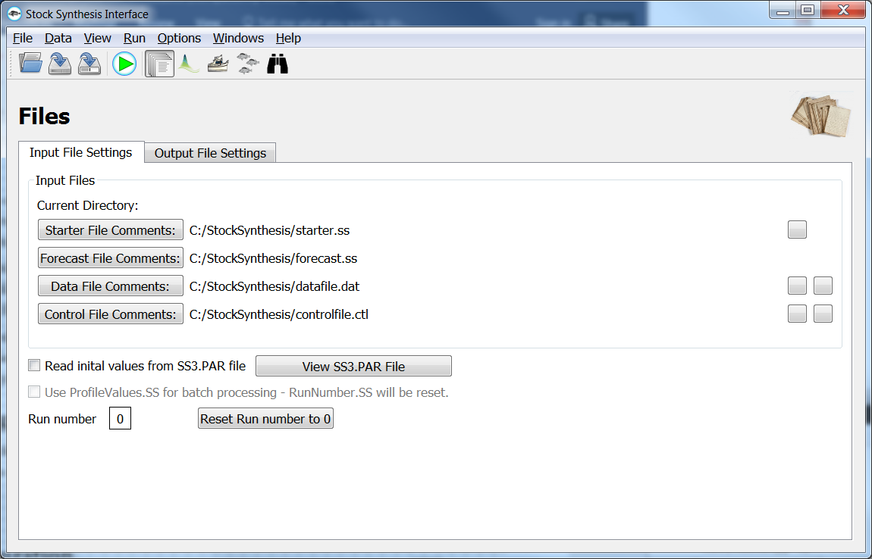

* 1. Output File Settings

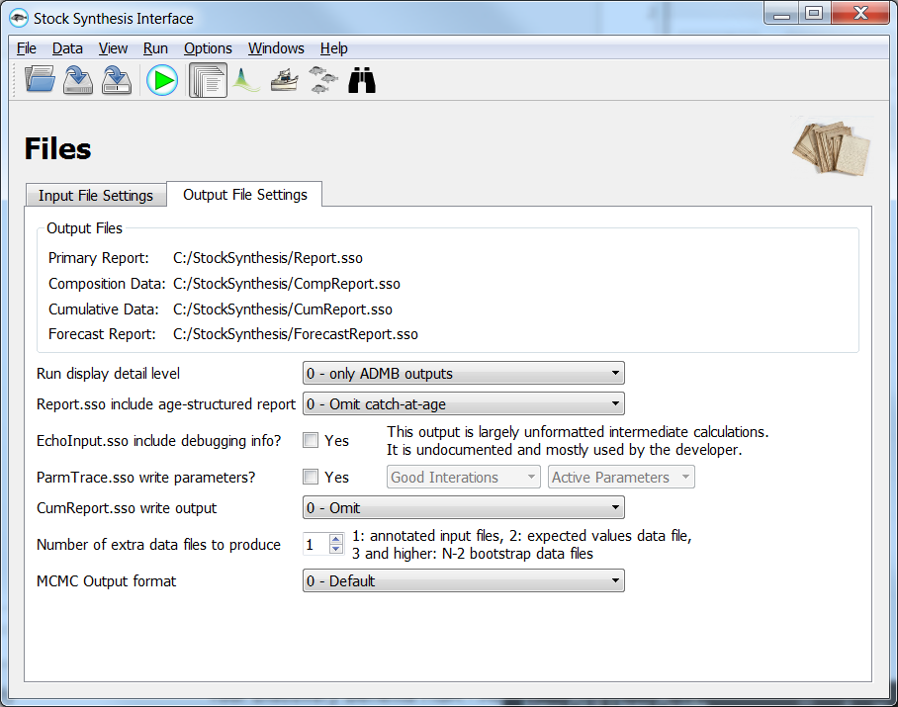

1. Configuration
   1. Dimensions
   2. Settings
   3. Composition Setup
   4. Environmental Variables
   5. Tag Data
   6. Blocks
   7. Additional Reporting

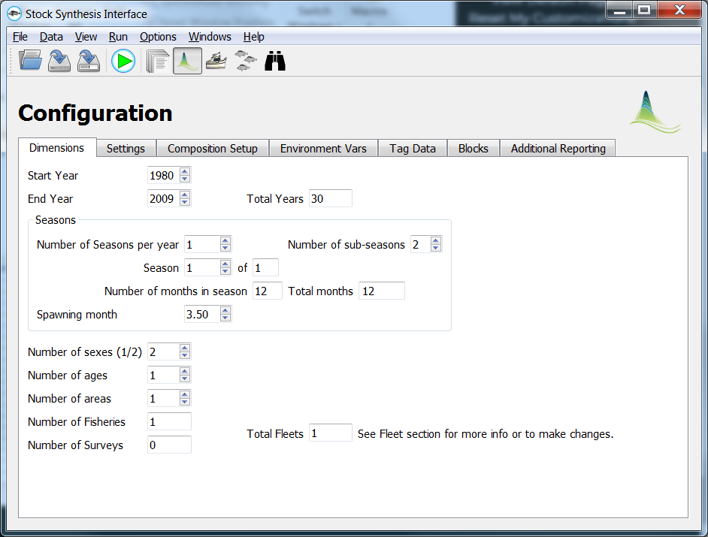

1. Fleet Data
   1. Basic Data
   2. Observations
   3. Compositions
   4. Catchability
   5. Selectivity
   6. Lambdas

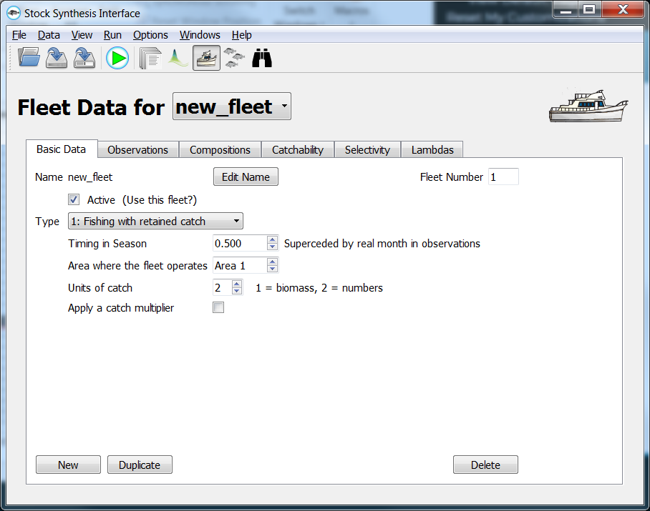

1. Population
   1. Growth
   2. Recruitment
   3. Maturity/Fecundity
   4. Movement
   5. Natural Mortality
   6. Fishing Mortality
   7. Seasonal Effects

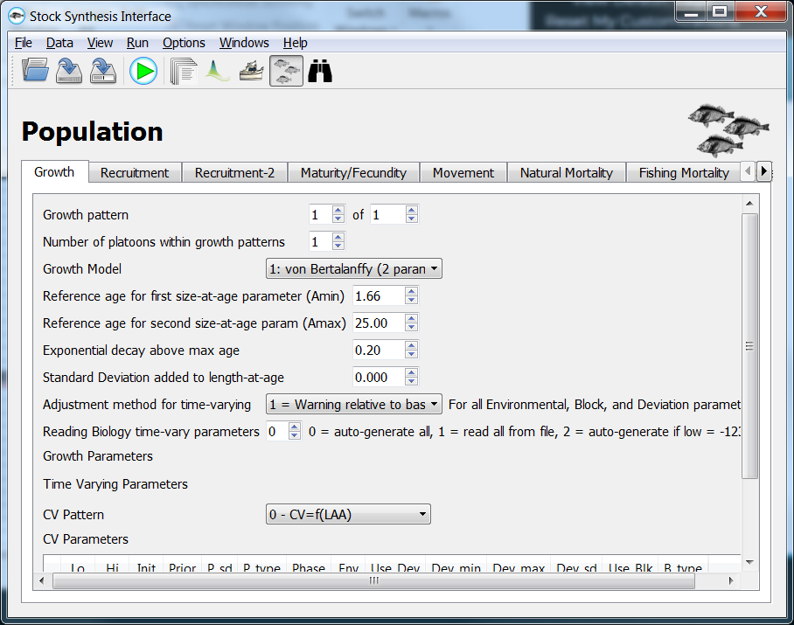

1. Forecast
   1. Specification
   2. Controls
   3. Catch

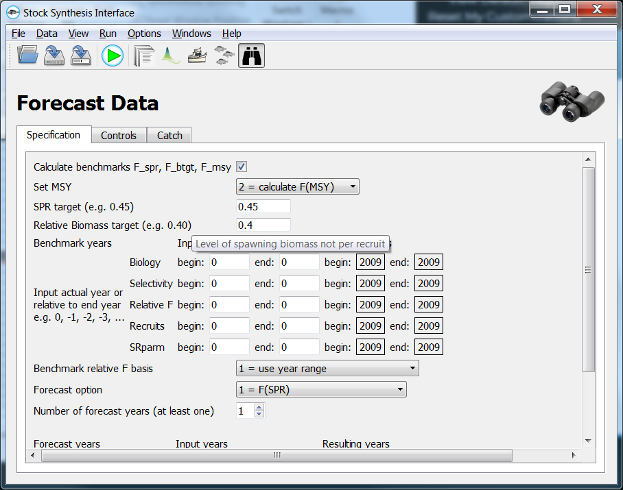

1. Running SS
   1. Executable
   2. Directory
   3. Options
   4. Outputs
      1. Normal Output
      2. Error Output
   5. Viewing Files

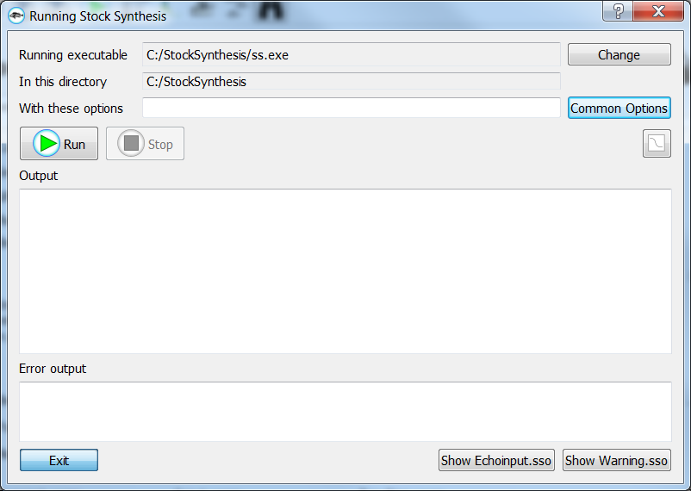

1. Appendix A – Running SS_trans

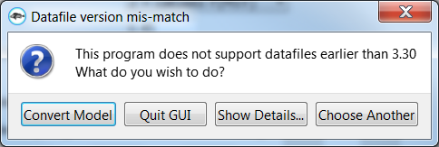

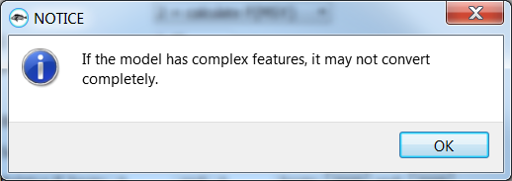

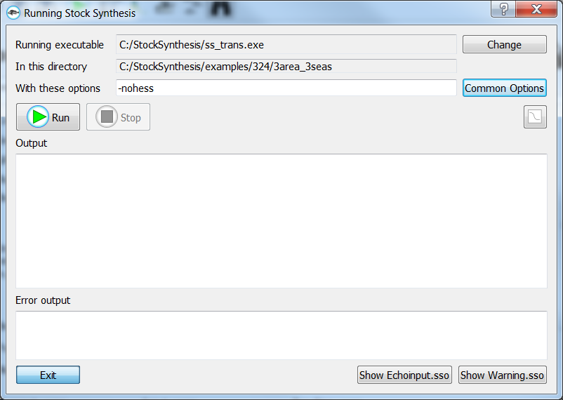

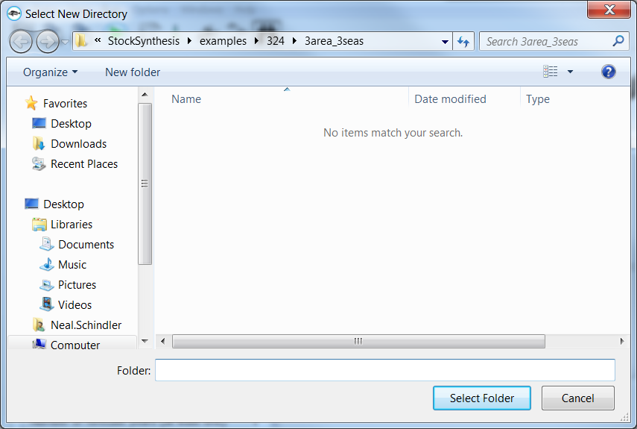

The GUI will then save the newly created files and read them in.