AST Lab Manual

Alice Beittel

Table of contents

# Welcome

**Last updated:** 2025-04-22 18:48:36 UTC

[West Coast coastal pelagic species](https://www.fisheries.noaa.gov/species/west-coast-coastal-pelagic-species) play an important role in the California Current ecosystem. They’re food sources for marine mammals, sea birds, and larger fish, and they support commercial and recreational fisheries (J. Zwolinski et al. 2014). Each year the NOAA Southwest Fisheries Science Center surveys the west coast from Baja Mexico to Vancouver Island, Canada to measure the biomass of 5 key coastal pelagic species: [Pacific Sardine](https://www.fisheries.noaa.gov/species/pacific-sardine#:~:text=Baja%20California%2C%20Mexico.-,Habitat,schools%20near%20the%20ocean%20surface.) *Sardinops sagax*, Northern Anchovy *Engraulis mordax*, Pacific Mackerel *Scomber japonicus,* Jack Mackerel *Trachurus symmetricus,* Pacific Herring *Clupea pallasii,* and Round Herring *Etrumeus acuminatus*. The biomass and abundance estimates derived from the survey are used in stock assessment models to support sustainable fisheries.

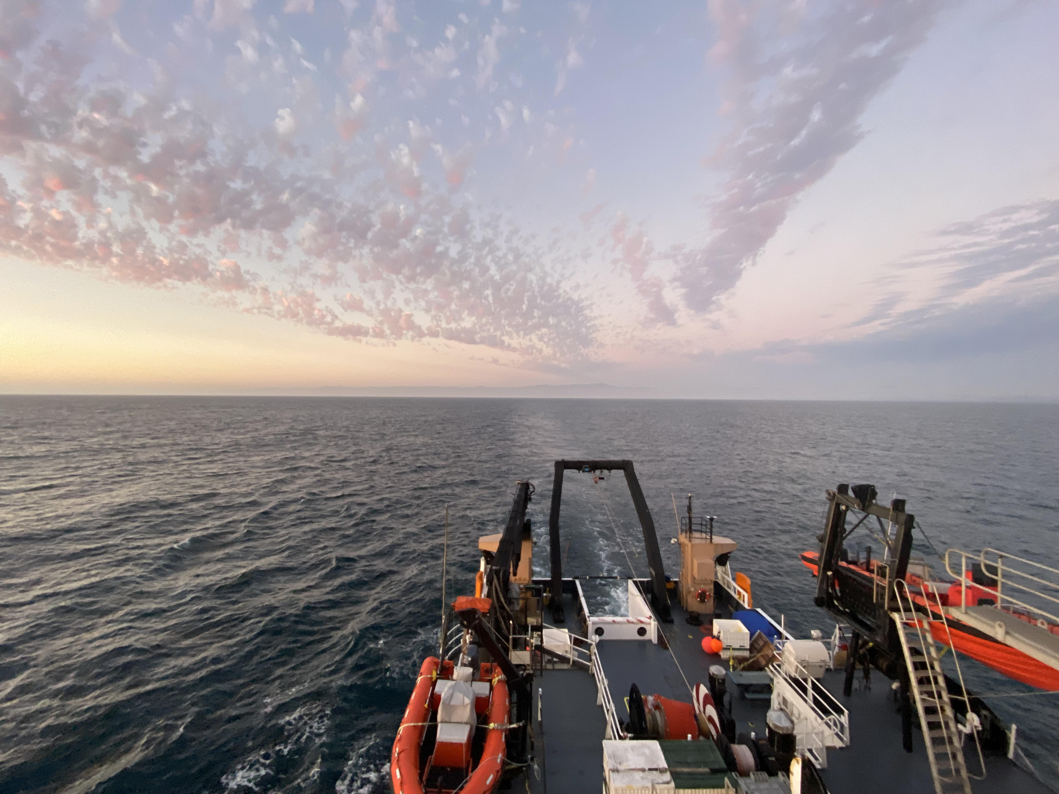

Survey work typically takes place on the NOAA Ship Reuben Lasker with acoustic sampling during the day and trawl sampling at night. Here is the back deck of the NOAA Ship Reuben Lasker at sunset . Inside the ship the biosampling team is getting ready for a night of trawling.

## Document Objective:

This resource demonstrate how the SWFSC uses acoustic data generate biomass estimates of Coastal Pelagic Species. As part of our commitment to open science, reproducibility, and transparency, we provide this metadata guide to compliment our public-domain data. Please consider this resource to be a **Living Document**. The code in this repository is regularly being updated and improved.

Do not hesitate to reach out (to us at either alice.beittel@noaa.gov or [GitHub issues](https://github.com/nmfs-swfsc-ast/echo-class/issues), especially if you find discrepancies in the data or want to suggest improvements to infrastructure. Thank you in advance for your collaboration and partnership with us as we develop our future data universe.

## User Resources

The survey produces two reports each year: A Survey Report and a Biomass Report. Each can be found at the NOAA Institutional Repository online

* [2023 Biomass Report](https://repository.library.noaa.gov/view/noaa/61651): *Distribution, biomass, and demographics of coastal pelagic fishes in the California Current Ecosystem during summer 2023 based on acoustic-trawl sampling*
* [2023 Survey Report](https://repository.library.noaa.gov/view/noaa/61647): *Report on the Summer 2023 California Current Ecosystem Survey (CCES) (2307RL), 17 July to 3 November 2023, conducted aboard NOAA Ships Reuben Lasker and Bell M. Shimada, fishing vessels Lisa Marie and Long Beach Carnage, and three uncrewed surface vessels*

## How to Access Our Data

**NOAA Coast Watch ERDDAP:**

[CPS Trawl Haul Catch Data](https://coastwatch.pfeg.noaa.gov/erddap/tabledap/FRDCPSTrawlLHHaulCatch.html)

[CPS Trawl Specimen Data](https://coastwatch.pfeg.noaa.gov/erddap/tabledap/FRDCPSTrawlLHSpecimen.html)

[NOAA Ship Reuben Lasker Underway Meteorological Data](https://coastwatch.pfeg.noaa.gov/erddap/tabledap/fsuNoaaShipWTEG.html)

**NOAA National Centers for Environmental Information (NCE):**

Locate raw acoustic data using the [NCEI Water Column Sonar Data Viewer](https://www.ncei.noaa.gov/maps/water-column-sonar/).

Download raw acoustic data via the viewer or the [AWS NCEI bucket](https://noaa-wcsd-pds.s3.amazonaws.com/index.html#data/raw/).

## NOAA README

This repository is a scientific product and is not official communication of the National Oceanic and Atmospheric Administration, or the United States Department of Commerce. All NOAA GitHub project code is provided on an ‘as is’ basis and the user assumes responsibility for its use. Any claims against the Department of Commerce or Department of Commerce bureaus stemming from the use of this GitHub project will be governed by all applicable Federal law. Any reference to specific commercial products, processes, or services by service mark, trademark, manufacturer, or otherwise, does not constitute or imply their endorsement, recommendation or favoring by the Department of Commerce. The Department of Commerce seal and logo, or the seal and logo of a DOC bureau, shall not be used in any manner to imply endorsement of any commercial product or activity by DOC or the United States Government.

## NOAA License

Software code created by U.S. Government employees is not subject to copyright in the United States (17 U.S.C. §105). The United States/Department of Commerce reserve all rights to seek and obtain copyright protection in countries other than the United States for Software authored in its entirety by the Department of Commerce. To this end, the Department of Commerce hereby grants to Recipient a royalty-free, nonexclusive license to use, copy, and create derivative works of the Software outside of the United States.

Copyright 2024 SWFSC Advanced Survey Technology Program  
  
Licensed under the Apache License, Version 2.0 (the “License”); you may not use this file except in compliance with the License. You may obtain a copy of the License at <http://www.apache.org/licenses/LICENSE-2.0>  
  
Unless required by applicable law or agreed to in writing, software distributed under the License is distributed on an “AS IS” BASIS, WITHOUT WARRANTIES OR CONDITIONS OF ANY KIND, either express or implied. See the License for the specific language governing permissions and limitations under the License.

# 1. Survey Background

## 1.1 Who conducts the survey?

The California Current Ecosystem Survey is conducted by researchers at the NOAA Southwest Fisheries Science Center from the Fisheries Resources Division. The survey is also made possible by volunteers from additional NOAA line offices and science centers, universities, international partners, NOAA interns, and inter-agency employees.

## 1.2 Where does the survey take place?

|  |  |
| --- | --- |
| Sardine distribution  Sardine distribution | General sampling scheme  General sampling scheme |

Figure 1.1: On left, a conceptual spring (shaded region) and summer (hashed region) distributions of potential habitat for the northern stock of Pacific Sardine along the west coasts of Mexico, the United States, and Canada. On right, the general sampling scheme of planned core-region (solid black lines), adaptive (dashed red lines), and nearshore lines (pink).

## 1.3 Research objectives:

1. Acoustically map the distributions, measure the species compositions and size-frequency distributions, and estimate the abundances and biomasses of CPS present in the survey area, e.g., Pacific Sardine Sardinops sagax, Northern Anchovy (*Engraulis mordax*), Pacifc Herring (*Clupea pallasii*), Round Herring (*Etrumeus acuminatus*), Pacific Mackerel (*Scomber japonicus*), and Jack Mackerel (*Trachurus symmetricus*)
2. Characterize and investigate linkages to their biotic and abiotic environments
3. Gather information regarding their life histories
4. Compare the species composition and size distributions of trawls and near shore vessel purse seine sets.

## 1.4 Survey History:

The SWFSC’s ATM surveys of CPS in the CCE began in 2006 with a focus on the northern stock of Pacific Sardine. Quickly the annual surveys demonstrated valuable ecosystem insights. Since then, they have expanded in scope and objectives to include the larger forage-fish assemblage and krill. This evolution, and the migratory behavior of Pacific Sardine, serve to explain the present survey region and design.

“Collectively, these annual or bi-annual ATM surveys provide a unique insight into the dynamics of forage fshes in the CCE, including their distributions, abundances, interactions, and environments. For example, results from 2006 through 2013 indicate that Pacifc Sardine dominated the CPS assemblage, but their biomass was declining (Demer and Zwolinski, 2012; Zwolinski and Demer, 2012) and their seasonal migration was contracting (Zwolinski et al., 2014). Meanwhile, harvest rates for the declining stock increased (Demer and Zwolinski, 2017), and the total forage-fsh biomass decreased to less than 200,000 t in 2014 and 2015 (Figs. 36, 37). The U.S. fshery for Pacifc Sardine was closed in 2015 (National Marine Fisheries Service, 2015), and there were reports of mass strandings, deaths, and reproductive failures in Brown Pelicans (Pelecanus occidentalis3), Common Murres (Uria aalge), Brandt’s Cormorants (Phalacrocorax penicillatus), and California sea lions (Zalophus californianus4) (McClatchie et al., 2016), all of which depend on forage species. Since 2016, the forage-fsh biomass has increased, mainly due to resurgences of Jack Mackerel and the now dominant central stock of Northern Anchovy (Figs. 36, 37), whose biomass primarily (2,466,108 t, or 94% of the total estimate biomass) occurred in U.S. waters. Between the summers of 2018 and 2021, the biomass of the southern stock of Pacifc Sardine in U.S. waters has increased from 33,093 to 45,332 t.”(Stierhoff et al. 2024)

## 1.5 Code of Conduct

### 1.5.1 What are Codes of Conduct?

Codes of Conduct are voluntary sets of rules that assist creators, developers, and users of code and data with data protection compliance and accountability in specific sectors or relating to particular processing operations.

Codes can help organizations to ensure all participants follow best practices and rules designed specifically for their sector or processing operations, thus enhancing compliance and collaboration. They are developed and managed by an association or other body (the ‘Code Owner’) which is representative of a sector (or category of data controllers or processors), with the expert and sectoral knowledge of how to enhance data protection in their area.

### 1.5.2 [Code of Conduct](https://github.com/nmfs-opensci/.github/blob/main/CODE_OF_CONDUCT.md) from the [nmfs-opensci GitHub](https://nmfs-opensci.github.io/).

# 2. NOAA Fisheries Open Science Code of Conduct

This code of conduct was developed and adapted from the Atom code of conduct in October 2021.

## 2.1 Our Pledge

In the interest of fostering an open and welcoming environment, we as contributors and maintainers pledge to making participation in our project and our community a harassment-free experience for everyone, regardless of age, body size, disability, ethnicity, gender identity and expression, level of experience, nationality, personal appearance, race, religion, or sexual identity and orientation.

## 2.2 Our Standards

Examples of behavior that contributes to creating a positive environment include:

* Using welcoming and inclusive language
* Being respectful of differing viewpoints and experiences
* Gracefully accepting constructive criticism
* Focusing on what is best for the community
* Showing empathy towards other community members

Examples of unacceptable behavior by participants include:

* The use of sexualized language or imagery and unwelcome sexual attention or advances
* Trolling, insulting/derogatory comments, and personal or political attacks
* Public or private harassment
* Publishing others’ private information, such as a physical or electronic address, without explicit permission
* Other conduct which could reasonably be considered inappropriate in a professional setting

## 2.3 Our Responsibilities

Project maintainers are responsible for clarifying the standards of acceptable behavior and are expected to take appropriate and fair corrective action in response to any instances of unacceptable behavior.

Project maintainers have the right and responsibility to remove, edit, or reject comments, commits, code, wiki edits, issues, and other contributions that are not aligned to this Code of Conduct, or to ban temporarily or permanently any contributor for other behaviors that they deem inappropriate, threatening, offensive, or harmful.

## 2.4 Scope

This Code of Conduct applies both within project spaces and in public spaces when an individual is representing the project or its community. Examples of representing a project or community include using an official project e-mail address, posting via an official social media account, or acting as an appointed representative at an online or offline event. Representation of a project may be further defined and clarified by project maintainers.

## 2.5 Enforcement

Instances of abusive, harassing, or otherwise unacceptable behavior may be reported by contacting the project team. All complaints will be reviewed and investigated and will result in a response that is deemed necessary and appropriate to the circumstances. Further details of specific enforcement policies may be posted separately.

## 2.6 Attribution

This Code of Conduct is adapted from the [Contributor Covenant](https://contributor-covenant.org), version 1.4, available at [https://contributor-covenant.org/version/1/4](https://contributor-covenant.org/version/1/4/)

# 3. Data Acquisition

## 3.1 Survey Equipment

### 3.1.1 Acoustic Instruments

|  |
| --- |
| Figure 3.1: Transducer locations on the bottom of the centerboard aboard Lasker. |

On *Lasker* and *Shimada*, multi-frequency Wideband Transceivers (Simrad EK80 WBTs; Kongsberg) were confgured with split-beam transducers (Simrad ES18, ES38-7, ES70-7C, ES120-7C, ES200-7C, and ES333- 7C on *Lasker* and ES18, ES38B, ES70-7C, ES120-7C, and ES200-7C on *Shimada*; Kongsberg). The transducers were mounted on the bottom of a retractable keel or “centerboard” (Figure 3.1). The keel was retracted (transducers ~5-m depth) during calibration, and extended to the intermediate position (transducers ~7-m depth) during the survey. Exceptions were made during shallow water operations, when the keel was retracted; or during times of heavy weather, when the keel was extended (transducers ~9-m depth) to provide extra stability and reduce the efect of weather-generated noise. Transducer position and motion were measured at 5 Hz using an inertial motion unit (Applanix POS-MV; Trimble).

### 3.1.2 Underway CTD

On *Lasker* and *Shimada*, conductivity and temperature profiles were measured down to 300 m using calibrated sensors on a probe cast from the vessel while underway (UnderwayCTD, or UCTD; Teledyne Ocean- science). Casts were typically conducted between two to four times along each transect. These data indicate the depth of the surface mixed layer, above which most pelagic CPS reside during the day. These data were also used to estimate the time-averaged sound speed (Demer, 2004), for estimating ranges to the sound scatterers, and frequency-specific sound absorption coefficients, for compensating signal attenuation of the sound pulse between the transducer and scatterers (Simmonds and MacLennan, 2005).

## 3.2 Software

### 3.2.1 Echosounder Software

EK80

### 3.2.2 NetTime

On *Lasker* and *Shimada*, the computer clocks were synchronized with the GPS clock (UTC) using a synchronization software called NetTime.

### 3.2.3 EAL

The 38-, 70-, 120-, 200-, and 333-kHz echosounders were controlled by the EK80 Adaptive Logger (EAL2, Renfree and Demer, 2016). The EAL optimizes the pulse interval based on the seabed depth, while avoiding aliased seabed echoes, and was programmed such that once an hour the echosounders would record three pings in passive mode, for obtaining estimates of the background noise level.

### 3.2.4 K Sync

To minimize acoustic interference on *Lasker* and *Shimada*, transmit pulses from the EK80s, acoustic Doppler current profiler and echosounder (Simrad-Kongsberg EC150-3C), multibeam echosounder (Simrad- Kongsberg ME70), imaging sonar (Simrad-Kongsberg MS70), scanning sonar (Simrad-Kongsberg SX90), and a separate acoustic Doppler current profiler (Teledyne RD Instruments OS75 ADCP) were triggered using a synchronization system (Simrad K-Sync; Kongsberg). The K-Sync trigger rate, and thus the echosounder ping interval, was modulated by the EAL using the 18-kHz seabed depth provided by the Scientific Computing System (SCS).

## 3.3 Raw Acoustic Data Format

Measurements of volume backscattering strength (*Sv*; dB re 1 m2 m-3) and target strength (*TS*; dB re 1 m2), indexed by time and geographic positions provided by GPS receivers, were stored in Simrad-Kongsberg .raw format with a 1-GB maximum file size. During daytime, the echosounders operated in CW mode and logged to 60 m beyond the detected seabed range or to a maximum range of 500, 500, 500, 300, and 150 m for 38, 70, 120, 200, and 333 kHz, respectively. During nighttime, the echosounders operated in FM mode and logged to 100 m. For each acoustic instrument, the prefix for each fle name is a concatenation of the survey name (e.g., 2307RL), the operational mode (CW or FM), and the logging commencement date and time from the EK80 software (v21.15.1). For example, a file generated by the Simrad-Kongsberg EK80 software for a WBT operated in CW mode is named 2307RL_CW-D20220826-T155651.raw.

# 4. Data Processing

After data aqusition, we identify acoustic echos of schooling CPS using a semi-automated data processing algorithm using Echoview software and in-house Posit code in the estimATM [repository](https://github.com/kstierhoff/estimATM). With Echoview, we extract the backscatter of swim bladder fish and process using soundspeed and echosounder calibration values housed inside an Echoview Calibration Supplement (.ecs) file. The Echoview filters and thresholds were based on a sub-sample of echoes from randomly selected CPS schools. We complete the processing with the estimATM package in extract_CPS_NASC.R, where we further refine the backscatter selection to extract only CPS. Here we will cover the Echoview and estimATM semi-automated processing workflow.

### 4.0.1 Data Processing Overview

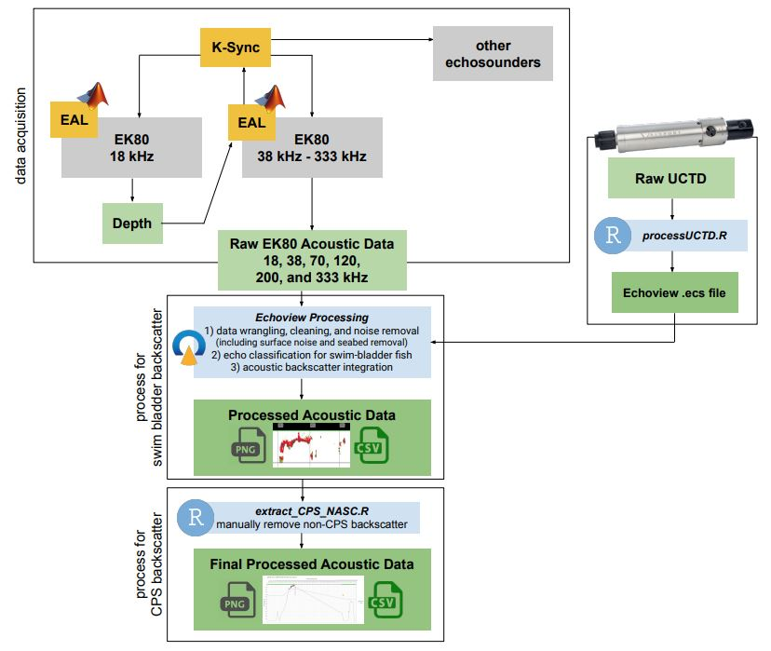

Overview of CPS Acoustic Processing. Vessel position and attitude data is used from the POS MV (not shown).

### 4.0.2 Echoview Processing Workflow

In Echoview, we organize, clean, and extract acoustic backscatter of swim bladder fish. There are three key steps to this process:

1. Data wrangling, cleaning, and noise removal (including surface noise and seabed removal)
2. Echo classification for swim-bladdred fish
3. Acoustic Backscatter Integration. The aim of the filter criteria is to retain at least 95% of the noise-free backscatter from CPS while rejecting at least 95% of the non-CPS backscatter.

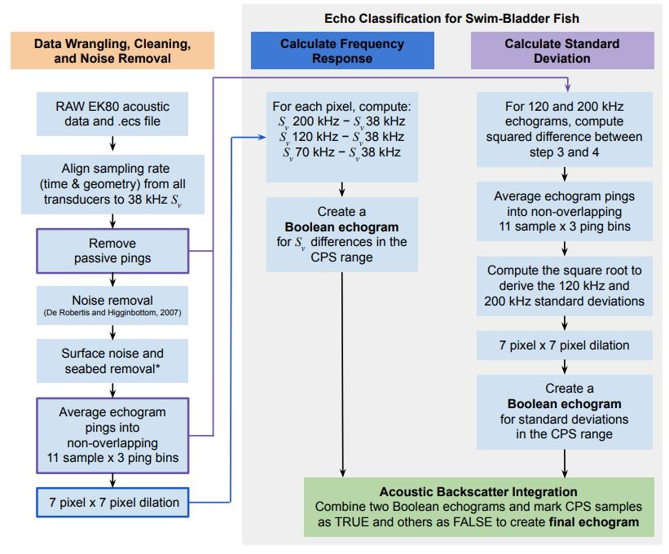

Simplified dataflow of processing in Echoview. *Surface noise and seabed removal replies on two manual inputs: the Integration Start and Integration Stop lines (not pictured, see step 5).

#### 4.0.2.1 **Section 1) Data Wrangling, Cleaning, and Noise Removal:**

1. Load RAW EK80 acoustic data and Echoview Calibration Supplement (.ecs)file into Echoview. The .ecs file contains soundspeed information calculated from the nearest (temporally and spatially) Underway CTD cast and echosounder calibration parameters. This file is used at the very beginning to convert from power to Sv (volume-backscattering coefficient).
2. Align sampling rate (time and geometery) from all transders to the 38 kHz Sv. Acousticians call this step ‘matching geometry’ of all Sv variables. Making sure pings are aligned from all echosounders is important for calculating the frequency response of backscatter in steps later on.
3. Remove passive-mode pings.
4. Noise removal: estimate and subtract background noise using the background noise removal function described in De Robertis and Higginbottom (2007).
5. **Surface noise and seabed removal** is completed by manually drawing an Integration Start and Integration Stop line in Echoview. The Integration Start line is drawn at the shallowest depth to include surface CPS schools but exclude transducer ring down and surface noise due to sea state (typically around 5 meters below the transducer face or ~10m depth). The Integration Stop line is drawn closest to the seabed to include bottom dwelling animals but exclude any non-living seabed features (typically 3 m above the estimated seabed (Demer et al. 2009) or to the maximum logging range (e.g., 350 m), whichever is shallowest). When drawing the lines, we set the color scale to a minimum Sv threshold of -60 dB which corresponds to a density of approximately three 20-cm-long Pacific Sardine per 100 m3). Doing this helps visually pick out schools from the seabed and from non-swim bladder animals that appear as diffuse scattering layers in the water column. The area of the water column between the two lines sets the depth range that will be integrated for swim bladder fish in steps later on.
6. Average the noise-free Sv echograms using non-overlapping 11-sample by 3-ping bins.
7. Expand the averaged, noise-reduced Sv echograms with a 7 pixel x 7 pixel dilation. This replaces each averaged datapoint from Step 6 with the maximum datapoint surrounding it in a 7x7 pixel region.

#### 4.0.2.2 **Section 2) Echo Classification for Swim Bladder Fish**

##### 4.0.2.2.1 *Calculate Frequency Response*:

1. For each dilated pixel, compute:

* Sv 200kHz − Sv 38kHz
* Sv 120kHz − Sv 38kHz
* Sv 70kHz − Sv 38kHz
* The difference between Sv values provides the frequency response for those pixels. Swim bladder fish have a unique frequency response which we can use extract those acoustic returns in the next step. Acoustic returns that fall within the Sv ranges below are flagged as meeting the criteria for typical swim bladder fish, including CPS.

1. Create a Boolean echogram for Sv differences in the CPS range:

* −13.85 < Sv 70kHz − Sv 38kHz < 9.89
* − 13.5 < Sv 120kHz −Sv 38kHz < 9.37
* − 13.51 < Sv 200kHz − Sv 38kHz < 12.53

##### 4.0.2.2.2 *Calculate Standard Deviation*:

1. For 120 and 200 kHz, compute the squared difference between the noise-filtered Sv (remove passive pings) and averaged Sv (11-sample x 3 ping bin averages).
2. Average the results using an 11-sample by 3-ping window to derive variance.
3. Compute the square root to derive the 120- and 200-kHz standard deviations (σ120kHz and σ200kHz, respectively).
4. Expand the standard deviation echograms with a 7 pixel x 7 pixel dilation (same step as Section 1, Step 7).
5. Create a Boolean echogram based on the standard deviations in the CPS range:

* σ120kHz > -65 dB
* σ200kHz > -65 dB
* Diffuse backscattering layers have low σ (J. P. Zwolinski et al. 2010) whereas fish schools have high σ. Intersect the two Boolean echograms to create an echogram with “TRUE” samples for candidate CPS schools and “FALSE” elsewhere. Mask the noise-reduced echograms using the CPS Boolean echogram .

#### 4.0.2.3 **Section 3) Acoustic Backscatter Integration**

1. Integrate the volume backscattering coefficients (sV , m2 m-3) attributed to CPS over 5-m depths and averaged over 100-m distances;
2. Output the resulting nautical area scattering coefficients (sA; m2 nmi-2) and associated information from each transect and frequency to comma-delimited text (.csv) files.

### 4.0.3 Posit Processing Workflow

The exported .csv file from Echoview contains all swim bladder backscatter which can include non-target species such as rockfish. In order to further refine the acoustic classification to retain only CPS backscatter, the processed .csv file proceeds to the final semi-automated processing step in Posit using extract_CPS_NASC.R, an R-based tool in the estimATM package.

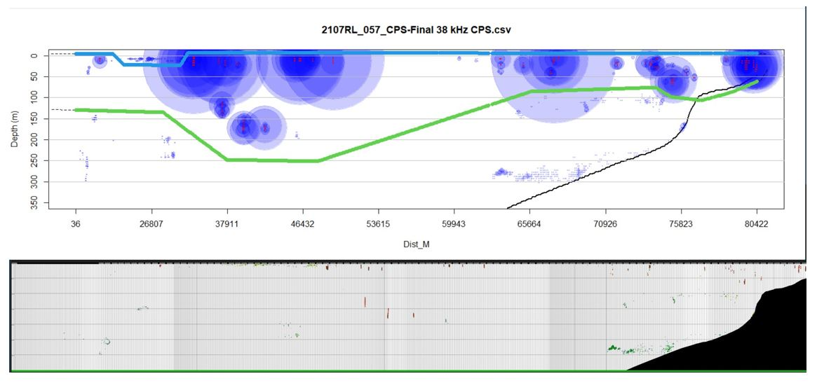

Echoes from fishes with swimbladders (blue points, scaled by backscatter intensity) along an example acoustic transect (top) and the corresponding Echoview echogram image (bottom). In this example, the upper (blue) and lower lines (green) indicate boundaries within which echoes were retained. When the lower boundary is deeper than the seabed (black line), echoes above the seabed are retained. Echoes from deep, bottom-dwelling schools of non-CPS fishes with swimbladders, and from diffuse scatters near the surface are excluded.

The script will open a plot (top) where the acoustics technician can draw new integration start line (blue) and stop line (green). Blue points that fall below the stop line will be excluded while blue points below the start line will be included from the resulting .csv file. The goal is to visually review the Echoview exported echogram image (bottom) and remove backscatter that you believe are not CPS (e.g., rockfishes, hake), possibly contain accidental seabed, or any surface noise amd diffuse scattering layers. The process of picking out CPS from other swim-bladder fish can be tricky as CPS can have a range of characteristics. The [Backscatter Identification](https://nmfs-swfsc-ast.github.io/echo-class/content/identification.html) section goes into detail on this process.

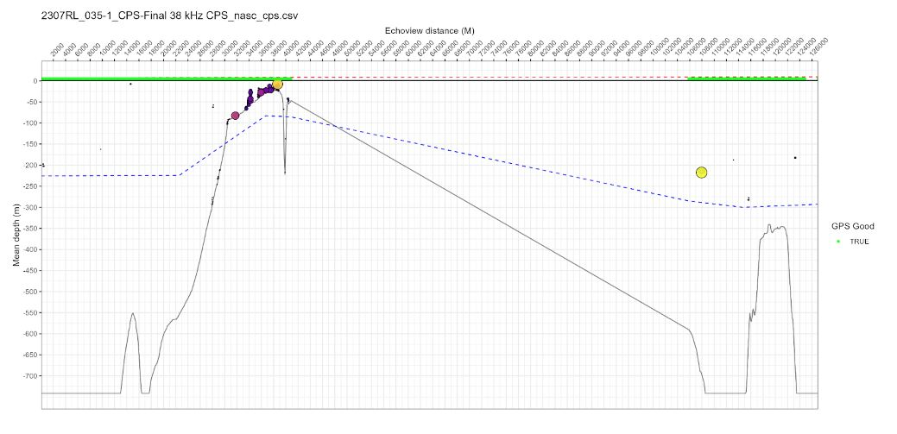

Once you are happy with the two lines, an image will appear showing the results of your editing. If the backscatter needs to be removed, or put back, you can re-run the script and the results will be replaced.

**The result is a final .csv with only backscatter information for CPS targets.**

# 5. Backscatter Identification

#### 5.0.0.1 Acoustic Characteristics of CPS

While the acoustic properties of swimbladder fish depends on several factors, the most important are the acoustic wavelength, swimbladder size, and swimbladder orientation to the incident sound pulse. We use 39, 70, 120, and 200kHz to capture a range of swimbladder sizes and orientations. During our nightly trawl catches, we measure the standard length for a collection of fish. Using the standard length we estimate the dorsal surface area of a swimbladder (swimbladder size). Knowing the approximate dorsal surface area of a swimbladder allows us to calculate the backscattering cross-section of one bladder and in turn the **volume backscattering coefficient** (many swim bladders together such as a school of fish). We are able to calculate backscattering coefficients for each CPS species. You may also hear the word Target Strength, which is a logrithmic function of the backscattering cross-section and describes how sound reflects off the swim bladder depending on its size. For this survey we calculate target strength as a logarithmic function of frequency and species-specific parameters obtained theoretically or experimentally and fish total length from trawl samples. Full details on species-specific target strength parameters can be found in the survey biomass report [here](chrome-extension://efaidnbmnnnibpcajpcglclefindmkaj/https://swfsc-publications.fisheries.noaa.gov/publications/CR/2024/2024Stierhoff.pdf).

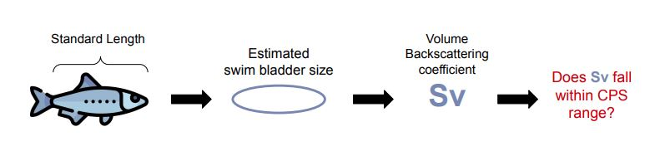

**Sv differences in the CPS range:**

−13.85 < Sv 70kHz − Sv 38kHz < 9.89

− 13.5 < Sv 120kHz −Sv 38kHz < 9.37

− 13.51 < Sv 200kHz − Sv 38kHz < 12.53

#### 5.0.0.2 **The automated CPS processing in ‘Echoview’ filters for all CPS meeting the criteria above, however some non-CPS targets still pass through the filter, specifically fishes like rockfish. To remove these CPS-like targets, we manually review each exported Echoview echogram.**

#### 5.0.0.3 **Below is how we do that.**

Using the ‘extract_CPS_NASC.R’, an R-based tool in the ‘estimATM’ package, we remove non-CPS targets from final echograms. This process aims to distinguish CPS from non-target species from mid-water, demersal, and benthic swim bladder fishes.

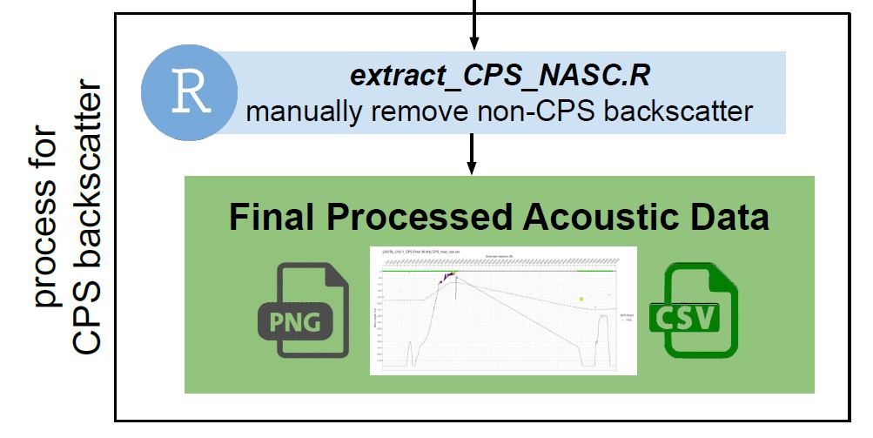

We follow a decision guide to help distinguish CPS and retain the backscatter that meets the criteria in green.

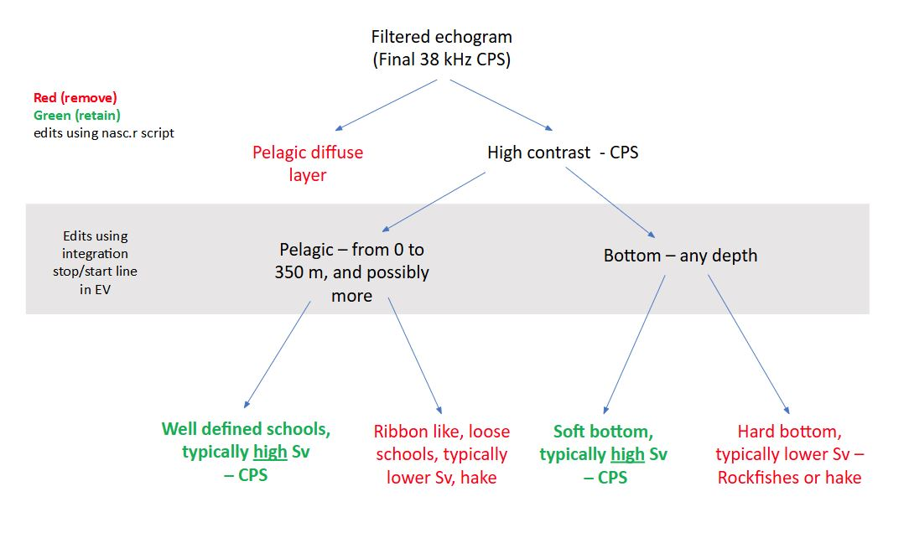

Below is an example of a well defined school with high Sv. CPS schools can occur in near the surface, mid-water column, or compressed to the seabed (especially in shallow waters during the day).

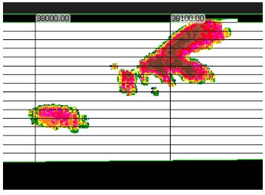

CPS near sea surface

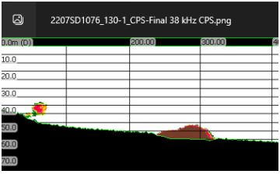

CPS near seafloor

Below are examples of non-CPS that we manually using ‘extract_CPS_NASC.R’.

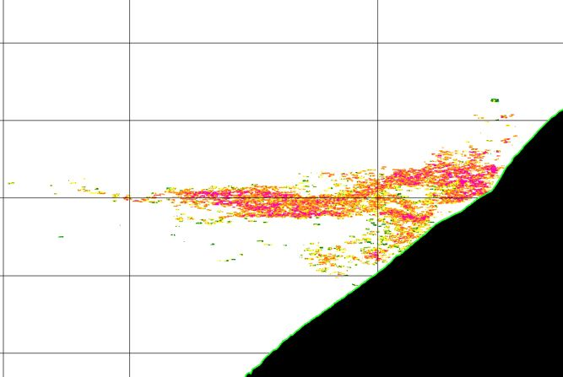

Diffuse biological layer. Diffuse schools will often be observed offshore near the surface, near a shelf break, or deeper than ~250m

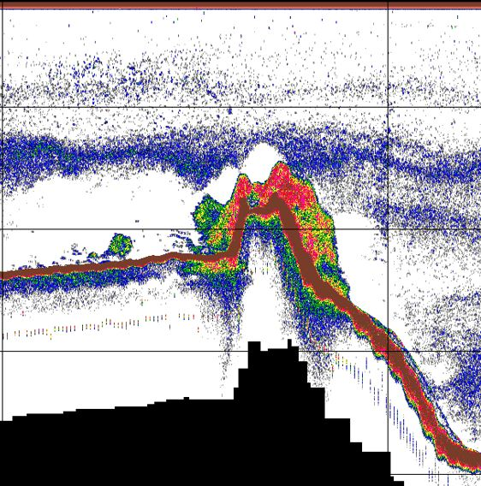

Rockfish on a seamount. Rockfish often will be observed near rugged or rocky seabed.

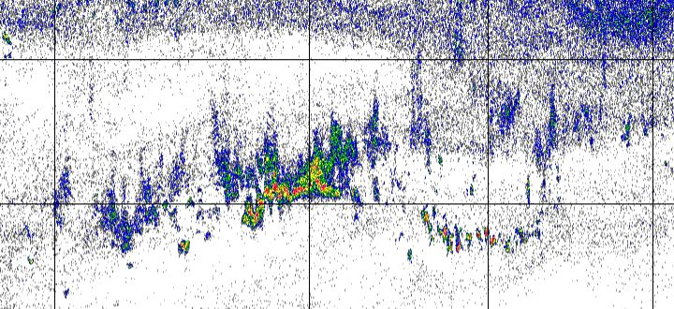

The hake snake. Hake tend to be mid-water column and in a snaking schooling behavior.

When looking at Echoview echograms of acoustic transects, if there are areas where we are unsure if the backscatter is CPS or not CPS based on visual inspection, we dig deeper and examine how the **volume backscattering coefficient (Sv)** changes over each frequency. We refer to this as the frequency response. Swimbladder fish are expected to have a flat or decreasing frequency response across 38kHz, 70kHz, 120kHz, and 200kHz (Figure 5.1) with the decrease or flattening occurring between 120kHz and 200kHz.

|  |
| --- |
| Figure 5.1 |

*Reference: Content is adapted from* [*this google document: Name that Backscatter!*](https://docs.google.com/document/d/1-YxJs1veotnSZJIWPH6vJjYOA5Dt1iETaqmNv8eNoTk/edit?tab=t.0)

# 6. Trawl Selection

Acoustic transects are processed for CPS backscatter on the day of acquisition and used to determine nightly trawl locations. This page will walk through the process of trawl selection.

### 6.0.1 **1. Visual Comparison**

The acoustics technician on watch completes a visual comparison between an in-house published map (plotSurvey) of backscatter results and the transect acoustic echogram. Dense schools of CPS seen in the echogram will correlate to colorful bubbles on plotSurvey.

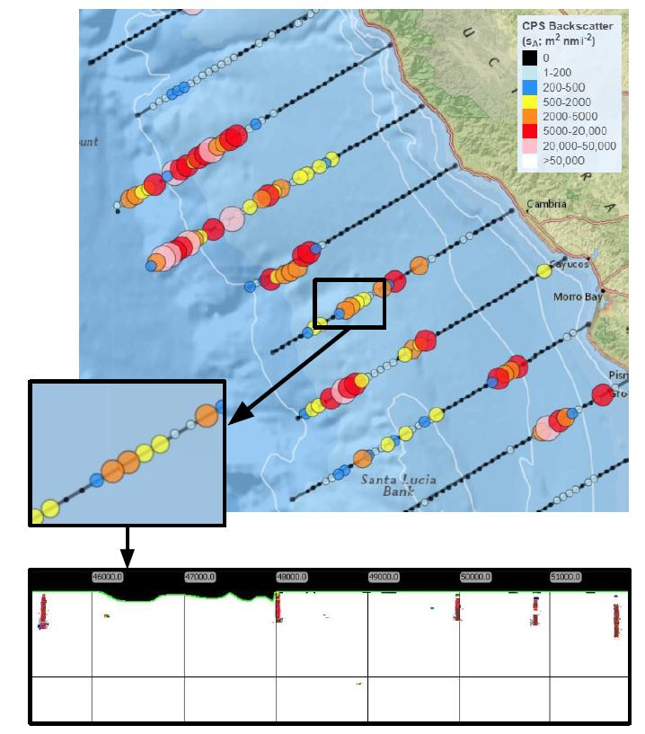

Clicking on summarized acoustic points shows a popup that contains the time and distance interval over which those data were summarized, allowing you to scrutinize the results of Echoview processing. We make sure to cross-reference backscatter spots on plotSurvey with the exported image from Echoview to make an informed trawl-location decision.

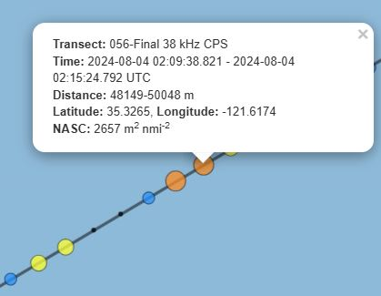

### 6.0.2 2. Best Judgement

The acoustics technician will select 2-3 trawls each night based on the backscatter observed during the daytime acoustic transect, operational efficiency, and expected CPS habitat. If no CPS backscatter is observed, trawl locations will default to using expected CPS habitat information and operational efficiency.

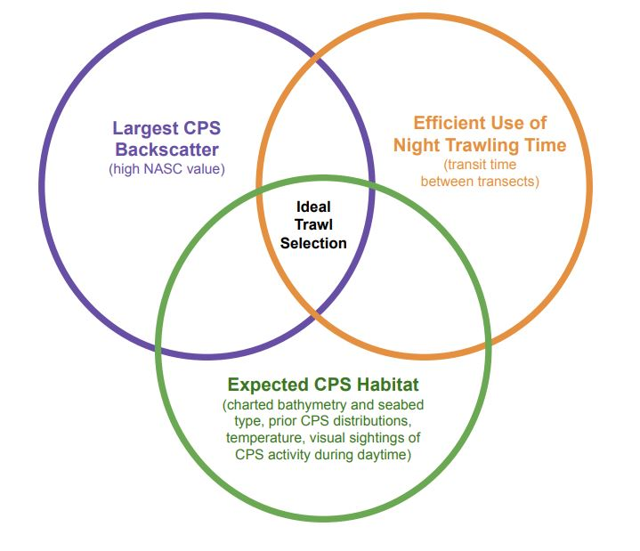

Expected CPS habitat is derived from prior survey results and models:

* Sardine habitat based on a 12-year data set of sardine eggs, remotely sensed oceanographic variables, sea surface temperature, chlorophyll *a* concentrations, sea surface altitude (J. P. Zwolinski, Emmett, and Demer 2011).
* Charted bathymetry – Pacific sardines can be found from the ocean surface to ~350m in depth and typically reside around smoother (less rocky) bottom types.
* Sardine eggs are most abundant at sea-surface temperatures of 13 to 15 ∘C, and larvae are most abundant at 13 to 16 ∘C. Temperature is a primary driver of the spatial and seasonal distribution of spawning. During warm ocean conditions, sardine spawning shifts northward concentrating in offshore regions and north of Point Conception to San Francisco and in some years is observed as far north as Oregon (Kuriyama, Zwolinski, and Hill 2020).

# 7. Reporting

Using the r package ‘estimATM’ several reports are generating using the final processed acoustic data.

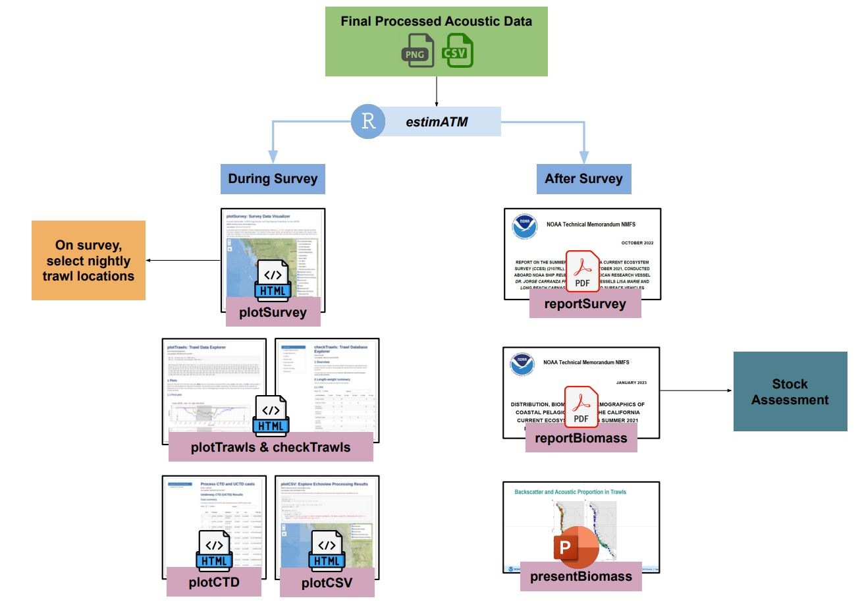

# References

De Robertis, Alex, and Ian Higginbottom. 2007. “A Post-Processing Technique to Estimate the Signal-to-Noise Ratio and Remove Echosounder Background Noise.” *ICES Journal of Marine Science* 64 (6): 1282–91. <https://doi.org/10.1093/icesjms/fsm112>.

Demer, David A., George R. Cutter, Josiah S. Renfree, and John L. Butler. 2009. “A Statistical-Spectral Method for Echo Classification.” *ICES Journal of Marine Science* 66 (6): 1081–90. <https://doi.org/10.1093/icesjms/fsp054>.

Kuriyama, Peter T., Juan P. Zwolinski, and Kevin T. Hill. 2020. “Assessment of the Pacific Sardine Resource in 2020 for u.s. Management in 2020-2021.” *Southwest Fisheries Science Center (U.S.)*. <https://doi.org/10.25923/R2FZ-4Y79>.

Stierhoff, Kevin L., Juan P. Zwolinski, Josiah S. Renfree, and David A. Demer. 2024. “Distribution, Biomass, and Demographics of Coastal Pelagic Fishes in the California Current Ecosystem During Summer 2023 Based on Acoustic Trawl Sampling.” *NOAA National Marine Fisheries Service Southwest Fisheries Science Center*. <https://doi.org/10.25923/1VGS-SF98>.

Zwolinski, Juan P., Robert L. Emmett, and David A. Demer. 2011. “Predicting Habitat to Optimize Sampling of Pacific Sardine (Sardinops Sagax).” *ICES Journal of Marine Science* 68 (5): 867–79. <https://doi.org/10.1093/icesjms/fsr038>.

Zwolinski, Juan P., Paulo B. Oliveira, Victor Quintino, and Yorgos Stratoudakis. 2010. “Sardine Potential Habitat and Environmental Forcing Off Western Portugal.” *ICES Journal of Marine Science* 67 (8): 1553–64. <https://doi.org/10.1093/icesjms/fsq068>.

Zwolinski, Juan, David Demer, George Cutter, Kevin Stierhoff, and Beverly Macewicz. 2014. “Building on Fisheries Acoustics for Marine Ecosystem Surveys.” *Oceanography* 27 (4): 68–79. <https://doi.org/10.5670/oceanog.2014.87>.