Assignment 3

Sed

By Nicholas Mueller

Please include the command, a screenshot showing it works as intended, cite all sources you used, and give a short explanation of how the command works and why.

1. Change the name Meg to Megan

For this command I use the -n option to suppress sed’s default behavior I use s/ followed by the string I want to replace Meg in this example with /Megan I use another /then p to print to screen the output.

Command: sed -n s/Meg/Megan/p datebook

1. Delete the last 3 lines.

Datebook has 53 lines this command tells sed to delete d lines 51 to 53 in the file datebook.

Command: sed 51,53d datebook

1. Print lines 2 through 4 .

Using -n to suppress default sed behavior to show just the lines I want the syntax is 2,4 specifies lines 2 to 4 then p to print followed by the filename

Command: sed -n 2,4p datebook

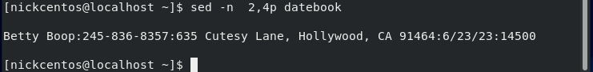

1. Delete lines containing Place.

Command: sed /Place/d datebook

1. Print all lines where the birthdays are in the first week of the month. Be careful of the dates for birthdays, the format is MM/DD/YY

In this problem I use -n to suppress default behavior then I specify /[0-9][/] any number followed by a slash, I want only the first week of the month so [1-7][/] the first seven days then a slash another [0-9] (any number) then /p to print matching lines.

Command: sed -n '/[0-9][/][1-7][/][0-9]/p' datebook

1. Append three asterisks to the end of lines starting with Sir

For this problem I use sed /Sir to find the pattern Sir then /a\ the a must be enclosed in forward then backward slashes then the \*\*\* to insert three asterisks and the filename datebook

Command: sed /Sir/a\ \*\*\* datebook

1. Replace the line containing "Westley Pirate" with the phrase "As you wish."

This command uses /c\ for replace preceded by the pattern Pirate: this finds lines with Westley Pirate then what follows the /c\ replaces lines that have Pirate: with As You Wish.

Command: sed ‘/Pirate:/c\As You Wish’ datebook (shown on next page)

1. Change Minerva McGonagall's birthday to 12/25/1960 . Assume you don't know Minerva's original birthday. Use a regular expression to search for it.

Command: grep -E [0-9][/][0-9][/][0-9] datebook first image and command are the regular expression I used to find Minerva’s birthday.

Next Command: sed -n s/2[/]3[/]36:/12//\/25\\/1960:/p datebook

In this command I tell sed -n to suppress default behavior (I only want to see what I changed) then s/ for substitute 2[/]3[/]36: this is the birthday must enclose the \ in brackets or sed gets confused. Then after my substitution pattern, what to substitute with the syntax /12\\/25\\/1960:/p note you must escape the / between the numbers by using \\ or it gives syntax error the /p means print.

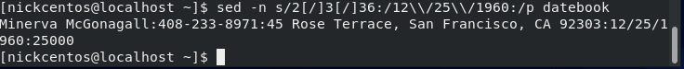

1. Delete all blank lines

Source Used: “Complete sed command | Delete empty lines in a file using sed command”

<https://www.youtube.com/watch?v=JOg1Ap9-HJE>

I looked up this command in a youtube video the syntax is

sed /^$/d datebook where the ^ and $ combined finds blank lines and /d deletes them from datebook file.

Command: sed /^$/d datebook

Source used: “Using sed, how can I append "START" above the first line and "END" below the last line?”

Link is here

<https://www.youtube.com/watch?v=M_8epMEIW4c>

1. Write a sed script that will (actual sed script, NOT just the commands on the command line)

This is the sed script I wrote starts with the #!/usr/bin/sed because this is a sed script and must use #!/usr/bin/sed that is where the sed commands are.

a. Insert above the first line the title - Great Literary Characters -.

b. Remove the duplicate lines

For b. the duplicate line was line 17 of datebook so it’s deleted with the command 17d in the script.

I didn’t think the remaining lines were duplicates as two start with Westley Pirate but end with different numbers and dates.

Also, blank lines are deleted using /^$/d

c. Print the contents of the file with the first name then the phone number

\*\*\*For part C.

I couldn’t find a way to get this kind of output using the sed script alone, so I piped the output to awk. shown below. I tell awk to print the first and second fields.

d. Append at the end of the file "Happily Ever after. The End"

I do this using

Command: $s/$Happily Ever after.The End/

shown below at the bottom of the picture.

