Week 2

Adding users to sudo

Cent OS method

Login as root

At the terminal as root type sudo vi /etc/sudoers

Go to where root is then under the root line type in your username then use exactly 4 spaces match the pattern spacing of root precisely: root ALL=(ALL)(tab here)ALL where root is your username nickcentos in this example.

After in insert mode (i) make changes hit escape then type :x!

\*\*Warning\*\*

Do Not change or add anything unless you know what you are doing check for errors before you save changes.

If you mess this up like I did the first time… root will lose sudo privileges!

I believe I fixed the situation by editing the etc/sudoers file in vi I think when no users are in this file sudo isn’t required to edit the contents, either that or I changed the file permissions for etc/sudoers to get back in and edit it. Which means that I should change file permissions to defaults again for security reasons.

Now login as the non root user and try a sudo command, shown below it worked.

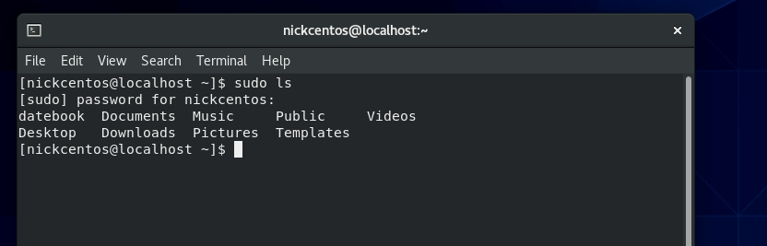

The Debian server method of adding users to is sudo very easy.

Login as root user then enter the command adduser nick sudo shown in the screenshots below

Check to see if it worked

Sudo now works with my non root account nick@debian.