FastMap: A Fast Algorithm for Indexing, Data-Mining and Visualization of Traditional and Multimedia Datasets

Christos Faloustas, King-Ip (David) Lin

University of Maryland, College Park

Outline

- Introduction
- Known techniques
- Proposed method
- Experiments and results
- Conclusions and comments

1. Introduction

FastMap: a new fast algorithm for mapping objects into points in some k-dimensional space

Goals: 1. efficient mapping of N given objects (N is large)
2. efficient retrieval of data

Possible applications:

- Multimedia databases (e.g. search by content in large datasets)
- Image databases (e.g. application in medicine)
- Time series (e.g. similarity in stock prices over some period)
- Similarity in string databases
- Visualization
- Clustering, etc.

General problem:

- GIVEN: N objects and N × N distance matrix of pairwise distances
- FIND: N points in some k-dimensional space such that the distances are preserved as well as possible

Specialized problem:

- GIVEN: N objects with n attributes each
- FIND: N points in some k-dimensional space such that the distances are preserved as well as possible

Requirements:

- Time complexity for mapping N objects must be o(N ²)
- Distances should be preserved
- An algorithm for mapping a new object in O(N logN) must be provided

2. Known techniques

Multidimensional Scaling (MDS)

- maps each object to a point in k-dimensional space to minimize stress function
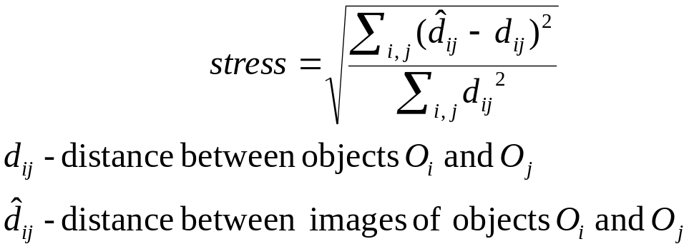

Steps of MDS:

- Assign each object a k-dimensional point
- Examine each point and compute N − 1 distances to the other objects and move the point to minimize stress

This is a “steepest descent” method of updating points.

Problems:

- O(N ²) time
- O(N ) for adding a new item
3. FastMap

- GIVEN: N objects and N×N distance matrix of pairwise distances
- FIND: N points in some k-dimensional space such that the distances are preserved as well as possible

Distance function: non-negative, symmetric, triangular inequality

Idea:

- start as though the objects O₁, O₂, ..., O_{N} are already points in some n-dimensional space
- project all the objects on k mutually orthogonal axes

Let’s project arbitrary object O_{i} to a line O_{a} O_{b}
Cosine law:
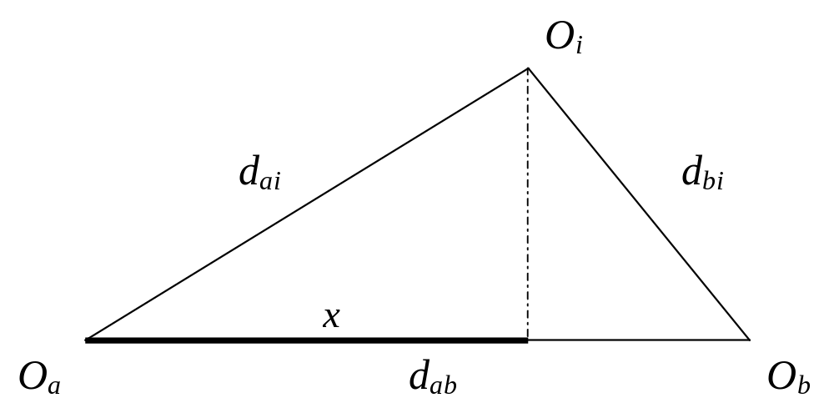
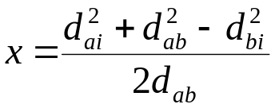

To obtain remaining k − 1 “dimensions”:

- all objects have to be projected onto a (n − 1)-dimensional hyper-plane H that is orthogonal to the line O_{a}O_{b}.

Let O_{i}` be the projection of object O_{i}.

Distances between new objects O_{i}` and O_{j}` are calculated from the following picture

How do we choose distant objects?

choose_distant_objects (set of objects, set of distances)

- Choose arbitrarily an object and declare it to be O_{b}

Repeat c times:

- set O_{a} = (the farthest object from O_{b})
- set O_{b} = (the farthest object from O_{a})

The cost: O(c⋅N)

4. Results

Several experiments are performed.

- comparison FastMap vs. MDS (k-fixed, N-varying)
- comparison FastMap vs. MDS (N-fixed, k-varying)
- stress function over time

- clustering of Gaussian data
- clustering of real data

5. Conclusions and comments

- new algorithm is proposed to map arbitrary objects into k-dimensional points
- input is a distance function between objects (N × N matrix)
- output is N k-dimensional points

Good points:

- Algorithm solves “distance problem” (doesn’t need features as inputs)
- Time complexity is O(kN)
- Mapping of a new query performed in O(k) time
- Better performance than MDS

Weak points:

- Strong demands on distance function (non-negative, symmetric, triangular inequality) really limits is application

