download-removebg-preview.png

PROJECT REPORT TEMPLATE

INTRODUCTION

# Overview

* 1. **the creating captivating birthday inivitation with canva project is centered around designing visually appealing and personalized birthday invitations using canva a well crafted birthday invitation sets the tone for a memorable celebration and makes recipients excited to attend**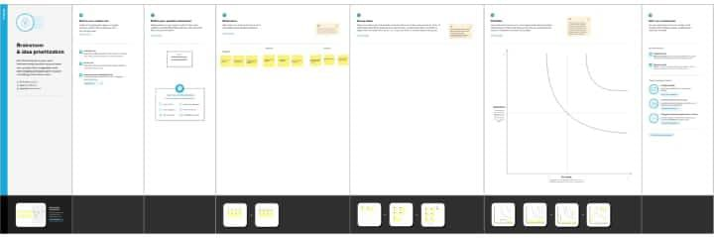

# Purpose

1. Small and Convenient
2. Affordable Advertisement
3. Give A visual aid to Remember your business
4. Business cards are a vital networking tool
5. Business Cards Create and professinal Image credible

# Problem Definition & Design Thinking

* 1. **Empathy Map**

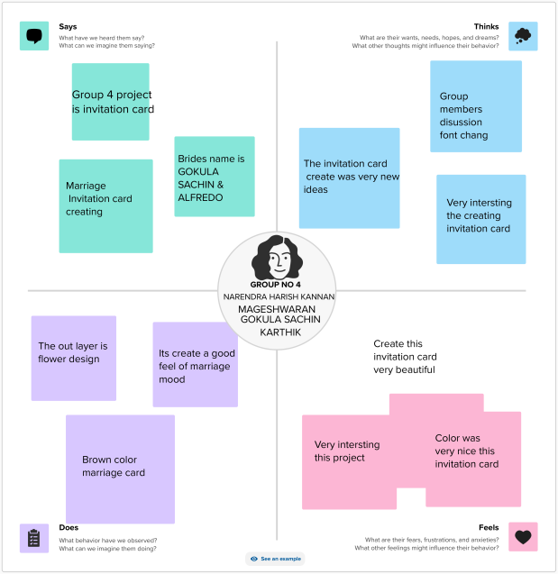

**RESULT**

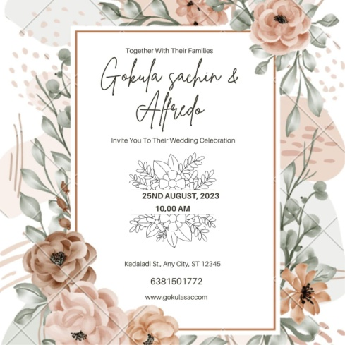

# ADVANTAGES & DISADVANTAGES Advantages

* Canva is very simple to use and user friendly
* Canva provides social media templates
* Canva offers a professional look
* Team access
* As well as million of image

# Disadvandage

* The free version is limited
* Unique elements cannot be created
* limited export setting s
* Alignment concerns
* Unable to move one design to another design

# APPLICATIONS

* We create a canva account
* Choose our design type
* And we used business card template
* we uploaded our backround image
* we used uploading photos, and adding text, and used to editing elements ,and change fonts
* Added to the women icon , flower design of corner.
* we created to business card
* Finally we downloaded a design

# CONCLUSION

People in our team worked together to make a business card on the topic " Designing professional business card " through this , a company's advertisement can be brought to the door of the card . canva is an essential tool for most business .It is easy to use offers a wide range of templates, its affordable, customizable and helps business with their branding. Graphic designing can be learned through this project.