概述

Tracing/Snooping、Sampling/Profiling区别
Tracing/Snooping是基于事件的跟踪，Samping/Profiling是基于时间的采样。
Tracing/Snooping可能导致跟踪引入负荷剧增；
Samping/Profiling引入的测试负荷相对稳定，但是有可能丢失部分信息。

bcc、bpftrace、libbcc、libbpf、bpf之间的关系
可以将整个架构分成三层：前端bcc和bpftrace、中间层libbcc和libbpf、内核BPF。
其他类似bcc/bpftrace的工具还有：适合嵌入式设备的ply、基于Python的工具。
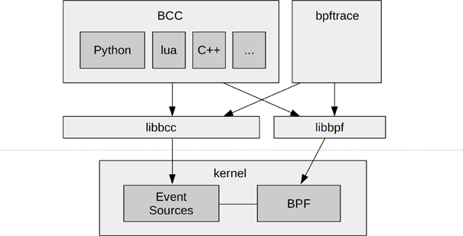
相关资源列表：
bcc：https://github.com/iovisor/bcc
bpftrace：https://github.com/iovisor/bpftrace
ply：https://github.com/iovisor/ply

Linux系统和应用bpf性能工具集
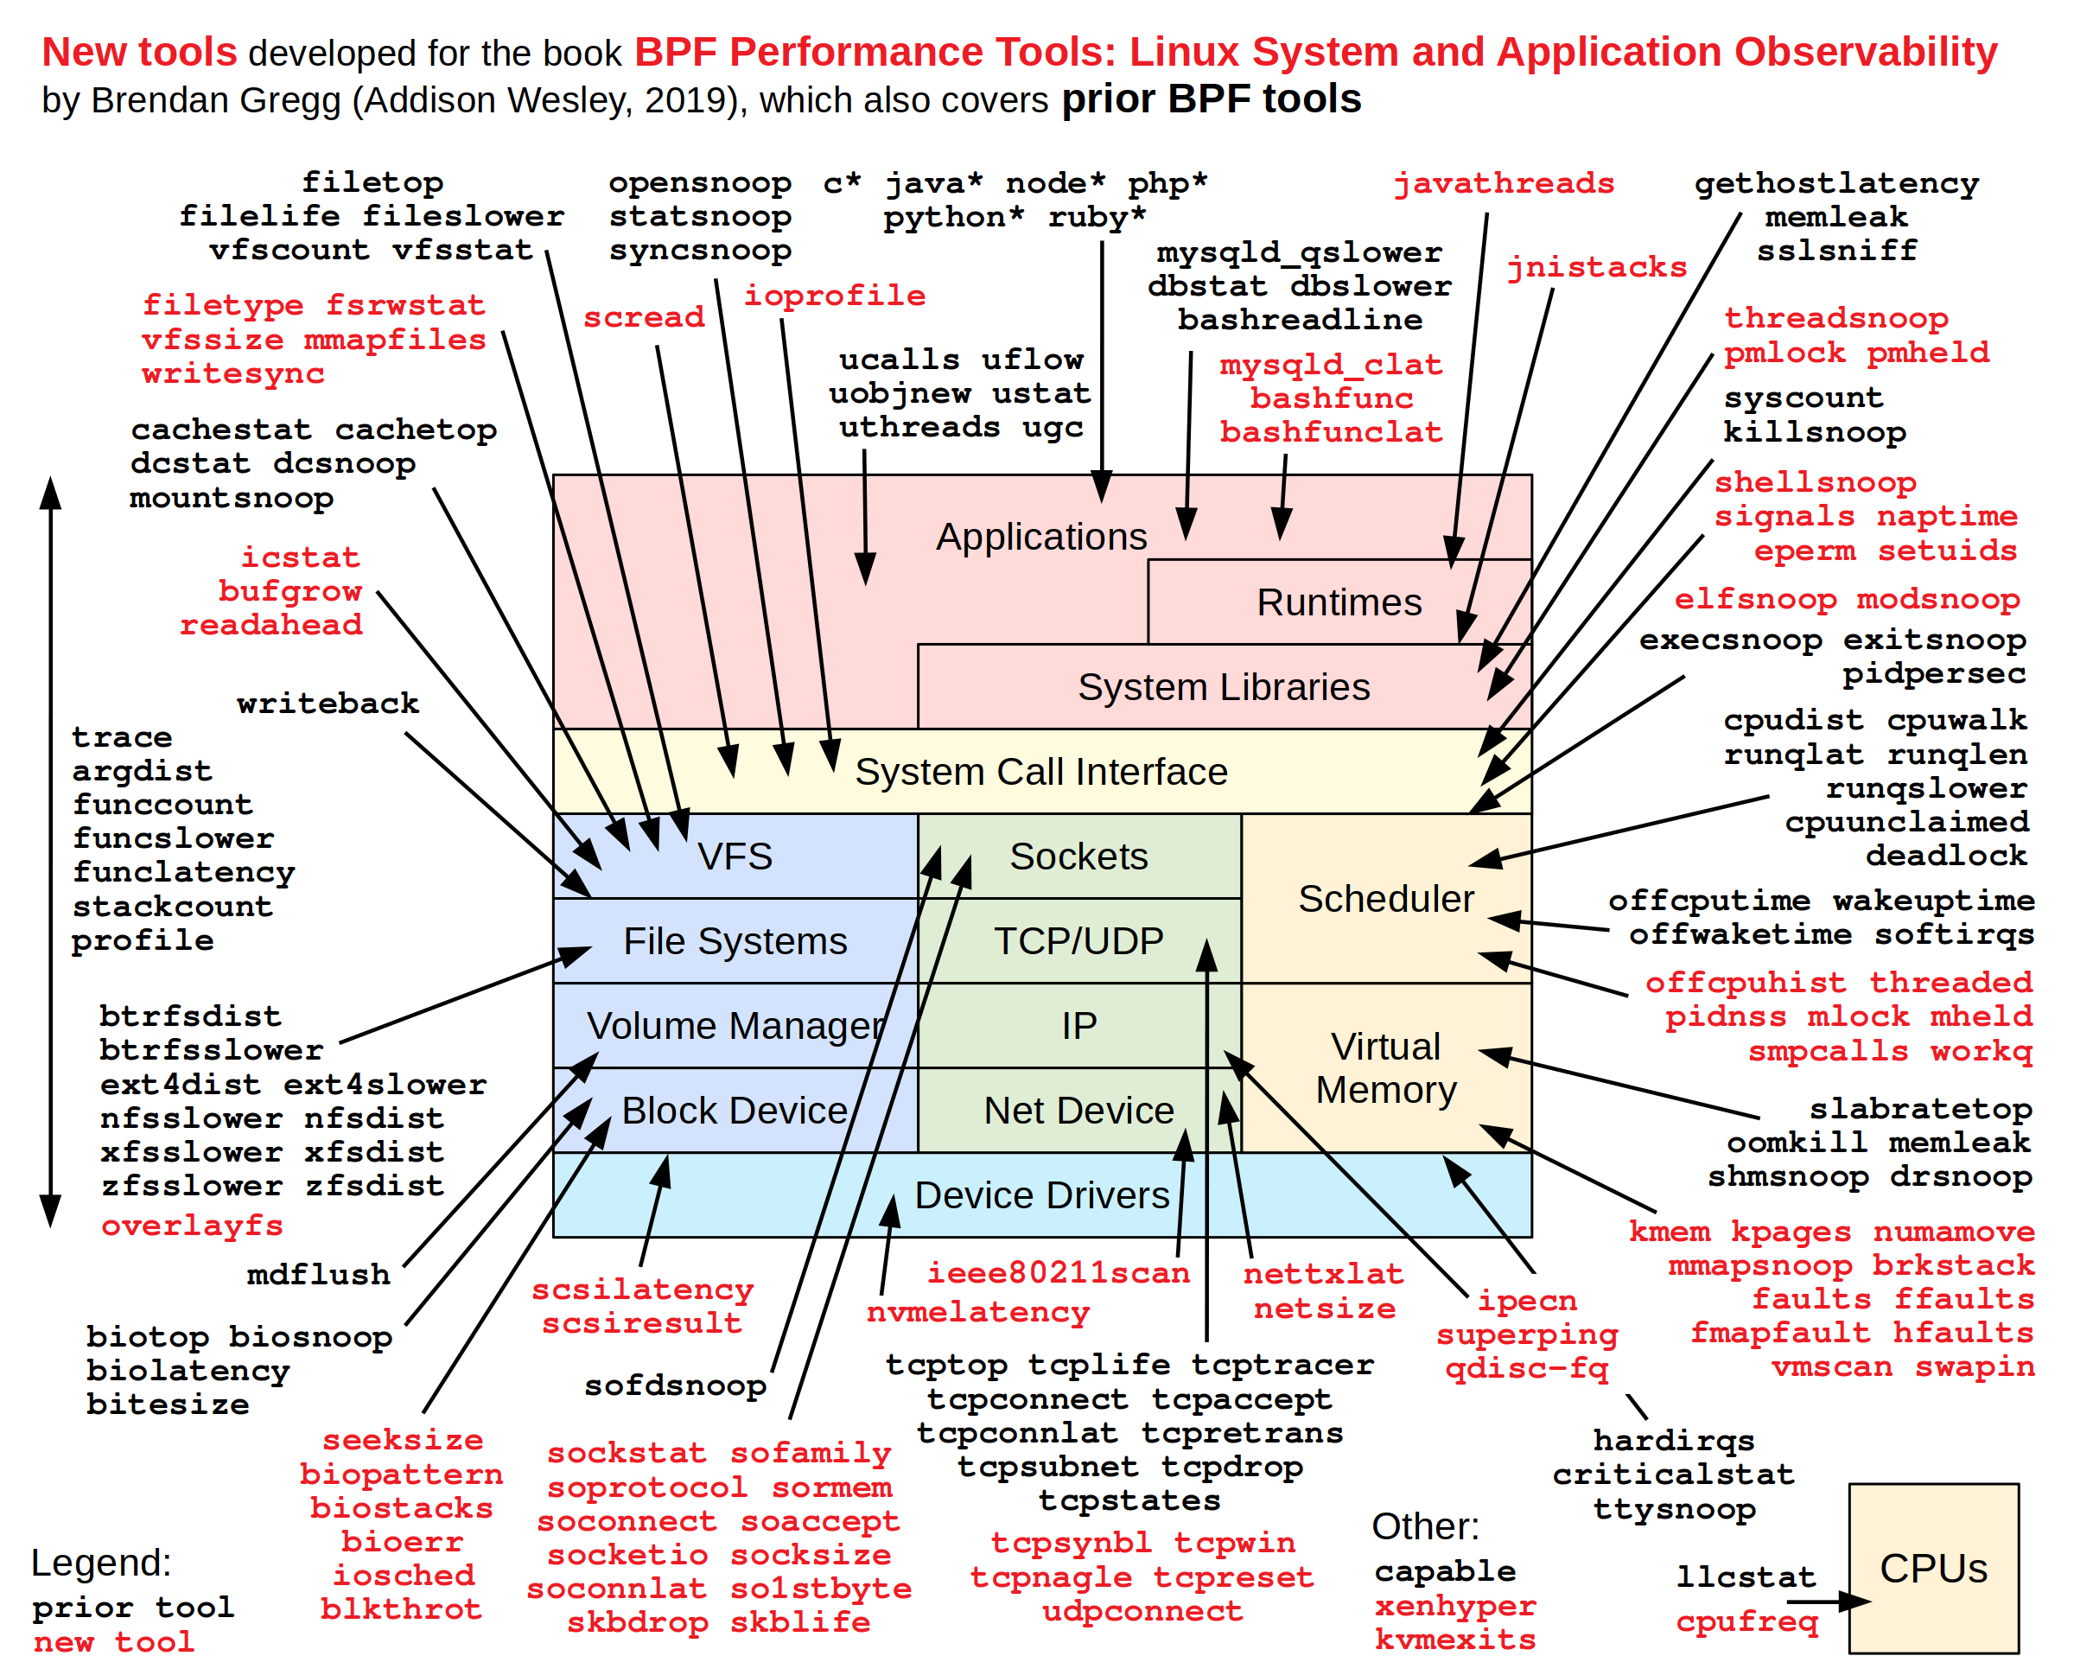

静态跟踪和动态跟踪
动态：kprobes和uprobes
动态跟踪可以在程序运行时插入跟踪，在不使用的时候开销极低。

静态：tracepoints和usdt
相对于动态跟踪，静态跟踪更加稳定。但是不够灵活，数量也受限。
BPF跟踪支持内核静态的tracepoints和用户空间的USDT(User-level Statically Defined Tracing)。

安装
dnf install bcc bpftool

cd /usr/share/bcc/tools
ls

待整理

bcc c example

https://github.com/iovisor/bpftrace/issues/987

bpftrace -e 'usdt:./foo:foo:main_enter { @start[tid] = nsecs; } usdt:./foo:foo:main_leave /@start[tid]/ { @ns[comm] = hist(nsecs - @start[tid]); delete(@start[tid]); }'

https://blog.srvthe.net/usdt-report-doc/

https://leezhenghui.github.io/linux/2019/03/05/exploring-usdt-on-linux.html

https://github.com/iovisor/bpftrace/blob/master/docs/tutorial_one_liners.md

入门示例

bpftrace -e 'tracepoint:syscalls:sys_enter_open { printf("%s %s\n", comm, str(args->filename)); }'
bpftrace -l 'tracepoint:syscalls:sys_enter_open*'
bpftrace -e 'tracepoint:syscalls:sys_enter_open* { @[probe] = count(); }'

动态跟踪kprobe

#!/usr/bin/env bpftrace
# test.bt

BEGIN
{
printf("Tracing stat syscalls... Hit Ctrl-C to end.\n");
// printf("%-6s %-16s %3s %s\n", "PID", "COMM", "ERR", "PATH");
}

k:sock_recvmsg,
k:sock_sendmsg
{
@[func, pid, comm] = count()
}

静态跟踪usdt

示例程序
# 安装依赖
dnf install systemtap-sdt-devel

# foo.c
#include <stdio.h>
#include <unistd.h>
#include <sys/sdt.h>

int bar(int r, int i) {
DTRACE_PROBE2(foo, bar_enter, r, i);
int result = r + i;
DTRACE_PROBE1(foo, bar_leave, result);
return(result);
}

int main(void) {
sleep(5);
DTRACE_PROBE(foo, main_enter);
int r = 0;
for(int i = 1; i <= 10; i ++) {
r = bar(r, i);
}
printf("- r=%d\n", r);
DTRACE_PROBE(foo, main_leave);
}

gcc foo.c -o foo

静态跟踪点
# 查看支持的跟踪点
bpftrace -l 'usdt:./foo:*'

#
bpftrace -e 'usdt:./foo:foo:main_enter { @start[tid] = nsecs; } usdt:./foo:foo:main_leave /@start[tid]/ { @ns[comm] = hist(nsecs - @start[tid]); delete(@start[tid]); }'

# foo.usdt.bt
#!/usr/bin/env bpftrace

BEGIN
{
printf("Tracing ... Hit Ctrl-C to end.\n");
// printf("%-6s %-16s %3s %s\n", "PID", "COMM", "ERR", "PATH");
}

// all
usdt:./foo:foo:main_enter
{
@start[tid] = nsecs;
}

usdt:./foo:foo:main_leave
/@start[tid]/
{
@us[comm] = hist((nsecs - @start[tid]) / 1000);
delete(@start[tid]);
}

bpftrace foo.usdt.bt

动态跟踪 uprobe/uretprobe
#!/usr/bin/env bpftrace
# test.u.bt
BEGIN
{
printf("Tracing ... Hit Ctrl-C to end.\n");
// printf("%-6s %-16s %3s %s\n", "PID", "COMM", "ERR", "PATH");
}

// all
// uprobe:./foo:main
u:./foo:main
{
@start[tid] = nsecs;
}

// uretprobe:./foo:main
ur:./foo:main
/@start[tid]/
{
@all_us[comm, probe] = hist((nsecs - @start[tid]) / 1000);
delete(@start[tid]);
}

bpftrace test.u.bt

One-Liners
https://github.com/iovisor/bpftrace#tools
https://github.com/iovisor/bpftrace/tree/master/tools

# Files opened by process
bpftrace -e 'tracepoint:syscalls:sys_enter_open { printf("%s %s\n", comm, str(args->filename)); }'

# Syscall count by program
bpftrace -e 'tracepoint:raw_syscalls:sys_enter { @[comm] = count(); }'

# Read bytes by process:
bpftrace -e 'tracepoint:syscalls:sys_exit_read /args->ret/ { @[comm] = sum(args->ret); }'

# Read size distribution by process:
bpftrace -e 'tracepoint:syscalls:sys_exit_read { @[comm] = hist(args->ret); }'

# Show per-second syscall rates:
bpftrace -e 'tracepoint:raw_syscalls:sys_enter { @ = count(); } interval:s:1 { print(@); clear(@); }'

# Trace disk size by process
bpftrace -e 'tracepoint:block:block_rq_issue { printf("%d %s %d\n", pid, comm, args->bytes); }'

# Count page faults by process
bpftrace -e 'software:faults:1 { @[comm] = count(); }'

# Count LLC cache misses by process name and PID (uses PMCs):
bpftrace -e 'hardware:cache-misses:1000000 { @[comm, pid] = count(); }'

# Profile user-level stacks at 99 Hertz, for PID 189:
bpftrace -e 'profile:hz:99 /pid == 189/ { @[ustack] = count(); }'

# 每秒各进程vfs*调用情况
bpftrace -e 'kprobe:vfs_* { @vfs[comm, func] = count(); } interval:s:1 { print(@vfs); clear(@vfs); }'

#
bpftrace -e 'tracepoint:raw_syscalls:sys_* { @[comm, probe] = count(); }'

bpftrace -e 'tracepoint:raw_syscalls:sys_* { @[comm, probe] = count(); }'

帮助

tplist

[root@localhost tools]# ./tplist -h
usage: tplist [-h] [-p PID] [-l LIB] [-v] [filter]

Display kernel tracepoints or USDT probes and their formats.

positional arguments:
filter A filter that specifies which probes/tracepoints to print

optional arguments:
-h, --help show this help message and exit
-p PID, --pid PID List USDT probes in the specified process
-l LIB, --lib LIB List USDT probes in the specified library or executable
-v Increase verbosity level (print variables, arguments,
etc.)
[root@localhost tools]# ./tplist -v syscalls:sys_enter_read
syscalls:sys_enter_read
int __syscall_nr;
unsigned int fd;
char * buf;
size_t count;
[root@localhost tools]#

CPU

系统调用

#!/usr/bin/env bpftrace

// bpftrace -e 'tracepoint:syscalls:sys_enter_* { @[comm, probe] = count(); }'

BEGIN
{
printf("Tracing ... Hit Ctrl-C to end.\n");
}

tracepoint:syscalls:sys_enter_*
{
@cnt[comm, probe] = count();
}

interval:s:1
{
time("%H:%M:%S PIDs/sec\n");
print(@cnt, 20);
clear(@cnt);
}

END
{
print(@cnt, 20);

clear(@cnt);
}

