G1 Combiner Parts Assembly Instructions

The G1 combiner parts are composed of 25 printed parts. Additional hardware needed to complete the build are:
- #10 X ½” button head screws (X8)
- 13/32” diameter spring cut to 15mm (X1)
All non-printed hardware can easily be obtained at Lowe’s or Home Depot.

All the parts in this build were printed in PLA. The head base, chestplate, and leg connector body should be printed with at least 50% infill. All other parts can be printed at 15% infill.
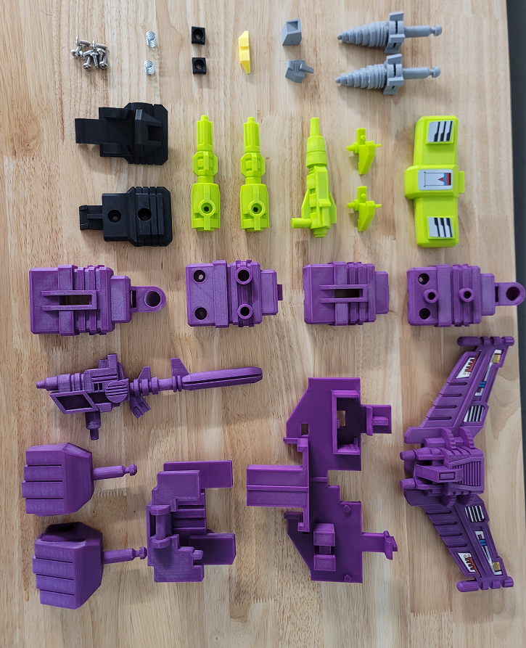
The springs used in this build are 13/32” diameter springs cut to 15mm total length:

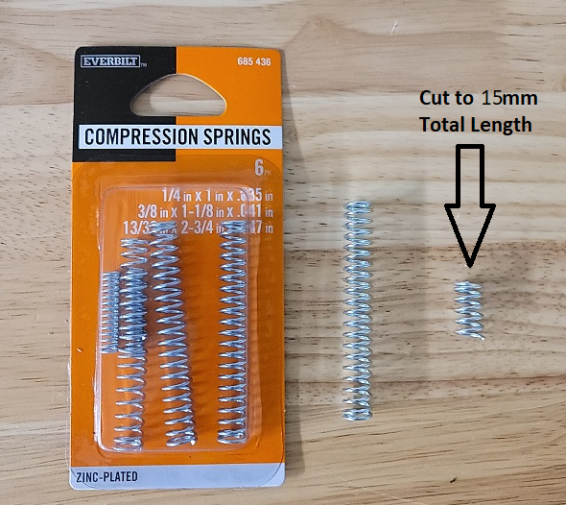

Super glue the eyes, lower face and forehead into the front head:

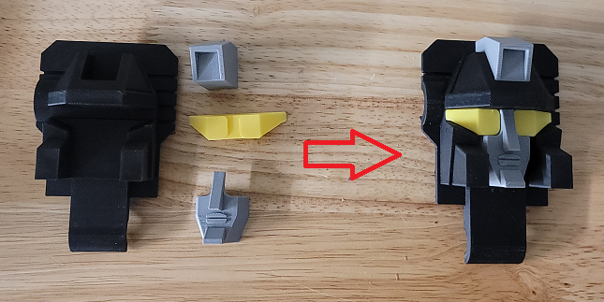

Screw the two springs into the spring stops. They should tighten when they reach the end:

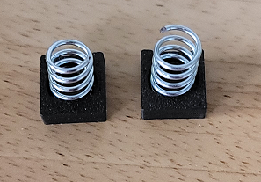

Attach the leg cannons into the leg connector body with #10 X ½” screws:

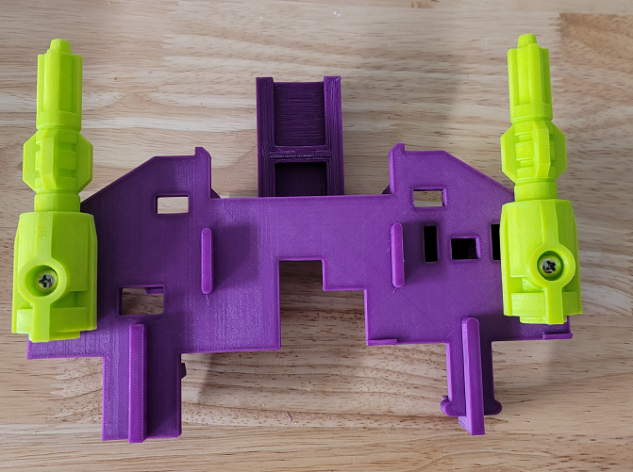

Place the triggers and spring assemblies into the left and right arm inner pieces:

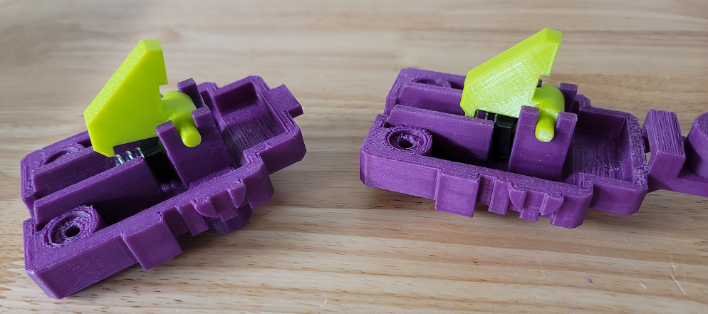
Place the left and right outer arm parts over the arm assemblies and screw them down with two #10 X 12” screws each:

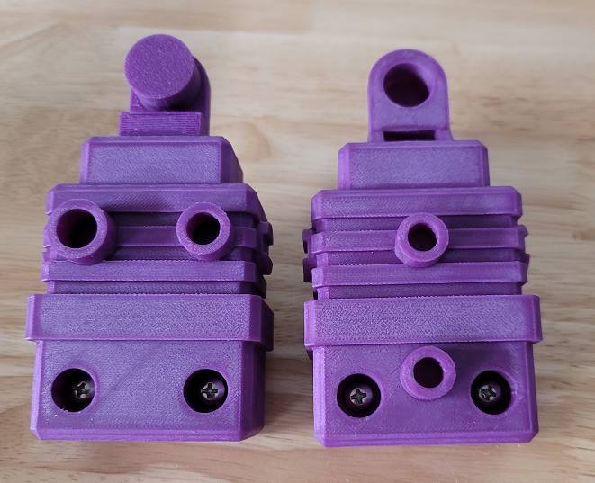

Place the head base with the front head assembly and attache the rear head with two #10 X 12” screws:

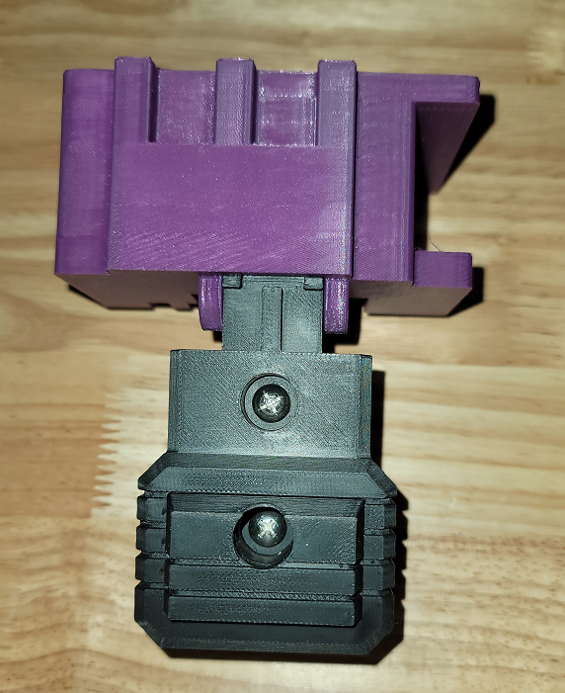

The G1 combiner parts are now complete!

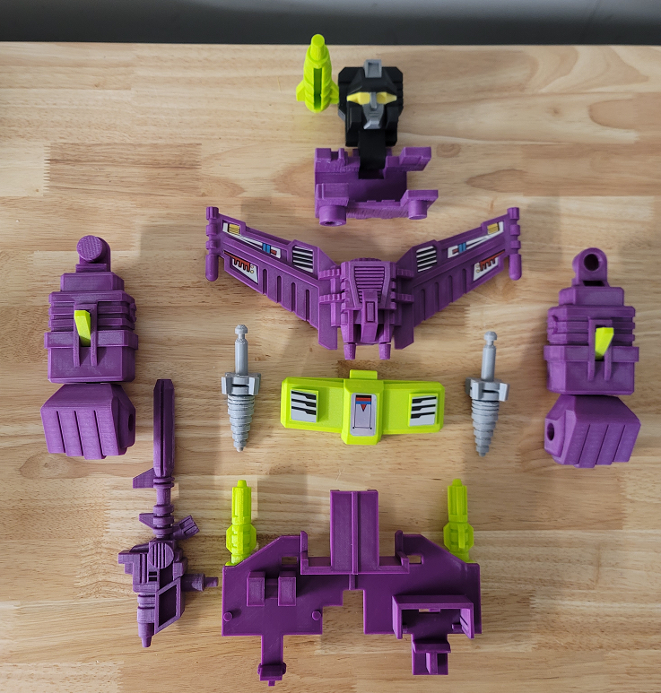

Stickers

The stickers have three layers. The stickers can be printed on transparent vinyl. A clear plastic layer can then be stuck to the top of the vinyl to protect it. The clear layers can them be stuck to a third layer of silvered vinyl. This creates stickers that have a metallic look like the original stickers. These stickers are thick and don’t bend around curves easily so the stickers should be cut wherever they wrap around curves. Cricut makes transparent and silvered vinyl designed for ink jet printers.

