Longhaul Assembly Instructions

Longhaul is composed of 30 printed parts. Additional hardware needed to complete the build are #10 X ½” button head screws (X5), 16d nail cut to 18mm (X2), 16d nail cut to 39mm (X2), 16d nail cut to 46mm (X2), 3/16” rod cut to 72mm (X1) and 3/16” rod cut to 90mm (X1). All non-printed hardware can easily be obtained at Lowe’s or Home Depot.

All the parts in this build were printed in PLA. All the parts were printed with 15% infill. The tires for this example have been printed with two different colors.

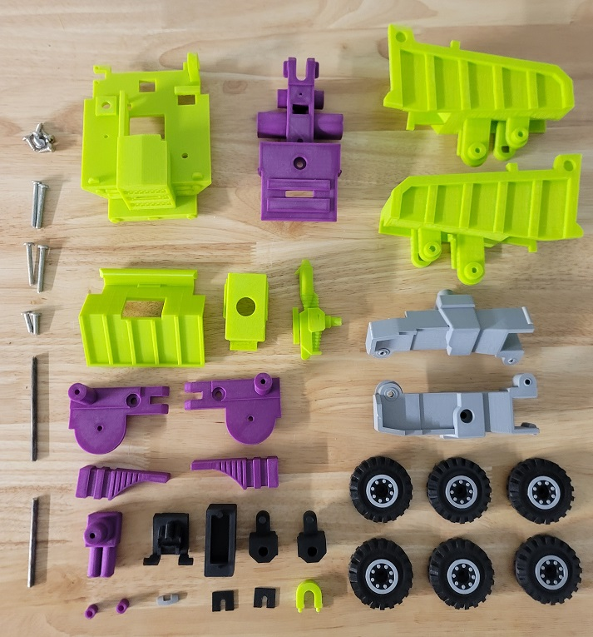

The nails used in the build are cut to a total length of 18mm, 39mm and 46mm:

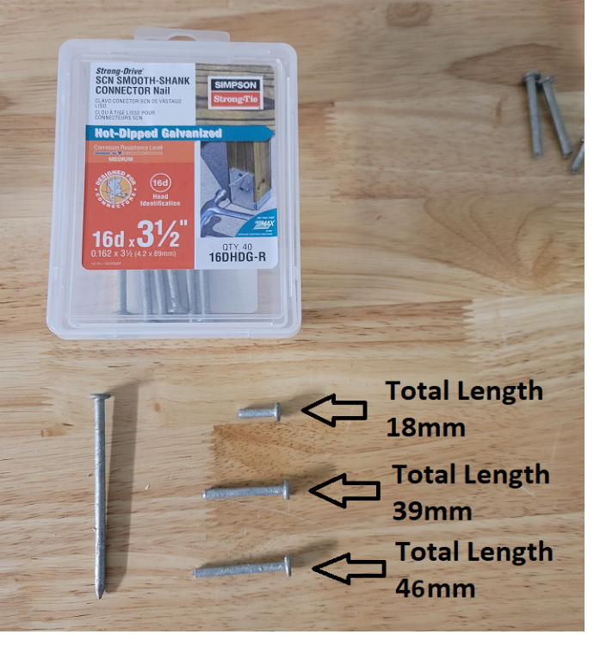

The steel rods used in the build are cut to a total length of 72mm and 90mm:

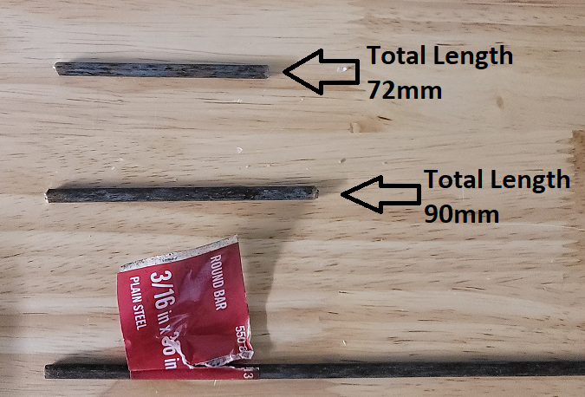

Super glue the visor into the main head:

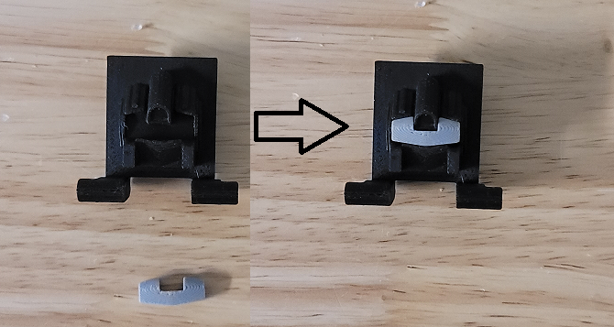

Double stack two tires onto the 39mm nails and superglue the nails into the left and right foot:

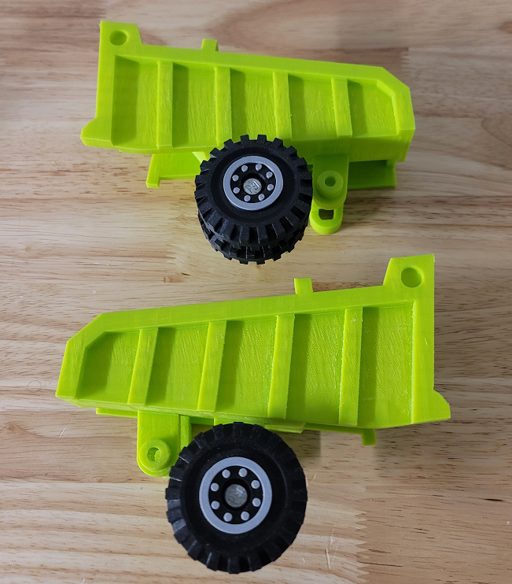
Press the 46mm nails through the left and right inner arms:

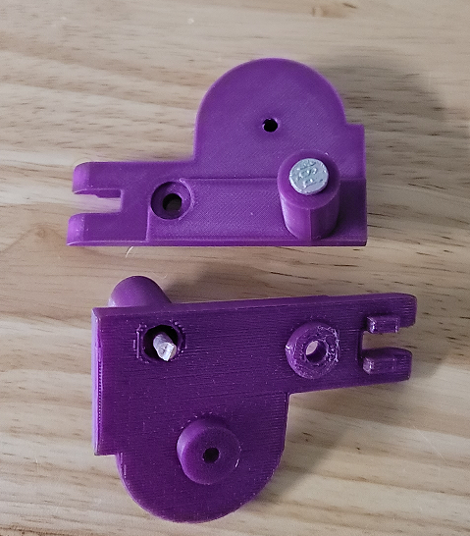

Super glue the arm rod collars to the end of the nails. The collars should be even with the end of the nail. Make sure no super glue gets between the collars and inner arms:

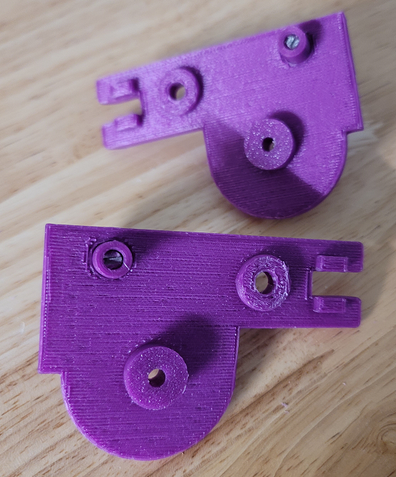

Screw the left and right legs together:

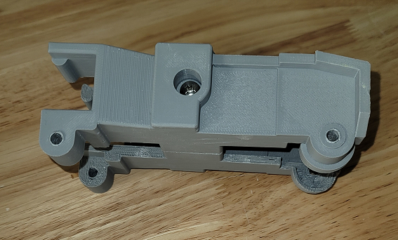

Place the roof onto the upper torso and super glue in the roof clip to trap the roof:

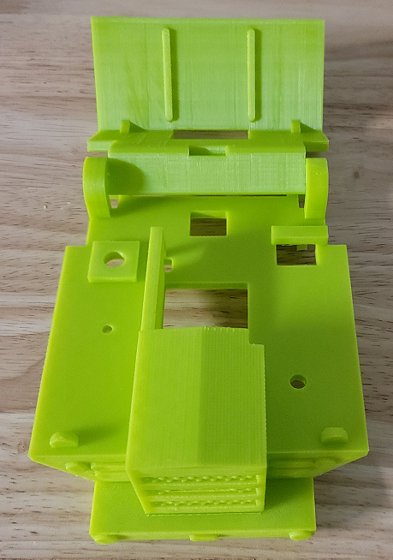

Place the head assembly on the upper torso assembly and insert the cab. Super glue the front of the cab to the upper torso:

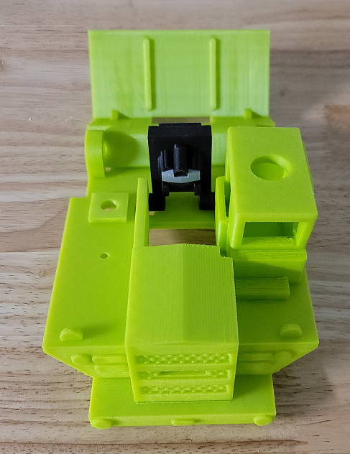

Screw the smoke stack onto the upper torso assembly:

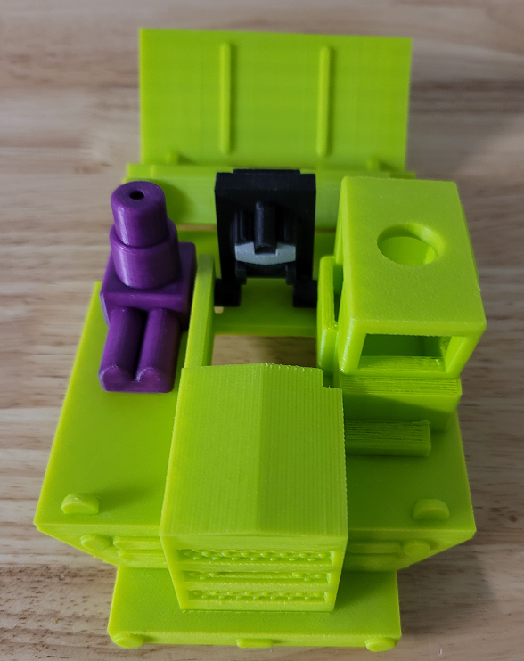
Place the remaining two tires on the 18mm nails and glue the nails into the inner arms:

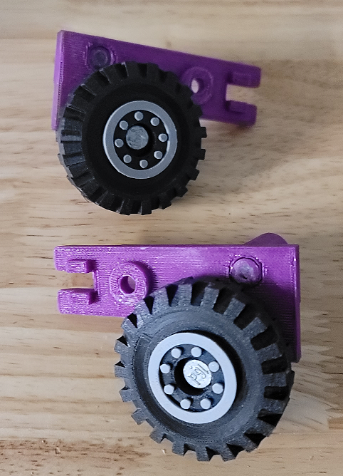

Place the fists in the arm assemblies and screw on the outer arms:

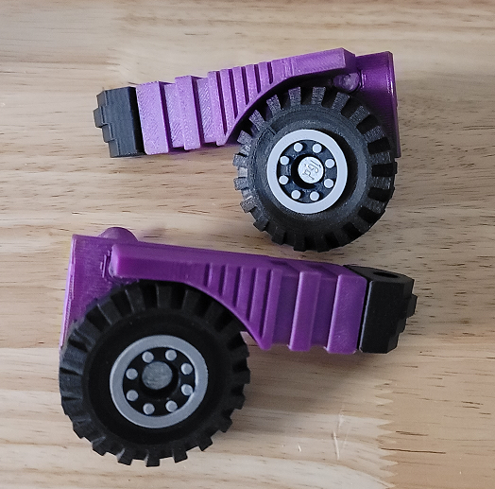

Connect the feet assemblies to the leg assembly by passing the 90mm rod through them all. Super glue the rod to the leg assembly at the arrows shown below:

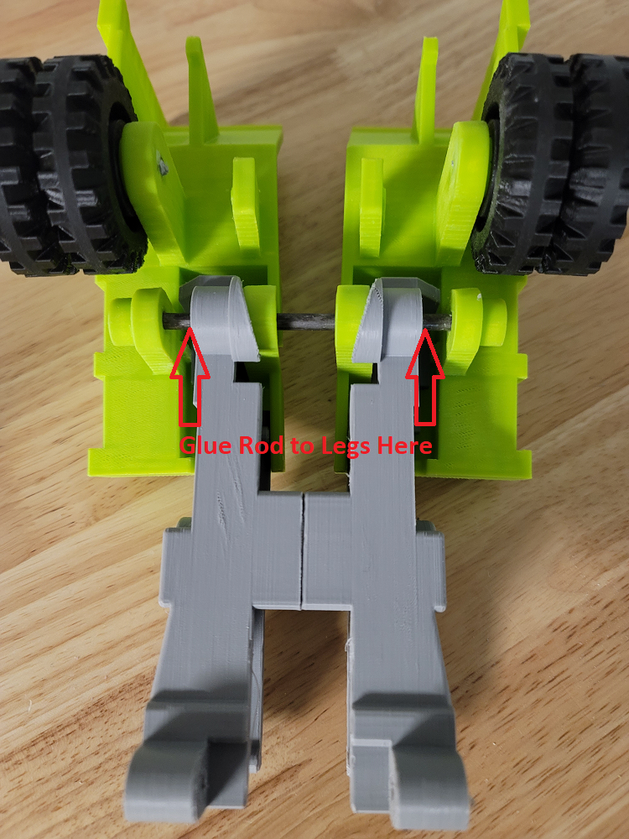

Super glue the waist filler to the lower torso:

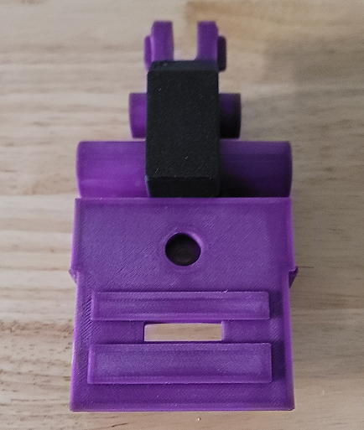

Clip the arm stops onto the nails as shown by the arrows below:

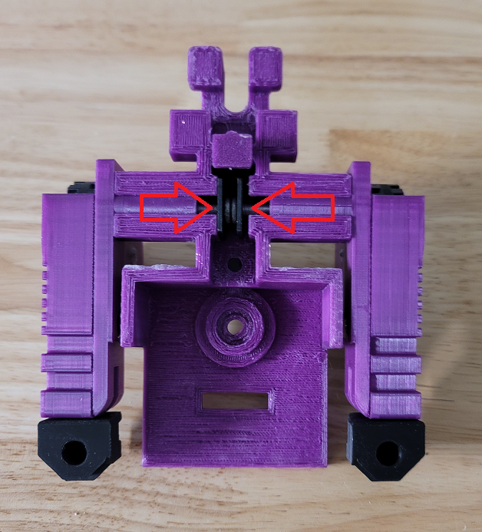

Connect the leg assembly and lower torso assembly together and run the 72mm rod through them as shown by the arrow below:

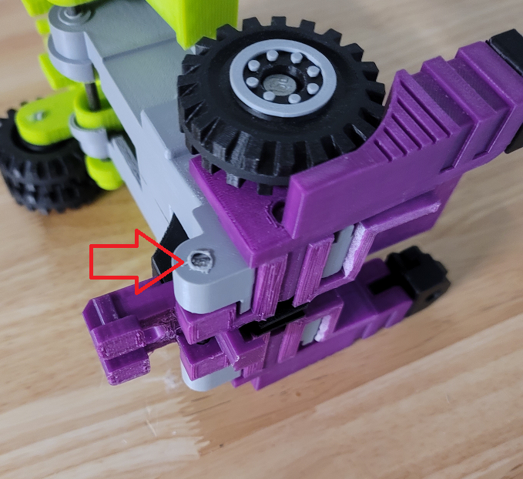

Place the upper torso assembly onto the lower torso assembly and screw them together:

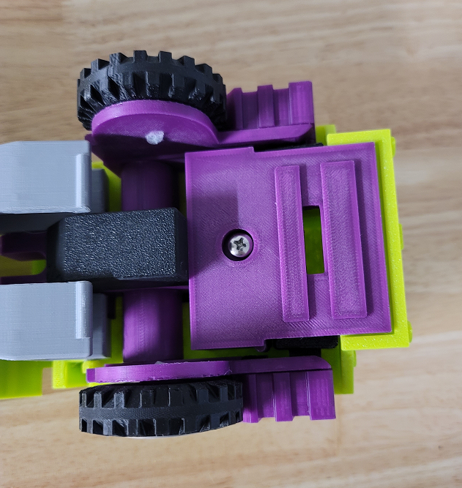

Loghaul is now complete!

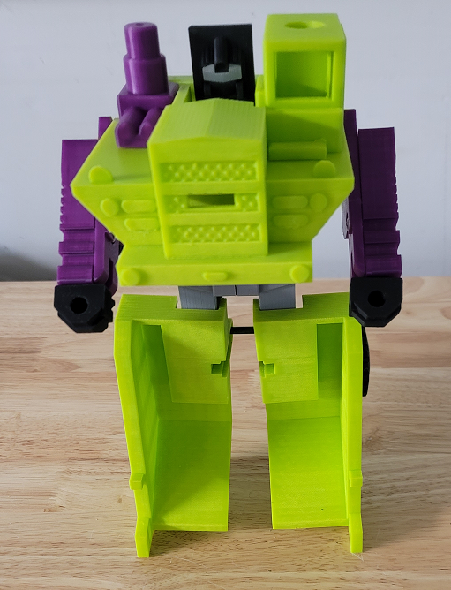
Stickers

The stickers have three layers. The stickers can be printed on transparent vinyl. A clear plastic layer can then be stuck to the top of the vinyl to protect it. The clear layers can them be stuck to a third layer of silvered vinyl. This creates stickers that have a metallic look like the original stickers. These stickers are thick and don’t bend around curves easily so the stickers should be cut wherever they wrap around curves. Cricut makes transparent and silvered vinyl designed for ink jet printers.

