Scavenger Assembly Instructions

Scavenger is composed of 24 printed parts. Additional hardware needed to complete the build are #10 X ½” button head screws (X6), #10-24 X 1/2” button head screw (X1), #10 X 1” button head screw (X1), ¼” X ¾” button head screws (X2), ¼” flat washer with a ½” outer diameter (X1) and a 5/8” diameter compression spring cut and stretched to 50mm. All non-printed hardware can easily be obtained at Lowe’s or Home Depot.

All the parts in this build were printed in PLA. The waist and arm connector should be printed with a minimum of 50% infill. All other parts can be printed with 15% infill.

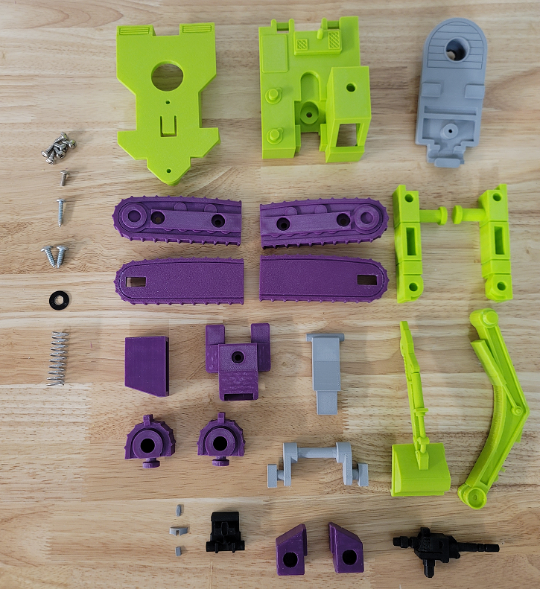

The spring used in this build should have about 10 loops cut off and they should be stretched to 50mm:

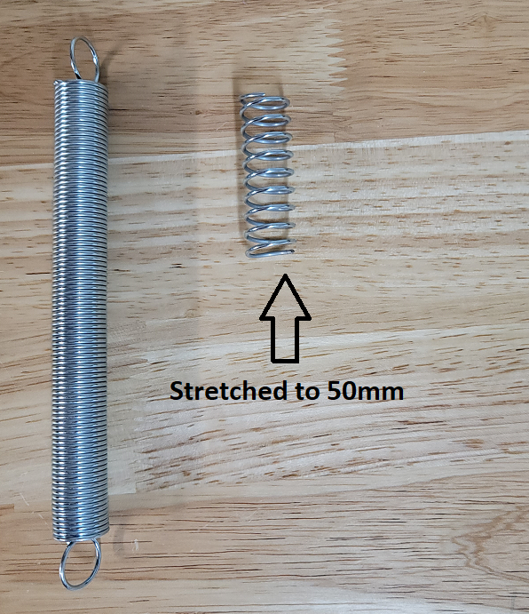

Super glue the forehead, eyes and chin into the main head:

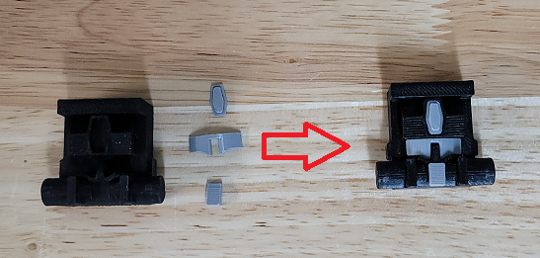

Secure the upper scoop and lower scoop together with a #10-24 X ½” screw. This should not be a pointed screw as it will slightly stick out of the other side:

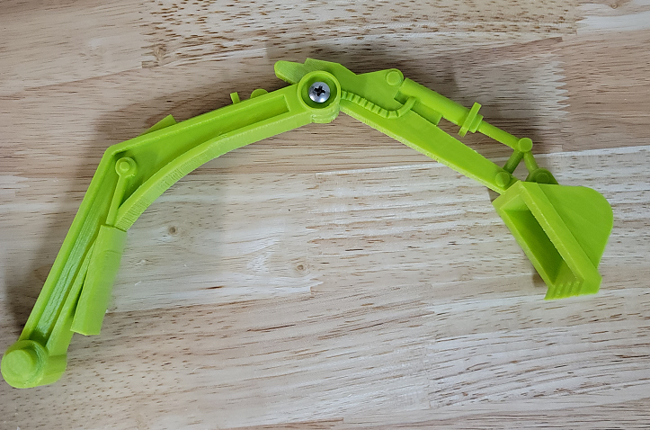

Stickers

The stickers have three layers. The stickers can be printed on transparent vinyl. A clear plastic layer can then be stuck to the top of the vinyl to protect it. The clear layers can them be stuck to a third layer of silvered vinyl. This creates stickers that have a metallic look like the original stickers. These stickers are thick and don’t bend around curves easily so the stickers should be cut wherever they wrap around curves. Cricut makes transparent and silvered vinyl designed for ink jet printers.

