Upgrades Assembly Instructions

The upgrades are divided into five parts due to the size of the project. All non-printed parts can be easily obtained from Lowe’s or Home Depot.

Gun and Adapter

The gun and adapter are the simplest parts of this project. They require no assembly and are simply printed. They can be printed with 15% infill. The adapter is used to firmly connect the gun to Devastator’s hand.

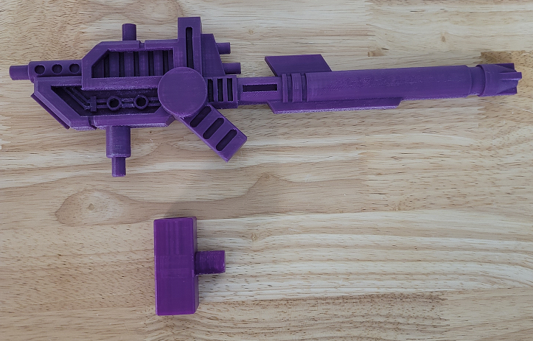
Chest Plate

The chest plate is composed of 7 printed parts. All parts can be printed with 15% infill.

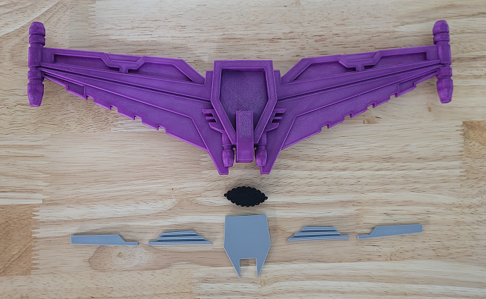
The top and the five inserts should be super glued to the main plate:

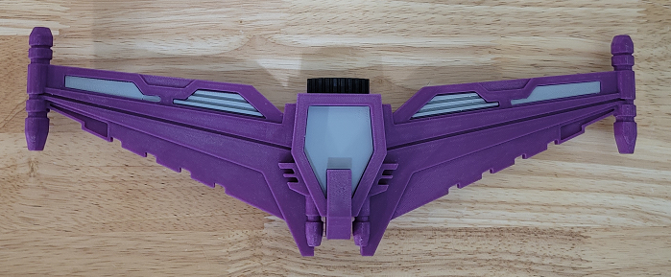
Heads

The heads are composed of 17 printed parts. Additional hardware needed to complete the build are #10 X ½” button head screws (X6). The lower clips should be printed with at least 50% infill to prevent them from cracking when assembling Devastator. All other parts can be printed with 15% infill.

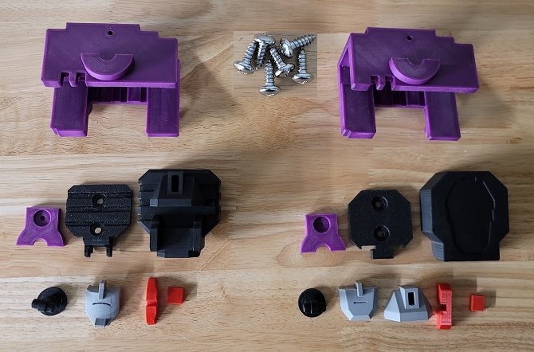

Super glue the face components into the front head on both heads:

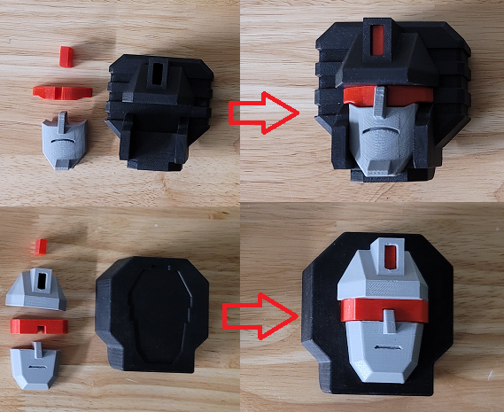
Put the neck into the back of the front head assembly in both heads. The neck pieces are both the same:

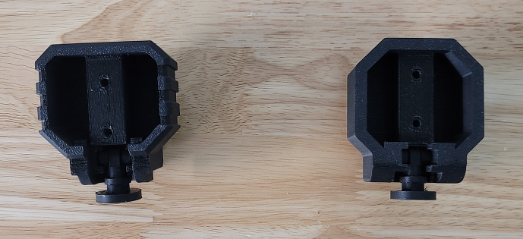
Screw the back head pieces to the front head assemblies using two #10 X ½” screws in each:

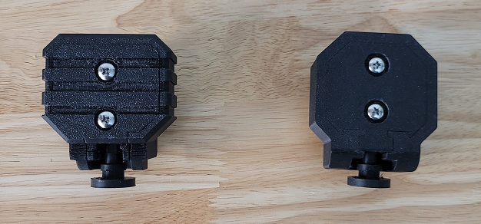

Attach the head assemblies to the lower clips with the upper clips and a single #10 X ½” screw in each assembly. Both upper and lower clips are identical:

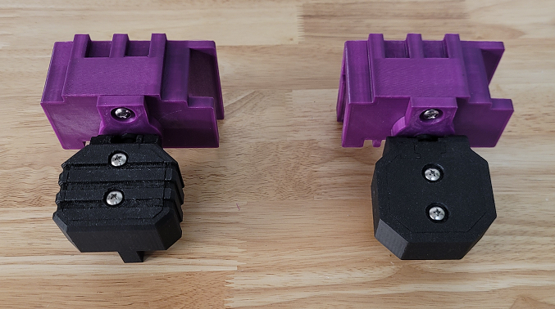
The heads are now complete:

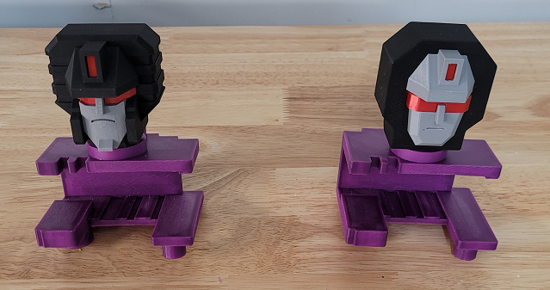

The many faces of Devastator:

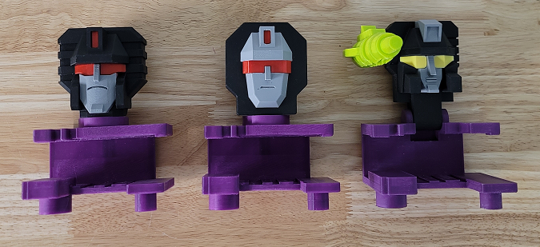

Arms

The arms are composed of 52 printed parts. Additional hardware needed to complete the build are 1 ½” finishing nails (X36). 28 of the nails should be cut to 10mm, 6 nails cut to 22mm and 2 nails cut to 34mm. Also, #10 X 1” (X6) button head screws are needed. All printed parts can be printed with 15% infill. The hand backs are 2 color prints in this version.

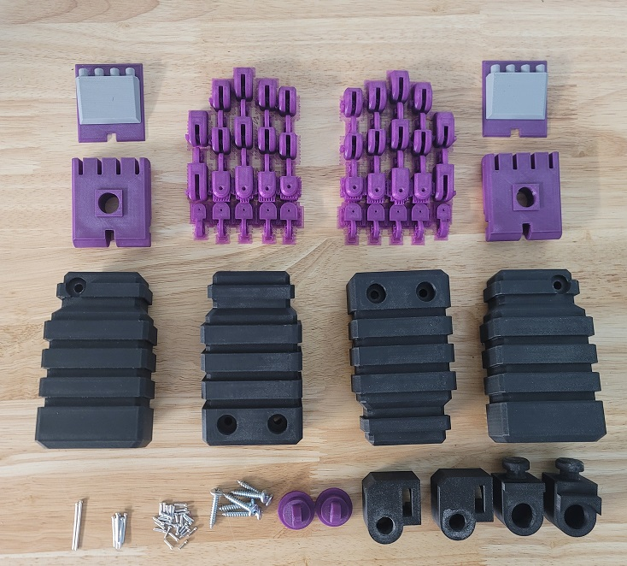

The finishing nails used for pinning the hand segments togethe can be found at Home Depot or Lowe’s:

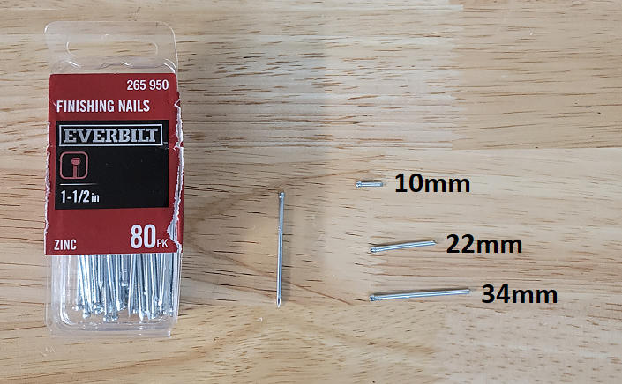
Super glue the hand backs onto the palms:

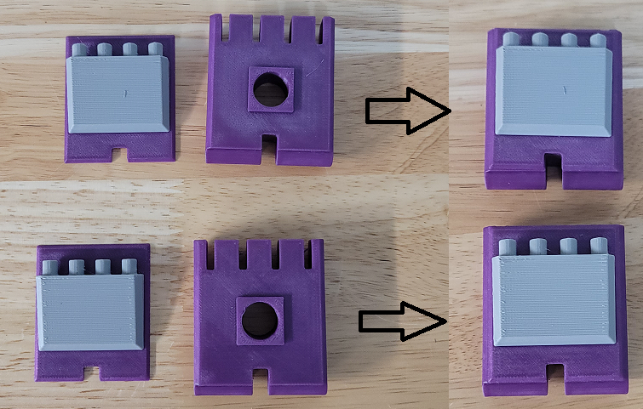

There are a total of 18 pins per hand. There are three sizes of pins. The image below shows what length of pin goes in what location. Each hand has 14 10mm pins, 3 22mm pins and a single 34mm pin. In the following image, the numbers correspond to the following pins:

1 – 10mm
2 – 22mm
3 – 34mm

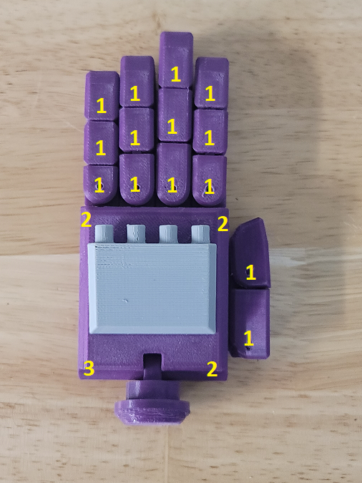

You should have two complete hands after the pins are installed:

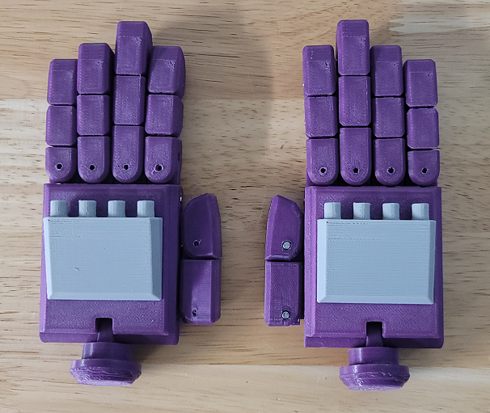

Snap the left and righ connectors into the elbows. Please note the elbows are identical but the left and right connectors are not. The right connector is shaped to attach to Scavenger while the left connector is shaped to attach to Bonecrusher:

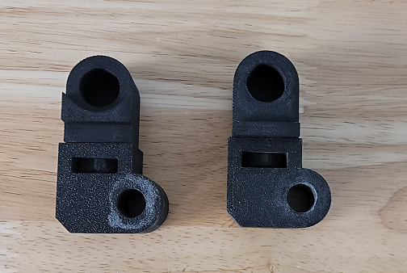

Place the elbow and hand assemblies into the inner arm:

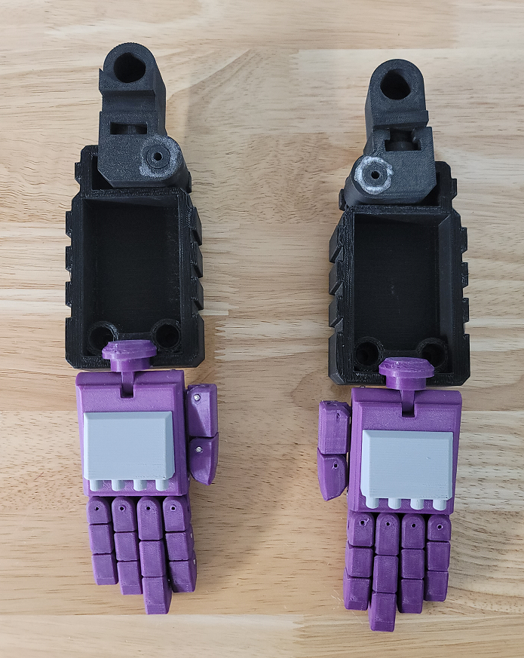

Place the outer arm on top of the inner arms and screw it down with a single #10 X 1” screw at the elbow in each arm. The tightness of this screw will determine the stiffness of the elbow joint:
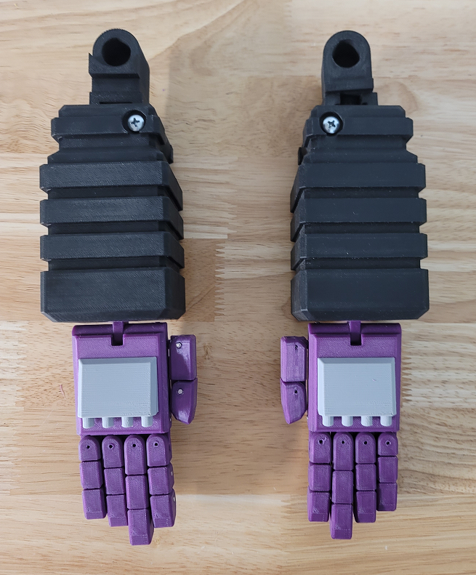

Flip the arms over and place two #10 X 1” screws into each arm. This will complete the arm assemblies:

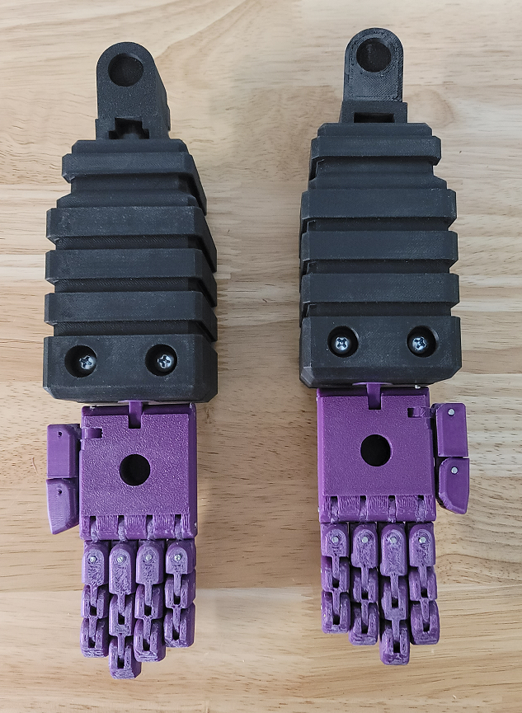

Waist

Waist

The waist is composed of 25 printed parts. Additional hardware needed to finish the build are #10 X 1” button head screws (X8). The hip gears and hip ratchets should be printed with at least 50% infill. The remaining parts can be printed with 15% infill.

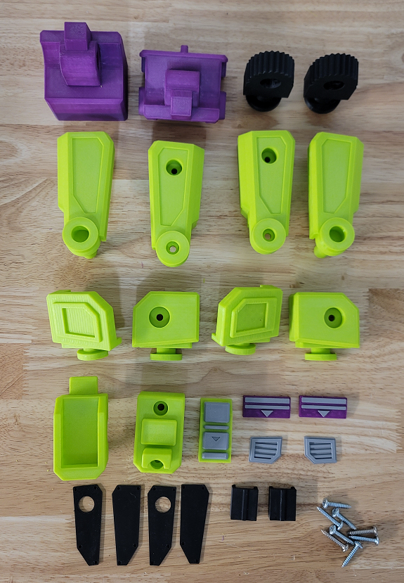

Glue all the inserts into their corresponding parts:

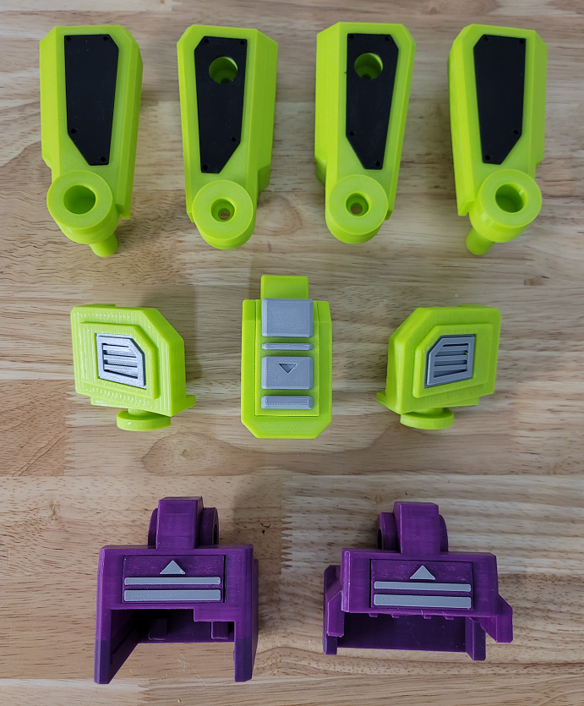

Place the hip ratchets and hip gears into the front hip assemblies:

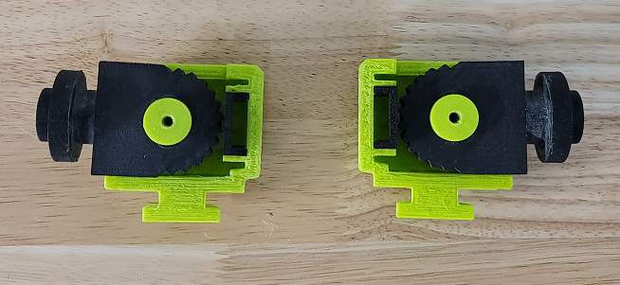

Attach the rear hips to the hip assemblies with a #10 X 1” screw in each:

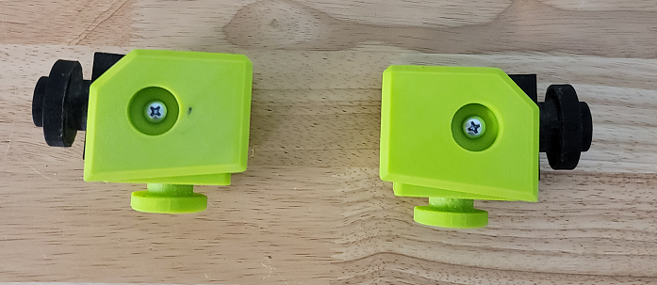
Put the hip assemblies into the outer leg assemblies. Put the Mixmaster and Scrapper connectors into the outer leg assemblies:

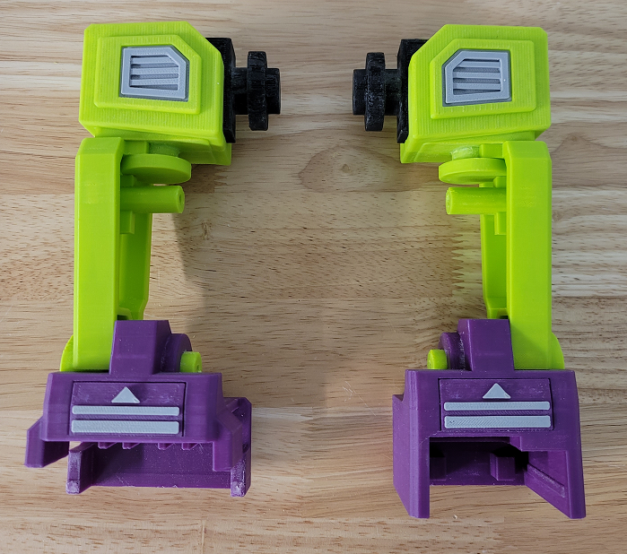

Add the inner legs to the outer legs and fasten them together with two #10 X 1” screws each:
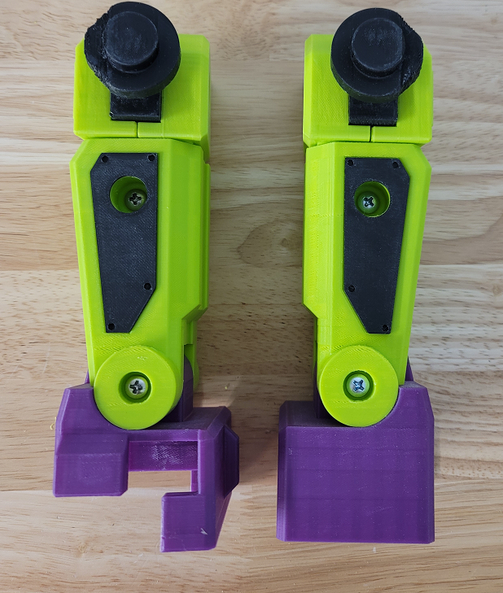

Put the left and right leg assemblies into the front crotch:

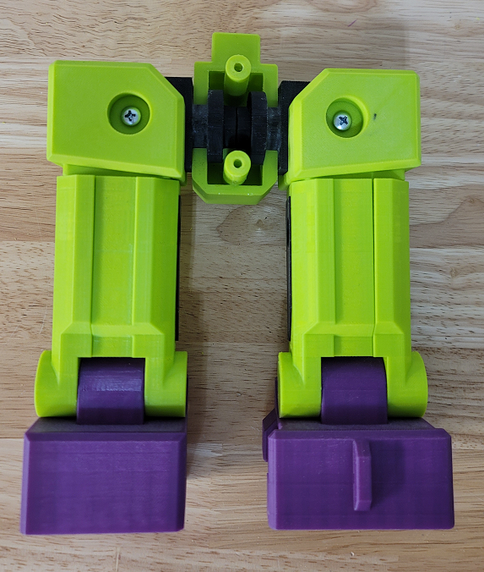

Place the rear crotch onto the front crotch and fasten them together with two #10 X 1” screws:

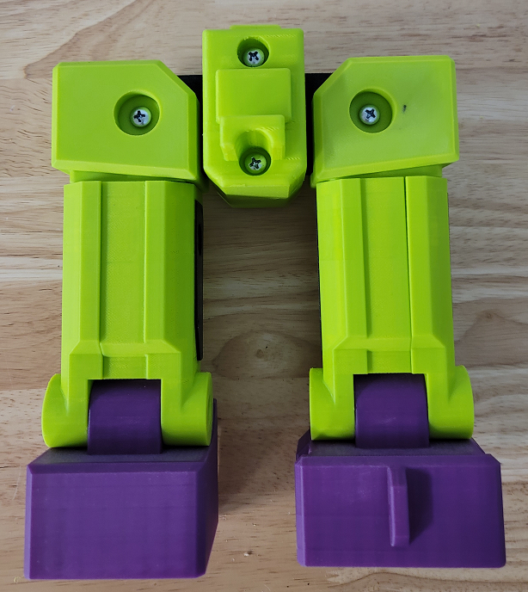

The upgraded combiner parts are now complete!

