Mixmaster Assembly Instructions

Mixmaster is composed of 32 printed parts. Additional hardware needed to complete the build are:
- #10 X ½” button head screws (X7)
- ¼” flat washer with a ½” outer diameter (X1)
- ¼” X ¾” Button head screws (X2)
- #10 X 3/8” taper head screws (X3)
- 16d nails cut to 18mm (X6)
- 13/32” diameter spring cut to 19mm (X1)
All non-printed hardware can easily be obtained at Lowe’s or Home Depot.

All the parts in this build were printed in PLA. All the parts were printed with 15% infill. The tires for this example have been printed with two different colors.

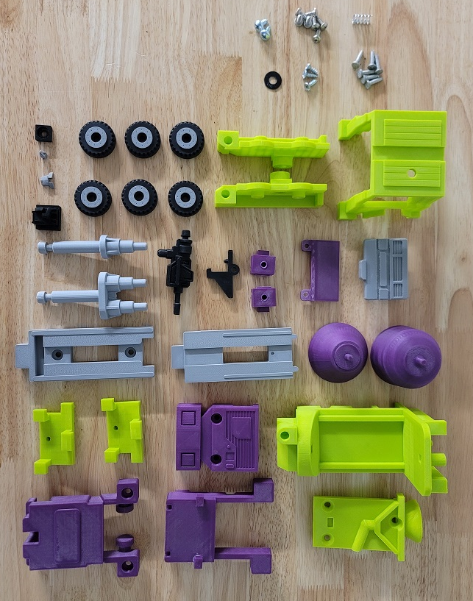

The nails used in the build are cut to 18mm and used as pins to hold the tires in place:

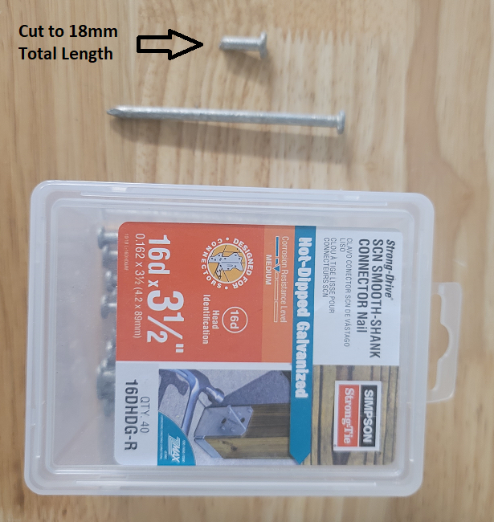

The spring used in this build is a 13/32” diameter spring cut to 19mm total length:

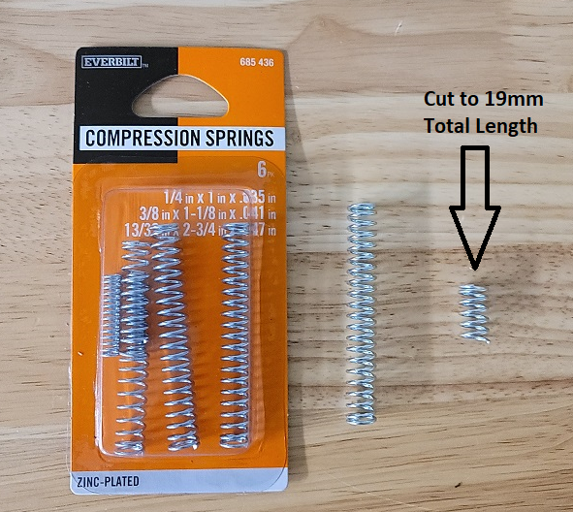

Super glue the lower face and forehead into the main head:

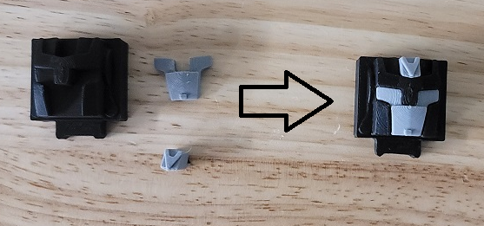
Screw the spring into the spring stop. It should tighten when it reaches the end:

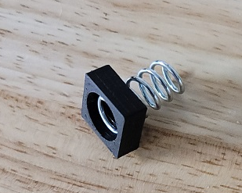

Place the trigger and spring stop assembly into the top of the rear torso:

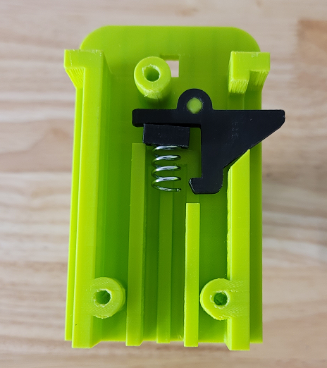

Screw the top onto the rear torso assembly with the three taper head screws:

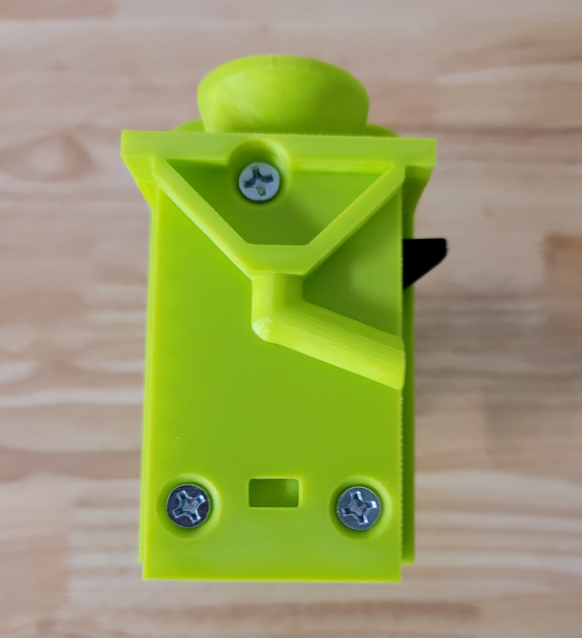

Connect the top and bottom mix drum pieces together and press them into the rear torso assembly:

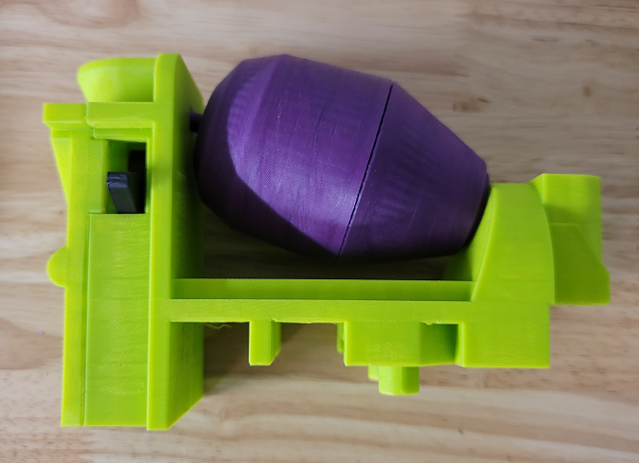

Screw the shoulders and arms together with the ¼” X ¾” screws:

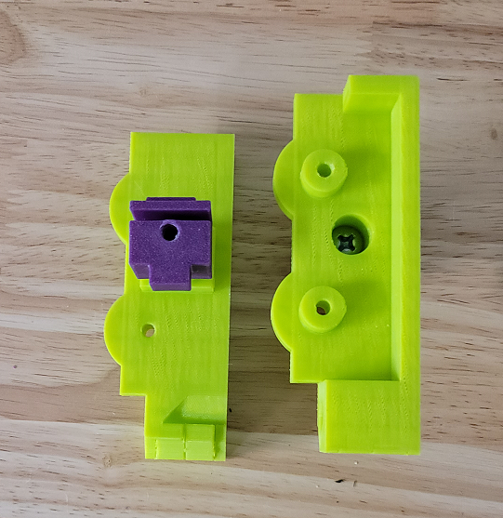

Super glue the pins into the arm assemblies and the front tire holders with the tires in place. The shoulders should be screwed into the arms before this step as it can be hard to get the shoulder screws into place after the tire pins have been glued:

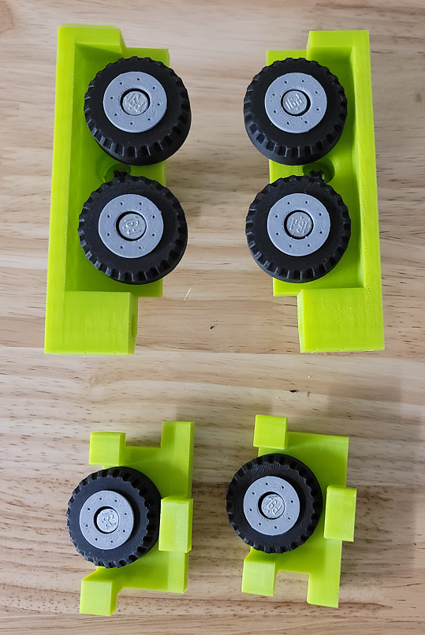

Place the arm and head assemblies into the rear torso assembly:

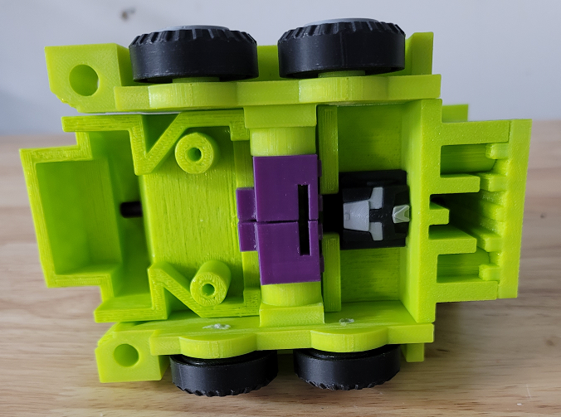

Push the wheel holder assemblies into the cab:

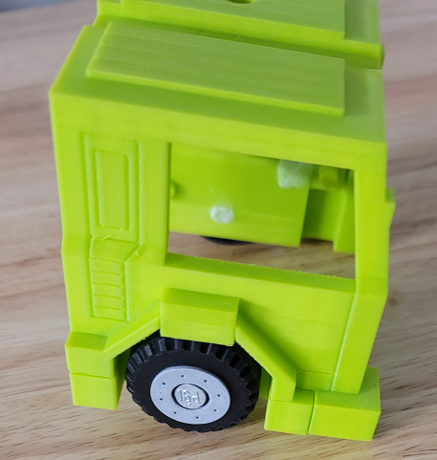

Place the windshield onto the pegs on the rear of the grill:

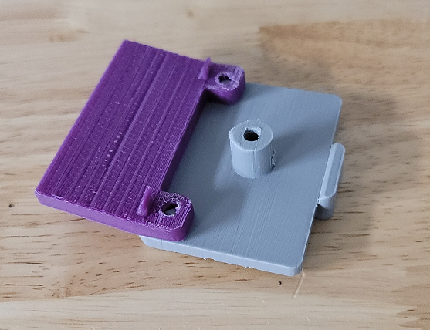

Loosely screw the rear legs to the grill assembly with a #10 X ½” screw and the ¼” washer. Do not tighten down the screw:

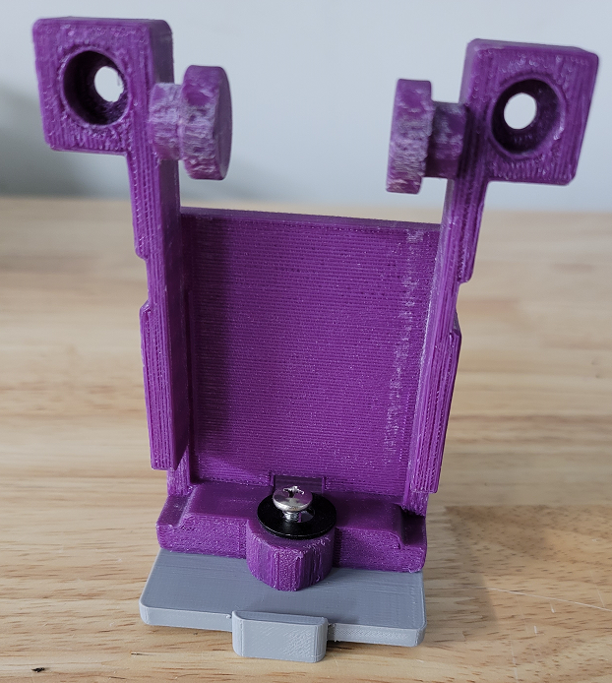

Place the cab assembly into the grill assembly. Ensure the tabs on the wheel holders fit into the pocket on the rear legs:

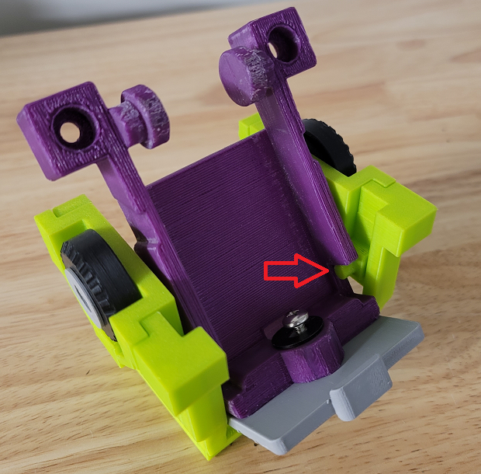

Place the front legs into the cab assembly. Once everything is fitted into place, tighten down the screw on the inside of the assembly:

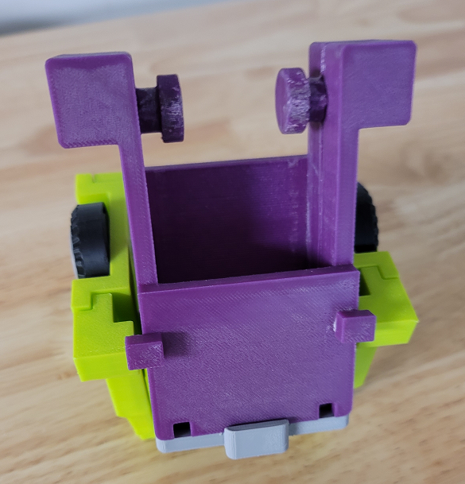

Screw the front and rear feet together with two #10 X1/2” screws:

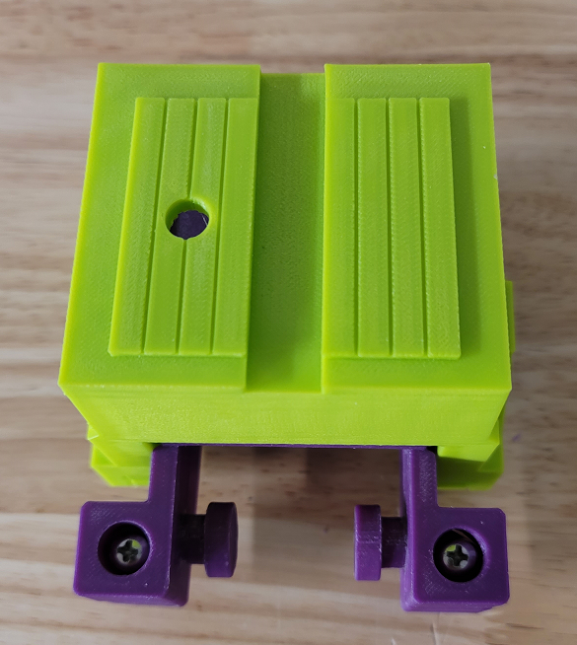

Put the rear legs into the feet assembly:

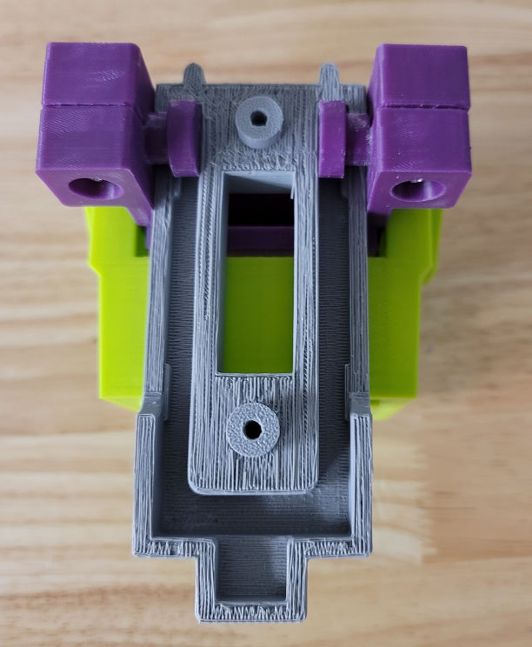

Put the front legs on the feet assembly and screw it into place with two #10 X ½” screws:

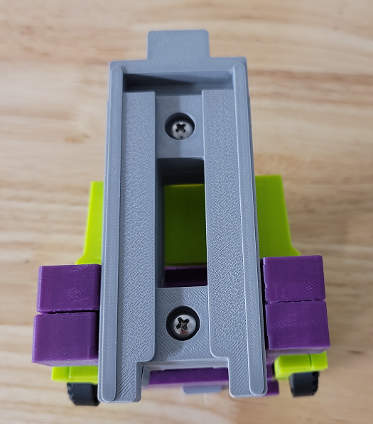

Place the feet assembly into the rear torso assembly:

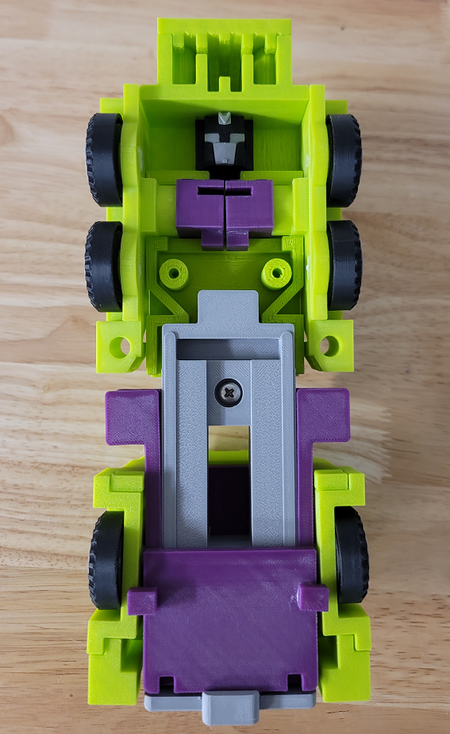

Install the front torso and secure it with two #10 X ½” screws:

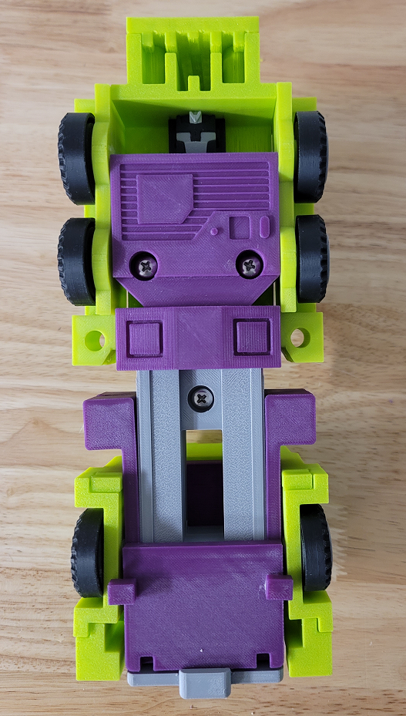

Mixmaster is now complete!

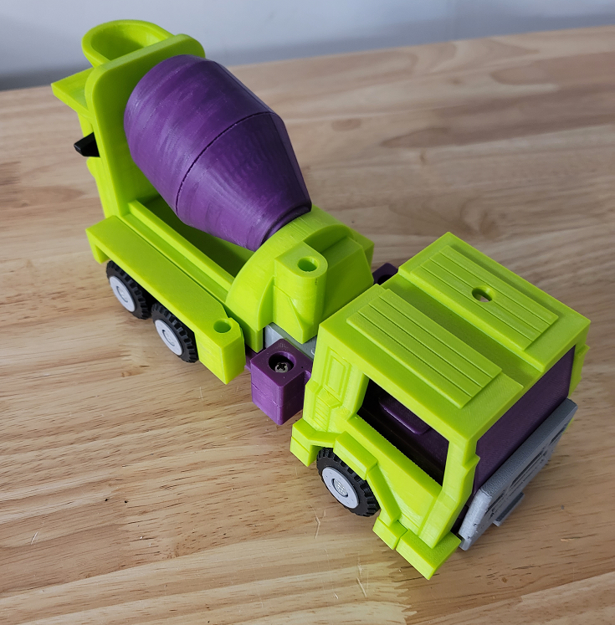

Stickers

The stickers have three layers. The stickers can be printed on transparent vinyl. A clear plastic layer can then be stuck to the top of the vinyl to protect it. The clear layers can them be stuck to a third layer of silvered vinyl. This creates stickers that have a metallic look like the original stickers. These stickers are thick and don’t bend around curves easily so the stickers should be cut wherever they wrap around curves. Cricut makes transparent and silvered vinyl designed for ink jet printers.

