Combiner Parts Rack Assembly Instructions

The combiner parts rack is composed of 38 printed parts.

All the parts in this build were printed in PLA. All the parts were printed with 50% infill.

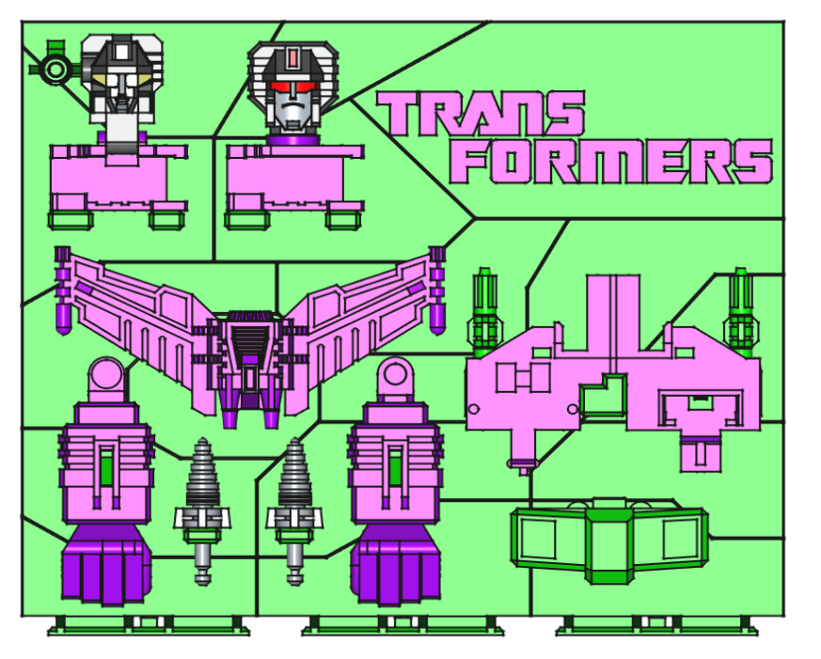

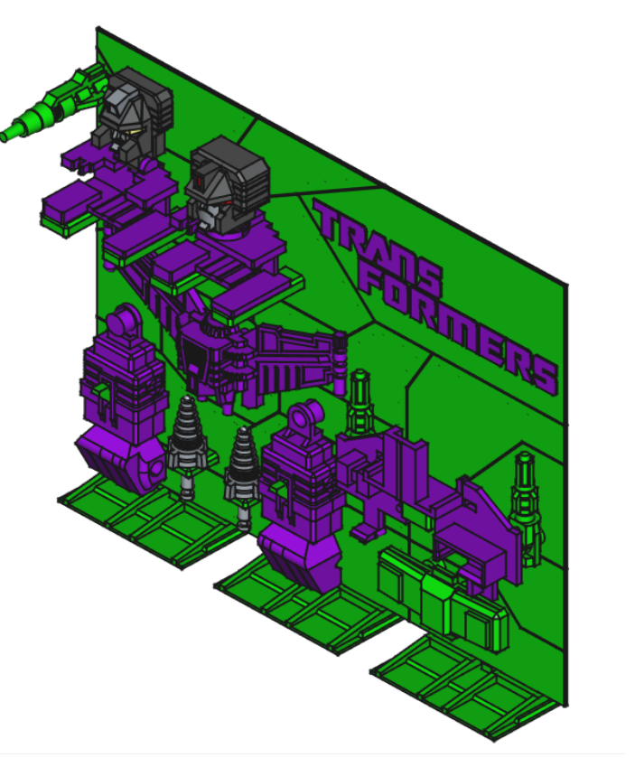

The back-plane is composed of 9 parts that are super glued together. The Transformers lettering is composed of 10 parts that are super glued into pockets on the back-plane. There is a re-enforcement framework that super glues to the back-plane composed of 10 rods and 6 connectors. There are 3 feet that press onto the bottom of the back-plane. Glue should not be necessary to hold them in place.

Below is a rear image of the back-plane that shows the seams of the individual parts and how they fit together:
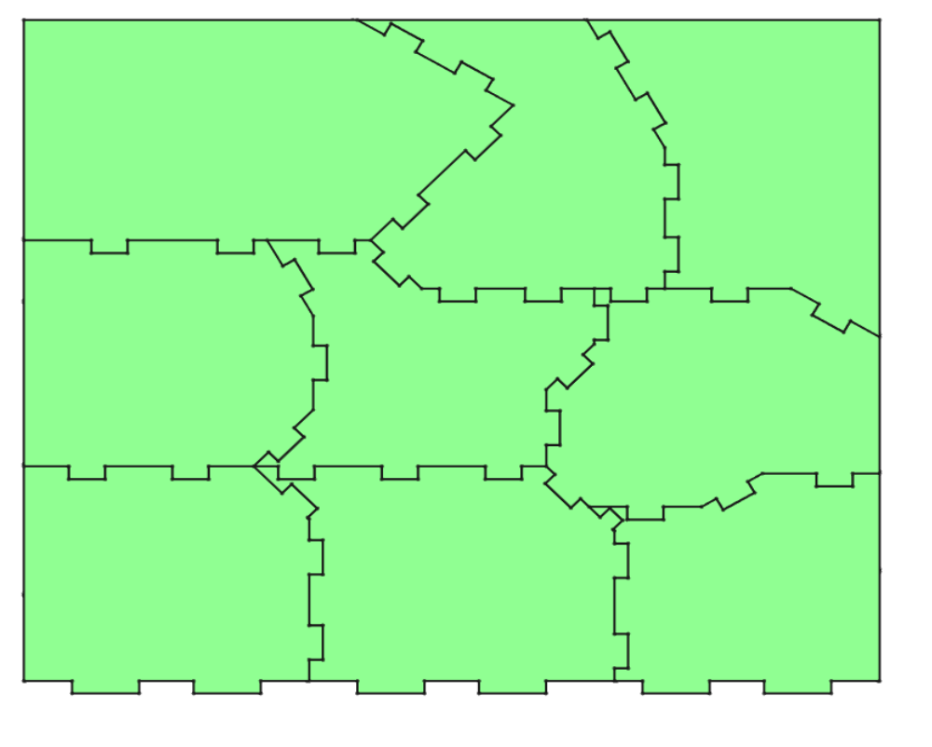

The back-plane with the re-enforcement is shown below:
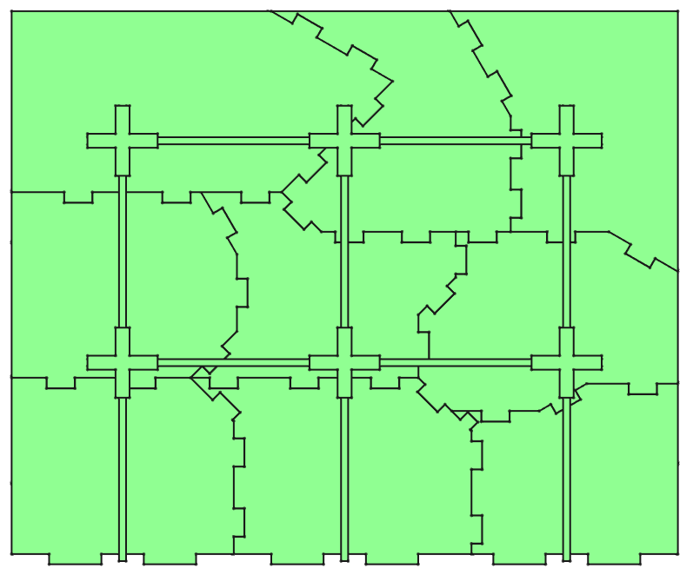

The image below shows how the back-plane and re-enforcement fit into the feet:

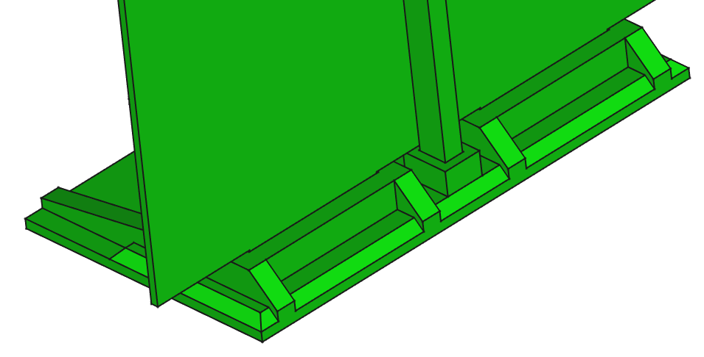

There are no stickers with this project.

