Bonecrusher Assembly Instructions

Bonecrusher is composed of 30 printed parts. Additional hardware needed to complete the build are #10 X ½” pan head screws (X11), ¼” flat washer with a ½” outer diameter (X2) and a large spring from a pop-up sprinkler head cut in half.

All the parts in this build were printed in PLA. All the parts with the exception of the waist were printed with 15% infill. There is more stress on the waist piece than the other pieces so it should be printed with a minimum 50% infill.
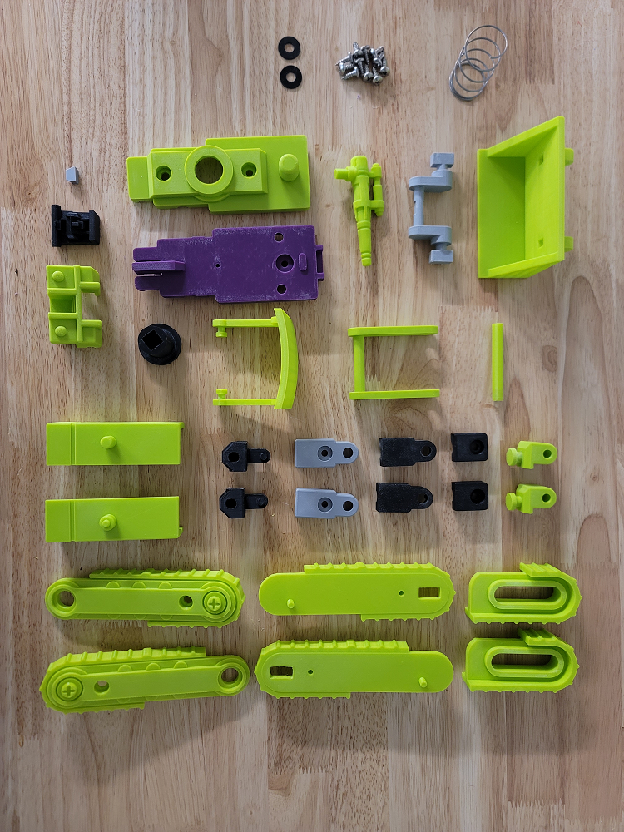

Below is the spring from a sprinkler head used for the Devastator arm joint. Only half the spring is needed:
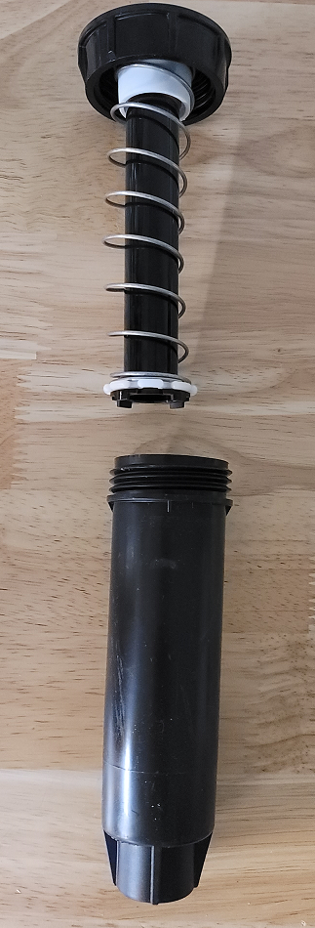

Glue the visor into the main head:
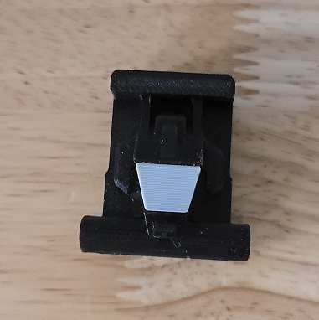

Screw the tricept and bicept pieces together with the shoulder pieces inserted:
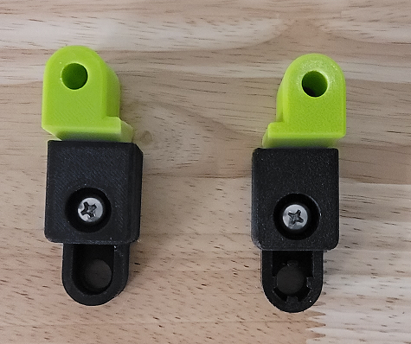

Insert the bicept/tricept/shoulder assemblies into the left and right arm guards. Insert the fists into the arm guards:
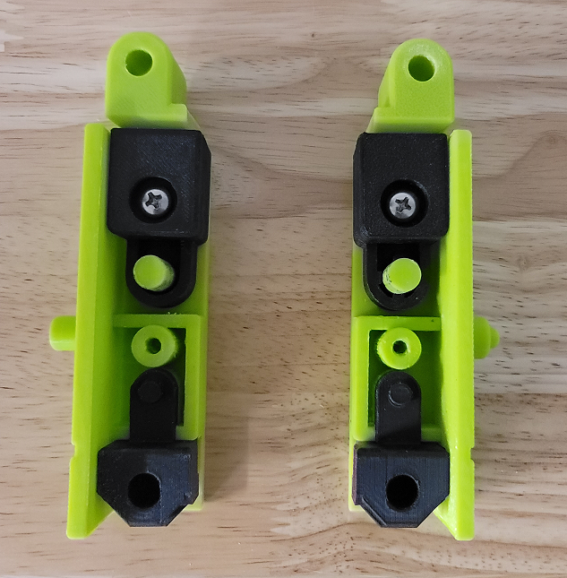

Screw the forearm pieces into the arm shields. This should capture all the pieces completing the two arms:
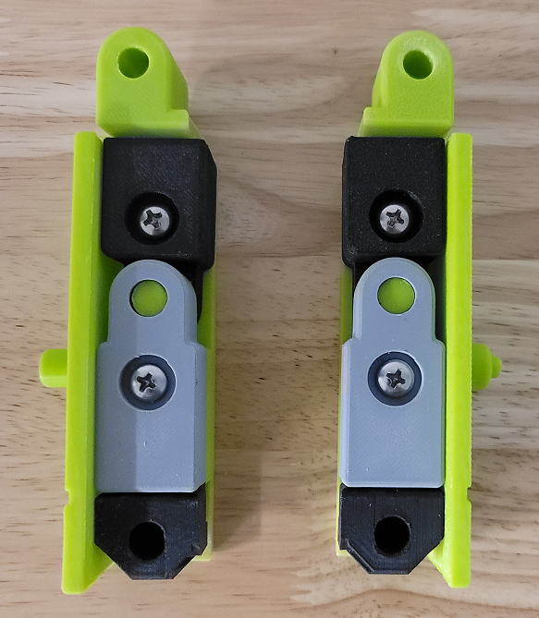

Insert the head assembly and canopy into the chest piece:
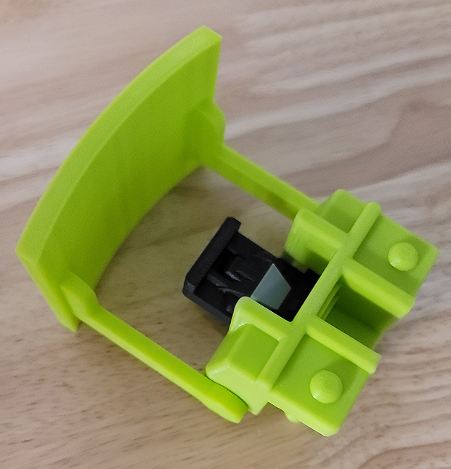

Insert the arm assemblies onto the chest pegs:
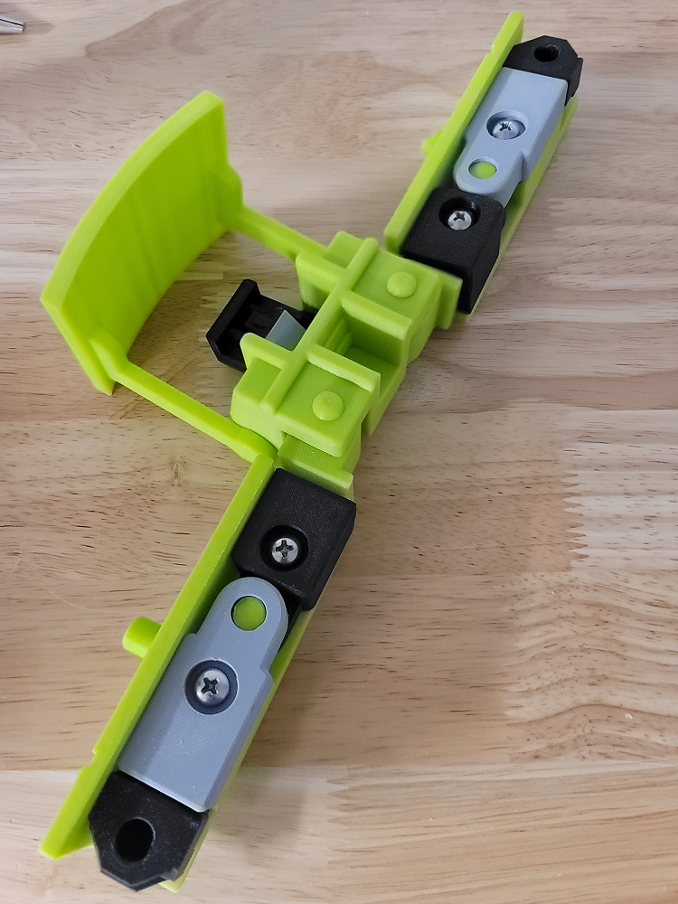

Screw the front torso into the chest assembly:
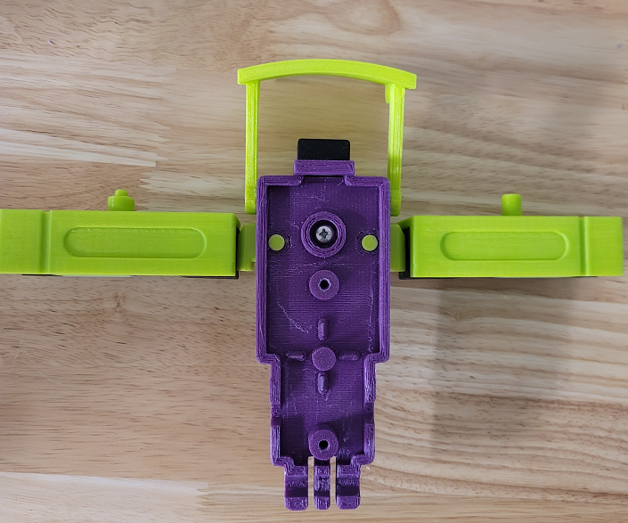

Insert the scoop rod into the scoop connector. The scoop connector should be flexed so it can be connected to the scoop:
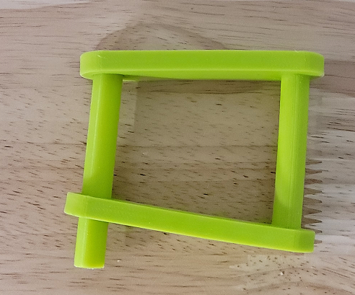

The scoop connector assembly can then be angled into the scoop:
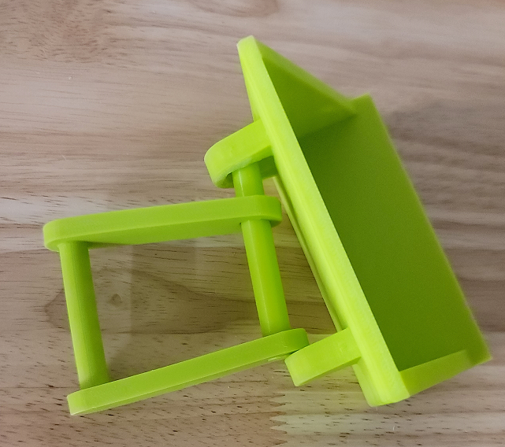

When inserted correctly, the scoop connector assembly should line up with the scoop. The scoop rod should then be centered between the scoop holes:
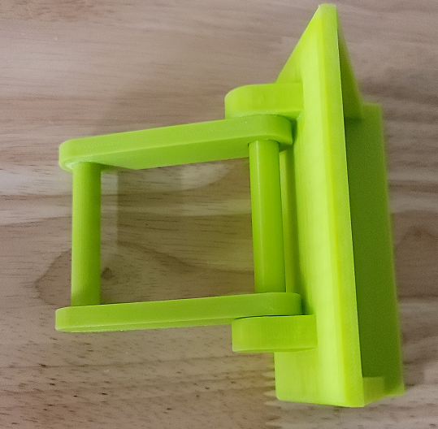

attach the left and right inner legs to the waist:
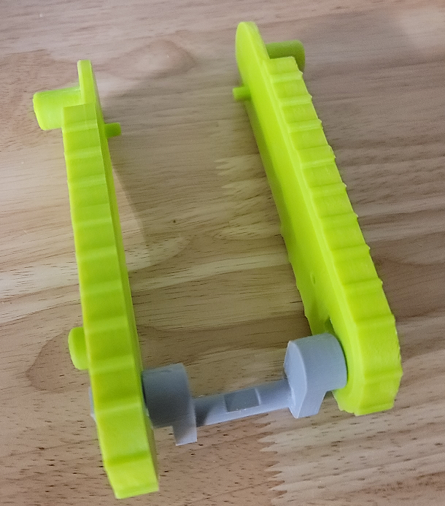

Insert the feet into the legs assembly:
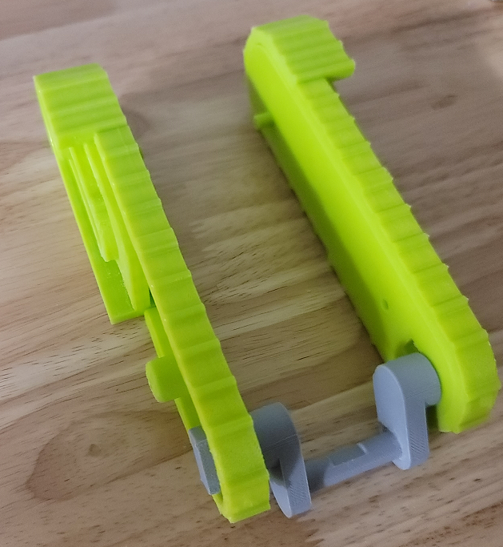

Attach the left and right outer legs to the legs assembly:
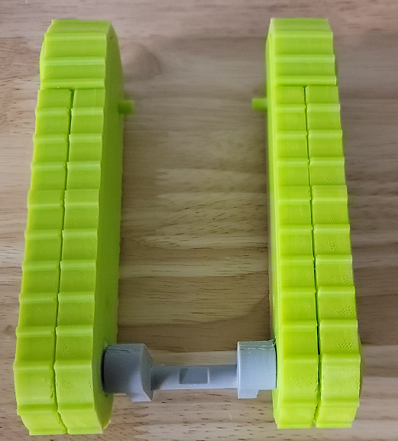

Place two screws in each leg. A ¼” washer should be placed under the screws near the feet. Tightening the lower screws too tight will make the feet hard to manipulate:
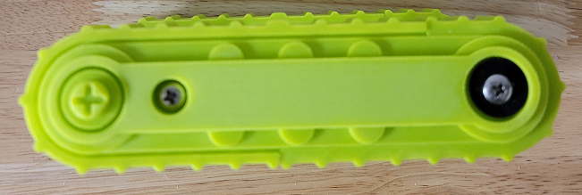
Place the legs assembly and scoop assembly into the rear torso. Also place the Devastator arm joint into the rear torso with the large spring underneath it:
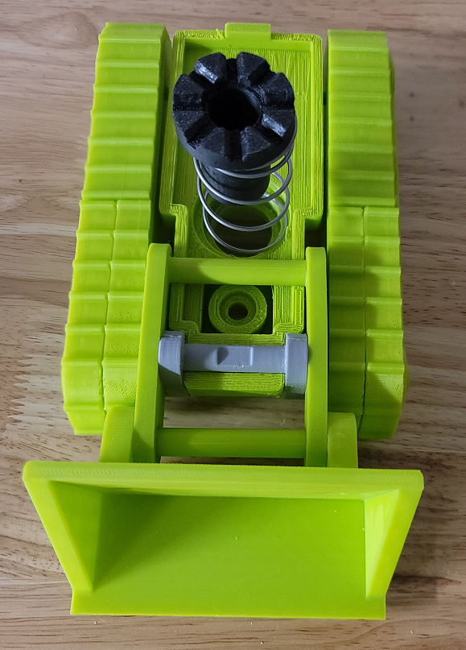

compress the front torso assembly and rear torso assembly together and screw them together with two screws:
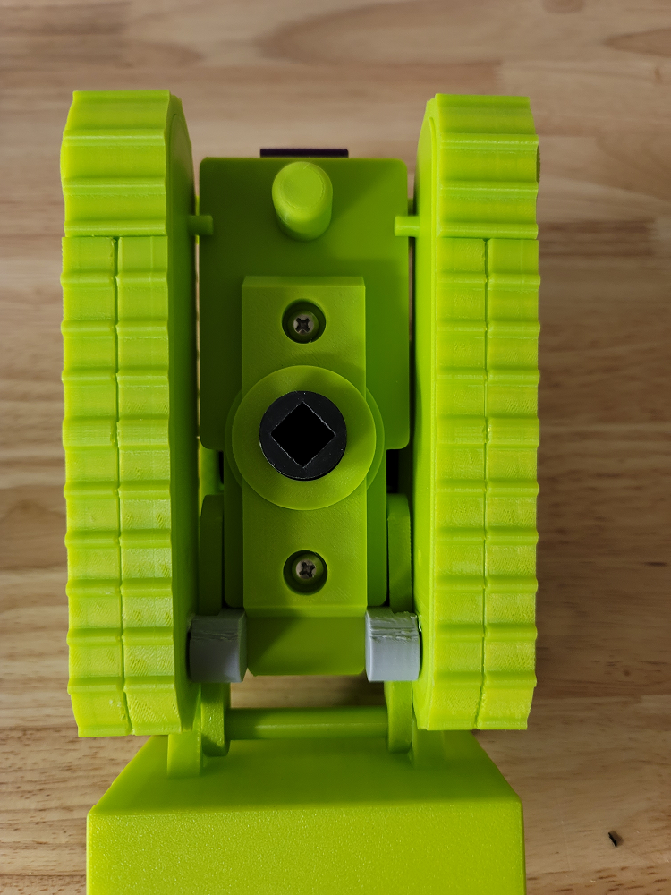

Bonecrusher is now assembled!
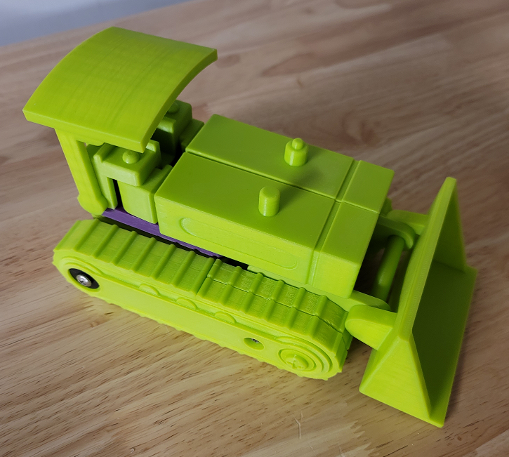

Stickers

The stickers have three layers. The stickers can be printed on transparent vinyl. A clear plastic layer can then be stuck to the top of the vinyl to protect it. The clear layers can them be stuck to a third layer of silvered vinyl. This creates stickers that have a metallic look like the original stickers. These stickers are thick and don’t bend around curves easily so the stickers should be cut wherever they wrap around curves. Cricut makes transparent and silvered vinyl designed for ink jet printers.

