Weapons and Rack Assembly Instructions

The weapons and rack are composed of 23 printed parts.

All the parts in this build were printed in PLA. All the parts were printed with 15% infill.

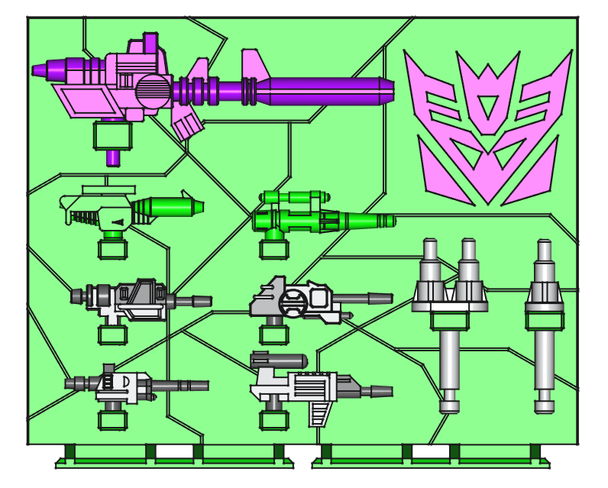

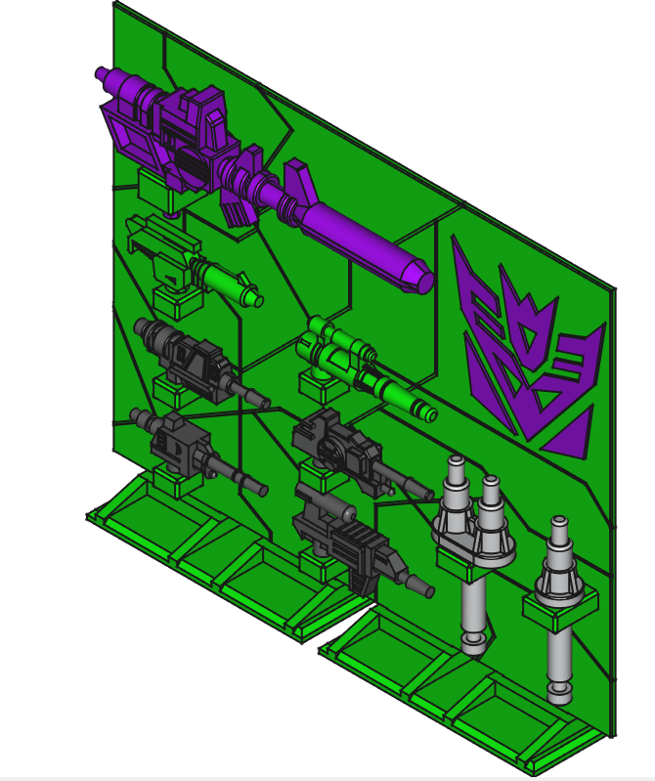

The back-plane is composed of eight parts that are super glued together. The Decepticon symbol is composed of four parts that are super glued into pockets on the back-plane. There are two feet that press onto the bottom of the back-plane. Glue should not be necessary to hold them in place.

Below is a rear image of the back-plane that shows the seams of the individual parts and how they fit together:

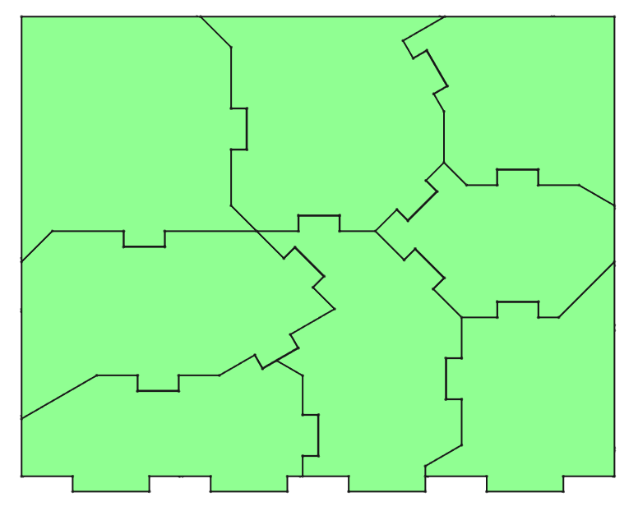

All of the original G1 weapons are included in this project. They will also be included in their associated individual projects. There are no stickers with this project.

