Scrapper Assembly Instructions

Scrapper is composed of 19 printed parts. Additional hardware needed to complete the build are #10 X ¾” pan head screw (X1), #10 X 1” pan head screw (X1), 3/16” steel rod cut to 86mm (X1) and 16d nail cut to 18mm (X4). All non-printed hardware can easily be obtained at Lowe’s or Home Depot.

All the parts in this build were printed in PLA. All the parts were printed with 15% infill. The tires for this example have been printed with two different colors.

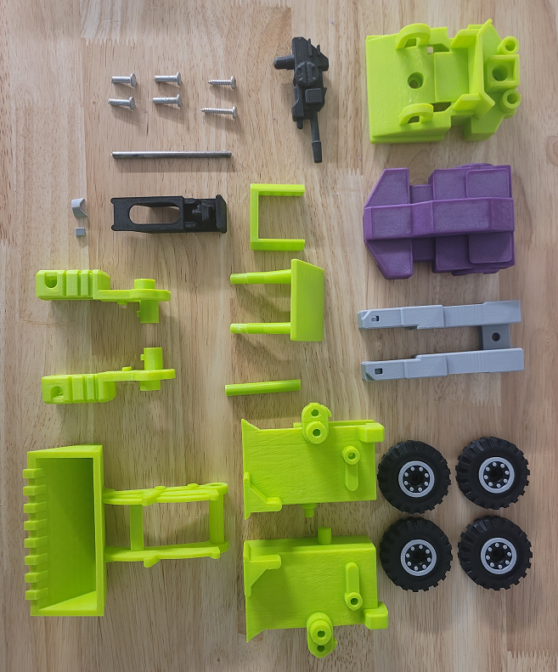

The nails used in the build are cut to 18mm and used as pins to hold the tires in place:

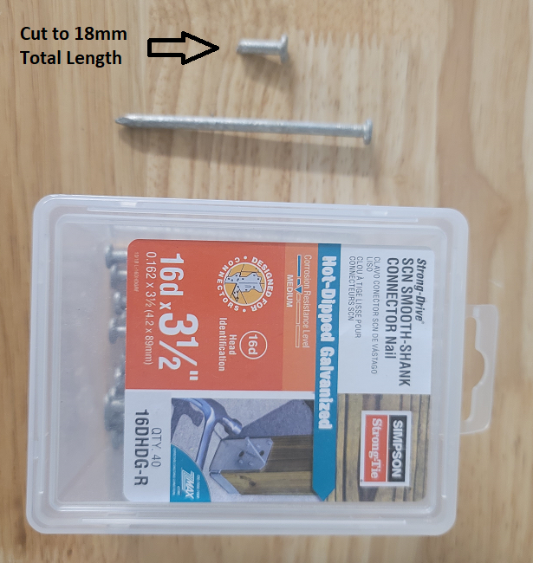

The steel rod used in the build is cut to 86mm in length and is used to hold the feet to the legs:

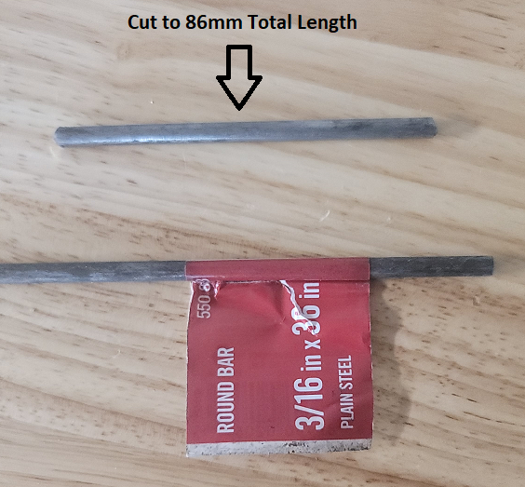

Super glue the forehead and visor into the main head:

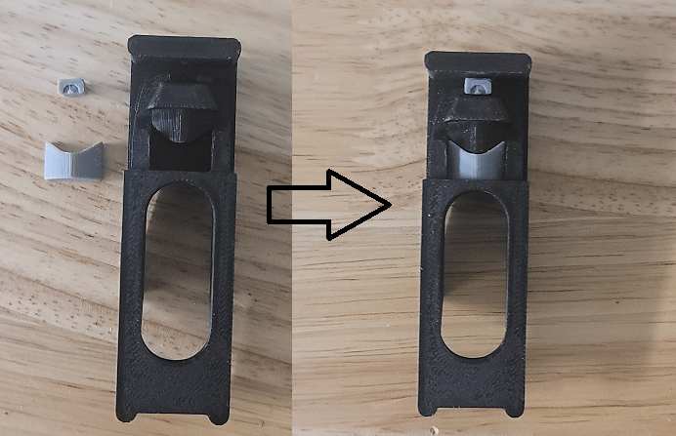

Super glue the pins into the arms and legs while passing through the tires. Don’t get super glue on the tires or the tires will not spin:

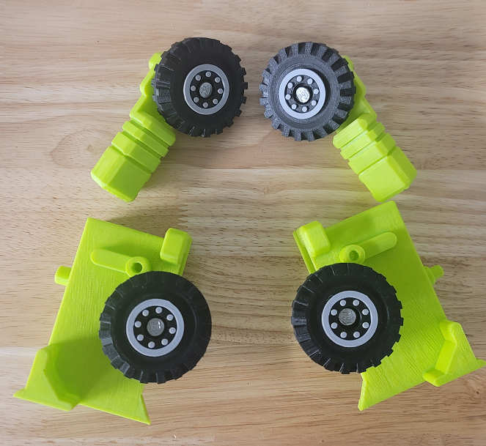

Place both feet on the legs and slide the rod through all three pieces. Super glue rod into place by placing the glue in the holes at the end of the legs:

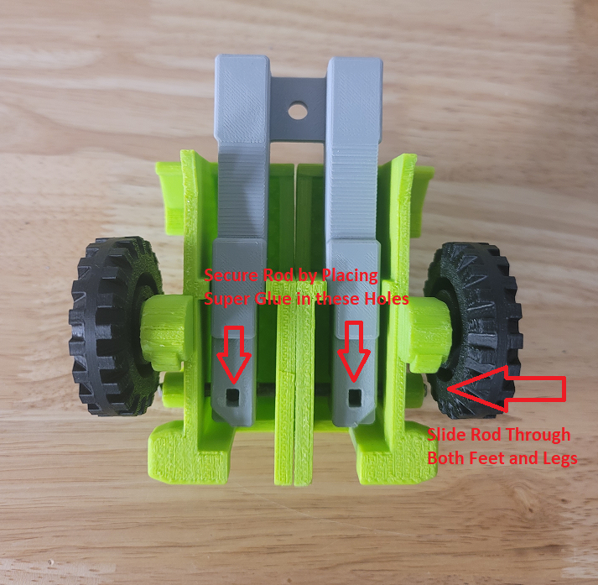

Place the head assembly, arm assemblies and legs assembly into the front torso:

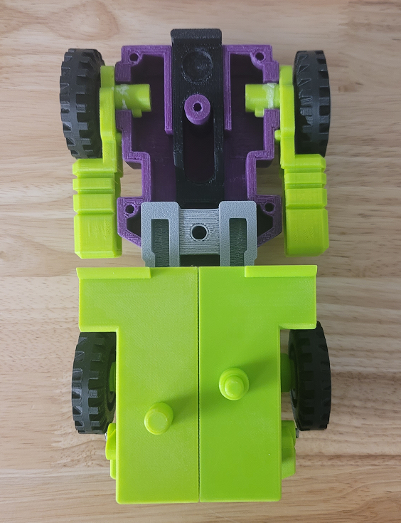

Place the scoop stop into the rear torso:

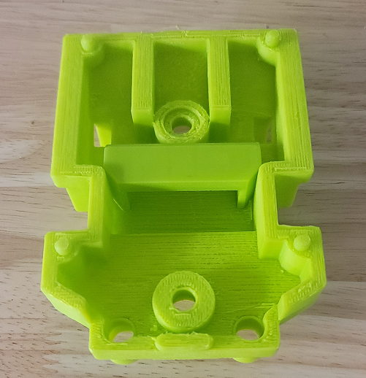

Put the front torso and rear torso halves together and screw them together. The screw near the front of the tractor is a #10 X ¾”. The screw near the middle of the tractor is a #10 X 1”:

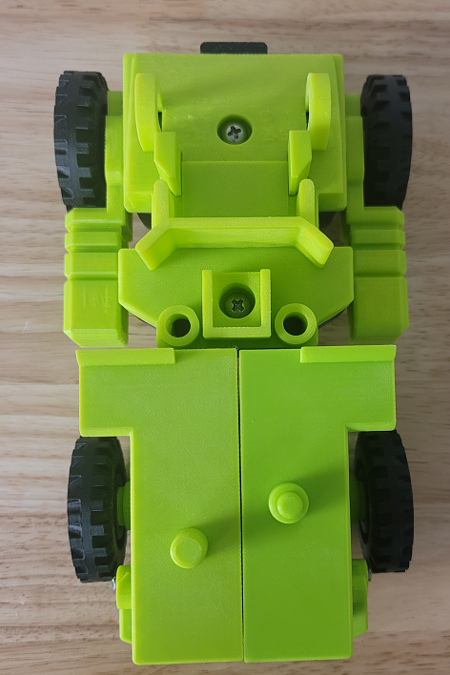

Place the scoop between the support columns on the rear torso. Slide the scoop rod through the support columns and scoop and center it:

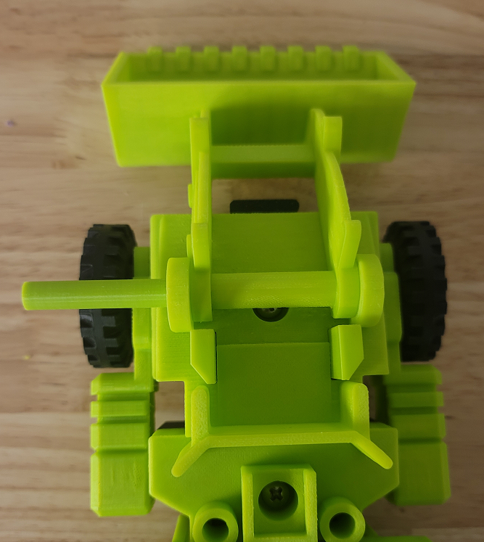

Attach the canopy to the rear torso. Scrapper is now assembled!

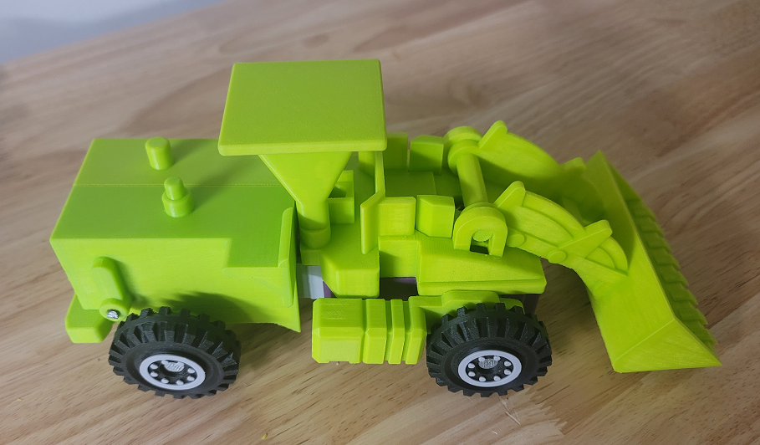

Stickers

The stickers have three layers. The stickers can be printed on transparent vinyl. A clear plastic layer can then be stuck to the top of the vinyl to protect it. The clear layers can them be stuck to a third layer of silvered vinyl. This creates stickers that have a metallic look like the original stickers. These stickers are thick and don’t bend around curves easily so the stickers should be cut wherever they wrap around curves. Cricut makes transparent and silvered vinyl designed for ink jet printers.

