Hook Assembly Instructions

Hook is composed of 30 printed parts. Additional hardware needed to complete the build are #10 X ½” button head screws (X8), #10 X ¾” button head screw (X1), ¼” X ¾” button head screws (X2), 16d nails cut to 18mm (X6), 16d nails cut to 50mm (X2) and ¼” flat washers with a ½” outer diameter (X3). All non-printed hardware can easily be obtained at Lowe’s or Home Depot.

All the parts in this build were printed in PLA. The waist link, arm link and legs should be printed with a minimum of 50% infill. All other parts can be printed with 15% infill. The tires for this example have been printed with two different colors.

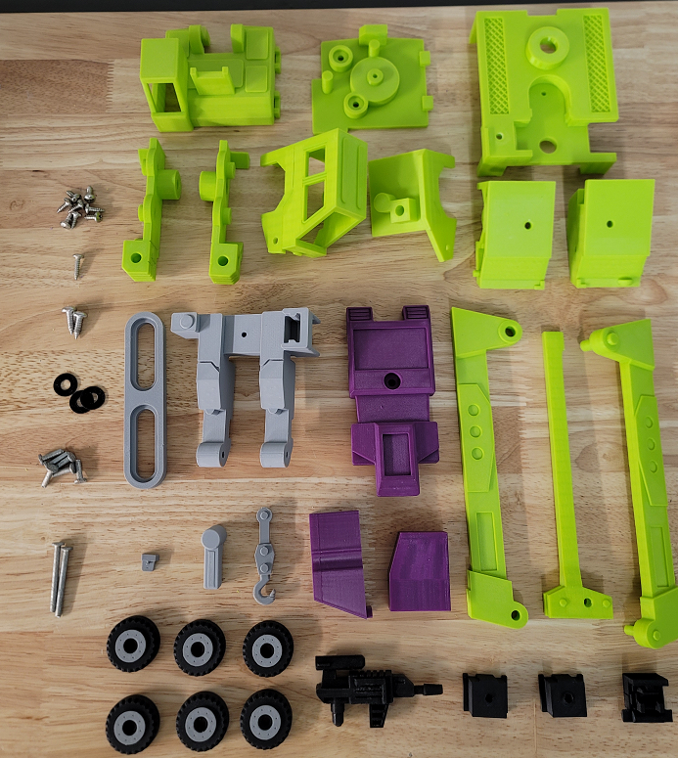

The nails used in the build are cut to a total length of 18mm and 50mm:

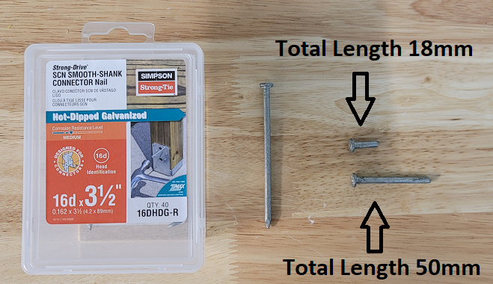

Super glue the face into the main head:

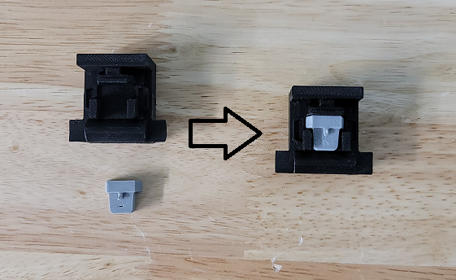

Place the hook into the inner crane boom. No glue should be used:
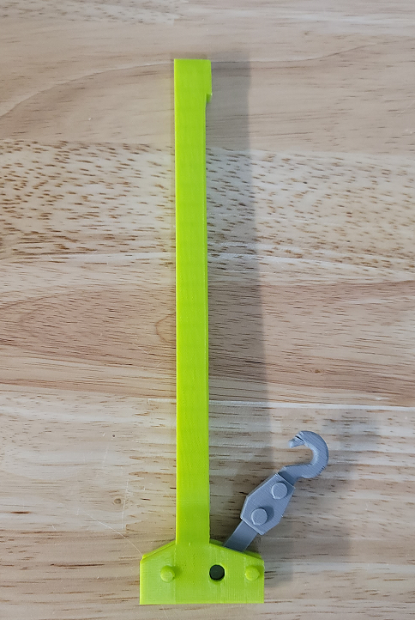

Place the crane boom assembly into the outer left crane boom:

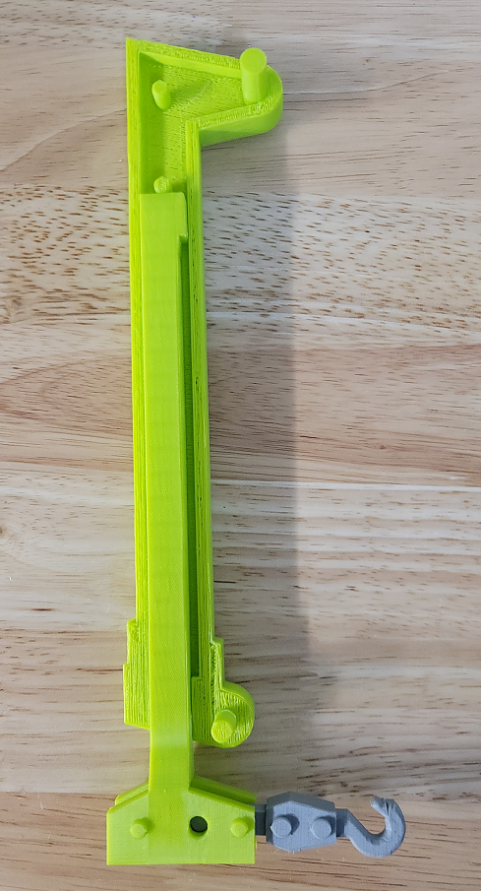

Super glue the outer right crane boom to the crane boom assembly. Make sure no glue gets on the inner crane boom:
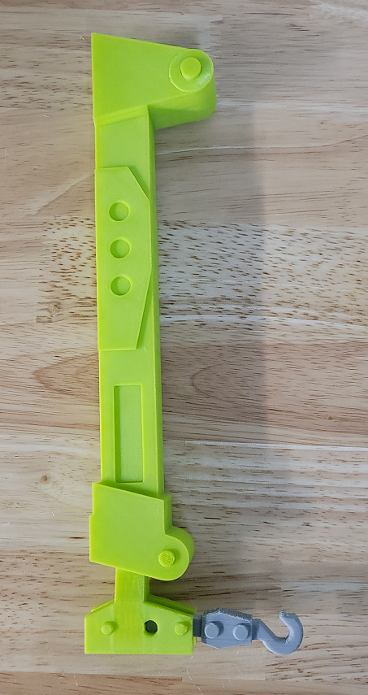

Attach the shoulders to the arms with ¼” X ¾” screws:

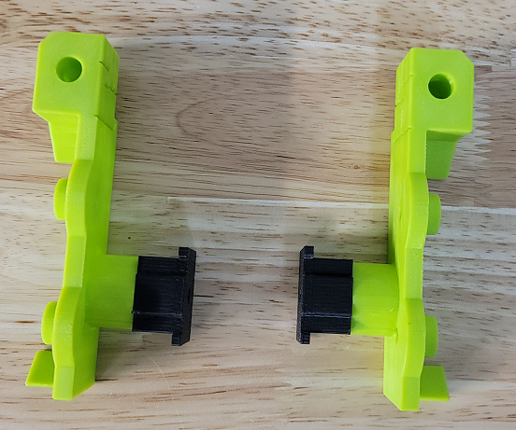

Once the shoulders are tightly screwed onto the arms, place a small amount of super glue in the shoulder hole to ensure the screw does not loosen over time:

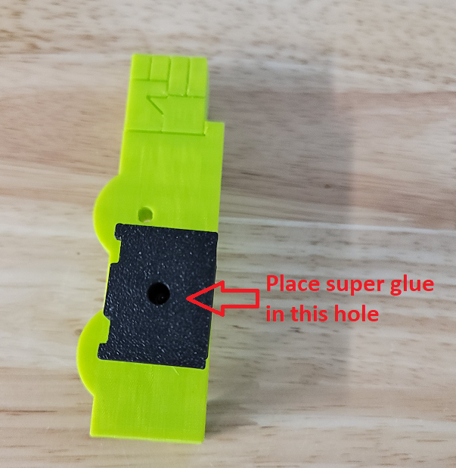

Place the 18mm nails through the tires and super glue them into their associated parts:

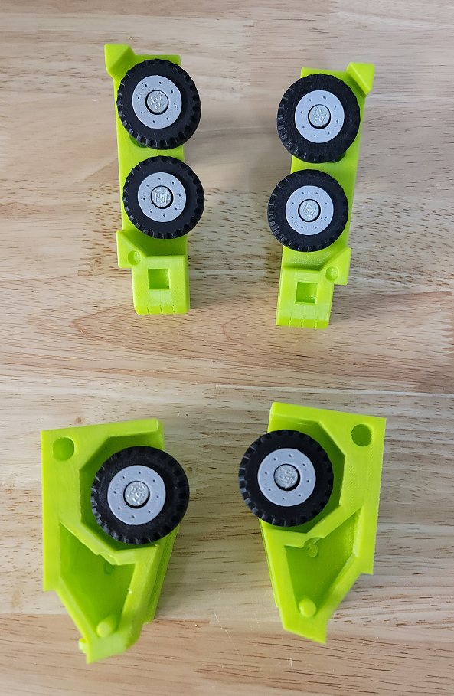

Place the crane boom assembly into the rear cab:

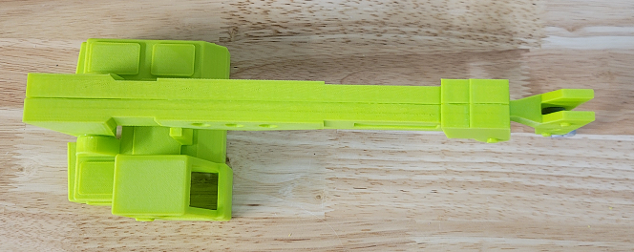
Place the rear windows into the rear cab assembly:

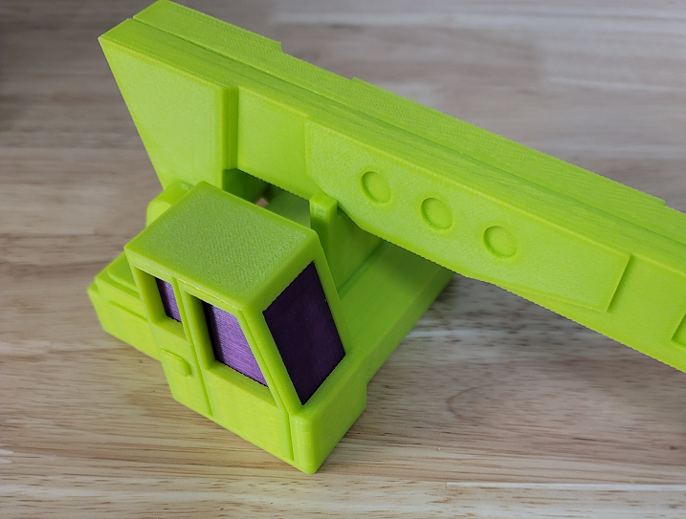

Place the swivel base onto the rear cab assembly and secure it with two #10 X ½” screws:

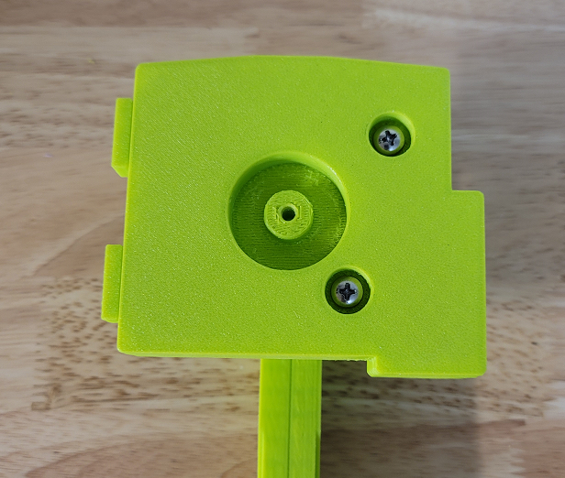

Secure the cab base to the rear cab assembly with a #10 X ½” screw and a washer:
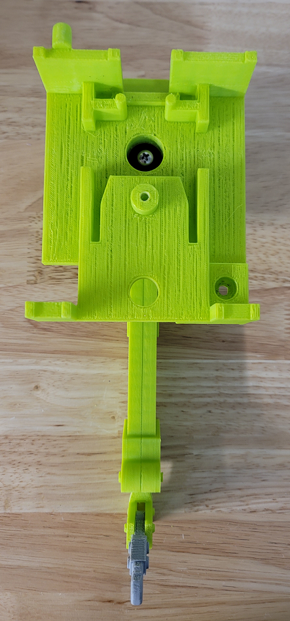

Place a small amount of super glue into the arm link and secure it to the rear torso with a #10 X ½” screw. Ensure no glue contacts the rear torso:

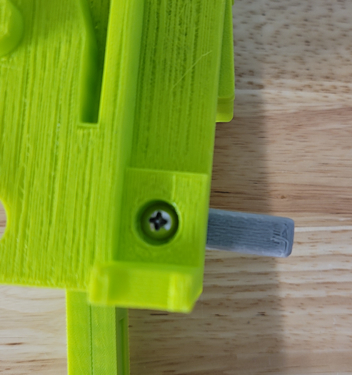

Insert the arm and head assemblies into the rear torso:

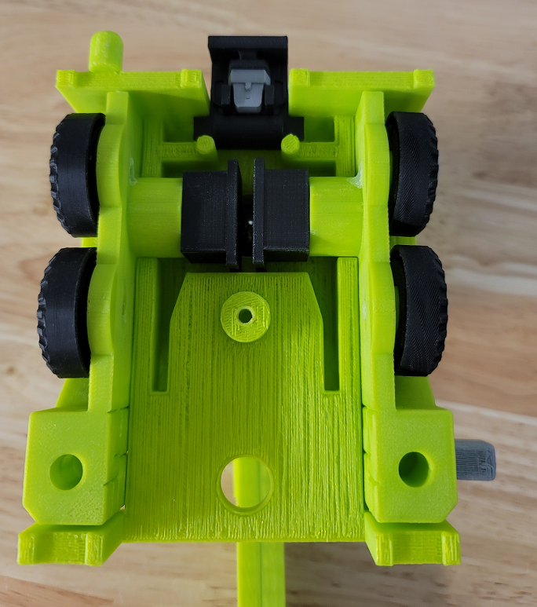

Secure the front torso to the rear torso assembly with a #10 X ½” screw:

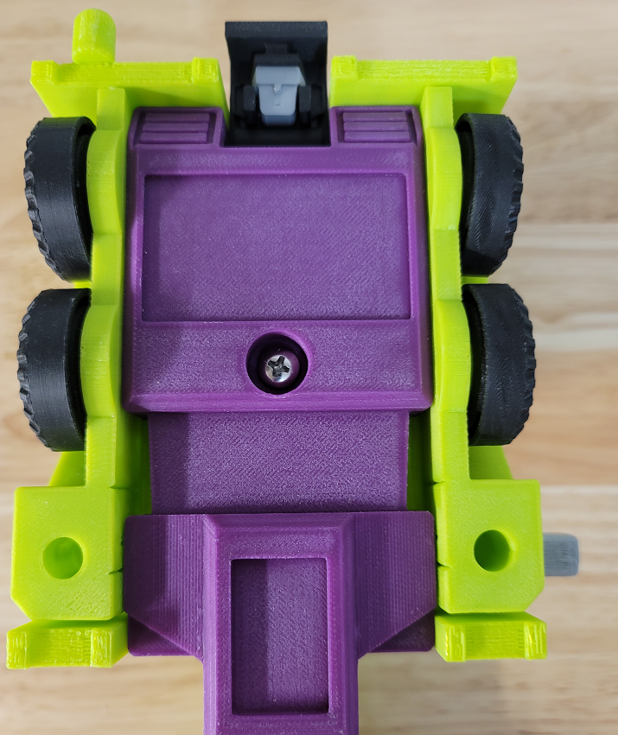

Secure the waist link to the upper body assembly with a #10 X ¾” screw and a washer:

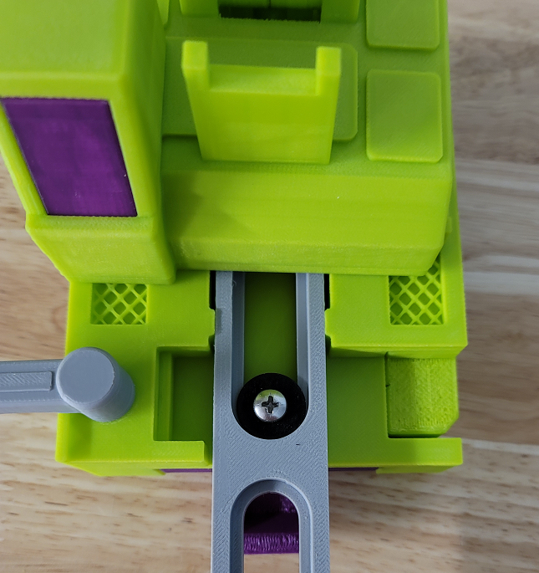

Insert the front window into the left outer leg:

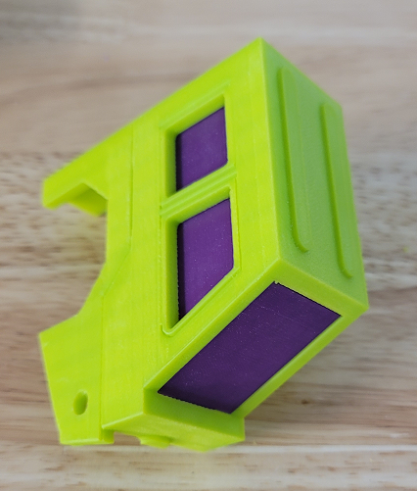

Place the inner leg assemblies onto the legs:

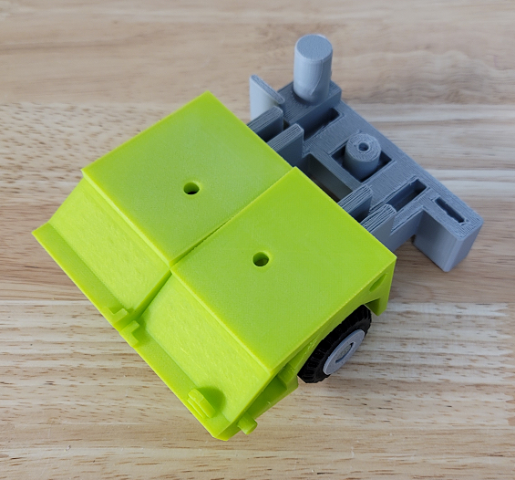

Place the 50mm nails through the leg assemblies:

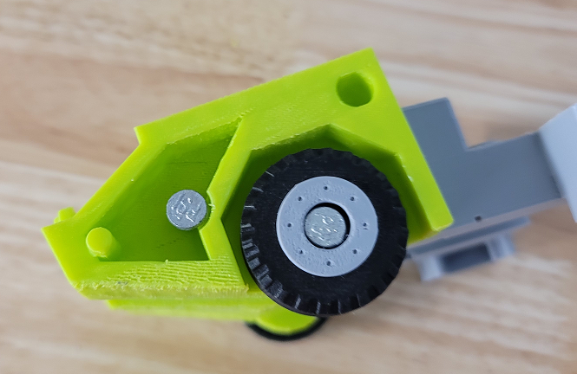
Place the outer legs onto the inner leg assemblies:

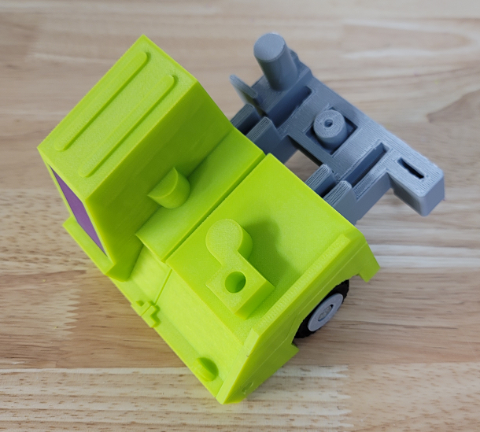

Attach the inner and outer legs together with a #10 X ½” screw in each:

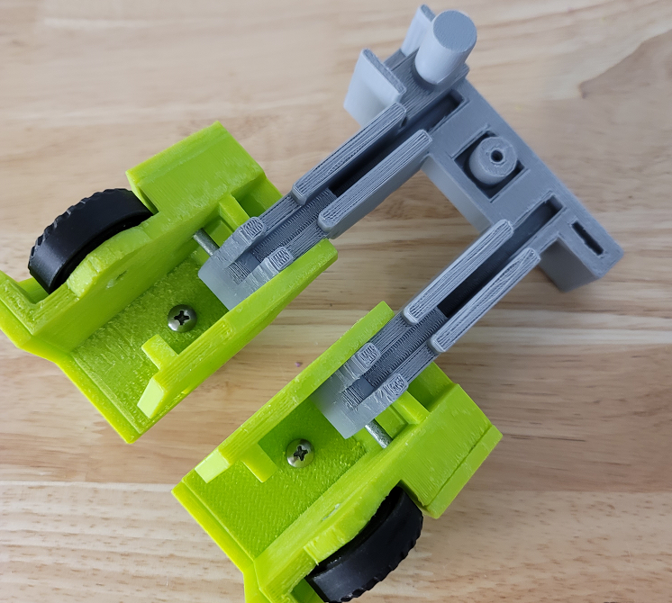

Secure the legs assembly to the upper body assembly with a #10 X ½” screw and washer:

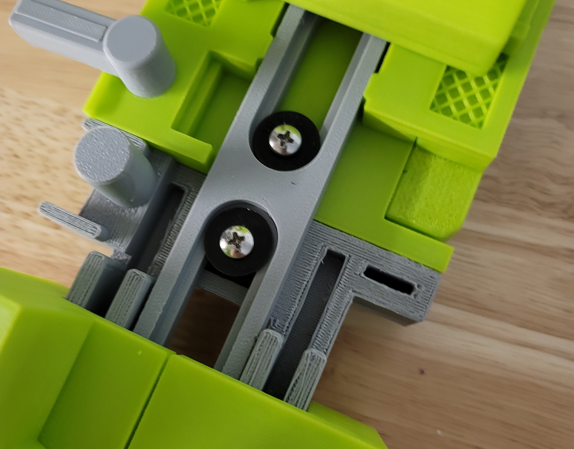

Hook is now complete!

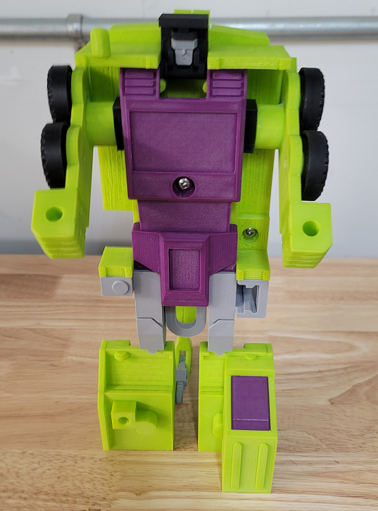
Stickers

The stickers have three layers. The stickers can be printed on transparent vinyl. A clear plastic layer can then be stuck to the top of the vinyl to protect it. The clear layers can them be stuck to a third layer of silvered vinyl. This creates stickers that have a metallic look like the original stickers. These stickers are thick and don’t bend around curves easily so the stickers should be cut wherever they wrap around curves. Cricut makes transparent and silvered vinyl designed for ink jet printers.

