11 second club project:

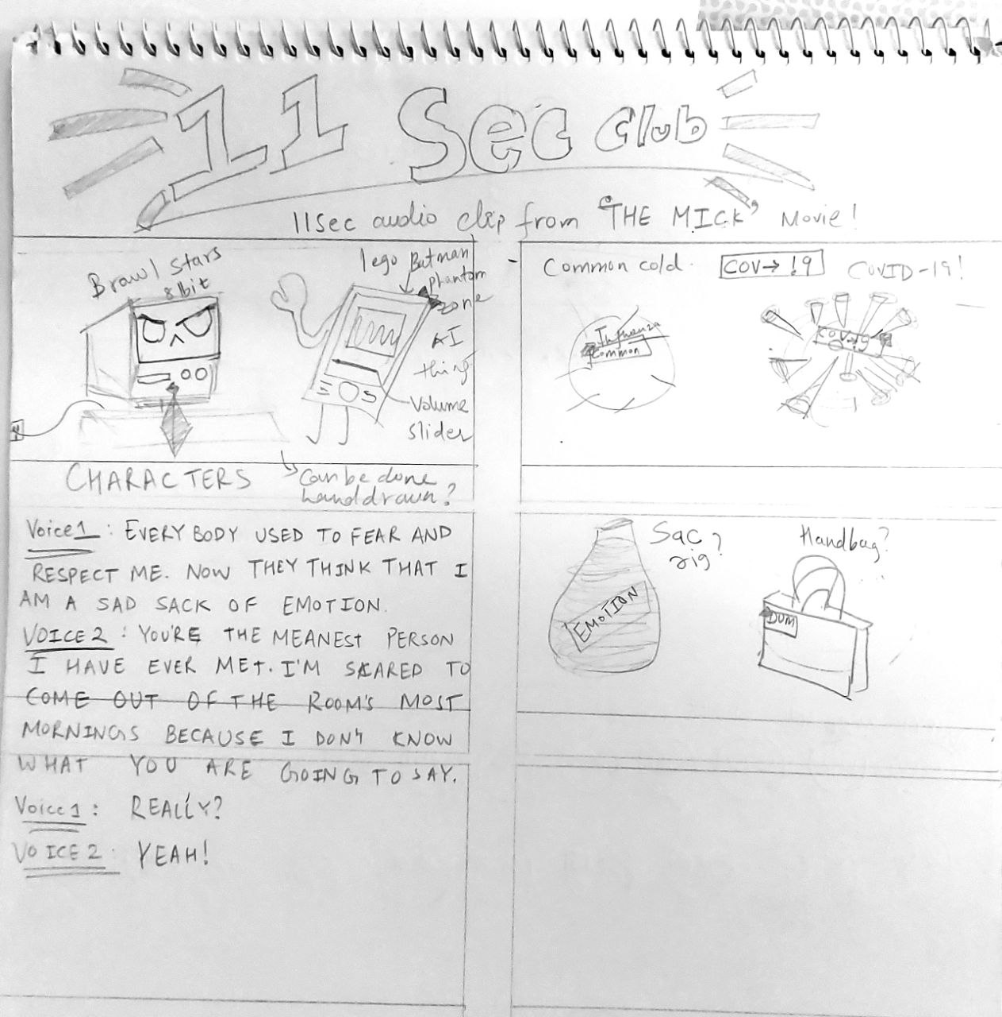

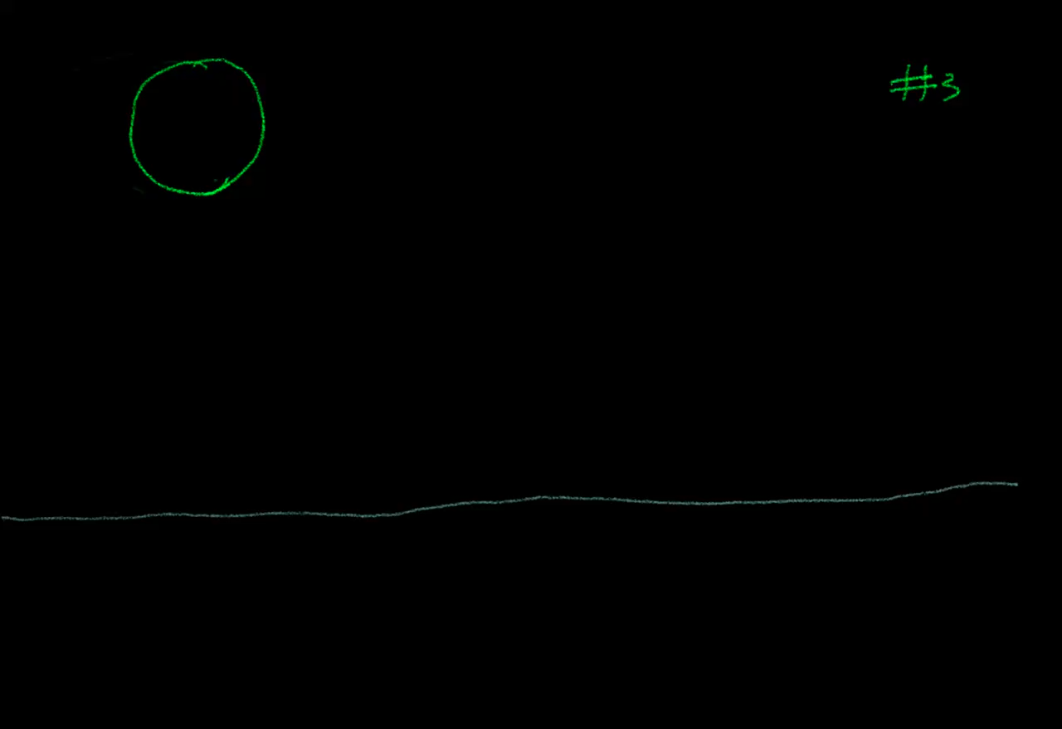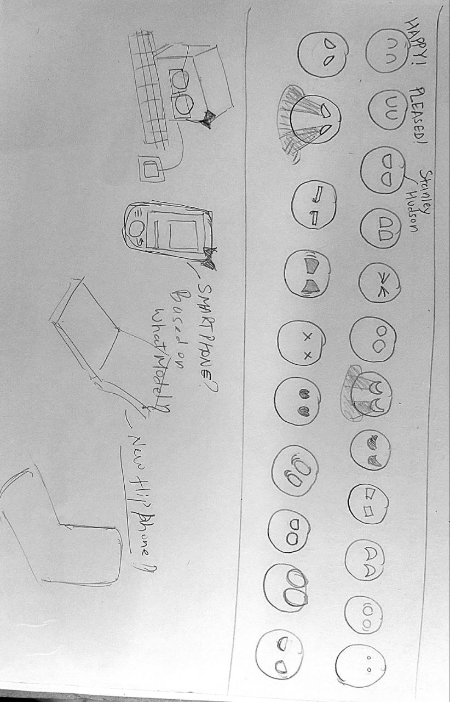Inspirations:

Inspirations for expressions of the the computer monitor will be the eye expressions above. I am thinking of animating in 2D.

Inspirations for characters:

8-Bit from Brawl Stars

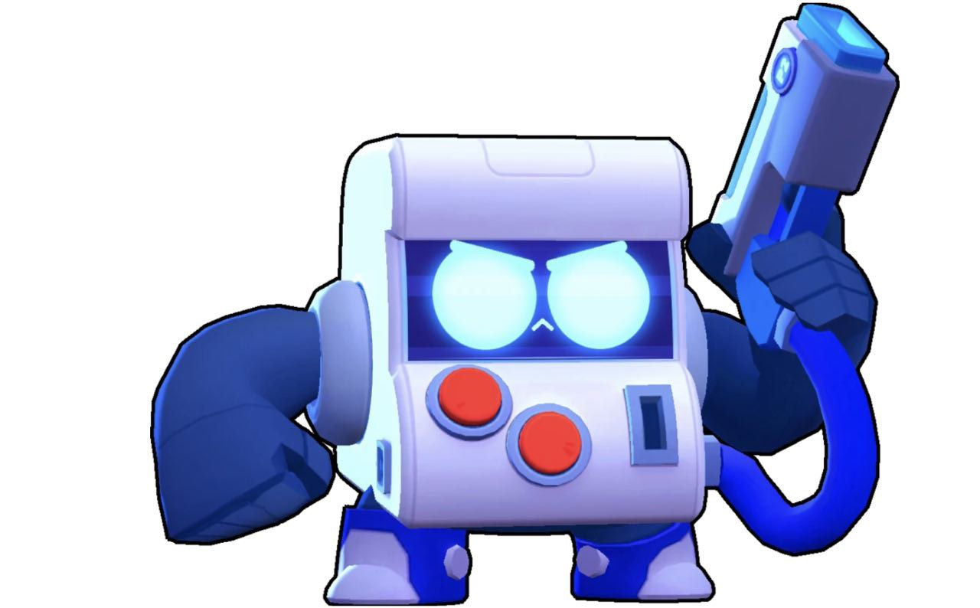The monitor from Lego Batman movie

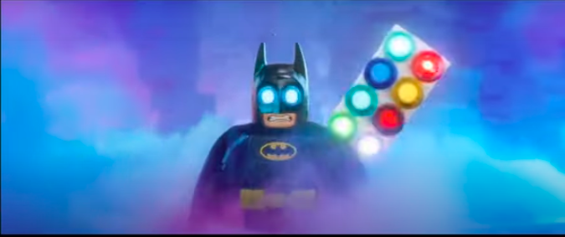Link for the reference for Smartphone: <https://youtu.be/O44qHvrMO3w>

Other plan if 2D animation doesn’t work out:

<https://vimeo.com/72566266>

Link for sac:

Link for the handbag: <https://www.artstation.com/artwork/4v9E2>  
  
  
  
