A Free Operating System For A Free Community
What Is Fedora?
Fedora is an operating system and a development platform based on the Linux kernel that is free to use, free to modify, free and legal to redistribute, and free from potentially damaging software patent encumbrances.
Fedora is built from the latest technologies from the free software world, and assembled by a community of users and developers who are passionate about providing and maintaining the best free software distribution in the world.
What Is the Fedora Project?
The Fedora Project is a Red Hat sponsored and community supported open source project. Our goal is the rapid progress of free and open source software and content. The Fedora Project makes use of public forums, open processes, rapid innovation, meritocracy, and transparency in pursuit of the best operating system and platform that free software can provide.

Fedora Project
http://fedoraproject.org

Fedora Ambassadors
http://fedoraproject.org/wiki/Ambassadors



http://fedoraproject.org

Fedora and the Infinity Logo are
registered trademarks of Red Hat, Inc.
Fedora
Fedora comes in both multiboot Live media and installable DVD formats, for 32-bit, 64-bit and ARM machines. Packages are selected to cater to a broad spectrum of use, from home and business use, to system administration and software development. No matter who you are, Fedora can provide you with the best free software to meet your needs.
The Desktop

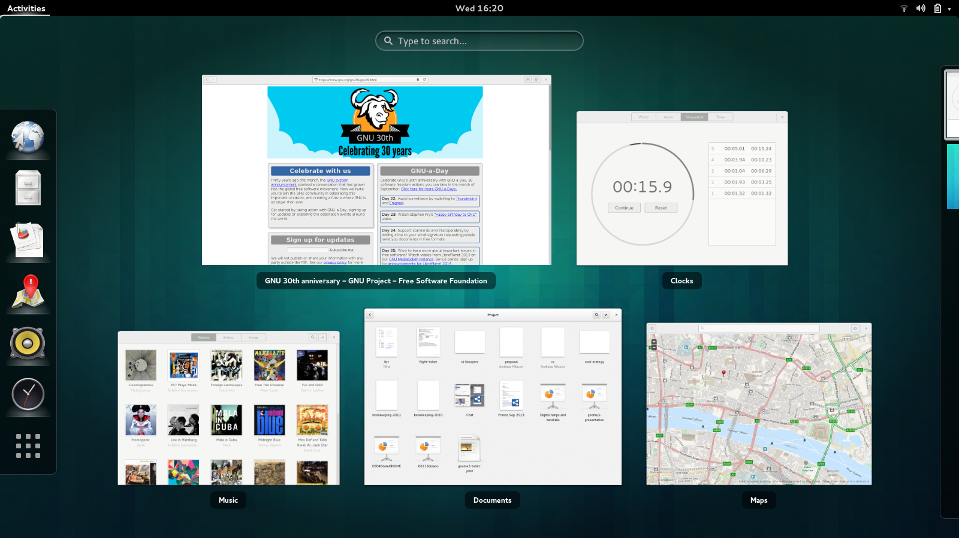
The default Fedora desktop uses the GNOME3 desktop environment.
If GNOME3 is not your desktop of choice, the latest versions of KDE, XFCE, LXDE, Mate, and even Sugar are readily available. You can easily install them off their live media, the install DVD or via the Fedora repositories on the internet.
The Cloud
Fedora provides ready-to-run cloud images for each supported Fedora release. These are available in Amazon EC2 and for direct download.
LibreOffice
LibreOffice is a multi platform and multi lingual open source office suite. It has everything you need for productivity in your business, studies and everyday tasks.
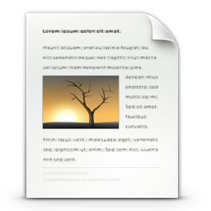
- LibreOffice Writer
(Word processor)
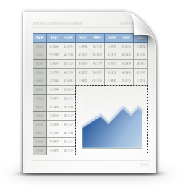
- LibreOffice Calc
(Spreadsheet application)
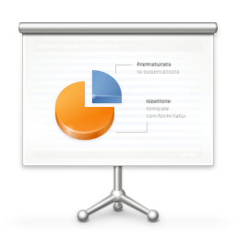
- LibreOffice Impress
(Slide show designer)
Developer tools / Developer Assistant
Our Developer Assistant UI helps to our new and old developers set up their favorite environments and tools. This includes packaging, plenty of language environment settings, and even Github support.
3D Printing Support / Engineering
We provide the latest and greatest 3D development tools for our users, without having to download binary blobs or run Python code from git.
Fedora Spins
We have plenty of specialized versions of Fedora to cover the specific needs of a user, or an user group. Not only Security, Design, Robotics, Electronics Lab we have, else the newest member of the mosaic is for music lovers and creators the Fedora Jam.
Getting Fedora
Fedora can be acquired easily through public mirrors, from BitTorrent, from ambassadors, and from our Fedora Free Media project or from online distribution vendors.
http://get.fedoraproject.org
Getting Support
Fedora Project wiki and mailing lists
https://fedoraproject.org/wiki/Communicate
Official Documentation
http://docs.fedoraproject.org
IRC channel
#fedora @ irc.freenode.net
Community forums
http://ask.fedoraproject.org
http://fedoraforum.org
Contributing to Fedora
Are you interested in contributing to Fedora? There are many ways you can become active in the project.
Whether you are a People Person, Designer, OS Developer, Packager or Administrator – we have a place for you. Just head to the following page and get started today!
http://join.fedoraproject.org

