A Free Operating System For A Free Community
What Is Fedora?
Fedora is an operating system and a development platform based on Linux that is free to use, free to modify, free and legal to redistribute, and free from potentially damaging software patent encumbrances.
Fedora is built from the latest technologies from the free software world, and assembled by a community of users and developers who are passionate about providing and maintaining the best free software distribution in the world.
What Is the Fedora Project?
The Fedora Project is a Red Hat sponsored and community supported open source project. Our goal is the rapid progress of free and open source software and content. The Fedora Project makes use of public forums, open processes, rapid innovation, meritocracy, and transparency in pursuit of the best operating system and platform that free software can provide.

Fedora Project
http://fedoraproject.org

Fedora Ambassadors



http://fedoraproject.org

Fedora and the Infinity Logo are
registered trademarks of Red Hat, Inc.

Fedora
Fedora comes in both Live media and installable DVD formats, for both 32-bit and 64-bit machines. Packages are selected to cater to a broad spectrum of use, from home and business use, to system administration and software development. No matter who you are, Fedora can provide you with the best free software to meet your needs.
The Desktop
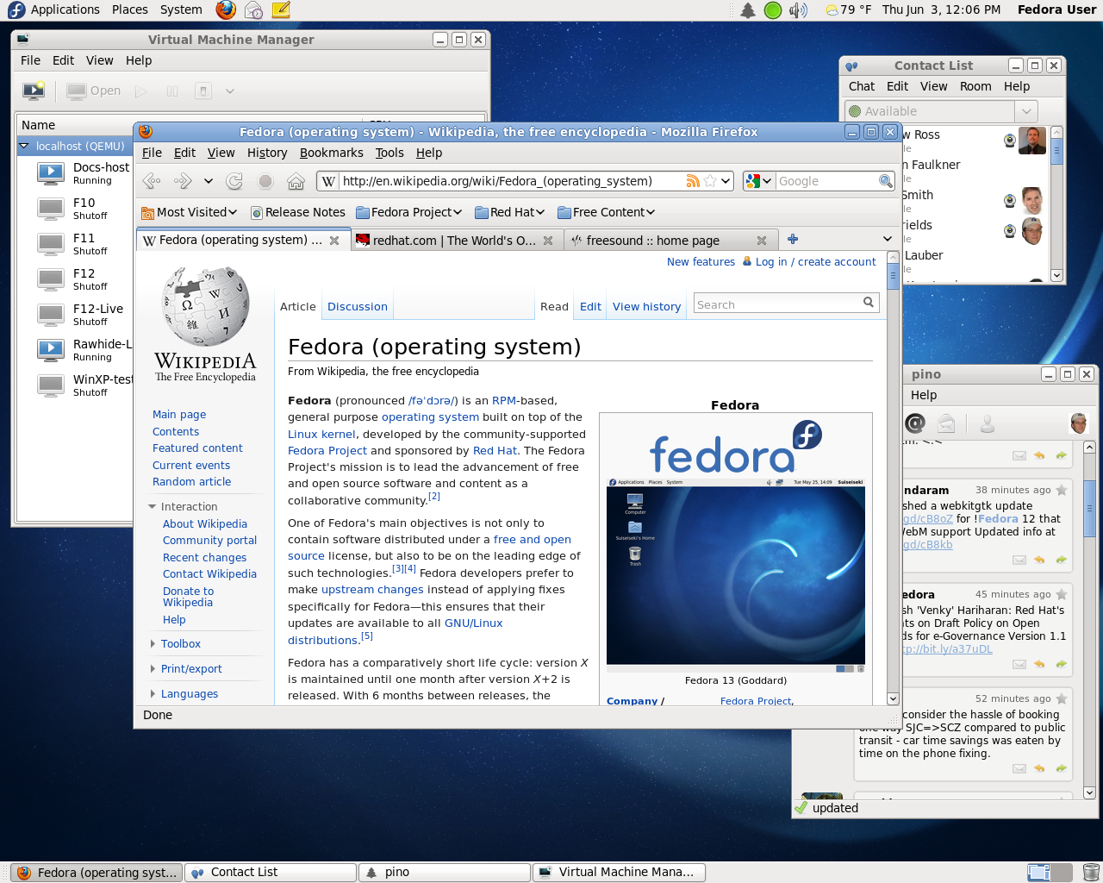
The default Fedora desktop uses the GNOME desktop environment. It is easy to use, simple and suitable for everybody. You are free to change the themes, or even to replace it with a different desktop environment altogether.
For the eye-candy lovers, Fedora includes Compiz, a 3D desktop, in its default installation.
If GNOME is not your desktop of choice, KDE, XFCE, and LXDE are readily available.
OpenOffice
OpenOffice.org is a multi platform and multi lingual open source office suite. It has everything you need for productivity in your business, studies and everyday tasks.
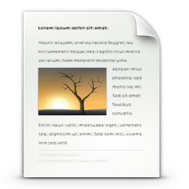
- OpenOffice Writer
(Word processor)

- OpenOffice Calc
(Spreadsheet application)
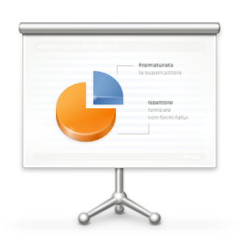
- OpenOffice Impress
(Slide show designer)
NetworkManager
NetworkManager provides excellent wireless network management and sharing support. It includes support for multiple devices and provides the capability of system-wide configuration.
PulseAudio
PulseAudio is installed and enabled by default. PulseAudio is an advanced sound server compatible with nearly all existing Linux sound systems. PulseAudio allows for hot-switching audio outputs, individual volume controls for each audio stream, networked audio, and more.
Plymouth
In the never-ending quest to improve the boot and startup sequence, Plymouth provides a flicker-free, fast boot time.

Getting Fedora
Fedora can be acquired easily through public mirrors, BitTorrent or using Jigdo.
http://get.fedoraproject.org
Getting Support
Fedora Project wiki and mailing lists
https://fedoraproject.org/wiki/Communicate
Official Documentation
http://docs.fedoraproject.org
IRC channel
#fedora @ irc.freenode.net
Community forums
http://fedoraforum.org
Contributing to Fedora
Are you interested in contributing to Fedora? There are many ways you can become active in the project.
Whether you are a People Person, Designer, OS Developer, Packager or Administrator – we have a place for you. Just head to the following page and get started today!
http://join.fedoraproject.org

