#

# HW 4: Fitting Accident Data with regression line

#

#########################################################

# Use This file as a template for your assignment.

# code and comments together with (selected) output from R console.

# submit selected plots.

# Your Name: _________Sample Solution____________________

# 1.

# -----------------

# Read in acci.txt file from the course web site. Plot the time series.

# Take difference with lag 12.

# Plot the differenced data. Call it D2.

**D <- read.csv("http://gozips.uakron.edu/~nmimoto/pages/datasets/acci.txt")**

**D1 <- ts(D, start=c(1,1), freq=12)**

**plot(D1, type='o')**

**D2 <- diff(D1, 12)**

**plot(D2, type='o')**

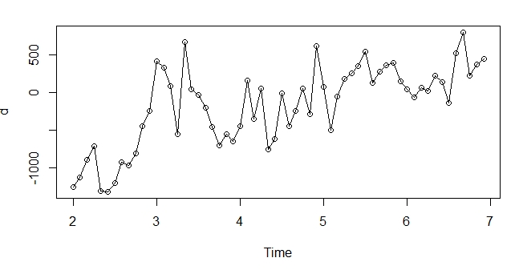

# 2.

# -----------------

# Fit D2 with linear trend using OLS.

# Is the slope significant? How did you determine?

# Can the output from the screen be trusted?

**t <- 1:length(D2)**

**Reg <- lm(D2~t); summary(Reg)**

**D3 <- ts(Reg$residuals, start=c(2,1), frequency=12)**

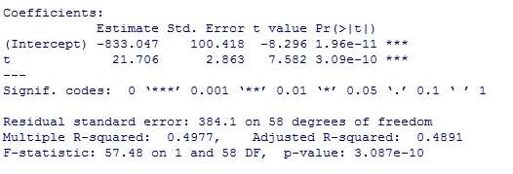

Trusting the Std Error on screen, the slope is significant, but SE can not be trusted, because we know the errors are correlated.

**Randomness.tests(D3)**

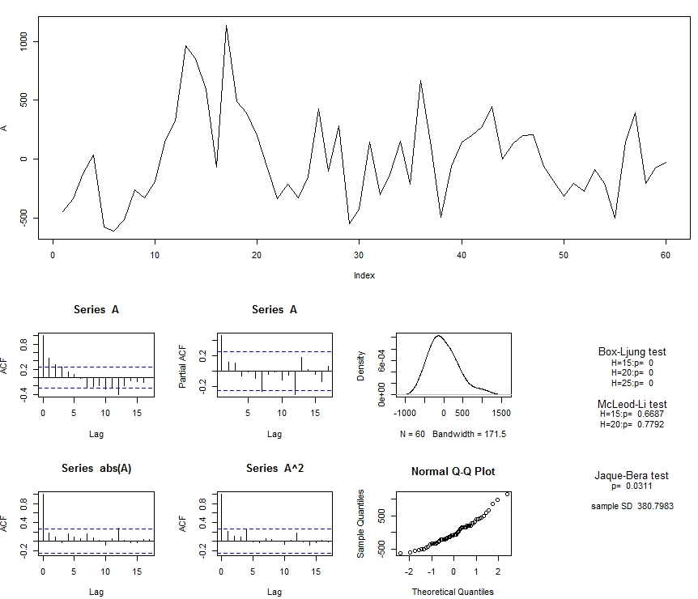

# 3.

# -----------------

# Fit residuals from (2) with seasonal ARIMA with d=0, D=0.

# (i.e. ARIMA(p,0,q)x(P,0,Q)12) Is the seasonal part necessary?

**est1 <- auto.arima(D3, D=0); summary(est1)**

**Randomness.tests(est1$residuals)**

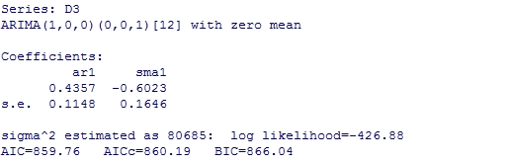

**est2 <- auto.arima(D3, seasonal=F); summary(est)**

**Randomness.tests(est2$residuals)**

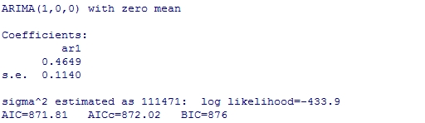

Both models pass the randomness tests, but since Seasonal MA coefficient is significant, and AICC is smaller, est1 is better model. We can use AICC here, because both model has d=0, D=0.

# 4.

# -----------------

# Using the best model from #3, predict twelve months ahead in D2.

**x.p <- predict(est1, n.ahead=12, se.fit=TRUE)**

**x.pred <- ts(x.p$pred, start=end(D2)+c(0,1), freq=12)**

**ts.plot(cbind(D3, x.pred), type="o", col=c('black','red'), lty=c(1,2) )**

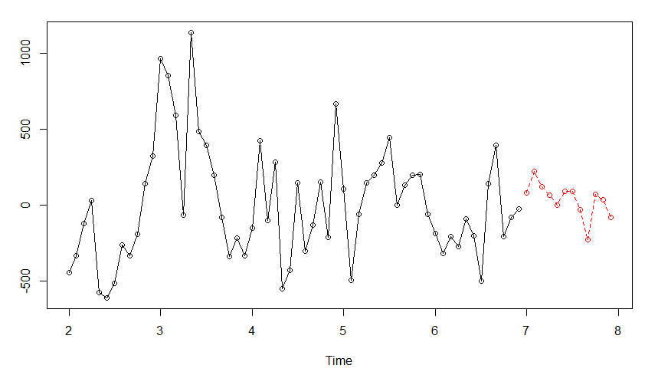

**t2 <- length(D2) + (1:12)**

**D2.pred <- -833.047 + 21.706 * t2 + x.pred**

**#-- Plot with prediction**

**ts.plot(cbind(D2, D2.pred), type="o", col=c('black','red'), lty=c(1,2) )**

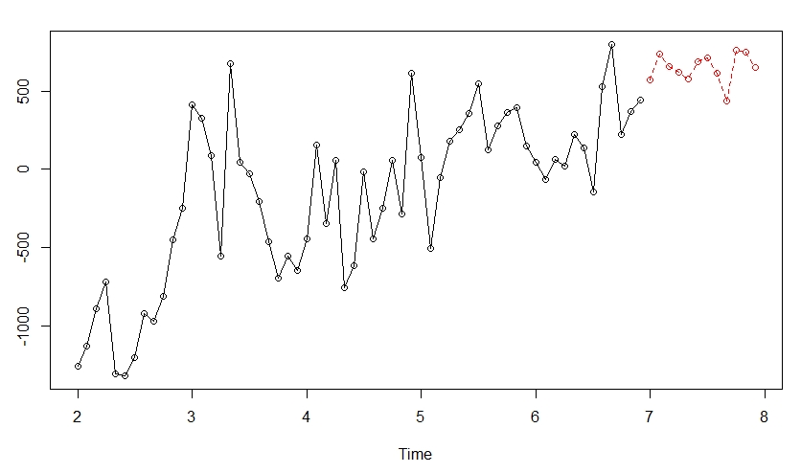

# 5.

# -----------------

# Using the prediction from #4, predict twelve months ahead in D1 (original TS).

**D1.pred <- D2.pred + as.numeric( window(D1, start=c(6,1), end=c(6,12)) )**

**#-- Plot with prediction**

**ts.plot(cbind(D1, D1.pred), type="o", col=c('black','red'), lty=c(1,2) )**

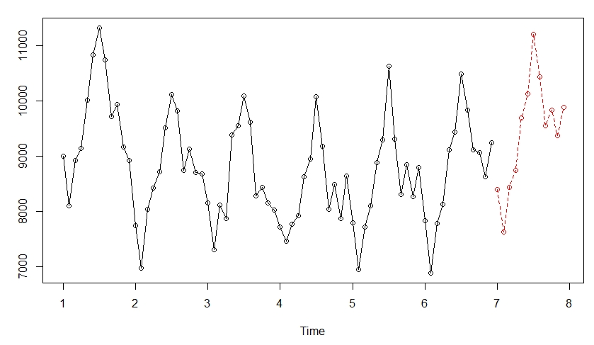

# 6.

# -----------------

# Using your model from In-class Ex2-#2, (ARIMA(p,1,q)x(P,1,Q)12 model), predict

# twelve-month ahead in D1.

# 7.

# -----------------

# Using your model from In-class Ex2-#3, (ARIMA(p,0,q)x(P,1,Q)12 model), predict

# twelve-month ahead in D1.

# 8.

# -----------------

# Compare your prediction from #5, #6, and #7. Plot the one-month predictions on

# the sampe plot. Which one do you like the best?