PHENIKAA UNIVERSITY
PHENIKAA SCHOOL OF COMPUTING

FINAL REPORT
Software architecture
TOPIC : Design and Evaluation of Multi-Agent Architectures
for Stock Price Prediction: A Vietnam Case Study
CLASS: SA_N01
Group: 3
Teacher: ThS. Vũ Quang Dũng
Name | ID | Contact
Nguyễn Minh Dương | 23010441 | 23010441@st.phenikaa-uni.edu.vn  0328451322

Ha Noi, 12-2025
Contents
1.Cover page 2
2.Abstract/Summary 2
3.Lab Specific Section: I. Requirements Elicitation & Modeling 3
3.1 Software Requirements Specifications (SRS) 3
3.1.1 Functional Requirements (FRs) 3
3.1.2 Non-Functional Requirements (NFRs) 3
3.1.3 Architecturally Significant Requirements (ASRs) 4
4. Architectural Design (note: Problem analysis of next lab) 6
4.1 The Problem Statement 6
4.2 Impact of ASRs on Coordination Architectures 6
5. Conclusion & Reflection 7

1.Cover page
- Title: Design and Evaluation of Multi-Agent Architecturesfor Stock Price Prediction: A Vietnam Case Study
- Course information: Software Architecture
- Student Details: Nguyen Minh Duong, ID: 23010441
- Date: 12/2025

2.Abstract/Summary

The Multi-Agent Stock Price Prediction System project aims to develop a robust agent-based modeling framework that accurately captures the complex and volatile dynamics of Vietnam’s emerging equity market. This initial lab focused on requirements elicitation and modeling. We documented essential Functional, Non-Functional, and Architecturally Significant Requirements (ASRs) in a structured format. The core system behavior was formally modeled using a UML Use Case Diagram, clearly defining system boundaries, external actors (End Users, Interaction Agent, Data Collection Agent, Data Analysis & Price Prediction Agent, Storage System), and key behavioral relationships.
This foundation establishes the scope and the critical architectural drivers that will be addressed in subsequent labs, particularly the design of the Hierarchical, Round Robin, Ensemble Voting, Decentralized, Federated, and Event-Driven Architectures in next Lab 2.

3.Lab Specific Section: I. Requirements Elicitation & Modeling

Software Requirements Specifications (SRS)

Functional Requirements (FRs)
These requirements define the specific behaviors and functions the Multi-Agent Stock Price Prediction System must provide.

ID | Description | Priority
FR-01 | The system must ingest historical and real-time market data (price, volume, order book) from HOSE, HNX, and UPCoM sources. | Critical
FR-02 | The system must enable specialized agents to perform domain-specific analysis (e.g., technical indicators, fundamental ratios, risk profiles, news sentiment | Critical
FR-03 | The system must coordinate agent outputs through selected architectures (Hierarchical, Round Robin, Ensemble Voting, Decentralized, Federated, Event-Driven) to generate unified price predictions. | Critical
FR-04 | The system must integrate LSTM-based foundation modeling to capture temporal dependencies as the initial predictive state. | High
FR-05 | The system must output multi-horizon forecasts (short-term 3 days, medium-term 14 days, long-term 60 days) with confidence scores and investment recommendations (BUY, SELL, HOLD). | High

Non-Functional Requirements (NFRs)
These requirements specify criteria that can be used to judge the operation of the system, not specific functions.
ID | Attribute | Description | Impact
NFR-01 | Performance (Speed) | The simulation of 1000 trading ticks must complete in under 30 seconds on a standard laptop. | High
NFR-02 | Scalability | The system must support increasing the number of agents from 100 to 1000 without code changes. | Critical
NFR-03 | Reproducibility | Simulation runs with the same random seed and parameters must produce identical results. | High
NFR-04 | Extensibility | The system must allow addition of new agents or LLMs (e.g., Gemini, GPT-4o, Llama-3.1) with changes isolated to modular components. | High

3.1.3 Architecturally Significant Requirements (ASRs)
These are the non-functional requirements that have the most profound influence on the system's architecture, driving the selection of patterns.

ASR ID | Quality Attribute | Requirement Statement | Architectural Rationale
ASR-1 | Flexibility | The architecture must enable seamless switching between Hierarchical, Round Robin, and Ensemble Voting coordination at runtime via configuration. | This drives the adoption of pluggable patterns and modular separation between core prediction logic and coordination mechanisms, ensuring adaptability to different market scenarios.
ASR-2 | Real-time Interaction | Agents must interact and refine predictions within the same simulation cycle, supporting immediate responses to volatility or news events. | Necessitates an event-driven or parallel processing backbone over sequential models, influencing the choice of concurrent designs for handling sentiment-driven market shifts.
ASR-3 | Modifiability | Modifying an agent's analytical strategy (e.g., adding new indicators to PricePredictor) must not impact the LSTM foundation or other agents. | Enforces separation of concerns and interface-based modularity, guiding toward layered or componentized structures where domain-specific logic is isolated for easy updates.

3.2 Modeling Artifact: UML Use Case Diagram

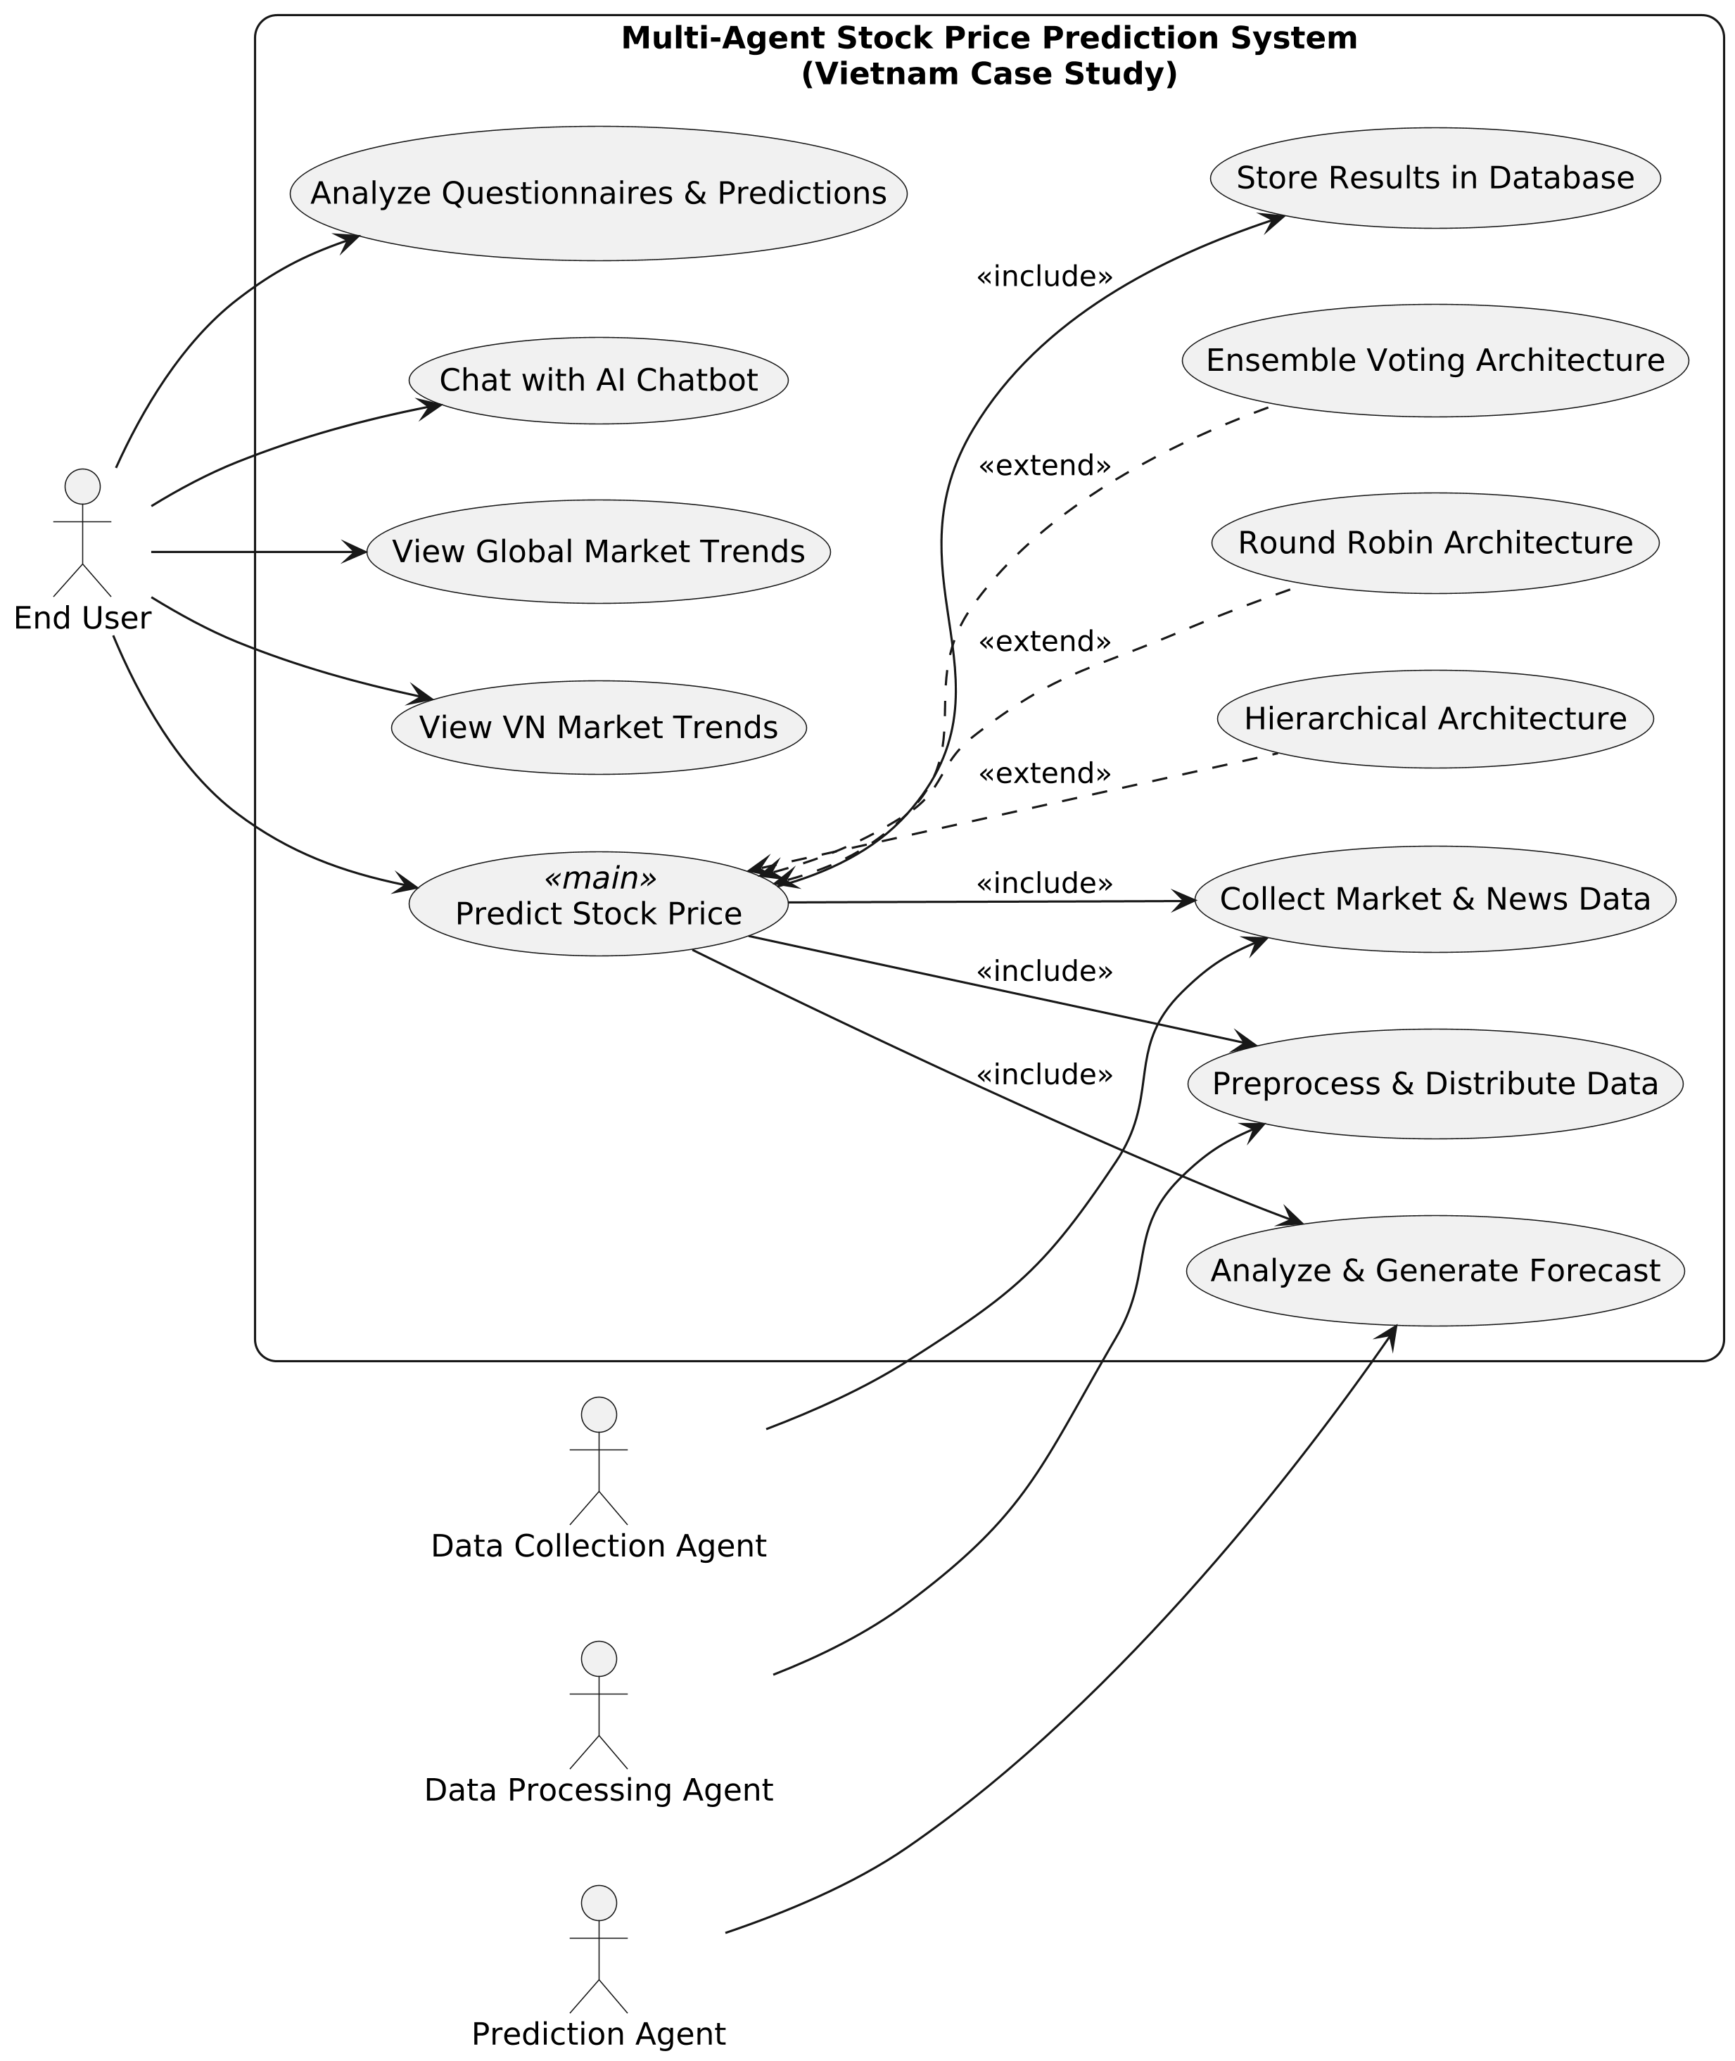
The system serves End Users who can perform five main use cases:
- Analyze Questionnaires & Predictions
- Chat with AI Chatbot
- View Global Market Trends
- View Market Trends (appears twice, likely a duplication)
A central Main Agent coordinates three alternative multi-agent architectures (shown as optional extensions):
- Hierarchical Architecture
- Round Robin Architecture
- Ensemble Voting Architecture
Supporting actors:
- Data Collection Agent gathers raw data
- Data Processing Agent and Prediction Agent handle analysis and forecasting
The Main Agent interacts with:
- Store Data
- Distribute Data
- Provide Data (Sentiment, Quality & Forecast)
- Analyze & Predict
The diagram illustrates a scalable AI-agent system for market intelligence with pluggable coordination architectures.

4. Architectural Design (note: Problem analysis of next lab)
The requirements elicited in Lab 1 have a direct impact on the design challenge of Lab 2: Coordination Architectures Design.

4.1 The Problem Statement
The problem is to design architectures that satisfy the core requirements while enforcing modularity, real-time interaction, and flexible coordination. The Hierarchical, Round Robin, and Ensemble Voting patterns are chosen as the structural approaches to address the Flexibility and Real-time Interaction ASRs identified in Lab 1.

4.2 Impact of ASRs on Coordination Architectures
- ASR-3 (Modifiability) → Layered Structure: ASR-3 demands that changes to individual agents remain isolated (e.g., updating sentiment analysis in TickerNews should not affect MarketNews). The coordination architectures inherently support this by defining distinct processing layers (Foundation LSTM, Agent Analysis, Aggregation) with controlled dependencies. This means: o The Agent Analysis layer (where domain-specific code resides) can be modified without impacting the Foundation layer. o The Aggregation layer can be adjusted (e.g., switching voting mechanisms) without affecting the Agent Analysis layer, provided interfaces remain consistent.
- ASR-2 (Real-time Interaction) → Aggregation Layer: ASR-2 requires rigorous agent coordination for immediate responses. In the coordination architectures, this logic is enforced in the Aggregation Layer. This ensures that interaction protocols are applied to core processes (e.g., prediction refinement), enabling parallel or sequential handling regardless of input source (e.g., news events or volatility spikes).
The next step (Lab 2) will use these requirements to formally define the three coordination architectures and model their logical components (e.g., Master Agent, Voting Engine) and interfaces within those structures.

5. Conclusion & Reflection
The requirements elicitation phase for the Multi-Agent Stock Price Prediction System successfully defined the project scope through detailed Functional, Non-Functional, and Architecturally Significant Requirements. The UML Use Case Diagram provides a clear visual model of user interactions and the critical path. The identified ASRs—especially those relating to Flexibility and Modifiability—directly necessitate the adoption of structured patterns like the Hierarchical, Round Robin, Ensemble Voting, Decentralized, Federated, and Agent-Driven Architectures for the subsequent design phase (next Lab 2), ensuring the architecture can sustainably support the required system behavi

