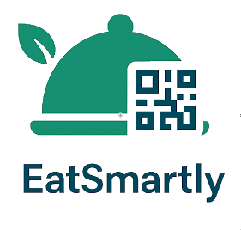
eatSmartly – Restaurant System POS
+ QR Digital Menu + Customer Ordering
v2.2 Installation Guide –

Videos Guide
For visual instructions on installing and using the application, visit our YouTube channel playlist:
eatSmartly Installation, Setup and demo Videos

Licensing
EatSmartly is sold exclusively on Envato under the following licenses:
- Regular License → Single restaurant installation with 03 possible scenarios, suitable for Fast food, Restaurants, cafés, Hotels…
- Extended License → Multi-restaurant installation suitable for : Food court , Mall
For more details, please refer to the “Licensing Scenarios” in page 12

“This documentation is for the purchased version of eatSmartly. Redistribution without permission is prohibited.”

Table of Contents
1. Introduction 3
2. System Requirements 5
3. Installation Guide 5
4. License Activation ..……………………………………………………………………………………………...7
5. First Launch & Initial Setup ………………………………………………………………...............................8
6. Printers Setup 8
6.1 Single Printer Setup (USB Mode) 8
6.2 Multiple Printers Setup (USB + Ethernet)……………………………………………………….……….10
7. Licensing Scenarios (Detailed) ……………………………………………………………………………….11
7.1 Regular License – Scenario 1: POS + One USB Printer ………………………………...................11
7.2 Regular License – Scenario 2: POS + multiple printers + TV notifications ...................................13
7.3 Regular License – Scenario 3: POS with Multi-Printers + QR Digital Menu
+ Customer Ordering ………………………………………………………………………..……………15
7.4 Extended License – eatSmartly with Multi Restaurents + Qr Digital Menu
+ Customer Ordering ……………………………………………………………………..………………18
8. QR code Menu Feature ……………………………………………………………………………..23
8.1 How It Works ……………………………………………………………………………………………...23
8.2 Generating the QR Code …………………………………………………….…….…………………….24
8.3 Performance & Network Requirements …………………………………….………………………….24
8.4 Important Notes ……………………………………………………………….………………………….24
9. Support policy ………………………………………………………………………………………….……….25
9.1 Standard Support (Regular License Buyers) ………………………………………………………...25
9.2 Premium Support (Extended License Buyers) ………………………………………………………25
9.3 How to Request Support ………………………………………………………………………………..26

Introduction
EatSmartly is a modern, offline-first Restaurant POS and QR Menu system designed to simplify restaurant management and enhance customer experience. It combines the essential tools for order management, billing, and kitchen coordination with innovative features like interactive QR menus and multi-language support.
Built to run locally on Windows (without requiring internet), EatSmartly ensures reliability, speed, and full control for restaurant owners. Whether you run a small café, a full-service restaurant, Hotel, or a multi-restaurant food court, EatSmartly adapts to your needs with flexible licensing options.

✅ Key Capabilities
- Complete POS Solution – Manage orders, receipts, payments, and staff roles with an intuitive interface.
- Printer-Free Operation – EatSmartly can run without any printer. Simply install and use the system to manage orders digitally (ideal for small cafés or fast-food stands).
- QR Digital Menu – Customers can scan a QR code and browse your menu on their smartphones, even offline.
- Ordering from QR Menu – Customers can place orders directly through the digital menu (if enabled).
- Multi-language & Multi-currency – Supports English, French, Arabic, and any menu language you choose.
- Profitability Tracking – Generate detailed reports on sales, costs, and net profits.
- Food Court Mode (Extended License) – Manage multiple restaurants with a shared QR code and route orders automatically to the right kitchen.
- Offline First – Works completely offline on a local network; internet is only needed for remote support or updates.
- Remote Support Ready – Integrated with AnyDesk for quick troubleshooting when needed.
- Flexible Printer Support –
  - ESC/POS printers (receipt + kitchen tickets)
  - EZPL label printers (kitchen stickers)
  - TSPL label printers (kitchen stickers)
- Printer-Free Operation – EatSmartly can run without any printer. Simply install and
🔹 Licensing Scenarios
- Regular License (Single Restaurant): suitable for Fast Food, Restaurants, cafés, Hotels…
  - Scenario 1: POS + one USB printer (receipts + kitchen tickets)
  - Scenario 2: POS + multiple printers + TV notifications
  - Scenario 3: POS + multiple printers + QR Menu (customers view and order from their phone)
- Extended License (Food Court / Multi-Restaurant) : suitable for Food court, Mall,..
  - One QR code for all restaurants in the food court
  - Customers select a restaurant inside the digital menu
  - Orders are routed automatically to the correct kitchen printers & cashiers
  - Each restaurant manages only its own orders

X What EatSmartly Does Not Include
To set the right expectations, EatSmartly does not currently provide:
- Purchasing Management (supplier orders, purchase invoices)
- Stock / Inventory Management (ingredients tracking, stock levels, wastage management)
- Integrated Payment Processing – EatSmartly does not connect to card readers, payment terminals, or online payment gateways. The cashier must handle all payments (credit/debit cards, mobile wallets, etc.) outside of the system.

System Requirements
To ensure smooth performance, your system must meet the following requirements:
- Operating System: Windows 10 (64-bit)
- Processor: Intel Core i3 or higher
- RAM: Minimum 4 GB
- Storage: Minimum 128 GB SSD
- Display: Touchscreen PC recommended
- Network: Local LAN / Wi-Fi for QR Menu access
- Printer: ESC/POS receipt printer supported
Before installing eatSmartly, ensure you have:
- Administrator rights on your Windows PC.
- A stable local network (if using QR menu).
- Your restaurant menu details ready for setup.

Installation Guide
⚠ Important Note:
- Before starting, make sure the D: partition exists on your PC (minimum free space: 15 GB).
- Installers must be run as Administrator.
  - Step 1 – Install Dependencies
- Locate “Step_1_eatSmartly_Dependencies.exe” in your package.
- Right-click it and choose “Run as Administrator”.
- The installer will install all required Windows components and prepare your system for eatSmartly.
- Once finished, proceed to Step 2.
This installer Include the AnyDesk remote support tool:
- Once your PC is connected to the internet, AnyDesk will display your ID number
- Share this ID with our support team if you require assistance or troubleshooting.
  - Step 2 – Install WampServer (64-bit)
- Locate “Step_2_wampserver3.3.0_x64.exe” in your package.
- Install it to D:\wamp64 path and keep all other installer settings to default.
- Start WampServer by double-clicking the pink “W” icon on your desktop.
  - Wait until the “W” icon in the system tray (bottom-right of your screen) turns green, which means Apache and MySQL are running.
- Switch PHP to 8.1.13:
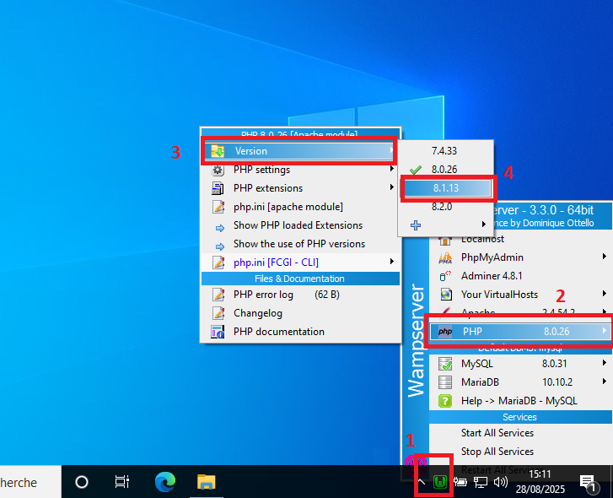
  - Left-click the green Wamp tray icon → PHP → Version → 8.1.13 (see the included screenshot).

  - Wamp will reload its services; wait again until the tray icon is green.
Remark: After eatSmartly installation finished, WampServer is configured to start automatically with Windows. You do not need to launch it manually each time in order to use eatSmartly.
  - Step 3 – Install eatSmartly Configuration
- Locate “Step_3_eatSmartly_Configuration.exe” in your package.
- Right-click it and choose Run as Administrator.
- The configuration tool will:
  - Create the database and user in MySQL 8.0.31.
  - Copy the eatSmartly application into D:\wamp64\www\eatSmartly\.
  - Apply local settings and create desktop/start menu shortcuts.
- After the setup completes, Open eatSmartly by double-clicking the desktop shortcut.
- Wait a little bit for the system to initialize its parameters for the first time.
- You will see the License Activation page:
- Send the License Generation Code and your company information to support.
- Enter the Activation Code you receive to unlock the software.
- Activation is one-time; eatSmartly works fully offline afterward.
✅ With these 3 steps completed, eatSmartly is ready to use.

License Activation
Before you can use eatSmartly, you must activate your license.

Steps:
- Open eatSmartly by double-clicking the desktop shortcut.
- The License Activation Page will appear, showing your License Generation Code.
- Send this code including your company info (Company Name, Purchase Code, activity domain: Fast food, café, restaurant, Hotel..., address and phone number) to our support team via email (s.eatsmartly@gmail.com) or WhatsApp (+213 (0) 561 69 87 16).
- Within 2 hours maximum, you will receive your Activation Code.
- Enter the Activation Code into the software and click Activate.
💡 The activation is a one-time process. The software works fully offline after activation.

First Launch & Initial Setup
After activation is complete, you can start using eatSmartly.
Default login credentials:
- Username: admin
- Password: 1234
Initial setup steps:
- Go to Settings → Company and update your business information and admin credentials.
- Add your menu categories and menu items.
- Configure your printers in Settings → Printers:
  - Client Receipts printer
  - Chef Tickets printer.

Printers setup
eatSmartly can work without any printer, if the user decided to print receipts and Tickets, one printer is sufficient to manage all restaurant printing; you can use it in USB mode or Ethernet mode. We recommend:
- USB mode, if the client decides to use only one printer to manage its restaurant.
- Ethernet mode, if the client decides to use more than one printer to manage its restaurant. In this case, the Cashier printer will be in USB mode Connection and the other printers (for Chefs Tickets) will use the Ethernet Connection mode.

Single Printer Setup (USB Mode)
- Connect and Install your receipt printer normally using the “manufacturer’s driver”.
- Rename the Printer to “eatSmartlyPrinter”
  - Open Control Panel → Devices and Printers.
  - Right-click on your receipt printer → Printer Properties.
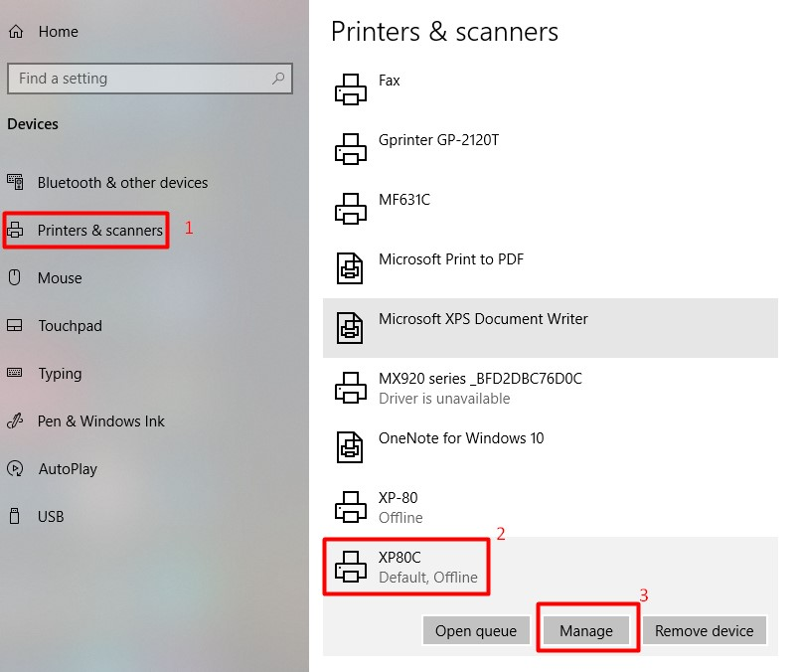
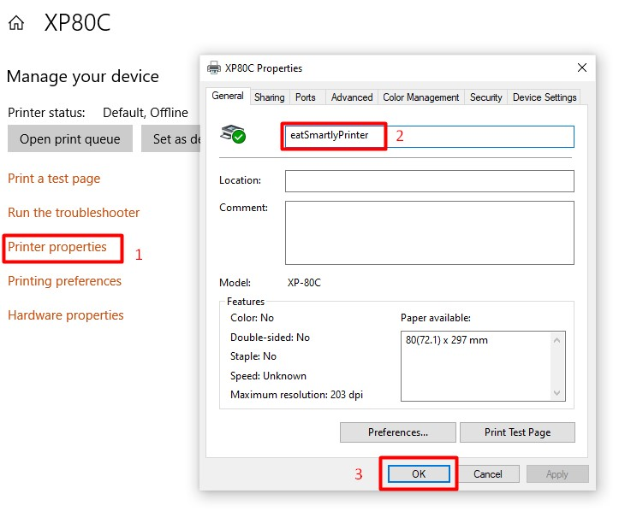
- Change the printer’s name exactly to: “eatSmartlyPrinter”
- Click Apply to save changes.
- Share the Printer
  - In the same Printer Properties window, go to the Sharing tab.
  - Check Share this printer.
  - Enter the Share name exactly as: “eatSmartlyPrinter”
  - Click Apply → OK.
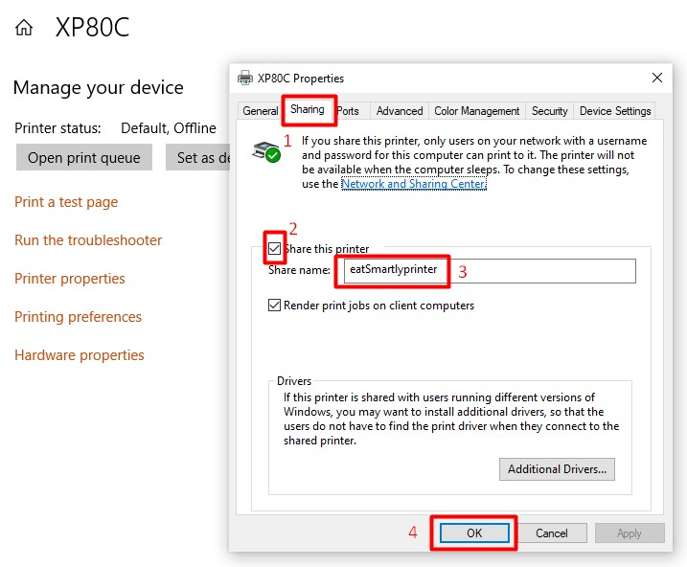
Hint: In one-printer mode, the single printer will print both the Chef’s kitchen tickets and the customer’s receipts.

Multiple Printers Setup (USB + Ethernet)
In larger restaurants, you may want one cashier printer and separate kitchen printers for different kitchen sections.
- Cashier Printer (USB Mode)
  - Must be USB-connected to the main POS PC.
  - Install and rename it exactly as in the Single Printer setup: “eatSmartlyPrinter”
  - Share it with the same name: “eatSmartlyPrinter”
- Kitchen Printers (Ethernet)
  - Connect via Ethernet to local network.
  - Assign a fixed IP (e.g., 192.168.1.2, 192.168.1.3).
Recommendation:
  - Cashier printer → USB
  - Kitchen printers → Ethernet with static IP

Licensing Scenarios (Detailed)

Regular License – Scenario 1: POS + One USB Printer
This is the simplest setup, where a single USB printer is used for both customer receipts and kitchen tickets.
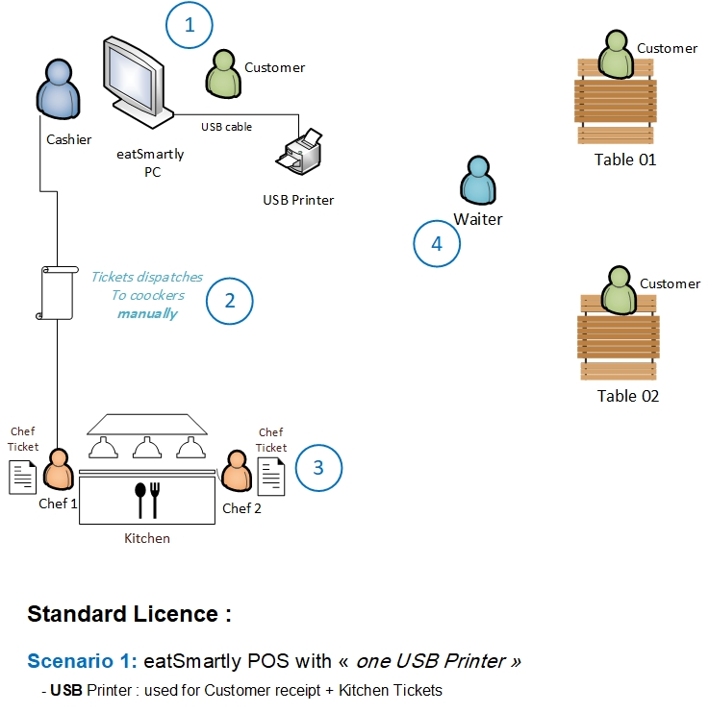

Workflow
Step 1 – Order Taking
- A waiter takes the order at the table, or the customer places the order directly with the cashier.
Step 2 – Order Entry
- The cashier enters the order into EatSmartly and clicks Validate.
- At this point, the cashier chooses between two options:
  - Print Kitchen Ticket only → if the customer will pay later (after service).
  - Print Kitchen Ticket + Customer Receipt → if the customer pays immediately when placing the order.
Step 3 – Kitchen Preparation
- The USB printer prints the Kitchen Ticket.
- The Tickets dispatches manually to the chef(s).
- The kitchen staff prepares the order according to the printed ticket.
Step 4 – Serving the Order
- Once the food is ready, the waiter takes it from the kitchen and serves it to the customer.
- If payment was not already collected in Step 2, the customer pays at this stage and the cashier prints the receipt.
💡 Key Points of Scenario 1
- Only one USB printer is required.
- Suitable for small restaurants, cafés, or snack shops.
- Simple workflow, minimal equipment.
- Easy to manage by a single cashier and a small kitchen team.

Regular License – Scenario 2: POS + multiple printers + TV notifications
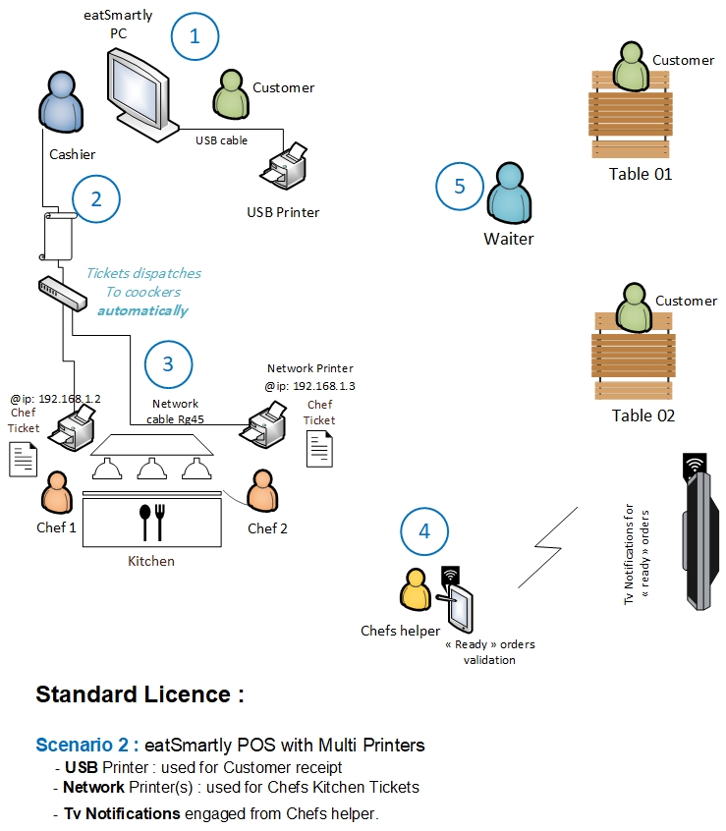

Workflow
Step 1 – Order Taking
- A waiter takes the order at the table, or the customer places it directly at the cashier.
Step 2 – Order Entry
- The cashier enters the order in EatSmartly and validates it.
- Immediately:
  - The USB printer prints the customer receipt (if the customer pays now).
  - The network kitchen printers automatically print the kitchen tickets, each directed to the correct section (e.g., Grill → Grill printer, Drinks → Drinks printer).
Step 3 – Kitchen Preparation
- Each chef receives the ticket directly on their dedicated network printer, depending on their section.
- Alternatively, one shared network printer can be used to handle all kitchen tickets, with chefs collecting their respective tickets from the same printer.
- Networking Requirement:
  - If you are using more than two printers, a network switch is required to connect all devices (PC, printers, chef helper, TV display).
  - All printers must be assigned fixed IP addresses for stable communication.
Step 4 – Chef Helper & Notifications
- A Chef Helper station (touchscreen PC or tablet) is used by kitchen staff to validate when an order or item is ready.
- Once validated, the order status appears as a notification on a TV screen.
- The TV notification screen can be placed:
  - Inside the kitchen or service area → so waiters know when orders are ready.
  - In the customer area → so customers can see when their orders are ready and collect them directly (self-service mode).
Step 5 – Serving the Order
- In table-service restaurants, waiters take the ready order when it appears on the TV screen and serve it to the customer.
- In self-service or fast-food restaurants, customers collect their orders directly when their order number appears on the TV.
- If payment was not already made, the cashier prints the receipt from the USB printer when the customer pays.
💡 Key Advantages of Scenario 2
- Automation – Orders are automatically sent to the right kitchen section without manual ticket delivery.
- Faster Service – Waiters and customers instantly know when orders are ready via TV notifications.
- Error Reduction – No missed or lost kitchen tickets.
- Flexible Modes – Works for both waiter-service restaurants and self-service/fast-food setups.
- Scalability – Supports one shared kitchen printer or multiple printers per section.
- Stable Networking – With a switch, the system can handle multiple Ethernet printers and displays smoothly.

Regular License – Scenario 3: POS with Multi-Printers
+ QR Digital Menu + Customer Ordering
This scenario extends the POS and multi-printer setup by adding QR Digital Menus and optional customer self-ordering. Customers connect to the restaurant’s local Wi-Fi network (offline, no internet required) and scan a QR code to access the interactive menu. Orders placed by customers are always validated by a waiter or cashier before being dispatched to the kitchen.

Workflow
Step 1 – QR Digital Menu Access & Customer Ordering (Optional)
- Customers connect to the restaurant’s offline Wi-Fi network.
- A QR code is placed on each table (with table name and unique table code) or on a takeaway code for to-go orders.
- Scanning the QR code opens the digital menu on the customer’s smartphone.
- Language & Currency: The menu language and currency are defined by the administrator in system settings (not selectable by the customer).
- Network Requirement: The restaurant must provide a stable Wi-Fi network capable of handling all customer devices connected simultaneously.
- Customers may select items directly from the QR menu.
- The system records the order with the table code to identify the source.
- The order is marked as “pending validation” and does not go directly to the kitchen.

Step 2 – Waiter Validation (Mandatory)
- A waiter or cashier reviews all customer-submitted orders on a tablet, mobile device, or POS terminal.
- The waiter checks item availability, adjusts if necessary, and validates the order.
- Only after staff validation does the order become “active” and move to the kitchen workflow.
Step 3 – Kitchen Preparation (like Scenario 2)
- Once validated, orders are automatically dispatched:
  - The USB printer can print the customer receipt (if payment is immediate).
  - Network printers print the kitchen tickets directly in the correct section (Grill, Pizza, Drinks, etc.).
- Chefs start preparing based on the printed tickets.
Step 4 – Chef Helper & Notifications
- Kitchen staff use the Chef Helper station (touchscreen PC/tablet) to validate when items are ready.
- Order status updates in real time and is shown:
  - On the TV notification screen for waiters and/or customers.
  - On the customer’s digital menu screen (if ordering was enabled).
Customer Order Tracking Option
- Customers can track their order status in the “Tracking” tab of the QR digital menu:
  - Created → Order placed by customer.
  - Validated → Confirmed by waiter/cashier.
  - Ready → Prepared and ready for pickup/serving.
- Customers can also enable notifications on their phone to get an alert when the order is ready.

Serving or Pickup
- In table-service restaurants, waiters deliver the order to the customer.
- In self-service/fast-food setups, customers collect their order when the TV screen or mobile notification shows “Ready.”
💡 Key Advantages of Scenario 3
- Stable Wi-Fi Required – Designed for restaurants with robust wireless networks to support many customers simultaneously.
- Controlled Workflow – All customer orders must be validated by staff before reaching the kitchen.
- Simple Language/Setup – Menu language and currency are set by the administrator (not customer-selectable).
- Real-Time Tracking – Customers can track their order status and get notifications.
- Flexible Service – Supports both waiter-service and self-service restaurant models.

Extended License – eatSmartly with Multi Restaurents
+ Qr Digital Menu + Customer Ordering
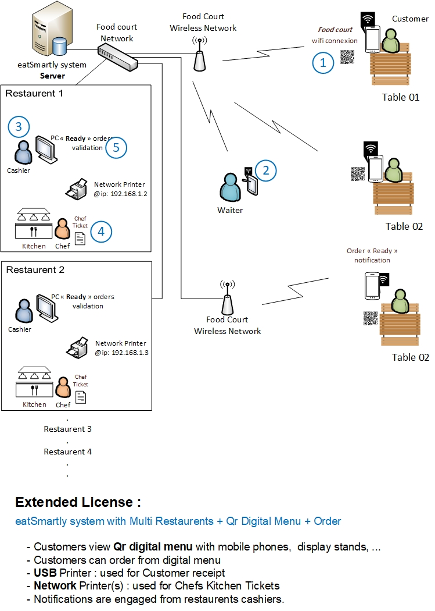
This scenario is designed for food courts and malls where multiple restaurants share the same dining space. Customers can sit at any table in the food court, scan a shared QR code, or use touchscreen kiosks/stands to access a consolidated digital menu that lists all participating restaurants.
Customers may browse, place orders (if enabled), and track their order statuses in real time.

Workflow
Step 1 – Accessing the Digital Menu
- Customers connect to the mall’s local Wi-Fi network.
- They scan the shared QR code available at tables or use kiosk touchscreens in the food court.
- The digital menu displays all available restaurants with their respective items and categories.
Step 2 – Customer Ordering (Optional)
- Customers can add items from one or multiple restaurants into a single cart.
- When they finish, they submit their order.
- The order is marked as Pending Validation by Food Court Staff to ensure control.
Step 3 – Food Court Waiter/Cashier Validation (Mandatory)
- Food court staff (not restaurant staff) receive all customer-submitted orders.
- They review and validate each order to check availability, prevent spam, and adjust quantities if needed.
- Once validated, the system splits the order automatically per restaurant.
- Each restaurant receives its respective tickets directly via POS/kitchen printers.
Step 4 – Kitchen Preparation
- Each restaurant starts preparing its validated orders.
- Kitchen tickets are sent to:
  - Network kitchen printers (chefs’ tickets)
- Chefs prepare based on their tickets, similar to previous scenarios.
Step 5 – Order Tracking & Notifications
- Customers can monitor order progress via their smartphones or kiosks:
  - Created → Customer submitted.
  - Validated → Approved by food court staff.
  - Ready → Restaurant cashier/chef helper marked the order as complete.
- Status is also displayed on TV screens in the food court.
- Customers can enable mobile notifications when their order is ready.
Step 6 – Payment Handling
- At the end of the meal, customers must pay each restaurant separately for their respective orders.
- This is the current reference workflow. However, we are open to working with mall management to define alternative models (e.g., centralized food court payment system).

Technical Requirements
- Dedicated Server Setup
  - The system must be deployed on a dedicated local server located inside the food court or mall’s IT infrastructure.
  - Server should provide:
    - High-performance CPU & RAM
    - SSD storage (with redundancy if possible)
    - High-availability configuration
- Network Infrastructure
  - A stable wired and wireless LAN is essential.
  - Business-class switches, routers, and access points (APs) must be used.
  - Wi-Fi must be able to support hundreds of simultaneous customer devices.
- Backup & Recovery
  - Daily automated backups of the database and configurations.
  - Backup stored in a separate secure location (cloud or another local server).
  - Recovery procedures must be tested to ensure minimal downtime.
- Scalability
  - Designed to handle multiple restaurants simultaneously without performance degradation.
  - Supports large customer traffic during peak hours.

Important Notes
- Pilot Stage: This scenario has not yet been deployed in a live food court/mall environment. We recommend starting with a QR Digital Menu only (no ordering) as the first phase, then enabling ordering once tested.
- Flexibility: The payment model (per restaurant vs centralized) can be adapted in collaboration with the mall owner.
- Added Value: This scenario transforms food courts into modern digital hubs, giving customers a seamless experience and helping mall owners differentiate their service.

Benefits of Scenario 4
- One QR Menu for all restaurants in the food court.
- Optional self-ordering with staff validation to ensure smooth operations.
- Real-time order tracking and notifications for customers.
- Strong technical infrastructure ensures stability and scalability.
- Can be rolled out step by step (QR viewing → ordering → advanced payment integration).
⚡ Scenario 4 (Extended License) is a premium solution intended for malls and food courts aiming to deliver a state-of-the-art digital dining experience while ensuring reliability with dedicated server infrastructure and professional IT setup.

QR code Menu Feature
eatSmartly allows you to provide customers with an interactive digital menu accessible directly from their smartphones via a QR code. See our demo video here:
eatSmartly Demo QR code Digital MENU video

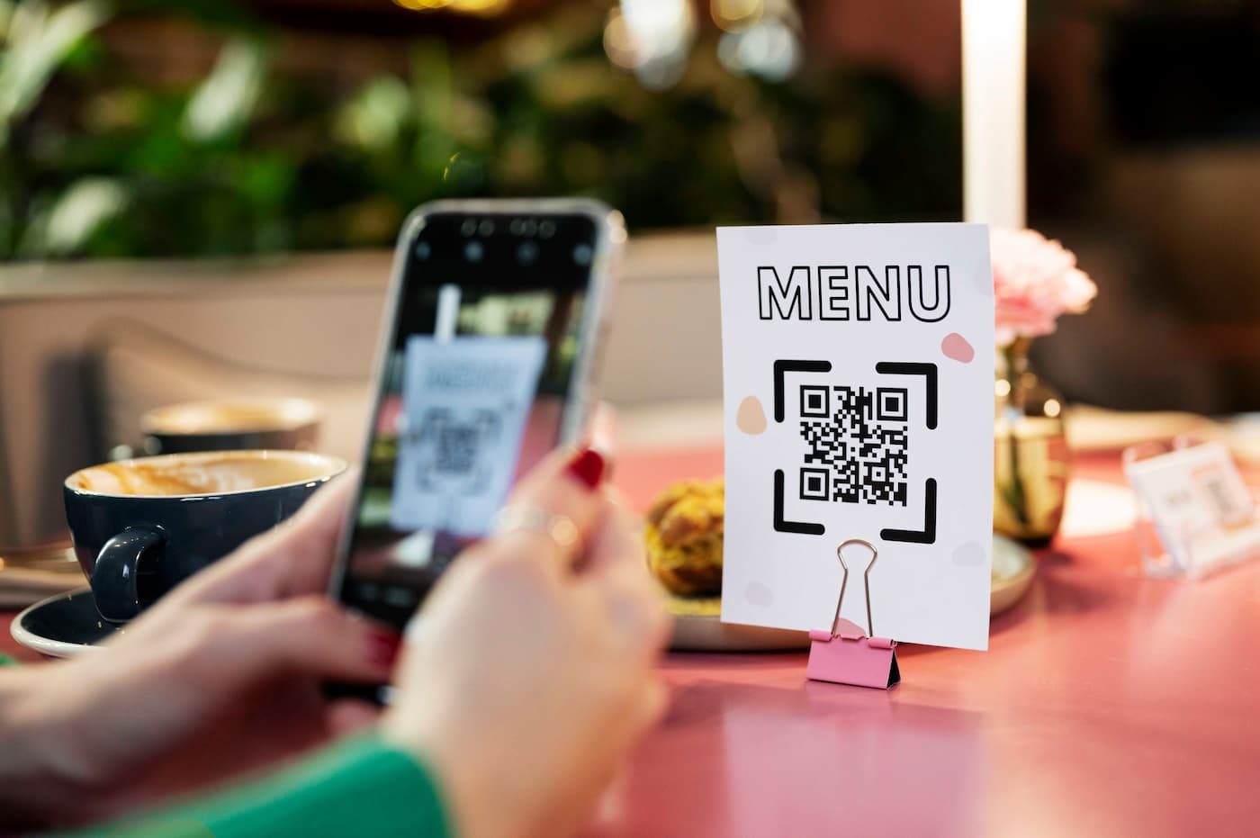

How It Works
- A QR code data contains your POS server’s fixed IP address (default: http://192.168.1.10).
- Customers connected to your local restaurant network (Wi-Fi) can scan the QR code to instantly access the interactive menu.
- If the ordering feature is enabled, they can place orders directly from their device.
- Works 100% offline without an internet connection.

Generating the QR Code
- Use any free QR code generator, such as:
https://www.the-qrcode-generator.com/
- Enter your POS server’s fixed IP address (e.g., http://192.168.1.10).

- Download the generated QR code image.
- Print and place the QR code on:
  - Each dining table
  - Menus
  - Walls or display stands near the entrance

Performance & Network Requirements
- Your Wi-Fi equipment must be able to handle the maximum number of customers expected to connect at the same time. Use commercial-grade access points for busy restaurants.
- Your POS PC should have enough performance (RAM, CPU) to handle multiple simultaneous connections when many customers access the menu at once.
- For food court mode or mall environments, the network architecture may differ. In such cases, our IT support team will work directly with your company’s technical staff to design and implement the proper setup.

Important Notes
- Ensure your POS server’s IP address is static and matches the one in the QR code.
- If the IP changes, you must generate a new QR code.
- The QR menu feature depends entirely on local network stability; internet connection is not required.

Support Policy

Standard Support (Regular License Buyers)
Duration: 6 months of free support from the date of purchase.
✅ Included:
- Installation assistance (if documentation is unclear).
- Bug fixes and troubleshooting related to EatSmartly.
- Answering questions about system features and usage.
X Not Included:
- Menu creation and data entry (this is available as a paid service on request).
- Server/Network setup for clients.
- Training for restaurant staff.
- Windows operating system issues (viruses, crashes, or unrelated dysfunctions).
- Custom feature development or software modifications.
Availability:
- License activation codes are delivered daily (except Fridays) between 08:00 – 20:00 (GMT +1).
- Installation help and bug fix support is available daily (except Fridays) between 18:00 – 22:00 (GMT +1).

Premium Support (Extended License Buyers)
- Availability: 24/7 daily support until the system is stable.
- Priority Handling: Extended License clients receive priority in support requests, ensuring faster response and dedicated assistance.
- Scope: Includes installation help, bug fixing, and technical guidance for deployment in large-scale environments such as food courts or malls.

How to Request Support
- Send your support request via email: s.eatsmartly@gmail.com
- For license activation requests, please refer to section “License Activation” on this document for more details.
- For other requests, please Include your purchase code and company name with clear description of the issue.
- For remote assistance, our team may use AnyDesk (installed automatically during dependencies setup), or any other tool to support you, in that case please send us your remote ID and password.

