
eatSmartly POS – Offline Restaurant Ordering System with QR Digital Menu
v2.3 User Manual –

“This documentation is for the purchased version of eatSmartly. Redistribution without permission is prohibited.”
Table of Contents
1. Introduction 3
2. Login 4
3. Dashboard 5
4. Category Management ……………………………………………………………….....................................7
5. Item Management 11
6. Attributes………………………………………………………………………………………………… ……. 14
8. Expenses Management ……………………………………………………………………………….……….23
9. User Management …………………………………………………………………………….………………..26
10. Cashier – Checkout (Order & Payments) ……………………………………………………………..……27
11. Chef UI …………………………………………………………… …………………………………….…..…29
12. Waiter UI ……………………………………………………………………………………………………….32
13. Settings …………………………………………………………………………………………………………34
14. Backup & Restore ……………………………………………………………………………………………..36
15. Printers Setup & Routing ……………………………………………………………………………………..38
16. QR Digital Menu & Customer Ordering ……………………………………………………………………..42

Introduction
eatSmartly is a restaurant Point of Sale (POS) and digital ordering system designed to simplify daily operations. It helps restaurants manage menus, take customer orders, print receipts, and generate sales reports — all through a clean and intuitive interface.
This user manual will guide you step by step through the main features of eatSmartly, starting from the login process and moving through menu management, order handling, reports, and customer digital menus.
👥 Who Can Use eatSmartly:
Customers: Over an interactive Digital Menu using Qr Code to view, order and track orders.
Administrator (Admin): Full access to system settings, users, and reports.
Cashier: Handles sales, billing, and receipts.
Waiter: Takes customer orders using the POS or digital menu validation.
Chef: Receives kitchen tickets and manages food preparation.

Login 🔑
After installation is complete, you can start using eatsmartly by clicking on the created desktop shortcut or by opening the navigator and visit: http://localhost/eatsmartly. You do not need to run Wamp server each time you use the application, it will start automatically on windows start.
head to login, the login page appears.

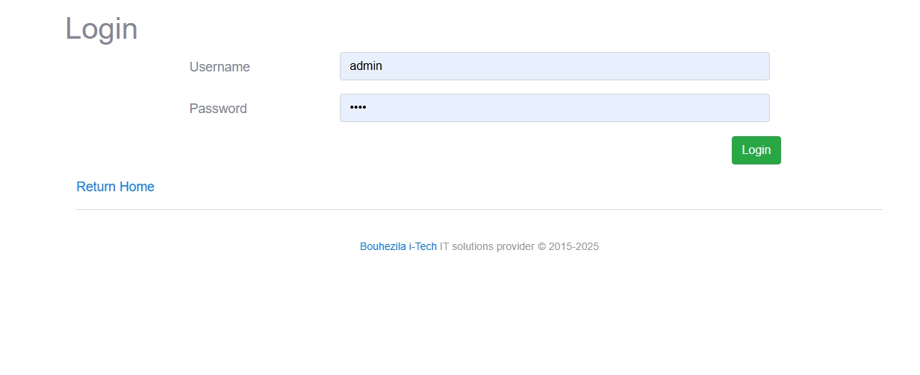
When you first use eatSmartly, an administrator account is already created for you:
- Username: admin
- Password: 1234
Use these credentials to log in for the first time.

Login Attempts & Security
- If the username or password is entered incorrectly 5 times in a row,
the system will automatically block login attempts.
- You will need to wait 2 minutes before trying again.

Important Note
After your first login, the administrator may think about changing the default password (via Settings → Company) to keep the system safe.

ℹ️ Other Predefined Users
eatSmartly also comes with ready-to-use accounts:
- Cashier → Username: cashier / Password: 123
- Waiter → Username: waiter / Password: 123
- Chef (All Categories) → Username: chef-all / Password: 123
  - This special user can view all orders waiting for preparation, without category restrictions.
👉 Once logged in successfully, you will be redirected to the Dashboard.

Dashboard 🖥️
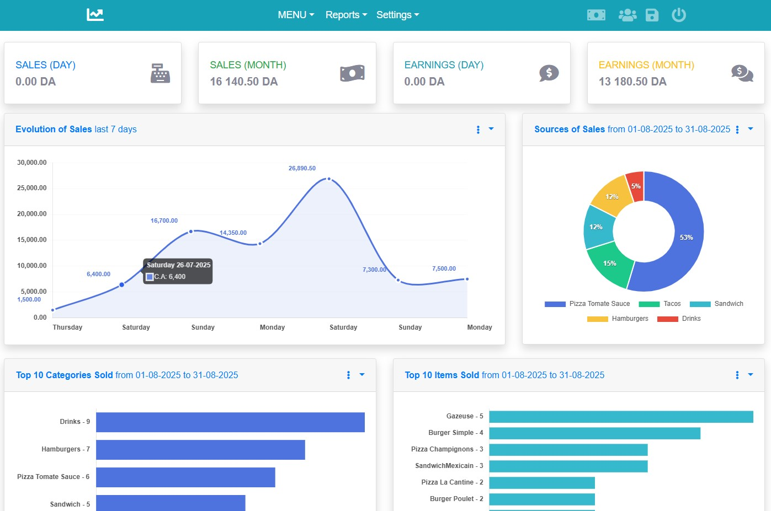
The Dashboard is the first screen you see after logging into eatSmartly.
It provides a real-time overview of your restaurant’s sales and earnings with detailed charts and statistics.

Key Elements on the Dashboard
- Sales & Earnings Summary (Top Panels)
  - Sales (Day / Month): Total amount of sales recorded.
  - Earnings (Day / Month): Net profit calculated after costs.
- Evolution of Sales (Last N Days)
  - N days could be modified as needed
  - Line chart showing daily sales amounts.
  - Helps identify the busiest and slowest days.
- Sources of Sales (Categories)
  - Pie chart displaying sales share by category (e.g., Pizza, Drinks, Tacos).
  - Quickly highlights which categories contribute the most to revenue.
- Top 10 Categories Sold
  - Bar chart listing the most sold categories during a selected period.
- Top 10 Items Sold
  - Bar chart showing the most popular menu items.
- Top Earnings Categories
  - Displays which categories generated the highest revenue.
- Top Earnings Items
  - Shows the items that brought the most profit.

Period Selection
- By default, the Dashboard is set to display the current month’s statistics.
- The manager can change this setting at any time by selecting a custom Start Date and End Date, then clicking Validate.
- All charts and statistics will refresh according to the chosen period.

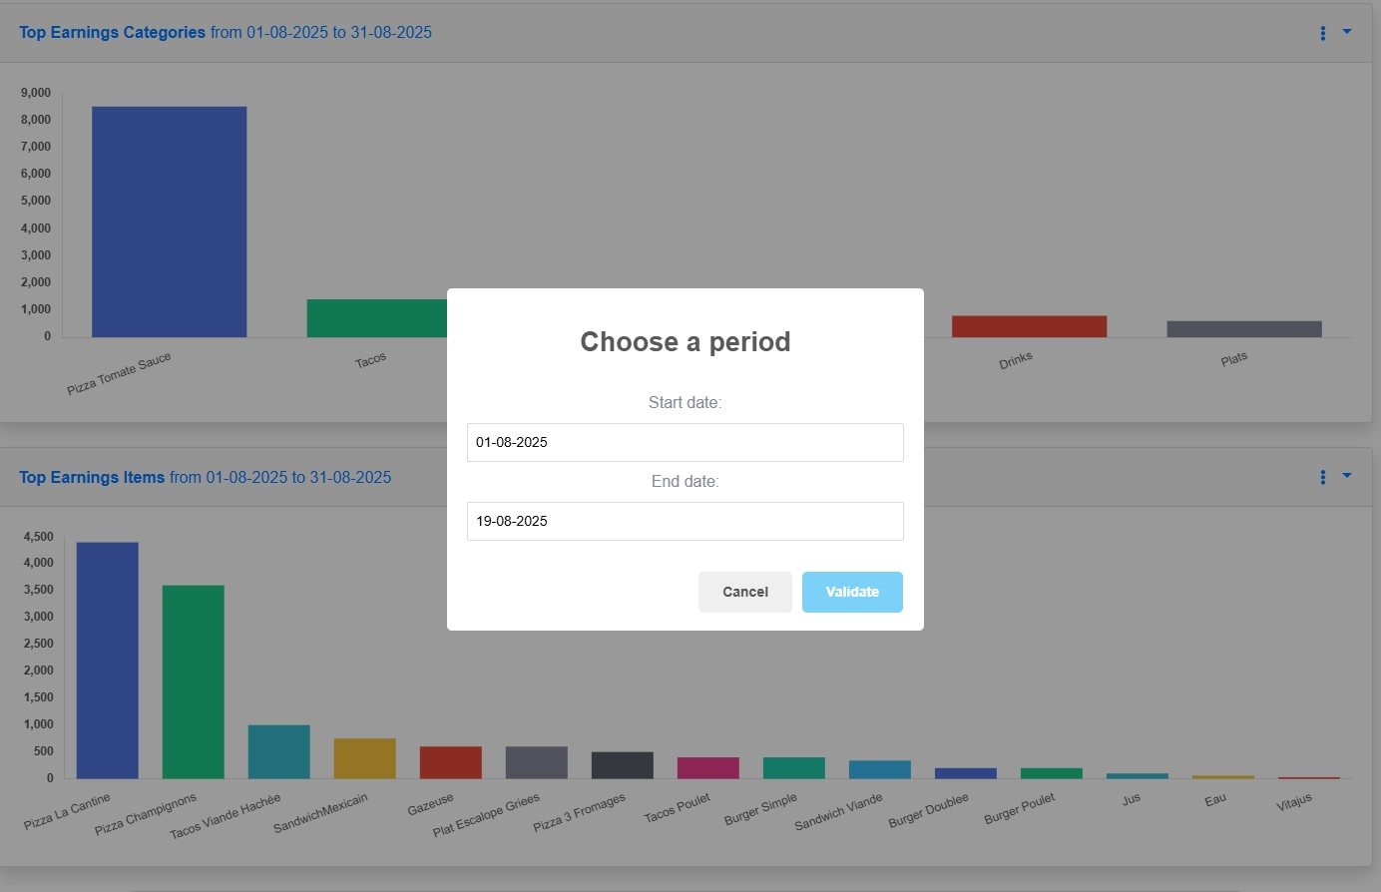

How to Use
- Review the top panels to see today’s and monthly sales/earnings.
- Analyze the charts to monitor customer preferences, top sellers, and revenue sources.
- Adjust your menu, pricing, or promotions based on these insights.
👉 The Dashboard gives managers a clear financial and operational picture of the restaurant, helping them make quick and informed decisions.

Category Management 📂

The Category Management module allows you to organize your restaurant menu into logical groups such as Pizza, Drinks, Sandwiches, Desserts, etc.
This structure makes it easier for both staff and customers to browse the menu and place orders.

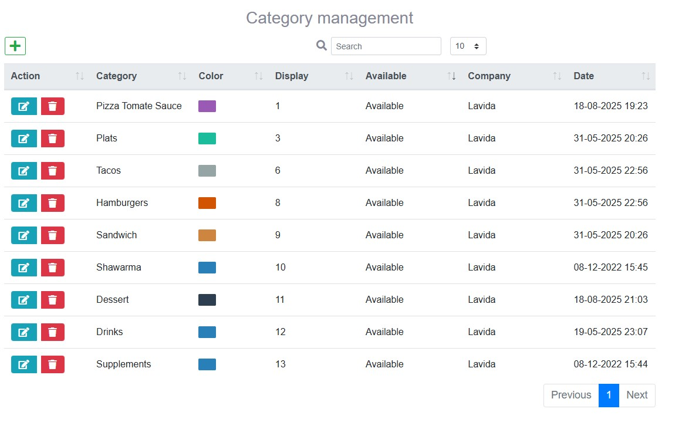

Category List
On the Category Management page, you can see all the categories you have created.
Each category displays:
- Name → the title of the category.
- Color → a color code to identify the category.
- Display Order → defines the sequence in which categories appear.
- Availability → whether the category is active or hidden.
- Company → assigned company (in multi-company setups).
- Date → creation or last update date.

Actions available:
- ✏️ Edit → modify category details.
- 🗑️ Delete → permanently remove a category.
- + Add New Category → create a new one.
- Search Bar & Pagination → quickly find and navigate categories.

Create or Edit Category
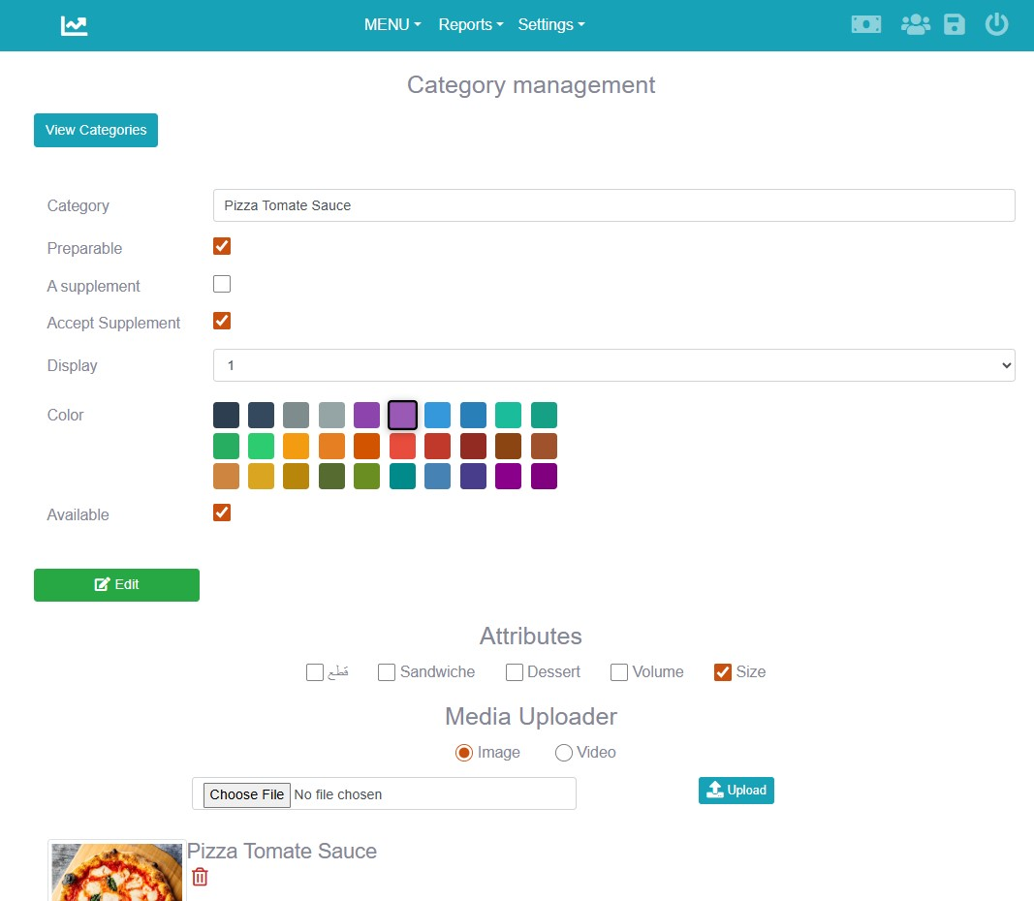

When creating or editing a category, you can define:
- Category Name → e.g., Pizza, Drinks, Sandwiches.
- Preparable → check if the items in this category require kitchen preparation.
- A Supplement → define if this is a supplement category (extra items).
- Accept Supplement → allow or block supplements inside this category.
- Display Order → controls the order in the menu.
- Color →
  - If the restaurant owner does not have images, colors make it easy to visually identify categories.
  - If images are later available, they can replace or complement colors.
- Available → activate or deactivate the category.

Attributes (Important)
Before creating items, the Attributes must be defined (explained later in the Attributes section).
Attributes simplify menu creation and prevent duplication of items.
Example:
Instead of creating 3 different products:
- Pizza Margherita L = 3$
- Pizza Margherita XL = 5$
- Pizza Margherita XXL = 8$
✅ You first create a Category “Pizza” and assign it the attribute Size (L, XL, XXL).
Then you create one item “Pizza Margherita” inside this category and assign the respective prices for each size.
This method saves time and keeps the menu clean.

Image Upload:
- Each category can have only one image.
- Images are especially important if the restaurant activates the Digital Menu feature, because customers browsing from their phone will see the category image.

Example Use
- Pizza → Preparable, Size attribute, category image set.
- Drinks → Not preparable, Volume attribute (e.g., 33cl, 50cl).
- Supplements → Supplement category, can be accepted in other categories (e.g., extra cheese).

🍕 Item Management
The Item Management module is where you create the actual menu products that will be sold under each category (e.g., Pizza Margherita, Burger Simple, Coca-Cola).
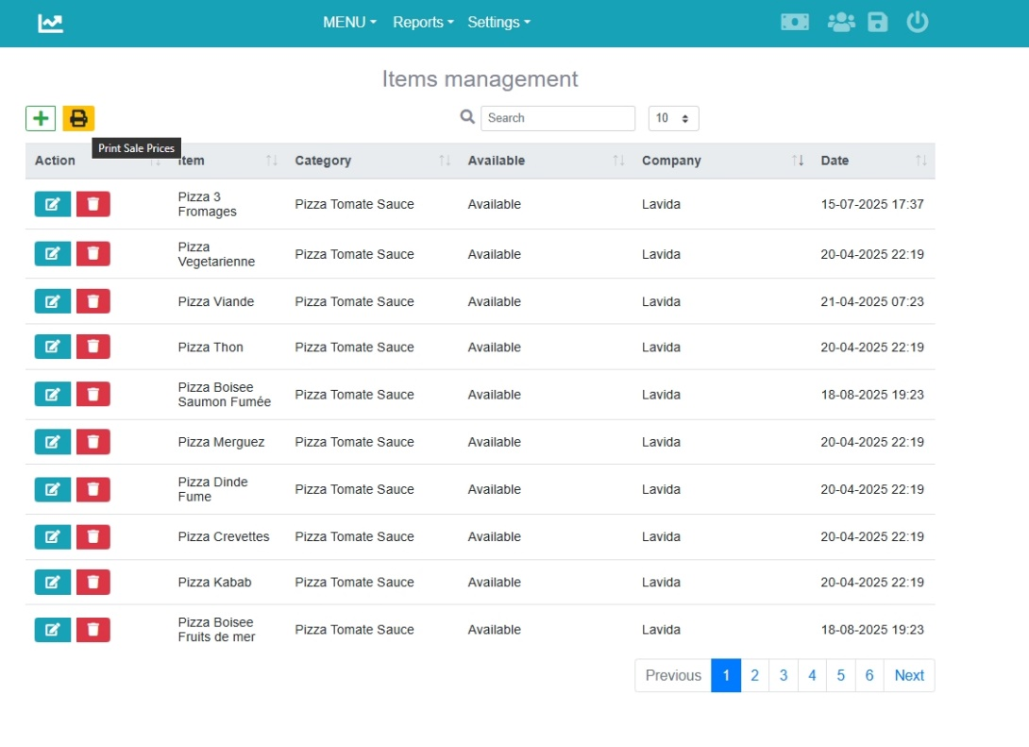

Item List
The Items Management page displays a list of all menu items.
Each row shows:
- Item Name → the product name (e.g., Pizza Thon, Burger Simple).
- Category → which category the item belongs to.
- Availability → whether the item is currently active or not.
- Company → the assigned company (in multi-company setups).
- Date → creation or last update.

Actions available:
- ✏️ Edit → modify item details.
- 🗑️ Delete → remove an item.
- + Add New Item → create a new one.
- 🖨️ Print Sale Prices → print a price list of all items.
- Search & Pagination → quickly find items and navigate multiple pages.

Create or Edit Item
When adding or editing an item, you will see the following fields:
- Item Name → e.g., Burger Simple, Pizza Margherita.
- Description → a short description of the product.
- Base Price → the selling price of the item.
- Cost → the internal cost of the item (useful for profit tracking).
- Category → select the category the item belongs to.
- Available → mark the item as active or inactive.
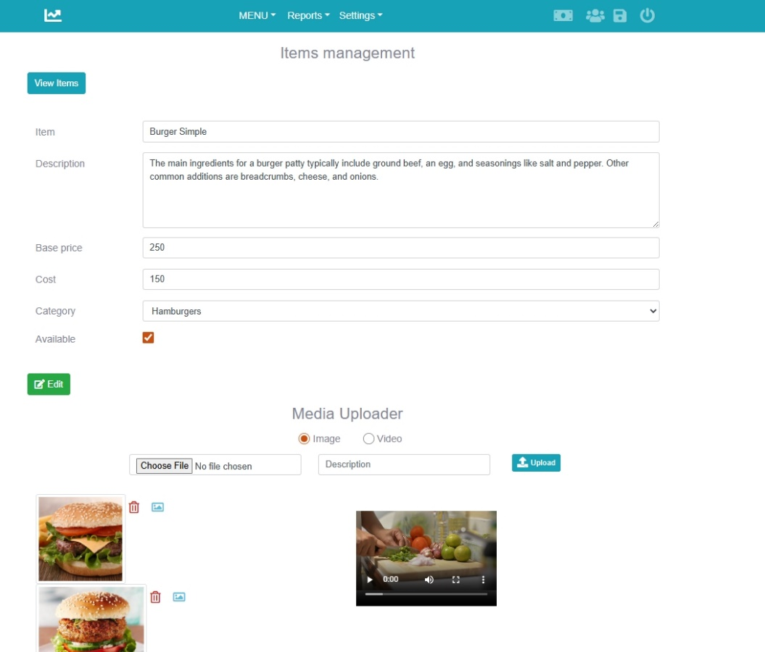

Media Uploader
- You can upload multiple images for each item.
- Images are shown later as a slideshow in the Digital Menu.
- You can choose one image as the cover to represent the item in listings.
- You can also upload videos to better present a dish.
File size & format limits:
- Images: up to 5 MB (.png, .gif, .jpeg, .jpg).
- Videos: up to 40 MB (.mp4).
If no image is uploaded:
- The item will be displayed using the category color selected when creating the category.
- This ensures that even without photos, the Digital Menu and POS remain visually organized.

Attributes & Pricing
If the category of this item has attributes (e.g., Size, Volume), you will assign the prices inside the item for each attribute value.
Example:
- Category: Pizza (with Attribute = Size: L, XL, XXL).
- Item: Pizza Margherita.
- In the item form, you assign:
  - L = 3$
  - XL = 5$
  - XXL = 8$
This way, one item can have multiple prices depending on the attribute.

Example Use
- Burger Simple → belongs to Hamburgers category, base price set.
- Pizza Margherita → belongs to Pizza category, uses Size attribute with multiple prices.
- Coca-Cola → belongs to Drinks category, uses Volume attribute (e.g., 33cl, 50cl).
👉 With items created, your POS and Digital Menu will now display the full menu for staff and customers.

Attributes 🏷️
Attributes define variations for items (such as size, Volume, flavor,…).
They allow you to sell the same product in multiple formats without creating separate items for each variation. They must be created before categories and items
Why Attributes Are Important
- Prevents duplication of items in the menu.
- Makes menu creation faster and easier.
- Keeps order-taking simple and clear for staff.
- Ensures the customer sees consistent product options.

How to Create Attributes
- Go to Menu → Attributes.
- Click Add Attribute.
- Define:
  - Attribute Name → e.g., Size, Volume, Spicy Level.
  - Attribute Values →
    - For Size: L, XL, XXL
    - For Drinks: 33cl, 50cl
- Save the attribute.

Example
Instead of creating three different products:
- Pizza Margherita L = 3$
- Pizza Margherita XL = 5$
- Pizza Margherita XXL = 8$
✅ You first create an Attribute: Size, with values (L, XL, XXL).
✅ Then, you create a Category: Pizza and assign it the Size attribute.
✅ Finally, when creating the item Pizza Margherita, you will set the prices for each size inside the item.
This method saves time and keeps the menu clean.
👉 Attributes must be created before categories and items, since categories can be linked to attributes, and items will later use them to define prices.

Reports 📑

Historical Orders
The Historical Orders report allows you to review all past orders made in the restaurant.
This feature helps managers and staff track sales, verify transactions, and resolve disputes if needed.
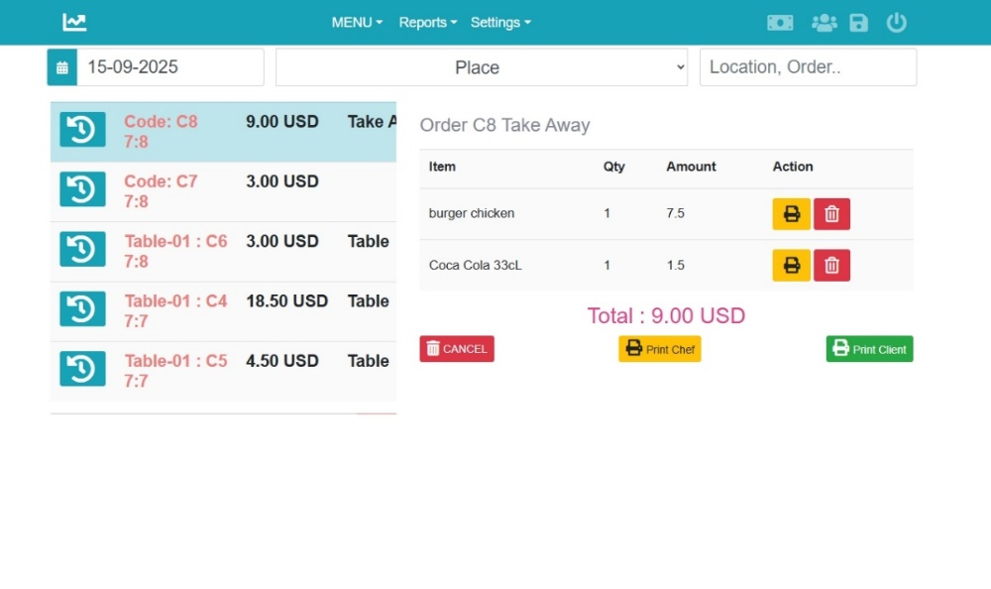

What You See on the Screen
- Order List (left side)
  - Displays all orders of the selected day / place / code.
  - Each order is identified by:
    - Code or Table Number (e.g., Table-01 : C6, Code: C7).
    - Total Amount (e.g., 9.00 USD).
    - Order Type → Table order or Take Away.
- Order Details (right side)
  - Shows all items included in the selected order.
  - For each item you see:
    - Item name (e.g., Burger Chicken, Coca Cola 33cl).
    - Quantity.
    - Amount.
    - Action buttons →
      - 🖨️ Print Chef → reprint the kitchen ticket.
      - 🖨️ Print Client → reprint the customer receipt.
      - 🗑️ Delete Item → (Admin only).
- Filters
  - Date Selector → search the reports by date.
  - Search Field → filter by place, location, or order number.

Actions & Permissions
- Manager / Admin
  - Can view all orders.
  - Can remove items from an order.
  - Can cancel an entire order.
  - Can reprint tickets (chef or client).

Example Use
- A Manager/Admin wants to check all orders from 15-09-2025 → they select the date and the list appears.

👉 Historical Orders ensure full control over past activity, with clear restrictions based on user roles.

Income vs Expense Report
The Income vs Expense Report shows all money that came in (sales) and all money that went out (expenses) during a selected period.
It provides the manager with a global view of the restaurant’s performance and general earnings.

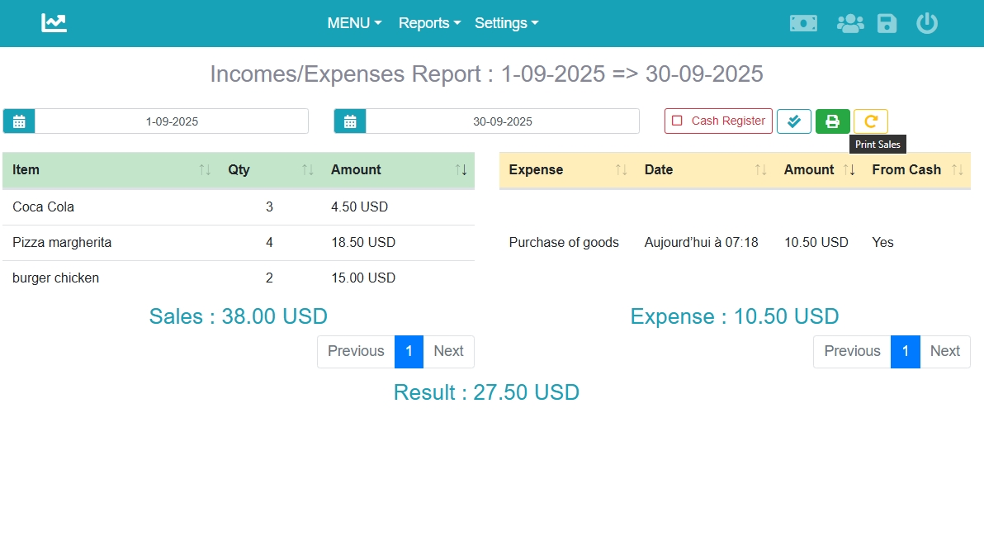

What You See on the Screen
- Date Range Selector
  - By default, the report displays the current month’s data.
  - The admin can change this by selecting a Start Date and End Date.
- Sales Section (left side)
  - Lists all items sold within the selected period.
  - Columns include:
    - Item Name (e.g., Coca Cola, Pizza Margherita).
    - Quantity sold.
    - Amount (total sales value for that item).
  - Total Sales → displayed at the bottom (e.g., 38.00 USD).
  - Print Option → sales are printed directly on the default cashier receipt printer (80 mm).
- Expenses Section (right side)
  - Lists all expenses recorded during the same period.
  - Columns include:
    - Expense Name (e.g., Purchase of goods).
    - Date.
    - Amount spent.
    - From Cash → indicates if the expense was taken directly from the cashbox.
  - Total Expenses → displayed at the bottom (e.g., 10.50 USD).
- Result
  - The difference between Sales (in) and Expenses (out).
  - Example: Result = 27.50 USD.
  - This gives the manager a global performance indicator for the restaurant.
- Cash Register Option
  - By clicking Cash Register, the system generates the actual cashbox amount for the current day.
  - This helps verify that the recorded data matches the physical cash in the register.

Who Can Access
- Admin only →
  - Can view sales, expenses, and result.
  - Can print the report.
  - Can check the real cashbox balance.
- ❌ Cashier and Chef cannot access this report.

Example Use
- The Admin opens the report → by default, they see the current month’s data.
- The report shows:
  - Sales = 38.00 USD
  - Expenses = 10.50 USD
  - Result = 27.50 USD
- The admin clicks Cash Register → the system calculates and displays the real amount in the cashbox for today.
- They can also print the sales part on the cashier receipt printer (80 mm).
👉 This report gives the Admin a clear picture of money in vs. money out, plus a direct control of the cashbox status.

Sales by Category Report
The Sales by Category Report shows how much each category and its items contributed to the restaurant’s sales over a selected period. It helps the manager understand which categories perform best, which items inside them generate the most revenue, and how sales are distributed across attribute values (e.g., sizes, volumes).

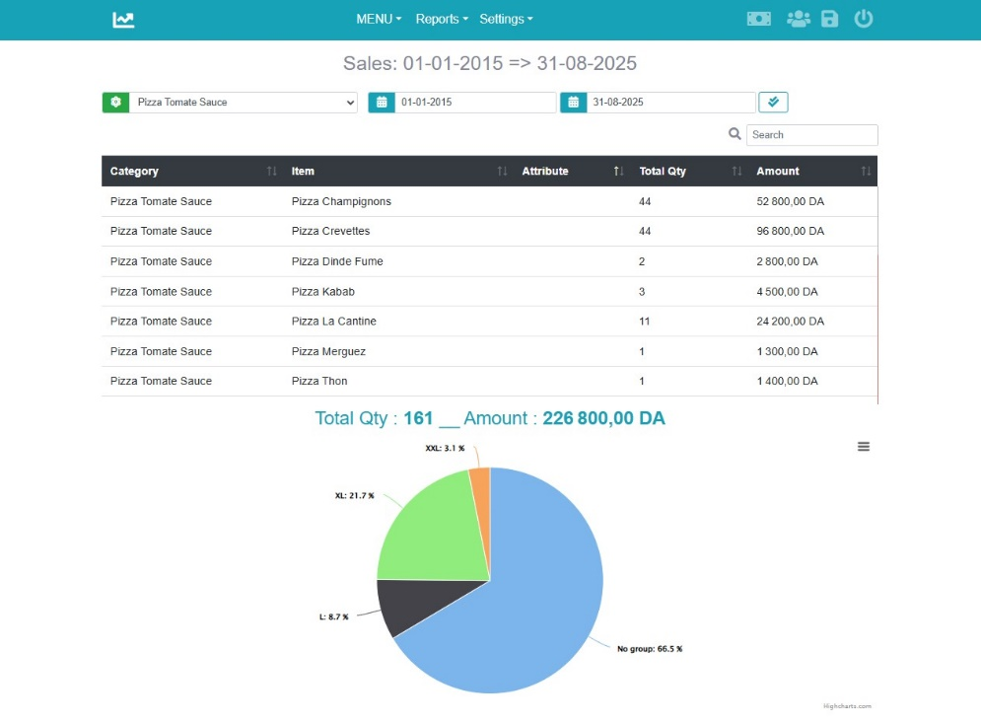

What You See on the Screen
- Date Range Selector
  - Select a Start Date and End Date to generate the report.
- Category & Item Breakdown (table view)
  - Category → the menu section (e.g., Pizza Tomate Sauce).
  - Item → the product sold (e.g., Pizza Champignons, Pizza Crevettes).
  - Attribute → the variation linked to the item (e.g., L, XL, XXL).
  - Total Qty → total number of items sold.
  - Amount → total sales value for that item.
- Totals (bottom of the table)
  - Total Quantity sold during the selected period.
  - Total Amount of sales (e.g., 226,800.00 DA).
- Pie Chart (visual view)
  - Displays the percentage distribution of sales across attribute values.
  - Example:
    - XL: 21.7%
    - L: 8.7%
    - XXL: 3.1%
    - No group (items without attributes): 66.5%

How to Use This Report
- Select which category you want to analyse.
- Check which items are the most popular inside each category.
- Analyze attribute distribution (e.g., which pizza sizes are most demanded).

Who Can Access
- Admin only → has full access to view and analyze sales by category and attribute.

Example Use
- The manager generates a report of the category “Pizza” for 01-01-2024 to 31-08-2025.
- They see that:
  - Pizza Crevettes and Pizza Champignons are top sellers in the Pizza category.
  - XL pizzas sell much more than L or XXL.
  - Total sales for the Pizza category = 226,800.00 DA with 161 items sold.
👉 This report helps the manager make informed decisions about menu adjustments, portion sizes, and promotions based on real sales data.

Earnings Report
The Earnings Report provides a detailed view of sales, costs, and profits within a selected date range.
It helps the admin track not just sales amounts but also real earnings after deducting item costs.
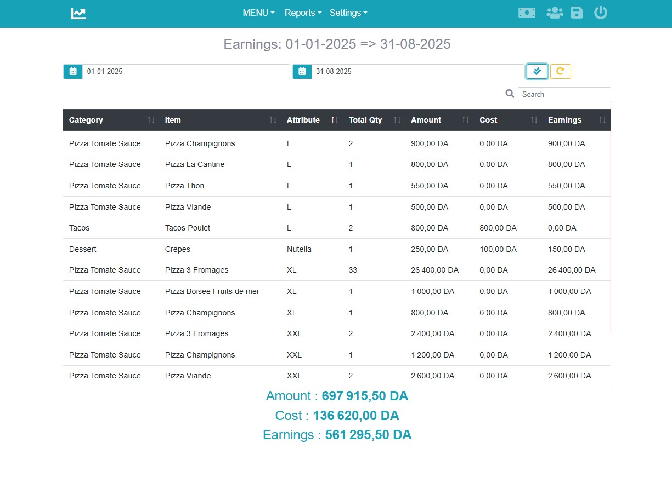

What You See on the Screen
- Date Range Selector
  - Choose a Start Date and End Date to generate the report.
- Earnings Breakdown (table view)
  - Category → the menu section (e.g., Pizza, Drinks, Burger).
  - Item → the product sold (e.g., Burger Chicken, Coca Cola, Pizza Margherita).
  - Attribute → if the item has variations (e.g., 1L, 33cl, L, XXL).
  - Total Qty → quantity sold in the period.
  - Amount → total sales revenue from the item.
  - Cost → total cost of the item (defined when creating the item).
  - Earnings → net profit = Sales Amount – Cost.
- Totals (bottom of the report)
  - Amount → total revenue from sales.
  - Cost → total cost of all sold items.
  - Earnings → overall profit for the selected period.

How to Use This Report
- Analyze which items generate the highest profit.
- Compare sales vs. costs to evaluate profitability.
- Identify low-margin items that may need price adjustment.
- Measure the restaurant’s overall earnings across categories and attributes.

Who Can Access
- Admin only → has full access to view and analyze earnings.
- ❌ Cashier and Chef cannot access this report.

Example Use
- The admin generates the report for 01-09-2025 to 30-09-2025.
- They see:
  - Total Sales Amount = 38.00 USD
  - Total Cost = 17.75 USD
  - Total Earnings (Profit) = 20.25 USD
- They notice that Burger Chicken brings the highest margin, while Coca Cola 33cl has a smaller profit margin.
👉 The Earnings Report is essential for monitoring profitability, adjusting menu prices, and making strategic business decisions.

Expenses Management
The Expenses Report allows the admin to track all money spent by the restaurant, whether for goods, staff, or other operating costs. It helps maintain financial control and ensures that all outgoing cash is recorded.
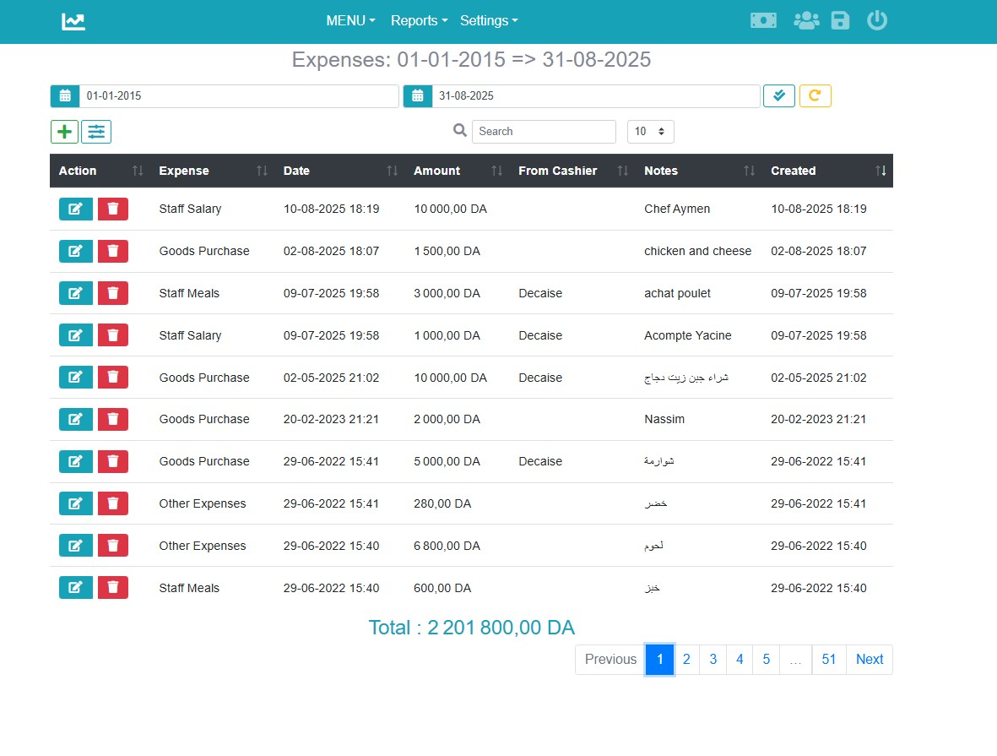

Expenses List
The Expenses Report page displays all recorded expenses for a selected period.
Each row shows:
- Expense Type → (e.g., Staff Salary, Goods Purchase, Staff Meals, Other).
  - 📌 Expense Types are defined in Settings first, then used when creating expenses.
- Date → when the expense was made.
- Amount → value of the expense.
- From Cashier → indicates whether the expense was taken directly from the cashier’s cashbox.
- Notes / Observation → details or comments about the expense (e.g., chicken and cheese, advance payment).
- Created → who or when the entry was created.

Actions available:
- ✏️ Edit → modify expense details.
- 🗑️ Delete → remove an expense.
- + Add Expense → create a new expense record.
- Search & Pagination → quickly filter and browse large lists.
Total Expenses → displayed at the bottom (e.g., 2,201,800.00 DA).

🛠️ Create or Edit Expense
When adding or editing an expense, you can define:
- Expense Type → choose from the types defined in Settings (e.g., Purchase of Goods, Staff Meals, Salary).
- Date → the date the expense was made.
- Amount → the value of the expense.
- Observation → short note to describe the expense (e.g., Buy cheese).
- From Cashier → check this option if the amount was directly taken from the cashier’s cashbox.

How It Works
- Expense Types must be set up in Settings → Expense Types before recording expenses.
- All expenses entered here will appear in Income vs Expense reports, impacting the result and cashbox balance.
- Expenses not marked From Cashier are considered external payments, not deducted directly from the register.

Who Can Access
- Admin only → has full rights to add, edit, and delete expenses.

Example Use
- The admin enters an expense:
  - Type = Purchase of goods (defined in Settings).
  - Date = 15-09-2025.
  - Amount = 10.5 USD.
  - Observation = Buy cheese.
  - From Cashier = ✅.
This expense will then reduce the day’s cashbox balance accordingly.
👉 The Expenses section ensures that every outflow of money is tracked and matched against sales, giving the manager full financial visibility.

👤 User Management
The User Management module allows the admin to create, edit, and organize all system users.
Each user has a role (Cashier, Waiter, Chef, Admin) that defines their access and responsibilities.
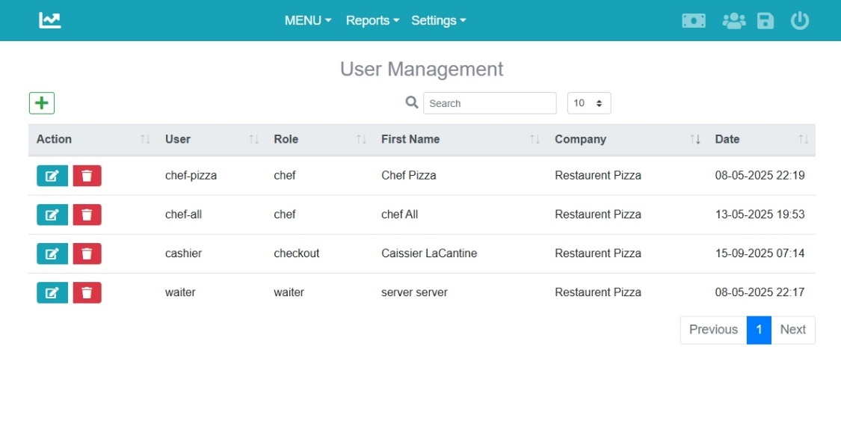

How It Works
- Username & Password → used for login.
- First/Last Name → helps identify the staff member.
- Role → determines the user’s permissions and interface.
- Printer → defines where the user’s tickets/receipts are printed.
- Categories (for Chefs only) → define which food categories each chef prepares.

Chef Role (Special Case)
- Chefs must be assigned categories (e.g., Pizza, Burger).
- When a customer orders items, the system groups them based on these categories.
- The assigned chef receives a kitchen ticket containing only the items from their categories.

Printers and Routing – Four Cases
The way printers are used in the restaurant depends on the size and workflow.
There are four common configurations:
- Case 0 → One printer for the entire restaurant (receipts + kitchen tickets).
- Case 1 → One chef handles all categories (separate cashier + kitchen printers).
- Case 2 → Multiple chefs, multiple logical printers but only one physical printer.
- Case 3 → Multiple chefs, each with their own physical printer.
👉 Details, examples, and setup tables for each case are explained in the :
Printers Setup & Routing Section.

Cashier – Checkout (Order & Payments) 💳
The Checkout screen allows the cashier to create orders, manage payments, and interact with customers efficiently.

🔑 Default Cashier User
- By default, the system creates a Cashier account: Username: cashier Password: 123
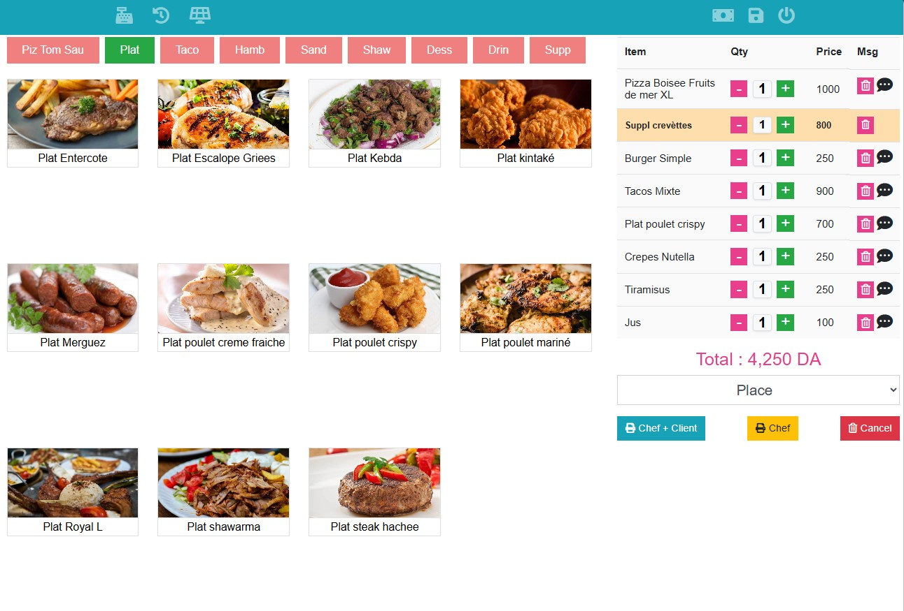

Top Navbar (left → right)
- Payments panel → access daily payment screen to confirm/collect payments.
- Today’s history → view all orders created today; reprint or delete non-paid orders.
- New order → open the checkout panel (current screen).
- Expenses → add daily expenses taken from the cashbox (registered immediately in reports).
- Backups → perform menu & database backups to keep system data safe.

Order Creation Flow
- Select Category
  - Categories are displayed as tabs at the top for quick access.
- Select Items
  - Items are shown with name and photo (if uploaded in Items).
  - Each selected item is added to the order cart (right panel).
- Modify Cart
  - Increase/decrease item quantity.
  - Remove items if needed.
  - Add a custom note for chefs (e.g., “less salt”).
  - Total updates automatically.
- Select Place (optional)
  - Dropdown to choose dining table or takeaway.
- Validate Order
  - Chef + Client (blue) → validate order, send to kitchen, take payment immediately, print receipt.
  - Chef (yellow) → validate order, send to kitchen, collect payment later from Payments panel.
  - Cancel (red) → clear the current order.

Workflow Examples
- Pay-first workflow → Add items → click Chef + Client → customer pays now → receipt + kitchen ticket printed.
- Pay-later workflow → Add items → click Chef → kitchen ticket printed → later, cashier goes to Payments panel to collect payment + print receipt.

Chef UI 👨‍🍳
The Chef Interface is designed for kitchen staff to receive and process orders quickly and clearly.
Each chef sees only the categories assigned to them in User Management (e.g., Pizza, Burger, Drinks).
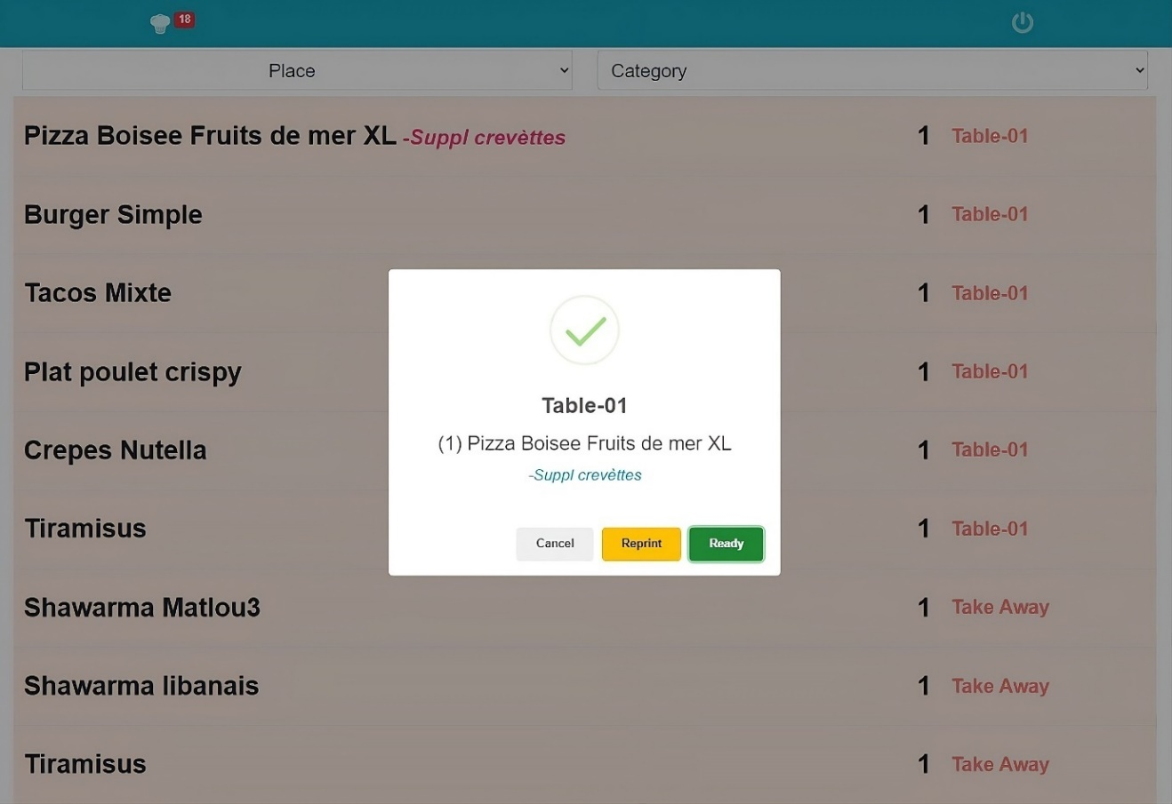

Orders Queue
- Incoming orders appear in a live list.
- Each line shows:
  - Item name (+ variations or extra notes).
  - Quantity.
  - Table number or Take Away.
- The interface is auto-refreshed every 15 seconds to keep the list up to date.
- At the top, chefs also see a notification badge showing the total number of pending items to prepare.
- Chefs can also search or filter orders by:
  - Place → e.g., Table-01, Take Away.
  - Category → e.g., Pizza, Drinks.

Example:
- Pizza Boisee Fruits de mer XL – Suppl crevettes → 1 unit → Table-01.
- Shawarma libanais → 1 unit → Take Away.

Actions per Order
When a chef clicks an item line, they can:
- Reprint → Print the ticket again (in case the original was lost/damaged).
- Ready → Confirm the item is prepared.

Real-Time Updates
- When the chef clicks Ready, the order status is updated in real-time:
  - Waiters see that the item is ready for serving.
  - If a TV screen or digital display is configured, the order status also appears there (for staff or customers).

Default “chef-all” User
- By default, the system provides a chef-all account.
- This user can see all categories (not restricted to one).
- It is typically used for:
  - A Chef Helper role who manages incoming orders.
  - A manager who wants one central view of all items.
  - Organizing and validating orders after preparation.

Example Workflow
- Order arrives → Customer orders Pizza + Burger.
- Routing → The system splits ticket items by category:
  - Pizza Ticket goes to the Pizza Chef UI.
  - Burger ticket goes to the Burger Chef UI.
- Chef actions:
  - Pizza Chef clicks Ready after cooking → Waiter notified.
  - Burger Chef reprints ticket (if needed) → then marks it Ready.
- Chef-all helper: Can monitor the whole queue, coordinate preparation, and validate items once confirmed

🍽️ Waiter UI
The Waiter Interface is designed to help waiters manage customer orders efficiently, especially in restaurants where the Digital Menu feature is enabled.

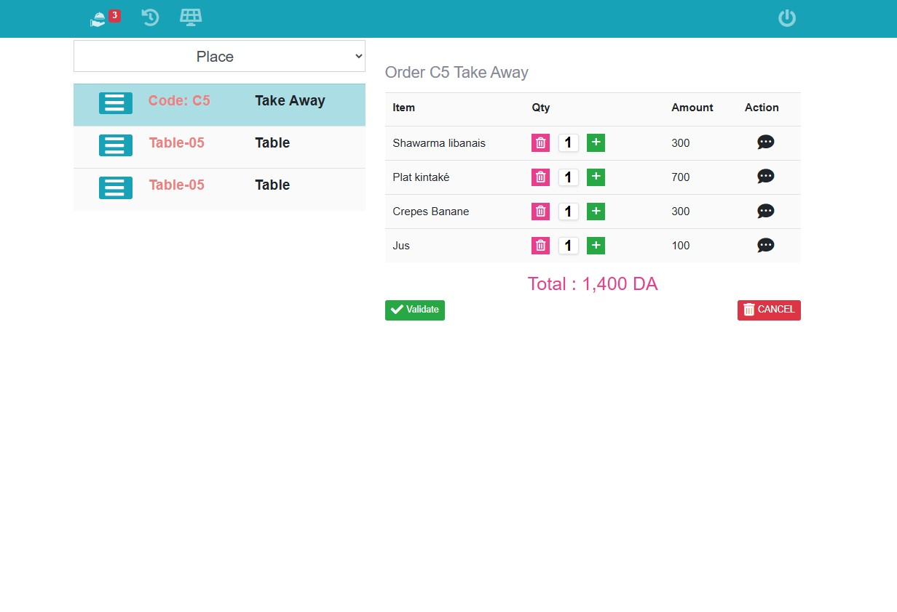

Order Validation
- When customers place orders through the Digital Menu, they appear first in the Waiter UI as pending.
- The waiter reviews the order and must validate it before it is sent to the kitchen.
- This ensures the waiter can:
  - Check availability of items.
  - Adjust or confirm quantities.
  - Add notes if needed.
👉 Once validated, the kitchen tickets are routed to the appropriate chefs.

Non-Preparable Items Panel
- Some items (like drinks, desserts, or pre-prepared products) don’t go to the kitchen.
- The Waiter UI has a dedicated panel (second icon from left) that shows these non-preparable items with a counter badge.
- This helps waiters remember what must be delivered directly to the customer.
Example:
If a customer orders Pizza + Drink:
- Pizza → goes to the kitchen ticket (Chef).
- Drink → appears in the Waiter’s non-preparable panel, so the waiter can deliver it directly.

Extra Capabilities
- The waiter can also access the Order Panel, similar to the cashier, to:
  - Create orders for customers at tables.
  - Manage order quantities.
  - Add notes to items.
  - Validate and send them to the kitchen.

Example Workflow
- Customer orders using Digital Menu: Pizza Margherita + Cola.
- Waiter validates the order in the Waiter UI.
- System sends Pizza to the Chef UI (kitchen ticket).
- Cola appears in Waiter’s non-preparable panel → waiter delivers it directly.
- Once food is ready, waiter serves it and collects the non-preparable items together.

Settings ⚙️
The Settings module allows the administrator to configure all essential parts of the system, adapting eatSmartly to the restaurant’s workflow.

Expense Types Management
- Create and manage different expense categories (e.g., Purchase of goods, Salaries, Shop expenses).
- These types are used later when the Cashier records daily expenses from the cashbox.
- Helps the manager track where money is being spent.

Table Management
- Create and organize all restaurant tables with unique codes (e.g., Table-01, Table-05).
- Codes are automatically linked to orders for easy identification.
- Supports dine-in orders (assigned to tables) and Take Away codes (generated for pickup orders).
- Each Table Code is a 4-digit code, used when customers order from the Digital Menu (if enabled).
- This code must be stuck on the table itself or near the QR code, ensuring that everyone seated at the table orders only for their table.

Printer Management
- Add and configure printers for Cashier receipts and Chef tickets.
- Supported protocols: ESC (80mm receipt printers).
- Printers can be connected via USB or Network (IP/Port).
- Includes a “Test Printers connection” button to verify setup.
- Printers are later assigned to users (cashier/waiter/chef) in User Management.

Pizza Variants Generator (1/2 and 1/4)
- Special feature developed for the a local market.
- Automatically generates Half (1/2) and Quarter (1/4) variants for pizzas.
- Requirements for proper setup:
  - Pizza categories must start with “Pizza”.
  - Items must be named Pizza + Item Name (e.g., Pizza Margherita).
  - An item like “Pizza aux choix” is required for the custom order option.
  - Categories (1/2_Pizza) and (1/4_Pizza) must be created as supplements.
- Buttons:
  - Generate → Auto-create 1/2 or 1/4 variants.
  - Delete → Remove these variants if not needed.

Company Settings
- Define global restaurant information:
  - Company name, description, address, contact info, GPS location.
  - Admin account can also be updated here (username, password, email).
- Take Away Code: only one unique code is used when customers order from the Digital Menu.
  - Prevents random/uncontrolled orders.
  - Ensures takeaway orders are clearly identified.
- Logo and Cover Upload:
  - The manager can upload their logo and cover image.
  - These are displayed in the QR Digital Menu, reinforcing restaurant branding.
- Company Options:
  - Enable/disable Chef tickets and Client receipts.
  - Option to print receipts in Arabic.
  - Define currency and system language.
  - Set the base folder for automatic backups.
✅ With these tools, the admin can fully control financial tracking, tables, printing setup, menu variations, and company identity, ensuring eatSmartly adapts to any type of restaurant.

Backup & Restore 💾
The Backup & Restore module ensures that your restaurant data is protected against loss or corruption.

Backup
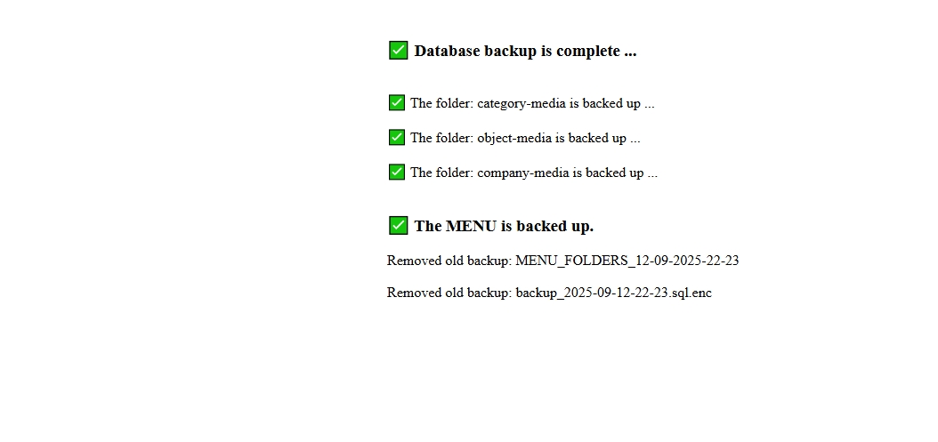
- Backups can be triggered manually by the Cashier or the Admin.
- Each backup includes:
  - Database (encrypted for security).
  - Menu-related files (company-media, category-media, object-media).
- Encryption prevents anyone from tampering with the database file.

- We recommend:
  - Running a backup every evening when the restaurant closes.
  - Storing backups on an external/removable drive, or at least in a folder separate from the OS partition (e.g., D:/backup on Windows 10).
  - This ensures data is safe even if the operating system crashes.
📌 Example:
At the end of the day, the cashier clicks Backup. The system saves:
- Encrypted database file.
- Media folders (menu images, company logo, product photos).

Restore
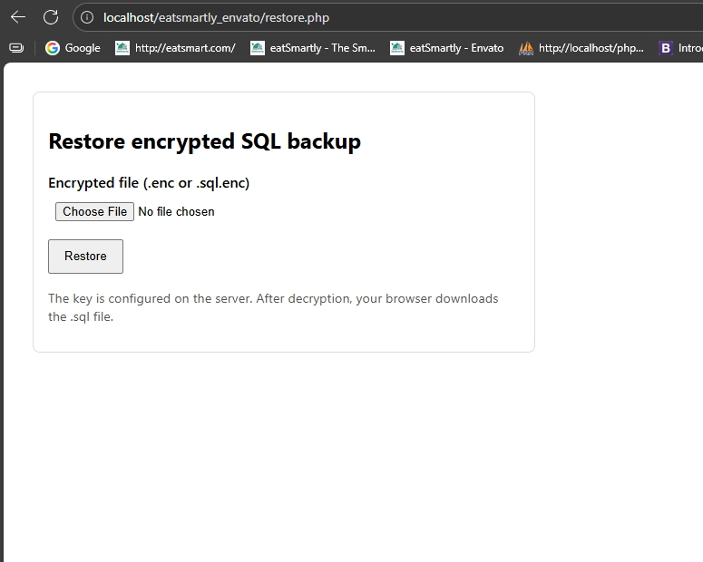
In case of data loss or corruption, the system can be restored:
- Go to: http://localhost/eatsmartly/restore.php
- Upload the encrypted database file (.enc or .sql.enc).
- The system decrypts and returns a .sql file.
- Import the .sql file back into phpMyAdmin to restore the database.
- Copy the media folders (company-media, category-media, object-media) back into the root eatsmartly application folder.
⚠️ Important Notes
- Restore requires some MySQL knowledge and basic technical skills.
- Always keep your encryption key safe (it is configured on the server).
- Without proper backups, restaurant orders, menus, and company data could be permanently lost.

✅ With this feature, eatSmartly ensures that your restaurant can always recover quickly after a crash or failure.

Printers Setup & Routing 🖨️
Printers in eatSmartly are flexible and can be configured depending on the restaurant size.
They determine how receipts (for customers) and kitchen tickets (for chefs) are printed.
- Cashier Printer → always prints client receipts.
- Waiter Role → shares the same printer as cashier.
- Chef Printers → print kitchen tickets, based on the categories assigned to each chef.
For clear use cases scenarios , please refer to eatSmartly installation document in section: “Use case Scenarios (Detailed)”

Printer Routing Cases
There are four main printer routing configurations:
Case 0 – One Printer for the Entire Restaurant
- All receipts and kitchen tickets are printed on the Cashier printer.
- Best for small cafés or snack shops.

User | Role | Categories | Printer (Logical) | Physical Output
Cashier | Checkout | – | Cashier_Printer | Client receipts + all kitchen tickets
Waiter | Waiter | – | Cashier_Printer | Same as cashier
Chef | Chef | All categories | Cashier_Printer | Kitchen tickets here too

👉 Result: One physical printer handles everything.

Case 1 – One Chef Handles All Categories
- A single chef is assigned all categories.
- Kitchen tickets go to one kitchen printer, while receipts still print on the cashier printer.

User | Role | Categories | Printer (Logical) | Physical Output
Cashier | Checkout | – | Cashier_Printer | Client receipts
Waiter | Waiter | – | Cashier_Printer | Same as cashier
Chef | Chef | All categories | Kitchen_Printer | One ticket with all items

👉 Result: One kitchen ticket for all items, plus separate receipts.

Case 2 – Multiple Chefs, Multiple Logical Printers (One Physical Printer)
- Create multiple logical printers (Pizza, Burger, Drinks).
- All logical printers are mapped to the same physical device.
- Each chef gets their own ticket, but all come out of one printer.

User | Role | Categories | Printer (Logical) | Physical Output
Cashier | Checkout | – | Cashier_Printer | Client receipts
Waiter | Waiter | – | Cashier_Printer | Same as cashier
Chef 1 | Chef | Pizza | Kitchen_Pizza | Pizza ticket
Chef 2 | Chef | Burger | Kitchen_Burger | Burger ticket
Chef 3 | Chef | Drinks | Kitchen_Drinks | Drinks ticket

👉 Result: All tickets are separated by category, but printed on one physical printer.

Case 3 – Multiple Chefs, Multiple Physical Printers
- Each chef has their own physical printer at their station.
- Kitchen tickets are routed directly to the right printer.

User | Role | Categories | Printer (Physical) | Physical Output
Cashier | Checkout | – | Cashier_Printer | Client receipts
Waiter | Waiter | – | Cashier_Printer | Same as cashier
Chef 1 | Chef | Pizza | Printer_Pizza | Ticket at Pizza station
Chef 2 | Chef | Burger | Printer_Burger | Ticket at Burger station
Chef 3 | Chef | Drinks | Printer_Drinks | Ticket at Drinks station

👉 Result: Each chef has their ticket printed directly at their workstation.
✅ With these 4 cases, you can manage anything from a small café with 1 printer to a large restaurant with dedicated printers per station.

Printer Receipt and kitchen Tickets examples

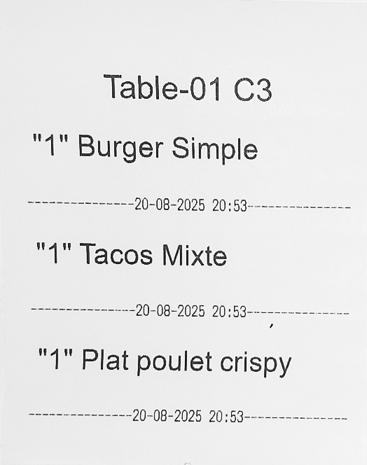
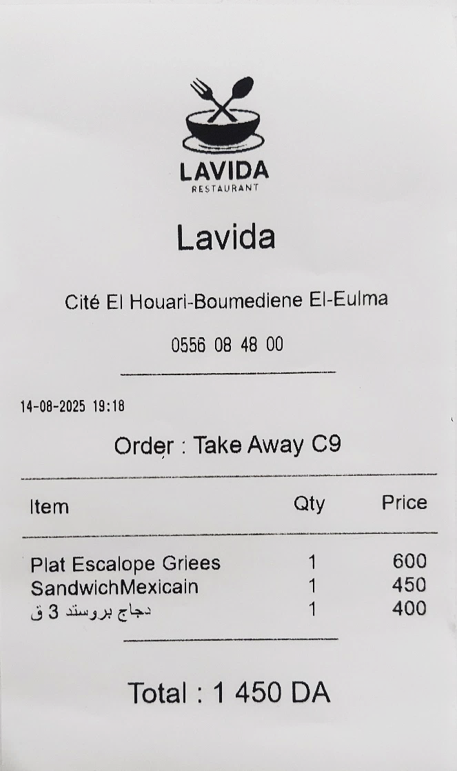

Figure 1 Kitchen ticket example -Chef prepare multi-Categories
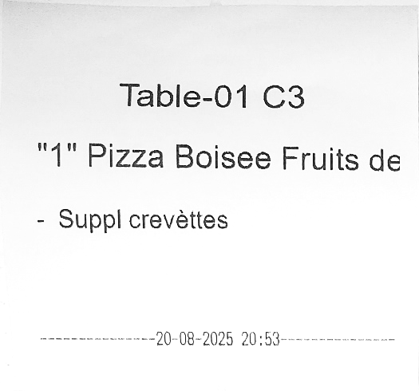

Figure 2 : Client Receipt example
Figure 3 Kitchen Ticket example -Chef Pizza

QR Digital Menu & Customer Ordering 📱
The QR Digital Menu allows customers to browse the restaurant menu and place orders directly from their own devices or from in-house terminals.
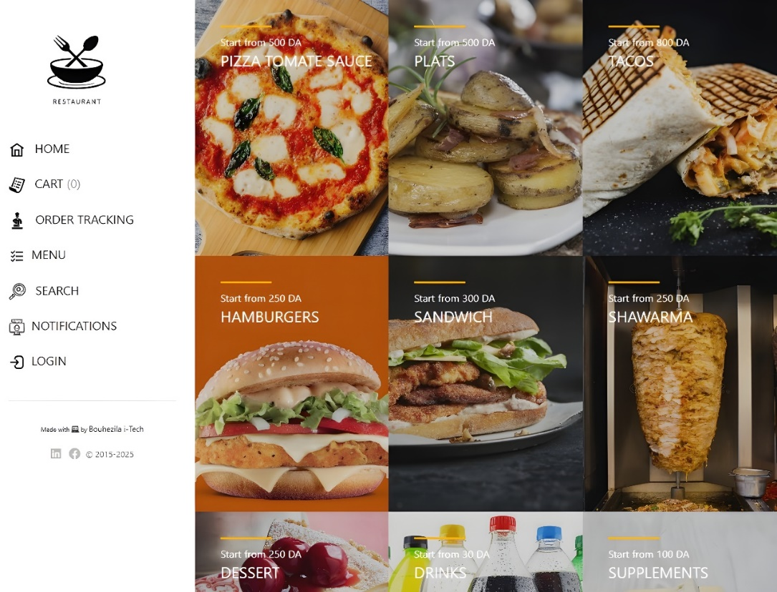

Setup
- The setup of the QR Digital Menu is detailed in the eatSmartly Installation Document.
- In short, it requires:
  - Enabling the Digital Menu feature.
  - Connecting customer devices to the restaurant’s wireless LAN.
  - Printing and displaying Table Codes (4-digit) on each table or near the QR code.
  - Configuring the Take Away Code in Company Settings.

Getting Started
- Customers must first connect to the restaurant’s wireless LAN.
- They can then scan the QR code displayed on their table.
- Alternatively, the restaurant may provide touchscreen stands or tablets for ordering.

Ordering Steps
Step 1 – Home Page
- After scanning, the customer sees the restaurant homepage with categories and quick access to:
  - Home, Cart, Order Tracking, Menu, Search, Notifications, Login.
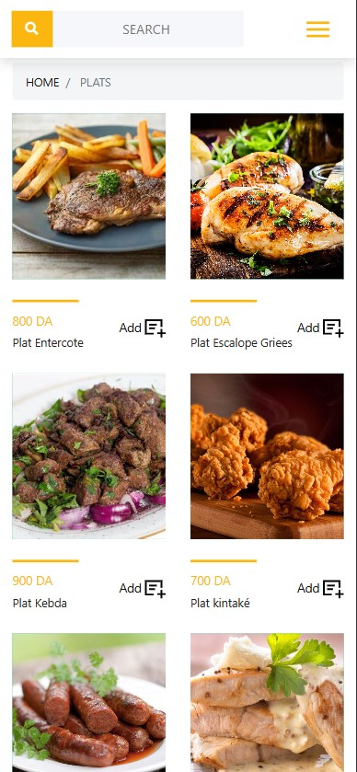
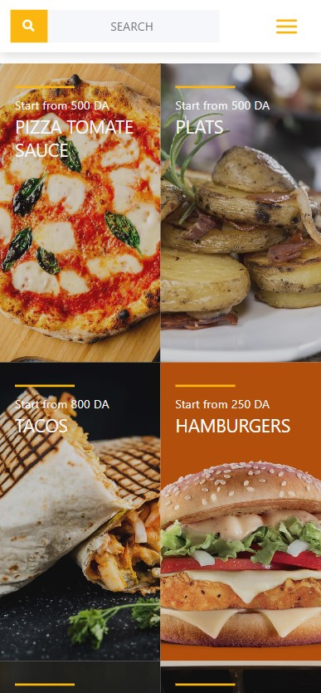
Step 2 – Browse Categories
- Categories are listed in a clean grid or sidebar (e.g., Pizza, Plats, Tacos, Shawarma, Drinks).
- Each category displays items with photos and prices.
Step 3 – Item Details

- Clicking on an item opens a detailed page:
  - Large image (with additional images or videos if available).
  - Description, availability status, and price.
  - Quantity selector and Add button.
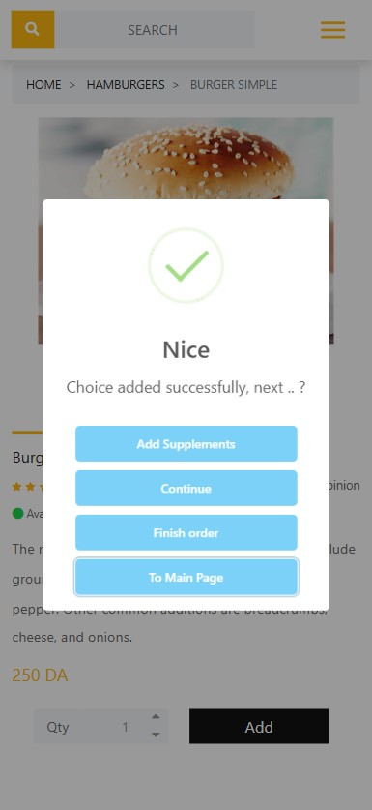
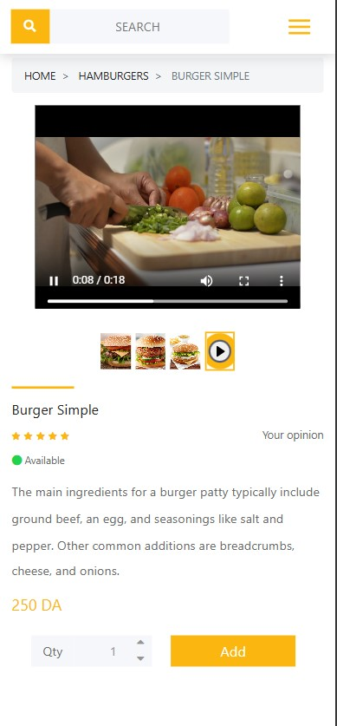

Step 4 – Add to Cart
- When the customer adds an item, a confirmation popup appears:
  - Options: Add Supplements, Continue, Finish Order, Back to Home.
- Supplements (extras) can be added if configured.

Step 5 – Cart & Validation
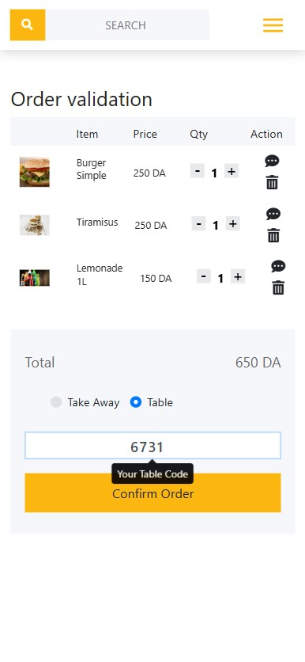

- The cart displays selected items, quantities, prices, and the total.
- The customer chooses Take Away or Table.
- For Table Orders: the customer must enter the 4-digit Table Code (printed on their table or next to the QR code).
- For Take Away Orders: the system uses the unique Take Away Code defined in Company Settings.

Step 6 – Order Tracking

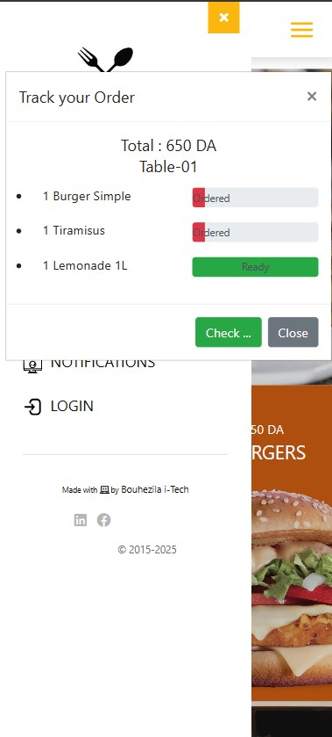
- Customers can track their order status in real-time:
  - Ordered, In Preparation, Ready.
- They see updates until the order is completed.

🔔 Notifications
- Customers can open the Notifications section.
- They choose their place (Table or Take Away).
- When the order is marked Ready, the customer is alerted with:
  - Sound on their smartphone.
  - Vibration for immediate attention.

---------------- user manual ended -----------------

