Guideline

Structure of Assignment
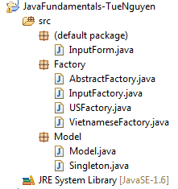
InputForm : class contains main method to run the assignment with the required design.
Factory Package: include 4 classes:
AbstractFactory: abstract class to implement Factory Pattern, contains getModel() method to get model corresponding US or Vietnamese format.
USFactory: class extends AbstractFactory to get model with American format.
VietnameseFactory: class extends AbstractFactory to get model with Viet Nam format.
InputFactory: a static class contain getFactoryObject() method to get USFactory of VietnameseFactory.

Model Package: include 2 classes:
Model: represent the object of the application with attributes: name, ID, phone, address.
Singleton: class implemented the Singleton Pattern, contain a Set<Model> to store list of models user input on GUI (InputForm).

- Main screen:
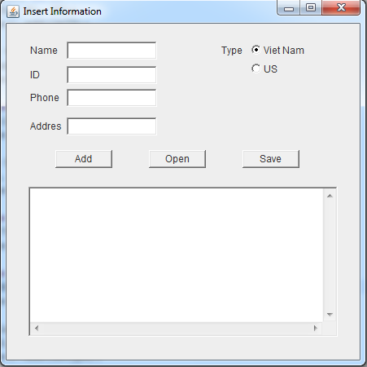
- Validate form empty
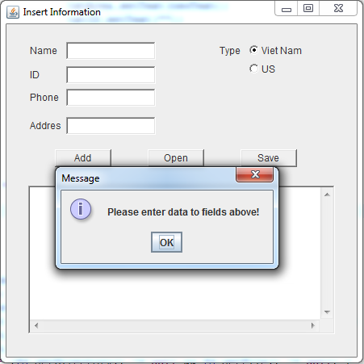
- Add data with the same ID
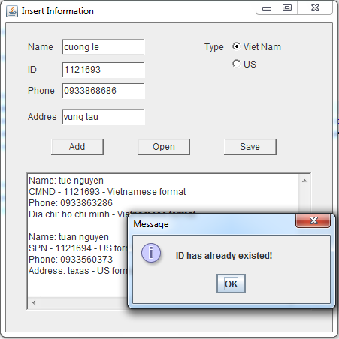
- Save data from text area to text file
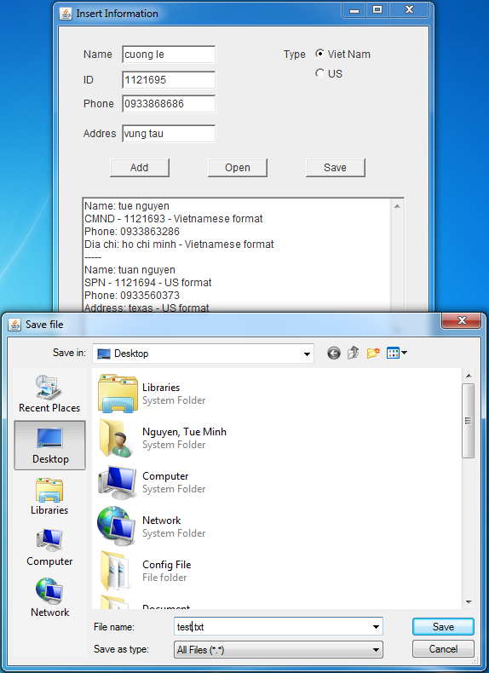
- Open saved file
