**Base Graphics Assignment**

**Problem Statement:**

Sam is in his third semester. He will learn the concepts of visualization in this semester.

The first exam is on ‘Base Graphics’ in R. Questions would be asked on the basis of what you’ve learnt in the respective module

Questions:

1. Create a bar-plot for the ‘PaymentMethod’ column.

a. Assign the color ‘burlywood4’

b. Assign the x-axis label to be “Payment Method”

c. Assign the title to be “Bar-Plot for Payment Method”

> plot(customer_churn$PaymentMethod, col="burlywood4", xlab="Payment Methods", main="Bar Plot for Payment Method")

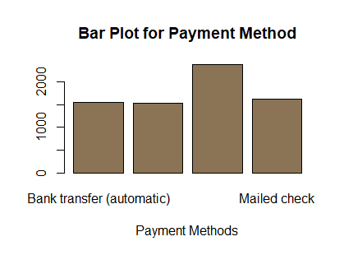

2. Create a histogram for the ‘TotalCharges’ column

a. Assign the color ‘forestgreen’

b. Assign the x-axis label to be “Total Charges”

c. Assign the title to be “Histogram for Total Charges”

> hist(customer_churn$TotalCharges, col="forestgreen", xlab="Total Charges", main="Histogram for Total Charges")

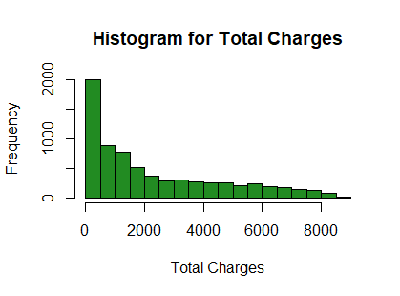

3. Create a density plot for the ‘TotalCharges’ column

a. Assign the color ‘maroon’

b. Assign the x-axis label to be “Total Charges”

c. Assign the title to be “Density plot for Total Charges”

> plot(density(na.omit(customer_churn$TotalCharges)),col="maroon", xlab = "Total Charges", main = "Density plot for Total Charges")

