**geom_histogram() Function Assignment**

**Problem Statement:**

Sam’s next exam is on ‘geom_histogram()’ function from the ggplot2 package. The questions will be asked on the basis of what you’ve learnt in the respective module.

Questions:

1. Build a histogram for the ‘tenure’ column

a. Assign the fill color to be ‘mediumspringgreen’

b. Assign the boundary color to be ‘azure’

c. Change the number of bins to be 100

> ggplot(data=customer_churn, aes(x = tenure)) +geom_histogram(bins=100, fill='mediumspringgreen', col='azure')

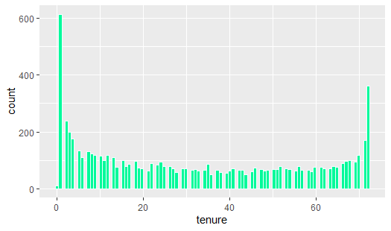

2. Build histogram for the ‘MonthlyCharges’ column

a. Assign ‘PaymentMethod’ to the fill aesthetic

b. Assign ‘OnlineBackup’ to the fill aesthetic

> ggplot(data=customer_churn, aes(x=MonthlyCharges, fill=PaymentMethod))+geom_histogram()

`stat_bin()` using `bins = 30`. Pick better value with `binwidth`.

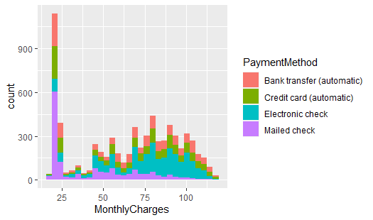

> ggplot(data=customer_churn, aes(x=MonthlyCharges, fill=OnlineBackup))+geom_histogram()

`stat_bin()` using `bins = 30`. Pick better value with `binwidth`.

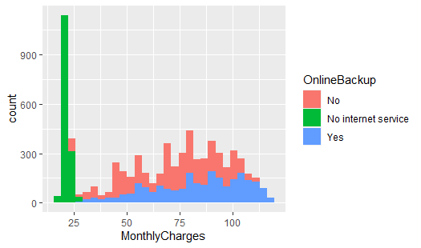

3. Build histogram for the ‘TotalCharges’ column

a. Assign ‘gender’ to the fill aesthetic

b. Assign ‘InternetService’ to the fill aesthetic

> ggplot(data=customer_churn, aes(x=TotalCharges, fill=gender))+geom_histogram()

`stat_bin()` using `bins = 30`. Pick better value with `binwidth`.

Warning message:

Removed 11 rows containing non-finite values (stat_bin).

